TEST EXECUTION & DEFECT FLOW
Test Execution:
Test Execution means running test cases and recording their results (Pass / Fail / Blocked).
Test Execution Lifecycle in Xray starts by creating a Test Execution issue, adding tests to it, executing them with Pass/Fail/Blocked status, attaching evidence, creating defects for failures, and re-executing after fixes while maintaining full execution history and traceability
In Xray (inside Jira):
- You do not execute tests directly inside the Test case
- You execute them inside a special issue type called: Test Execution
Why Test Execution exists:
Because:
- The same test can be run:
  - In multiple sprints
  - On multiple versions
  - By different testers
- Each run needs separate results & history
Test = What to test
Test Execution = When & how it was tested
Core Components in Test Execution Lifecycle
The lifecycle uses these Xray objects:
Object | Purpose
Test | The test case itself
Test Execution | Container where tests are executed
Test Plan (optional) | Groups multiple executions
Defect (Bug) | Created if test fails
Evidence | Screenshot, logs, proof
Create Tests
↓
Create Test Execution
↓
Add Tests to Execution
↓
Execute Tests (Pass/Fail/Blocked)
↓
If Fail → Create Defect
↓
After Fix → Re-execute
↓
Track History & Reports
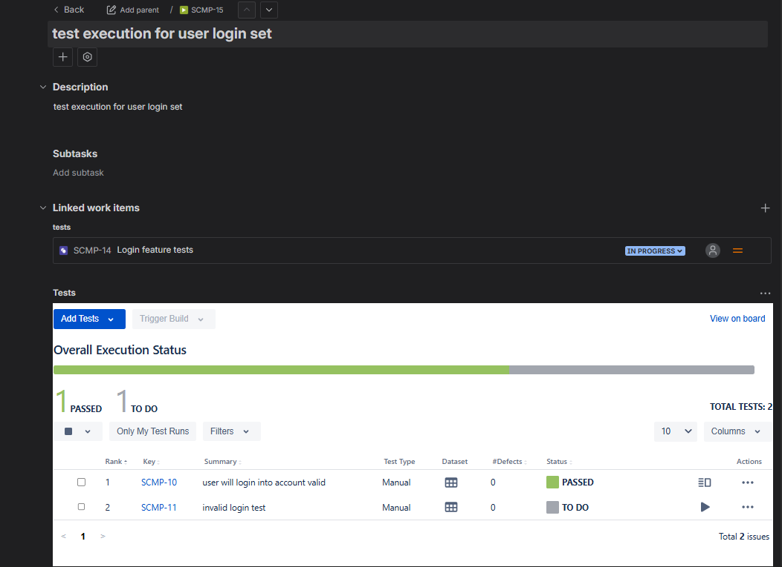
Status Flow in Execution
Each test inside execution has:
Status | Meaning
TODO | Not executed yet
PASS | Works correctly
FAIL | Bug found
BLOCKED | Could not test
Executing a Test
Performing the steps written in the test case and marking the resIn Xray:
- Tests are executed inside a Test Execution issue
- Each test gets a status
Execute a Test in Xray
Step 1: Open Test Execution
- Open Jira
- Open your Test Execution
- Click Execute
Step 2: Open One Test
- Click any test
- see:
  - Test steps
  - Expected result
  - Buttons:
    - PASS
    - FAIL
    - BLOCKED
Step 3: Execute Each Step
- Perform step in application
- Compare actual result vs expected result
- Then mark final status
Mark FAIL when:
- Any step produces wrong result
- Error message is wrong
- UI is broken
- Data is incorrect
- Performance issue blocks function
do immediately after FAIL
• Attach Evidence
- Screenshot
- Video
- Logs
• Click Create Defect
• Link it to test
Use BLOCKED when:
- Build not deployed
- Environment down
- Required feature is broken
- Dependency not available
- Test data not ready
Do NOT use BLOCKED when:
- Bug found → That is FAIL
- Test is wrong → That is FAIL
Decision Table
Situation | Status
Everything works | PASS
Any mismatch | FAIL
Could not test | BLOCKED
Not yet tested | TODO
Evidence in Testing
Evidence is stored at the Test Execution result level, not on the Test case
Proof that testing was actually done
Evidence can be:
- Screenshot
- Screen recording
- Log file
- API response
- Any document proving result
In Xray: Evidence is attached to the test execution result
Evidence is needed for:
✅ Proof for client
✅ Audit & compliance (ISO, CMMI, SOC, etc.)
✅ Developer debugging
✅ Manager review
✅ Avoiding disputes (“it works on my machine”)
Evidence is attached to:
- A specific Test
- Inside a specific Test Execution
- Not on Test case itself
So structure:
Test Execution
└── Test Result
└── Evidence attached here
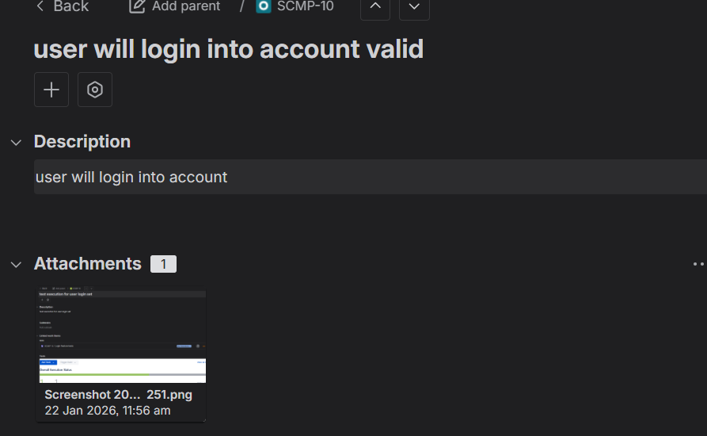
Xray allows multiple evidence per test execution result
Defect Flow
Defect flow in Xray starts from failed test execution, defect creation and linking, fixing by development, retesting in a new or same execution, and maintaining full execution history
The complete life cycle of a bug from detection to verification
Test Execution → Test Fails → Bug Created → Dev Fixes → Retest→ Close Bug
Why Defect Flow
✅ Ensures bugs are not lost
✅ Maintains traceability
✅ Shows quality of build
✅ Shows testing effectiveness
✅ Required for audits & management
Step 1: Test Fails During Execution
- You execute test in Test Execution
- Something doesn’t work
- You mark:❌ FAIL
Step 2: Attach Evidence
- Screenshot
- Video
- Logs
Never create bug without evidence.
Step 3: Create Bug in Jira
Inside failed test:
- Click Create Defect
- Jira Bug issue opens
- Fill:
  - Summary
  - Steps
  - Expected vs Actual
- Save
Now:
✅ Bug is created
✅ Automatically linked to:
- Test
- Test Execution
- Test Run
Step 4: Bug Lifecycle in Jira
Typical statuses:
Open → In Progress → Fixed → Ready for Test → Closed
Step 5: Developer Fixes the Bug
- Developer moves bug to: Fixed / Ready for Testing
Step 6: Retesting the Bug
2 ways:
✅ Option A: Same Test Execution (Quick retest)
- Reopen test
- Execute again
- If fixed → PASS
✅ Option B: New Test Execution (Best practice)
- Create:
Retest_Execution_Sprint10
- Add failed tests
- Execute again
Step 7: Close or Reopen Bug
- If test passes → Close bug
- If still fails → Reopen bug
Execution History
Xray keeps:
- Every execution
- Every result
- Every evidence
- Every linked defect

