Test Runs & Test Plans in TestRail
Test Run
A Test Run is a collection of test cases executed for a specific build or version.
👉 Example:
Running all Login and Payment test cases for Build v1.2.
A Test Run shows:
✔️ Which test cases to execute
✔️ Who will execute them
✔️ Execution status
✔️ Results
Test Plan
A Test Plan is a container that holds multiple test runs.
👉 Example:
Regression Plan contains:
- Chrome Test Run
- Firefox Test Run
- Mobile Test Run
Used when:
✔️ Multiple environments
✔️ Multiple teams
✔️ Large releases
Difference Between Test Run and Test Plan
Feature | Test Run | Test Plan
Contains | Test cases | Multiple test runs
Usage | Small execution | Large execution
Environment | Single | Multiple
Reporting | Individual | Combined
Complexity | Simple | Advanced
✔️ Use Test Run when:
- Small sprint
- Single environment
✔️ Use Test Plan when:
- Regression testing
- Multi-browser testing
- Multi-team testing
Creating a Test Run
You select:
- Test suite
- Test cases
- Assigned testers
- Milestone
- Description
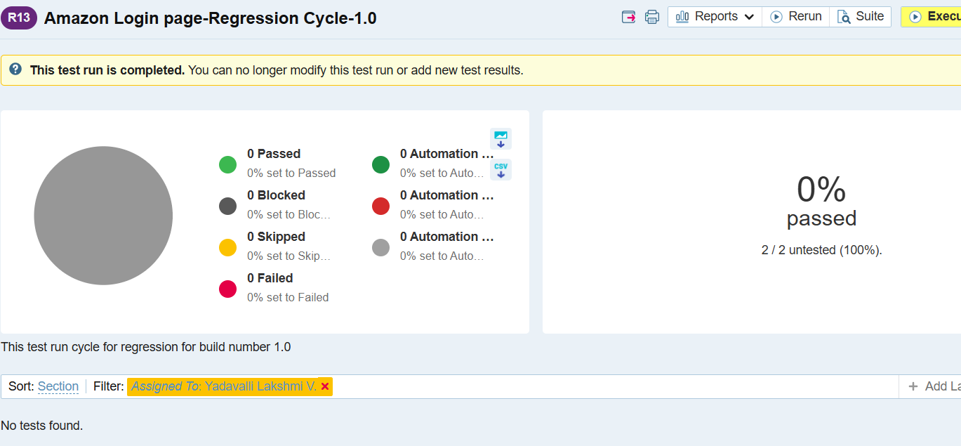
Creating a Test Plan
You create:
- Multiple test runs inside plan
- Assign different users
- Track consolidated progress
Executing Test Cases in TestRail
Executing a test case means:
✔️ Performing the steps written in the test case
✔️ Verifying actual result
✔️ Comparing with expected result
✔️ Marking the result (Pass / Fail / etc.)
✔️ Adding evidence (comments, screenshots)
👉 This is where real testing happens.
Execution Tracking
- Shows product quality
- Identifies failures early
- Provides release confidence
- Enables reporting
- Supports audits

Execution Statuses in TestRail
- Common statuses:
Status | Meaning
✅ Pass | Test succeeded
❌ Fail | Test failed
⏸ Blocked | Cannot execute
🔁 Retest | Needs re-run
⚪ Untested | Not executed
Defect Linking
You can link:
- JIRA ticket
- Bug ID
Evidence Attachment
Upload:
- Screenshots
- Logs
- Videos
Explain open run → execute → update status → attach evidence.
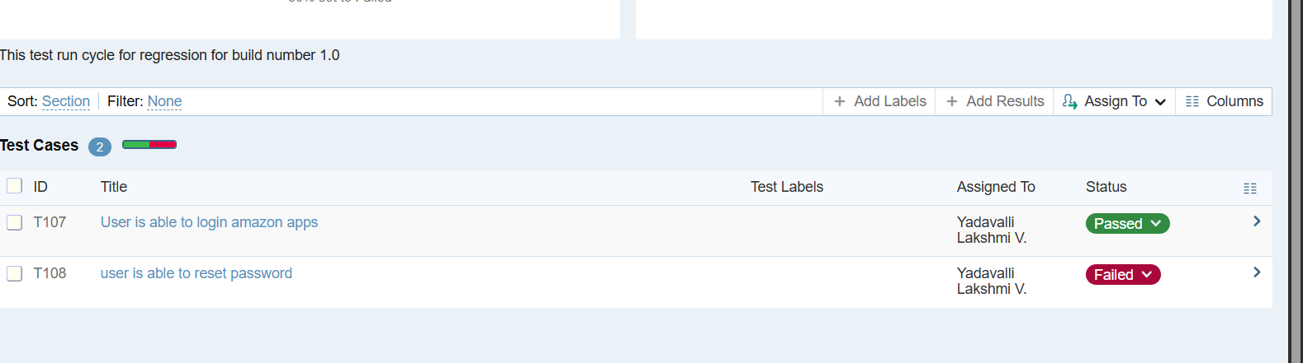
Milestones & Releases in TestRail
Milestone in TestRail
A milestone represents a testing phase or release used to track progress
A Milestone represents a project phase, sprint, or release.
👉 It helps track:
✔️ Progress
✔️ Completion
✔️ Quality status
✔️ Delivery readiness
Example:
- Sprint 1
- Release v2.0
- UAT Phase
Milestones Are Important for:
- Organize testing cycles
- Measure progress
- Track readiness
- Improve reporting
- Align with Agile sprints
Milestone contains:
- Multiple test runs
- Multiple test plans
- Status tracking

Milestone Status
Status | Meaning
🟢 Active | In progress
✅ Completed | Finished
🔴 Delayed | Behind schedule
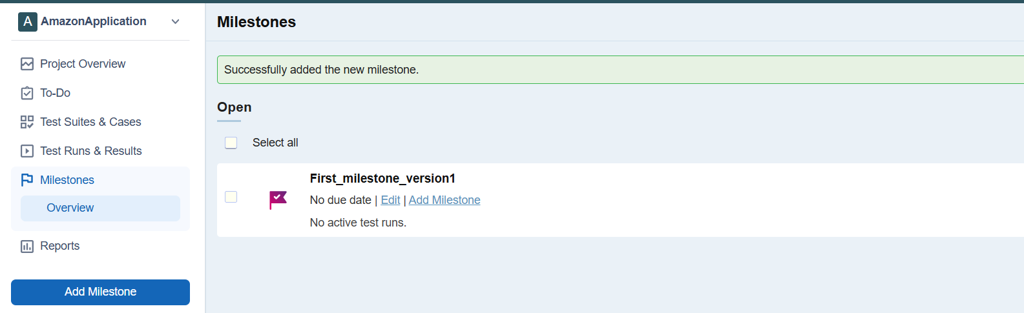
Reports & Metrics in TestRail
Reports in TestRail
Reports show:
✔️ Test execution status
✔️ Quality metrics
✔️ Progress
✔️ Risks
✔️ Readiness for release
👉 Reports convert raw test data into meaningful insights.
- Management visibility
- Release decision making
- Quality tracking
- Audit evidence
- Team performance
Types of Reports in TestRail:
1. Progress Report
Shows execution progress.
2. Coverage Report
Shows how many test cases exist per requirement.
3. Defect Report
Shows defects linked.
4. Comparison Report
Compare test runs.
Report Filters
Filter by:
- Project
- Milestone
- Run
- Status
- User
