TEST PLANNING & TRACEABILITY
Test Planning
It is a container used to plan, group, and track multiple test executions and tests for a specific sprint or release.
Deciding WHAT to test, HOW to test, WHEN to test, and WHO will test
Before writing or executing tests, we must plan.
Test Plan
In Xray, a Test Plan is:
A container that groups Tests and Test Executions for a specific goal:
- Sprint
- Release
- Regression cycle
- UAT cycle
With Test Plan:
✅ Clear scope
✅ Clear ownership
✅ Clear coverage
✅ Full traceability
Test Plan vs Test Execution
Test Plan | Test Execution
Planning object | Execution object
Decides scope | Executes tests
Groups multiple executions | Contains actual results
Used for reporting | Used for running tests
Answers: “What are we testing?” | Answers: “What happened?”

Test Plan = Strategy
Test Execution = Action
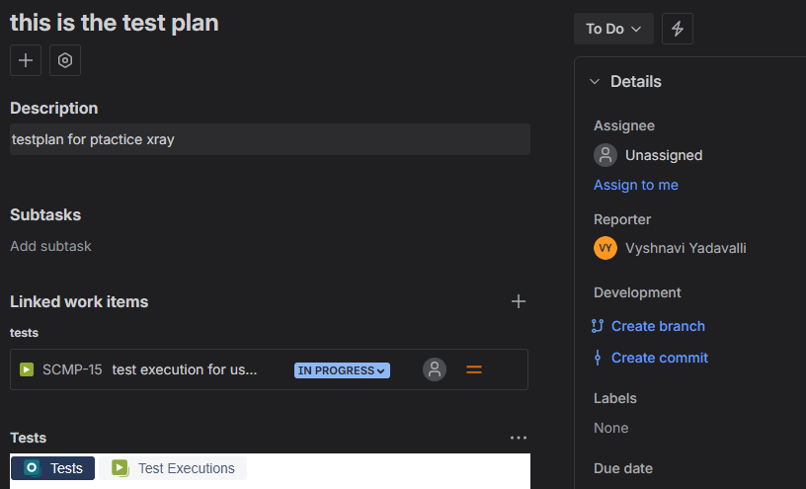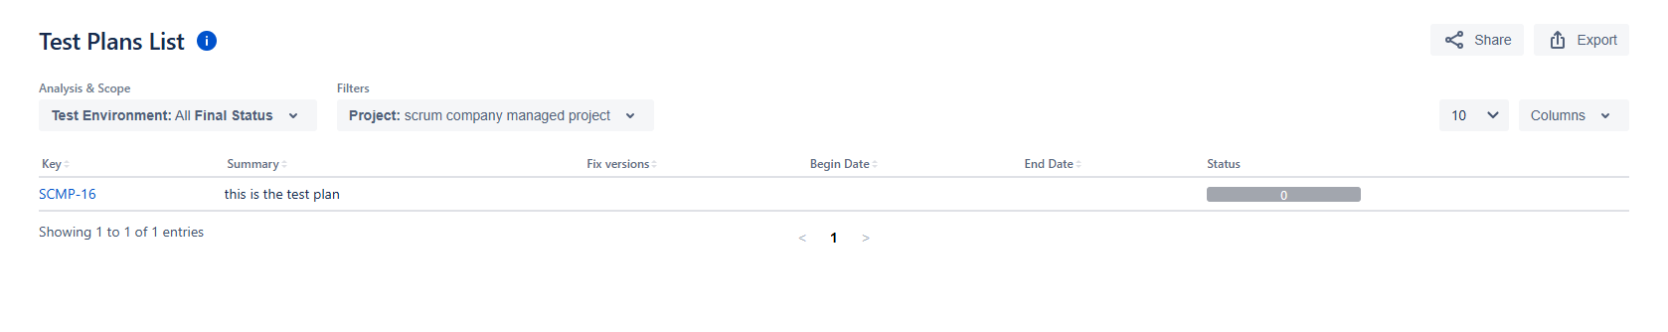
Sprint Test Planning (Agile Workflow)
Every sprint:
- Product owner finalizes stories
- QA:
  - Identifies tests
  - Updates Test Plan
- Create:
  - Sprint Test Execution
- Track:
  - Daily execution progress
Release Test Planning
For release:
Create:Release_Test_Plan_v1.0
- Include:
  - All sprint executions
  - Full regression
  - UAT
Regression Strategy Inside Test Plan
You maintain:
- Smoke Tests
- Sanity Tests
- Regression Tests
Regression Testing
Re-testing old functionality to make sure new changes didn’t break anything
Regression strategy is about creating reusable critical test suites and executing only risk-based, impacted tests to save time and ensure stability
Whenever:
- New feature is added
- Bug is fixed
- Code is changed
👉 We must do regression.
With strategy:
✅ Test only what matters
✅ Save time
✅ Reduce risk
✅ Faster releases
Regression Suite
A collection of critical tests that must always be executed
Types of suites:
- Smoke Suite (very small)
- Sanity Suite
- Full Regression Suite
In Xray you use:
- ✅ Test Sets → To group regression tests
- ✅ Test Plans → To plan regression cycles
- ✅ Test Executions → To run regression
Structure:
Regression Test Set
↓
Added to
Test Plan
↓
Executed via
Test Execution
Reusable Test Packs
A stable group of tests reused across releases
Examples:
- Login Pack
- Checkout Pack
- User Management Pack
These packs:
✅ Never change much
✅ Always reused
✅ Added to every regression execution
Smart Test Selection
Instead of running: ❌ 2000 tests
You run: ✅ Only tests impacted by change
How to select smartly?
Based on:
- Changed features
- Affected modules
- Past defect areas
- Risk level

Risk-Based Regression Strategy
Area | Regression Depth
Payment | Full
Login | Full
Profile UI | Partial
Report Download | Smoke only
Traceability
Ability to track each requirement through testing and defects
In simple words: “Show me proof that every requirement was tested.”
Traceability Chain
In Xray + Jira:
Requirement (Story)
↓
Test
↓
Test Execution
↓
Defect
This means you can:
✅ Start from requirement and go to bug
✅ Start from bug and go back to requirement
✅ Audit & compliance
✅ Management confidence
✅ Coverage tracking
✅ Risk identification
✅ Gap detection
✅ Release decisions
Coverage Matrix = Table showing which requirements have tests and executions
It shows:
Requirement | Tests | Executed? | Status
Story-1 | 5 | Yes | PASS
Story-2 | 0 | No | GAP
Story-3 | 3 | Yes | FAIL
Gap Identification
Gap = Requirement without test OR without execution
Types of gaps:
No test linked
Test exists but not executed
Execution exists but failed

