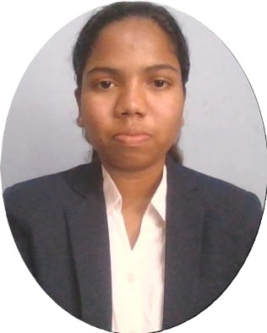 | Ms. Bhoomika D A |  | P: bhoomikannappa2005@gmail.com
 | Ms. Bhoomika D A |  | O: dbhoomikaBTECH23@ced.alliance.edu.in
 | Ms. Bhoomika D A |  | +91-9611054677
 | Ms. Bhoomika D A |  | https://www.linkedin.com/in/bhoomika-d-a-032932300/
 | Ms. Bhoomika D A |  | https://github.com/Bhoomikannappa
 | Ms. Bhoomika D A |  | https://www.hackerrank.com/profile/bhoomikannappa21

EDUCATION
Bachelor of Technology (B. Tech) in Computer Science and Engineering,
Year of Graduation: 2027|CGPA: 8.5
12th Grade (KSEAB)
Vijaya Pu college | 4th block Jayanagar, Bengaluru | Karnataka School Examination and Assessment Board, Karnataka, India | Year: 2023 | Percentage: 85%
10th Grade (KSEEB)
Morarji Desai Residential School | Dudda, Hassan | Karnataka Secondary Education Examination Board, Karnataka, India | Year: 2021 | Percentage: 90.72%

TECHNICAL SKILLS
- Programming Languages: Python, C, C++, HTML
- Database Technologies: SQL, MySQL
- Data Tools & Libraries: Pandas, NumPy, Matplotlib, Google Colab, Power BI, Cisco Packet Tracer
- Tools/Platforms: GitHub, VS Code
- Others: Data Structures & Algorithms, Data Analysis, Network and Communication, Operating System, Machine Learning

ACADEMIC PROJECTS
- MultiModel Interactive AI – [Python-OpenCV, SpeechRecognition, MediaPiPe]
- VidMentor App (Matching Student with Right Teacher) – [Python, HTML, NLP, SQL] (On progress).

CERTIFICATIONS
- AI-900:Microsoft Azure AI Fundamentals– Microsoft – 2025 see credential
- Getting Started with Artificial Intelligence – IBM SkillsBuild– 2025. See credential
- Basics of SQL and Python – Hackerrank – 2025 see credential
- Generative AI Unleashing– Infosys SpringBorad –2025 see credential
- Programming in C++: A Hands-on Introduction Specialization– Coursera– 2024 see credential
- Probability and Statistics for Machine Learning and Data Science – 2024

ACHIEVEMENTS & PARTICIPATIONS
- Social Internship – Healthcare Effectiveness: Gained insights into patient treatment practices, disease prevention parameters, and did community awareness programs during a healthcare-focused internship.

- Volunteering – Code Sangram (College-Level Hackathon Event): Contributed as a volunteer for a large-scale coding event, coordinating with participants and organizers to ensure smooth execution.

PORTFOLIO & VIDEO RESUME

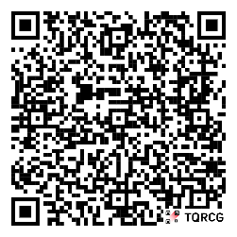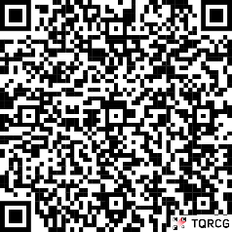
~1min ~3min

