Week-4:

PROGRAM – 1:

AIM: Write a java program with class named “book”, the class should contain various attributes such as title, author, year of publication it should also contain a constructor with parameters which initializes, title, author, and year of publication.

Create a method which displays the details of the book and display the details of two books.

CODE:

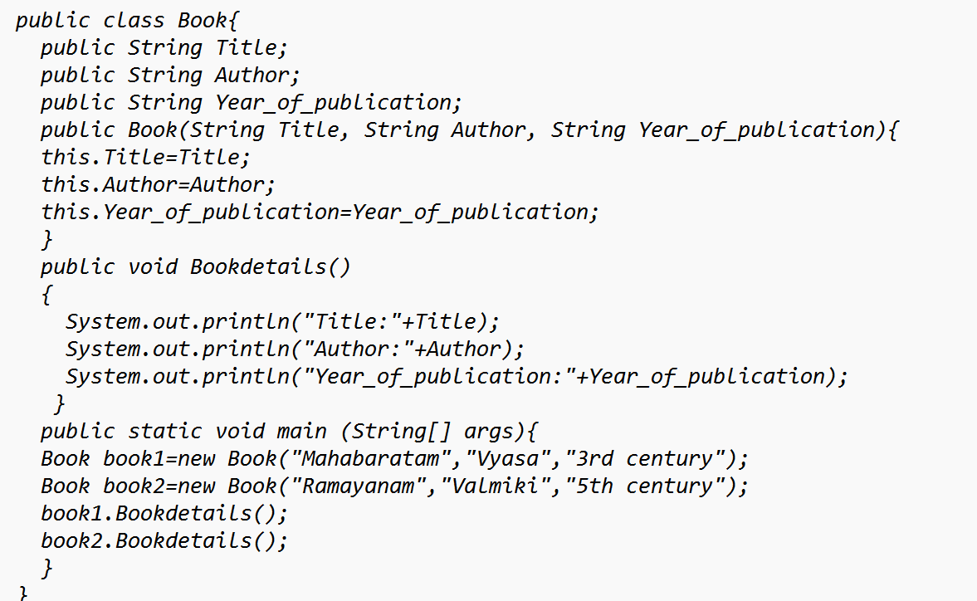

OUTPUT:

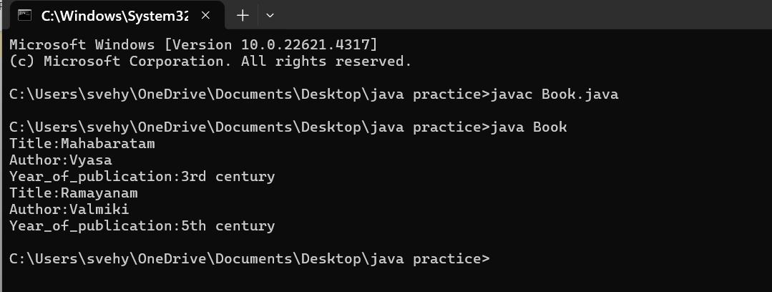

ERROR TABLE:

|  |  |
| --- | --- |
| **Code Error** | **Code rectification** |
| 1. Not defining the function in a file. 2. Two public class files should not be saved in the same file. | 1. To call the method we must define a function in a file. 2. Two public class files should be saved in different files. |

NEGATIVE CASE:

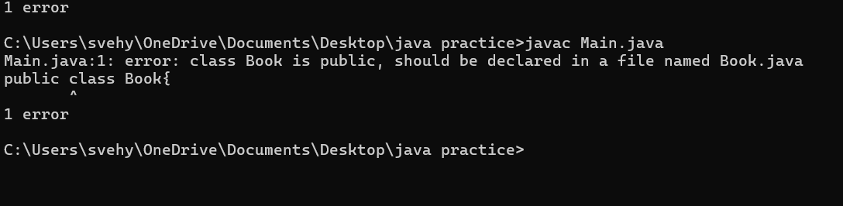

IMPORTANT POINTS:

1. While defining two classes for a code, we must be sure that we save both the classes in separate files.
2. While defining a method we should also define a function to call that method.

CLASS DIAGRAM:

|  |
| --- |
| Book   * Title: String * Author: String * Year of publication: int   + Book(title: String,  Author: String;  Year of publication: int  + displayDetails( ): void |

PROGRAM – 2:

AIM: Create a java Program with class named myclass with static variable count of int type, initialized to zero and a constant variable “pi” of type double initialized to 3.14 as attributes of the class, ow define a constructor for “myclass” that increments the count variable each time an object of my class is created (count++), finally print the final values of count and pi variables create three objects.

CODE:

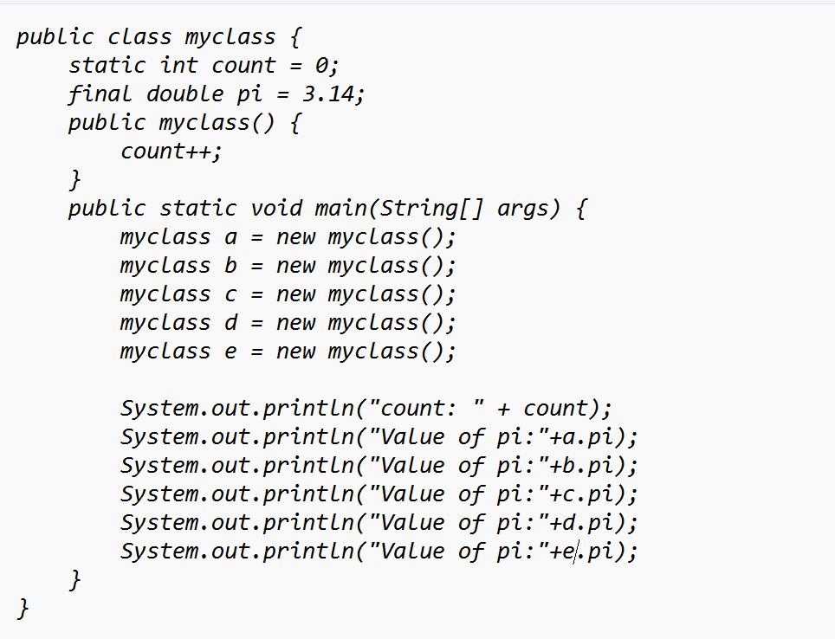

OUTPUT:

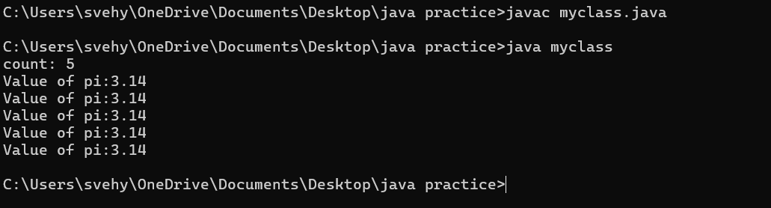

ERROR TABLE:

|  |  |
| --- | --- |
| **Code Error** | **Code rectification** |
| 1. Not Putting the semi-colon after calling a function, 2. Not giving the indentation properly. | 1. Put the semi-colon after calling a function. 2. All the indentation must be correct to run the code correct. |

NEGATIVE CASE:

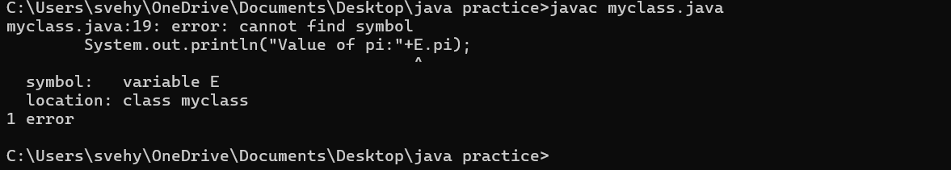

IMPORTANT POINTS:

1. We must declare the initial value of the variable before declaring the final one.
2. Here the main objective is to increase the count according to the number of objects we make, i.e the count increases when the no.of objects are increasing.

CLASS DIAGRAM:

|  |
| --- |
| Myclass   * Count: int * Pi: double   + myclass( )  + main(args: String[]): void |