AI Assisted Coding
Assignment-16.3
Name: S.Vyshnavi
HT.No: 2303A51920
Batch-07
Lab 16 – Database Design and Queries: Schema Design and SQL Generation
Task 1 – Hospital Management Database
Prompt: “Create SQL schema (Doctors, Patients, Appointments) with keys & constraints.
Add queries: doctor appointments, patient history, patient count per doctor. Include comments + indexing.”
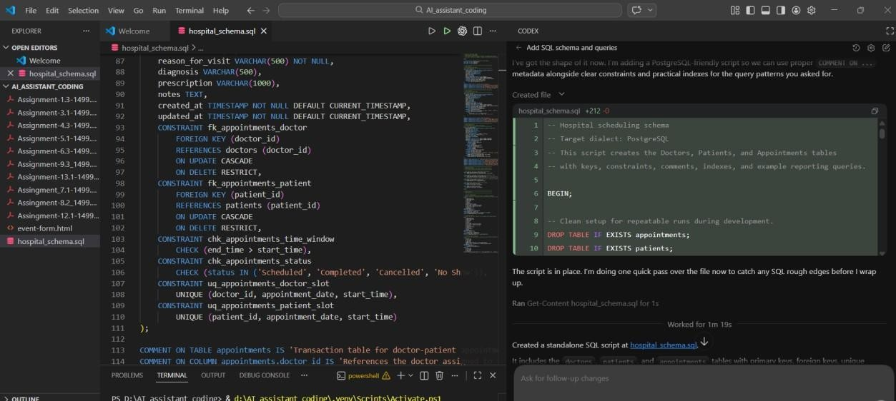

Task 2 – Real-Time Application: Online Shopping Database

Prompt: “Design SQL schema (Users, Products, Orders, OrderDetails). Add queries: user orders, most purchased product, monthly revenue. Include normalization + indexing.”

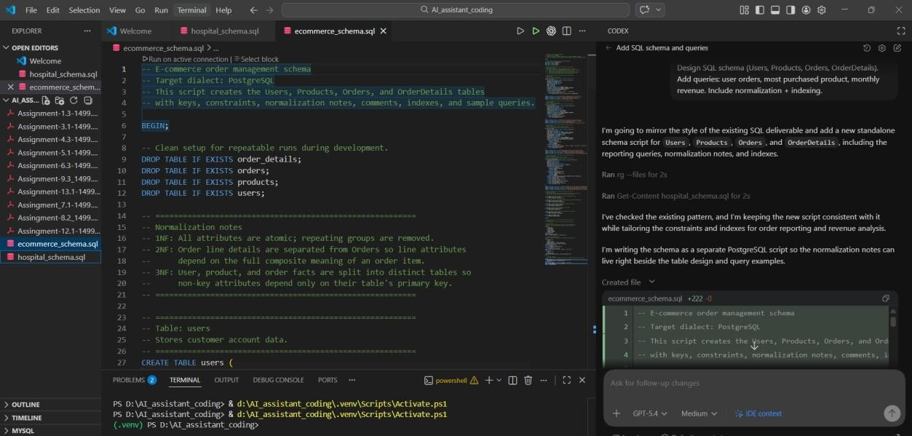
Task 3 – Library Database

Prompt: “Create SQL schema (Books, Members, Loans). Add queries: issued books, overdue books (>30 days), books per member. Include indexing.”

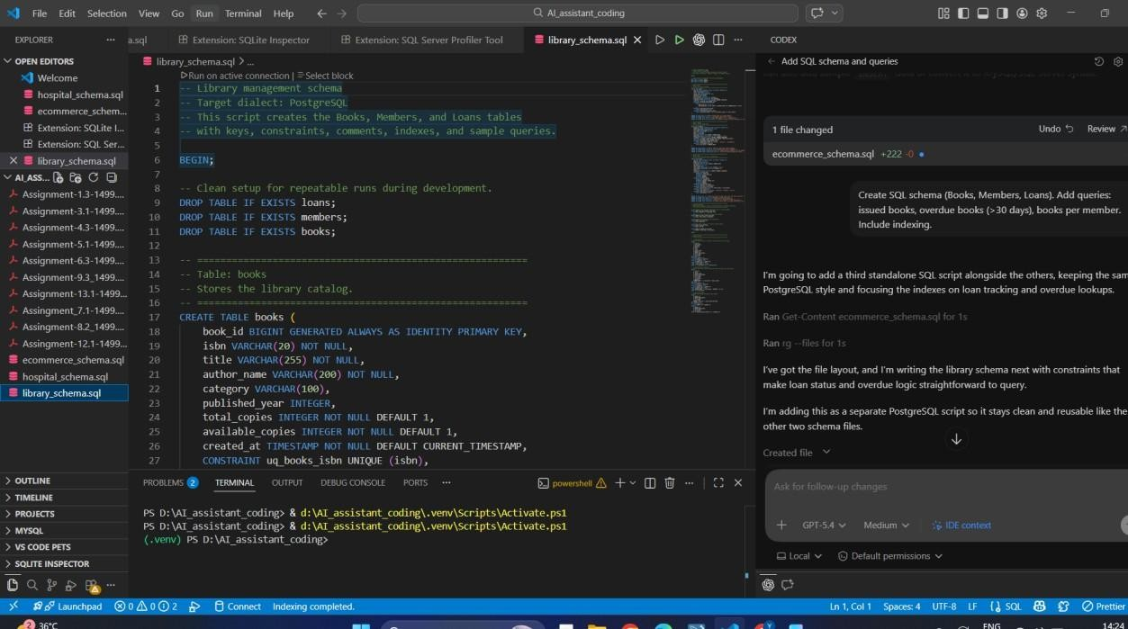

Task 4: Optimize Queries

Prompt: “Optimize SQL subquery using JOIN. Explain performance improvement and suggest indexes.”
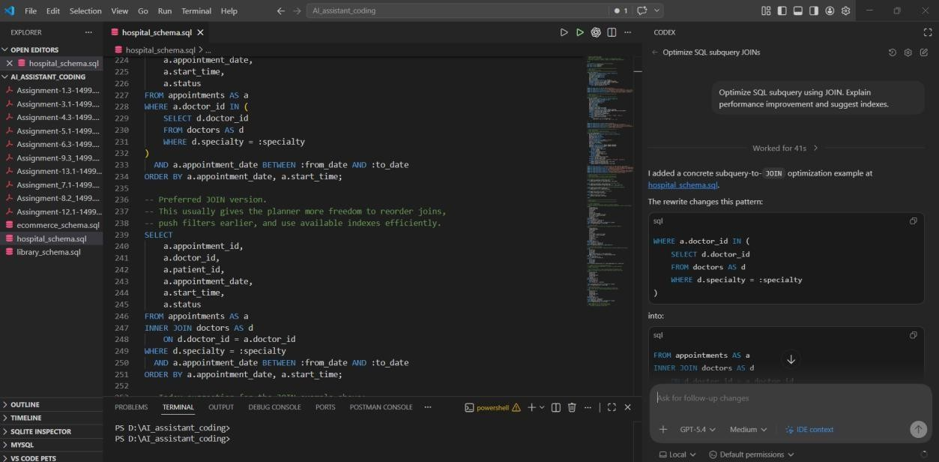

Task 5: University Course Registration
Prompt: “Design SQL schema (Students, Courses, Faculty, Registrations). Add queries: students per course, faculty >2 courses, most registered course. Include optimization.”

