Assignment-4.3
Name: S.Vyshnavi
Hall ticket No:2303A51920
Batch:07
Lab 4: Advanced Prompt Engineering – Zero-shot, One-shot, and Few-shot Techniques Task 1: Zero-Shot Prompting – Leap Year Check

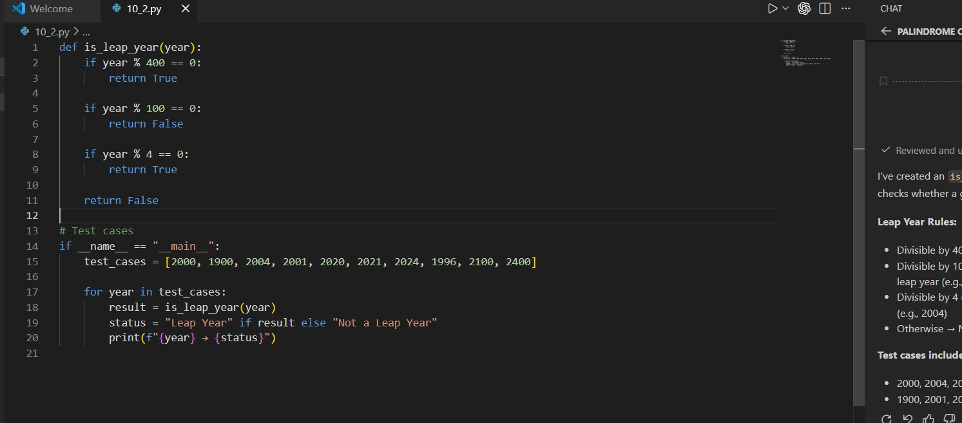
Output:
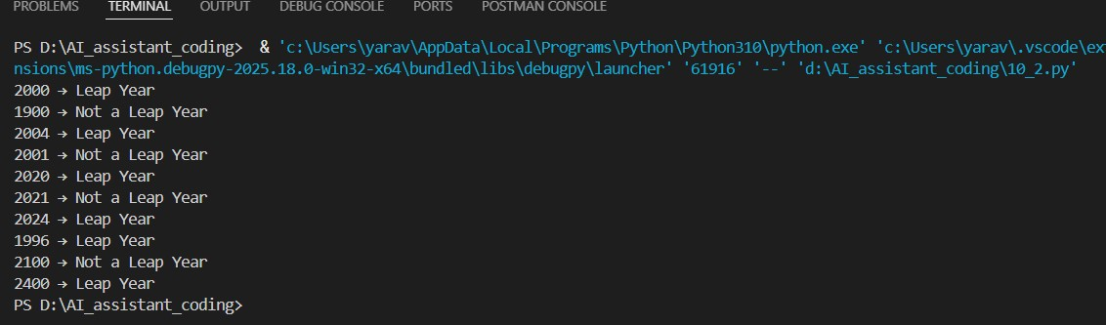
Task 2: One-Shot Prompting
Centimeters to Inches Conversion

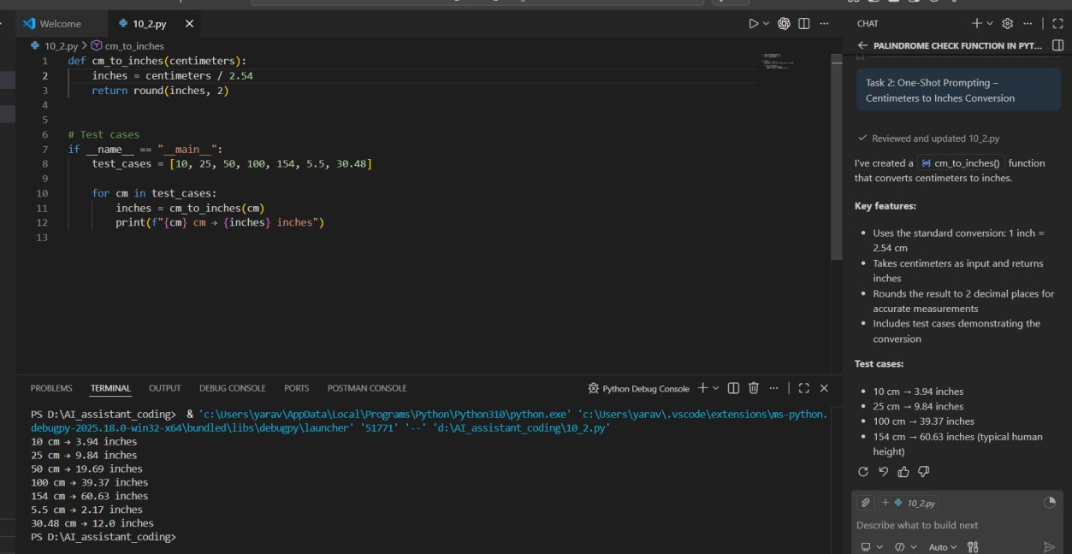

Task 3: Few-Shot Prompting – Name Formatting

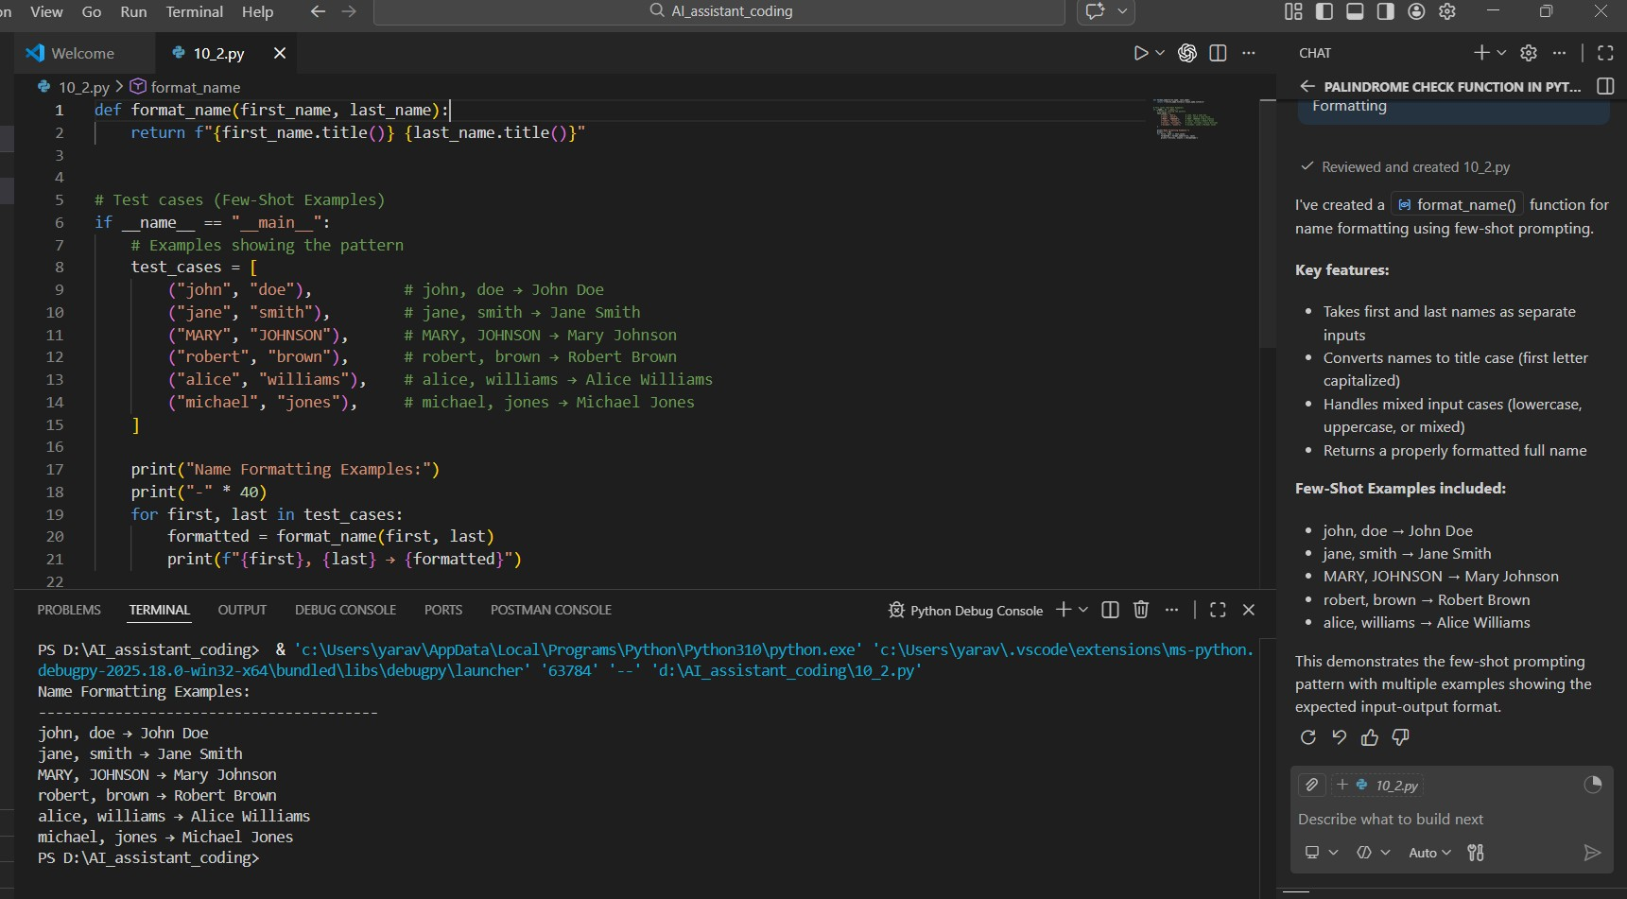

Task 4: Comparative Analysis – Zero-Shot vs Few-Shot

