ASSIGNMENT-8.2
Name: S. Vyshnavi
HT. No: 2303A51920
Batch: 07

Lab 8: Test-Driven Development with AI – Generating and
Working with Test Cases
Task Description
Task 1 – Test-Driven Development for Even/Odd Number Validator • Use AI tools to first generate test cases for a function is_even(n) and then implement the function so that it satisfies all generated tests.
Requirements:
- Input must be an integer
- Handle zero, negative numbers, and large integers Example Test Scenarios:
is_even(2) → True is_even(7) → False is_even(0) → True is_even(-4) →
True is_even(9) → False
Expected
Output
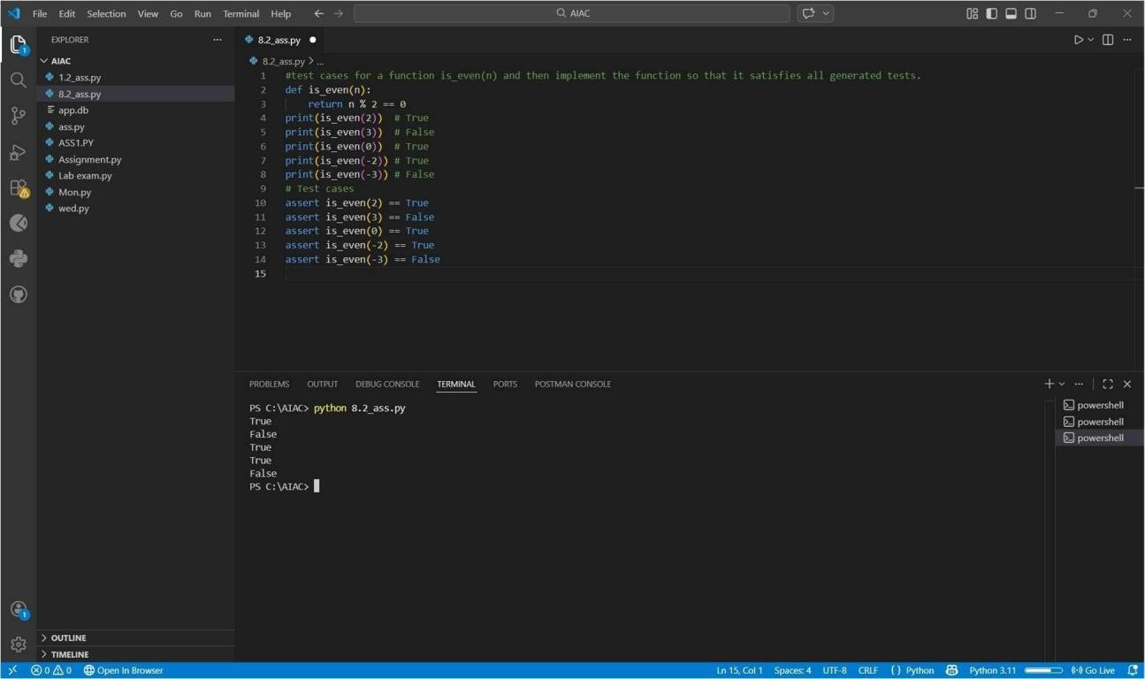
- A correctly implemented is_even() function that passes all AI- generated test cases
Task Description
Task 2 – Test-Driven Development for String Case Converter
- Ask AI to generate test cases for two functions:
- to_uppercase(text)
- to_lowercas
e(text)
Requirements:
- Handle empty strings
- Handle mixed-case input
- Handle invalid inputs such as numbers or None Example Test Scenarios: to_uppercase("ai coding") → "AI CODING" to_lowercase("TEST") → "test" to_uppercase("") → ""
to_lowercase(None) → Error or safe handling
Expected Output
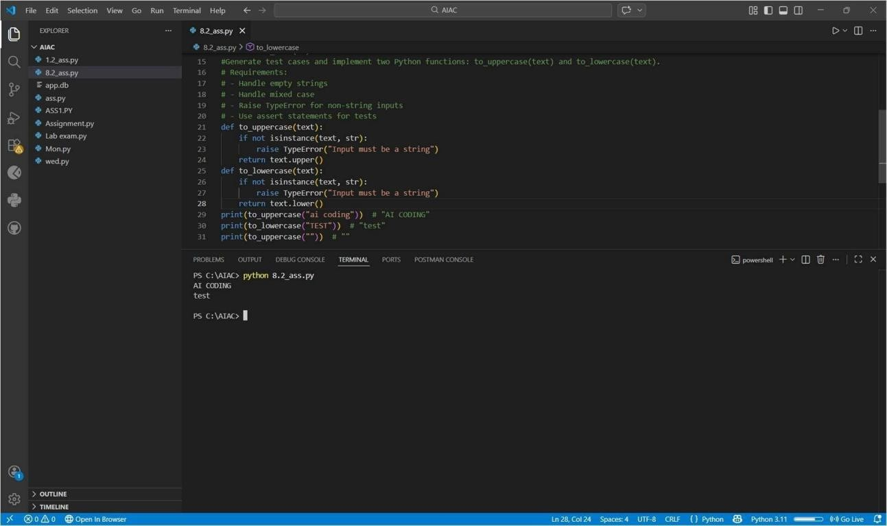
- Two string conversion functions that pass all AIgenerated test cases with safe input handling.
Task Description
Task 3 – Test-Driven Development for List Sum Calculator • Use AI to generate test cases for a function sum_list(numbers) that calculates the sum of list elements. Requirements:
- Handle empty lists
- Handle negative numbers
- Ignore or safely handle non-numeric values Example Test Scenarios:
sum_list([1, 2, 3]) → 6
sum_list([]) → 0 sum_list([-1,
5, -4]) → 0
sum_list([2, "a", 3]) → 5
Expected Output
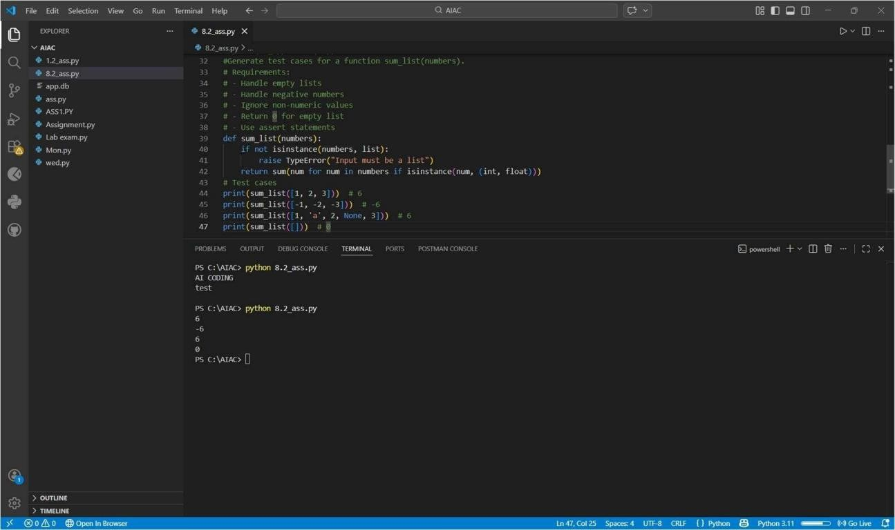
- A robust list-sum function validated using AI-generated test cases.
Task Description
Task 4 – Test Cases for Student Result Class
- Generate test cases for a StudentResult class with the following methods: • add_marks(mark)
- calculate_average()
- get_re
sult()
Requirements
:
- Marks must be between 0 and 100
- Average ≥ 40 → Pass,
otherwise Fail Example Test Scenarios:
Marks: [60, 70, 80] → Average: 70 → Result: Pass
Marks: [30, 35, 40] → Average: 35 → Result: Fail
Marks: [-10] → Error
Expected Output
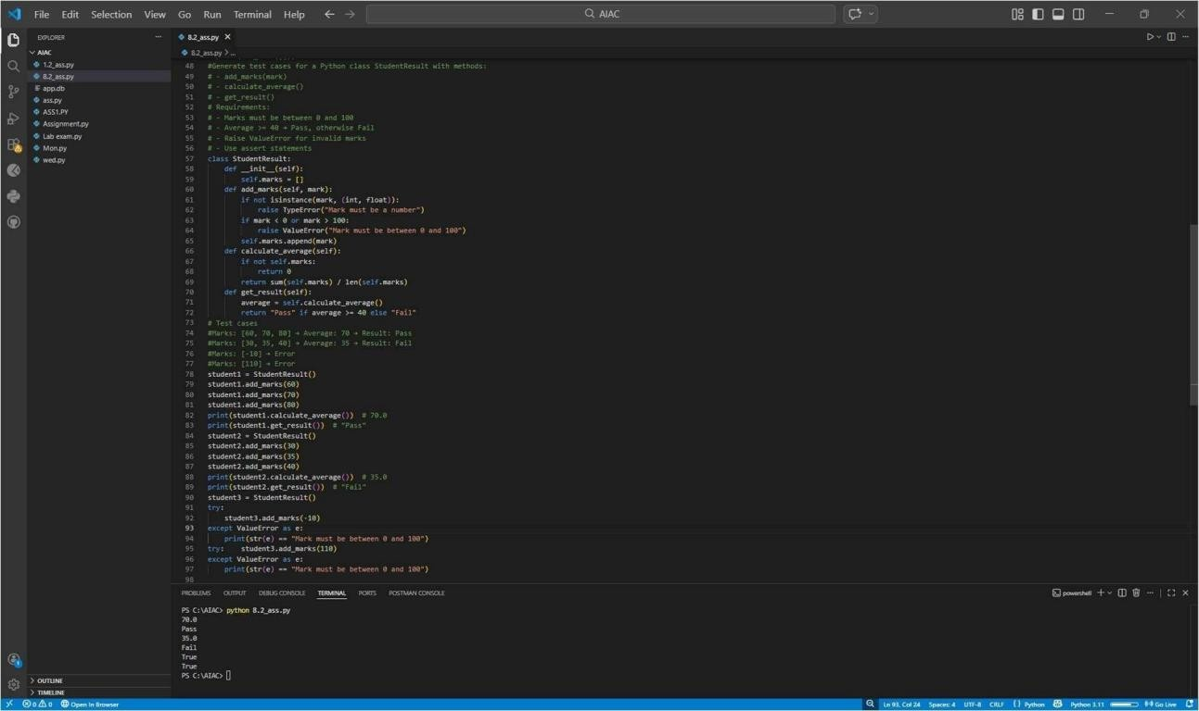
- A fully functional StudentResult class that passes all AI- generated test
Task Description
Task 5 – Test-Driven Development for Username Validator Requirements:
- Minimum length: 5 characters
- No spaces allowed
- Only alphanumeric characters Example Test Scenarios: is_valid_username("user01") → True
is_valid_username("ai") → False is_valid_username("user name") → False is_valid_username("user@123") → False
Expected Output
