Assingment-12.1
Name: Nandini Reddy

Hall Ticket no: 2303A51896

Lab: Algorithms with AI Assistance-Sorting,Searching,optimizing Algorithms

Task 1: Sorting-Merge sort Implementation

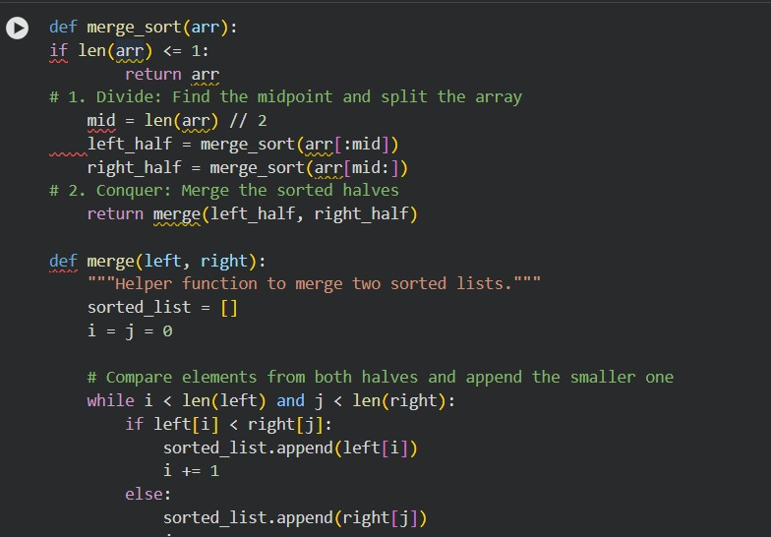

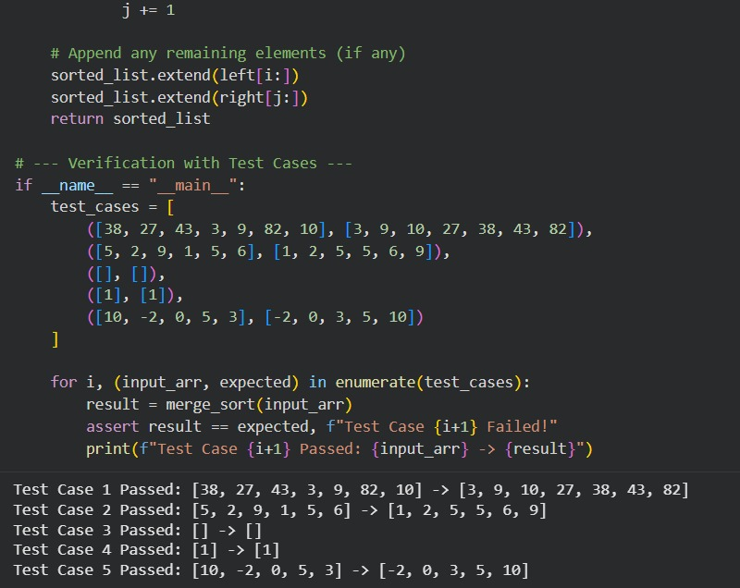

Task 2: Searching-Binary search with AI Optimization
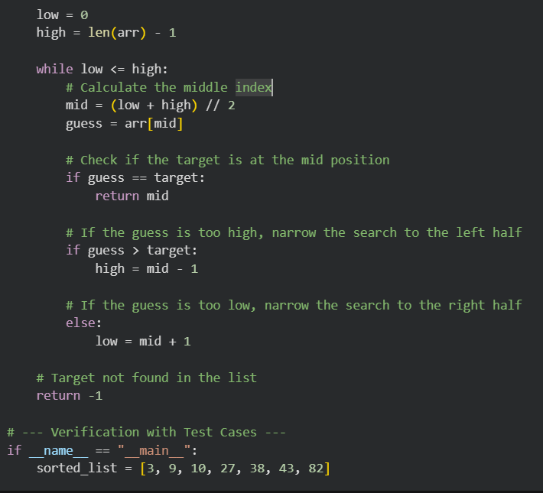

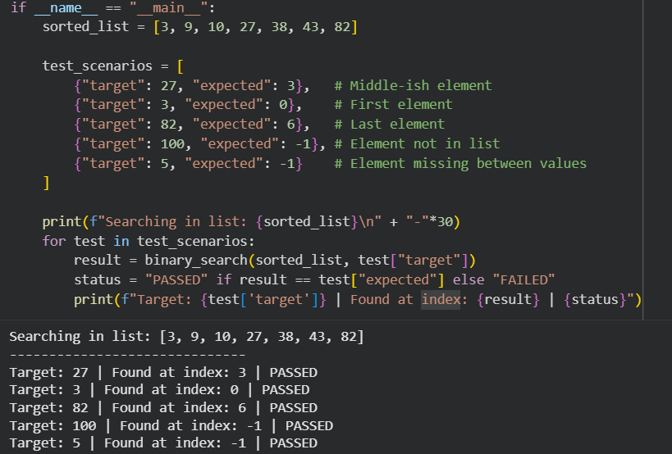

Task 3: Real time application-Inventory management System
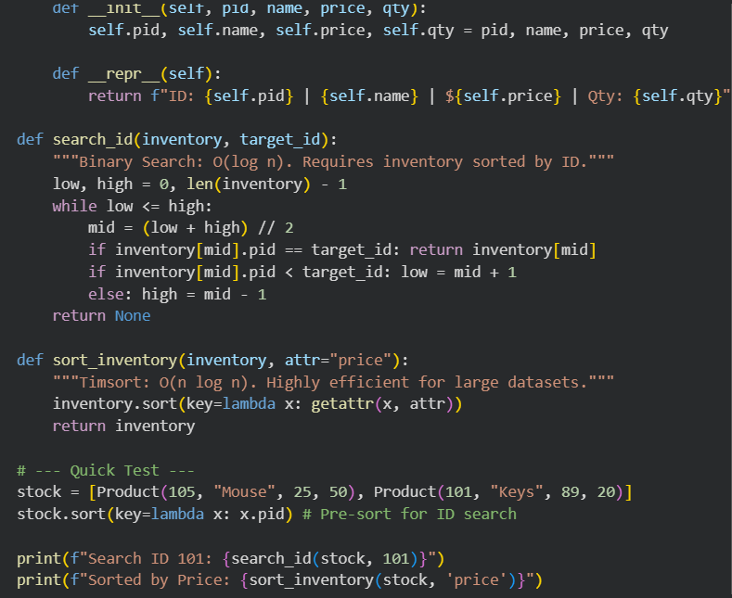

Task 4 : Smart hospital Patient Management System
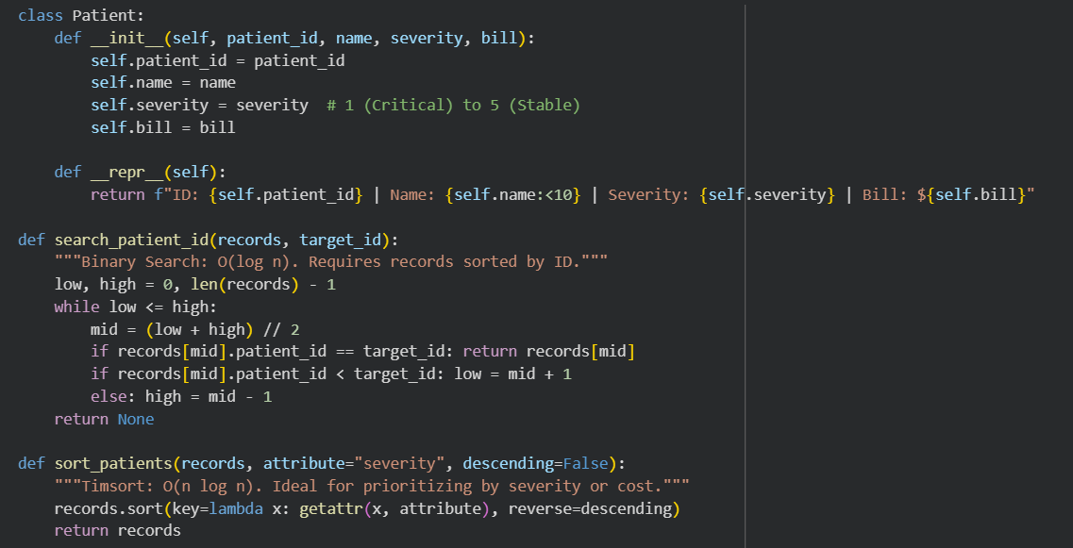

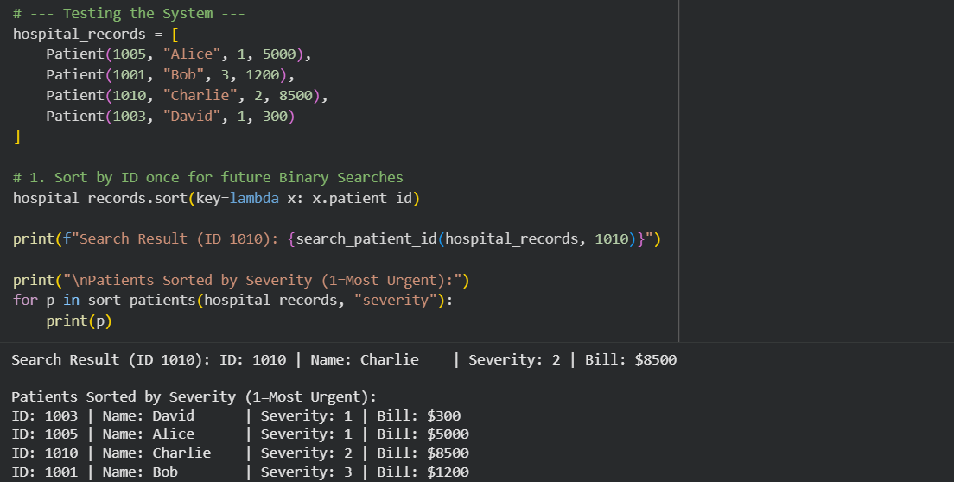

Task 5: University Examination result processing System
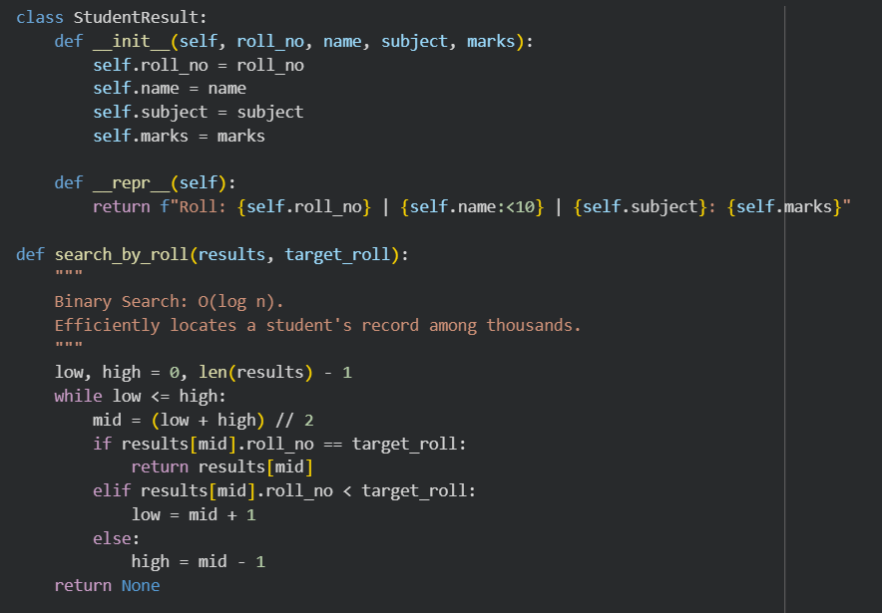

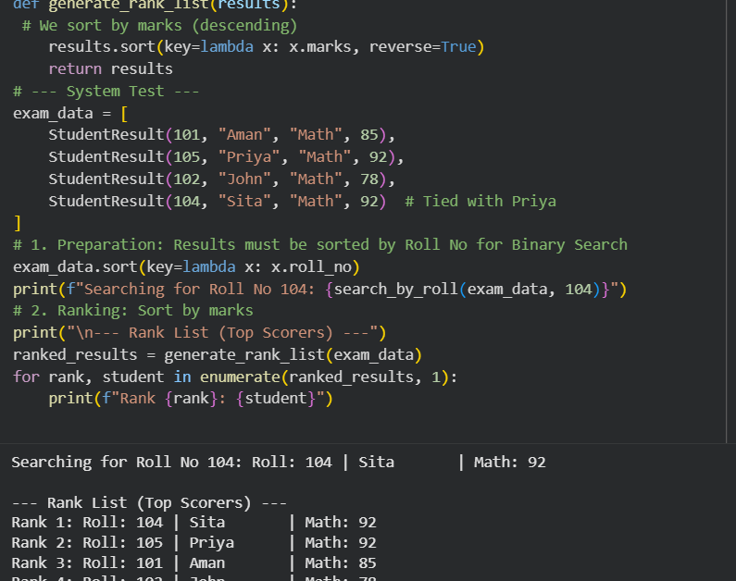

Task 6: Online food delivery platform
