ASSIGNMENT-6.3
Name: S. Vyshnavi
HT. No: 2303A51920
Batch: 07
Lab 6: AI-Based Code Completion – Classes, Loops, and Conditionals
Task Description #1: Classes (Student Class)
Scenario
You are developing a simple student information management module.
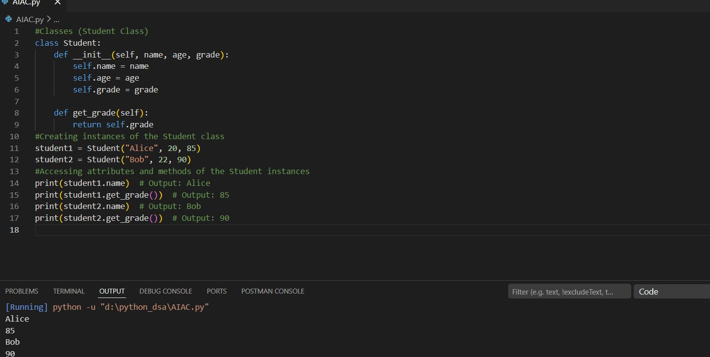

Task Description #2: Loops (Multiples of a Number)
Scenario
You are writing a utility function to display multiples of a given number.
Task
- Prompt the AI tool to generate a function that prints the first 10 multiples of a given number using a loop.
- Analyze the generated loop logic.
- Ask the AI to generate the same functionality using another controlled looping structure (e.g., while instead of for).
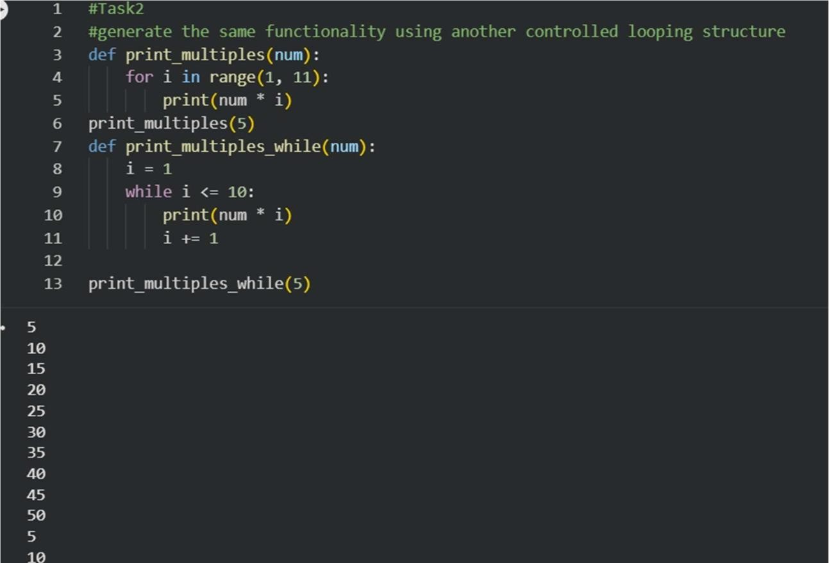
Task Description #3: Conditional Statements (Age Classification)
Scenario
You are building a basic classification system based on age.
Task
- Ask the AI tool to generate nested if-elif-else conditional statements to classify age groups (e.g., child, teenager, adult, senior).
- Analyze the generated conditions and logic.
- Ask the AI to generate the same classification using alternative conditional structures (e.g., simplified conditions or dictionary-based logic).
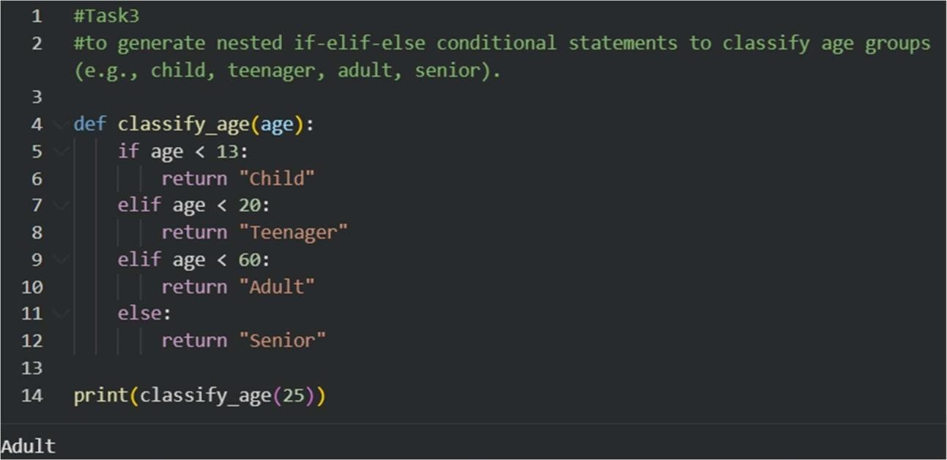
Task Description #4: For and While Loops (Sum of First n Numbers)
Scenario
You need to calculate the sum of the first n natural numbers.
Task
- Use AI assistance to generate a sum_to_n() function using a for loop.
- Analyze the generated code.
- Ask the AI to suggest an alternative implementation using a while loop or a mathematical formula.
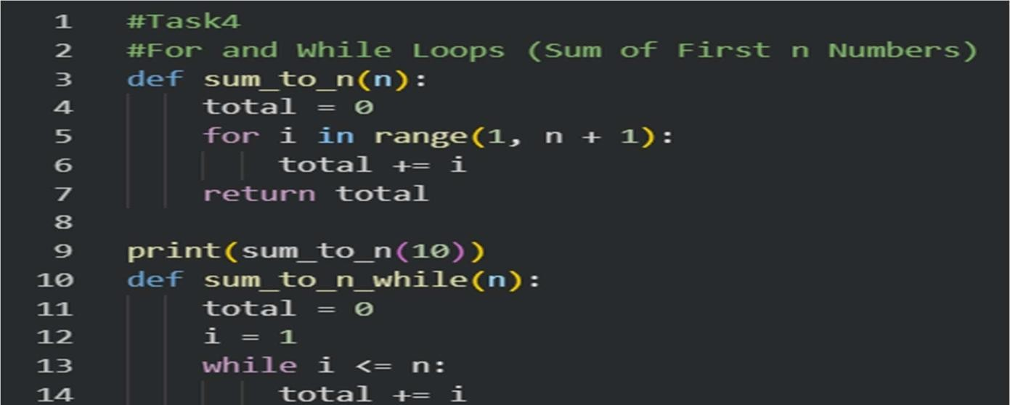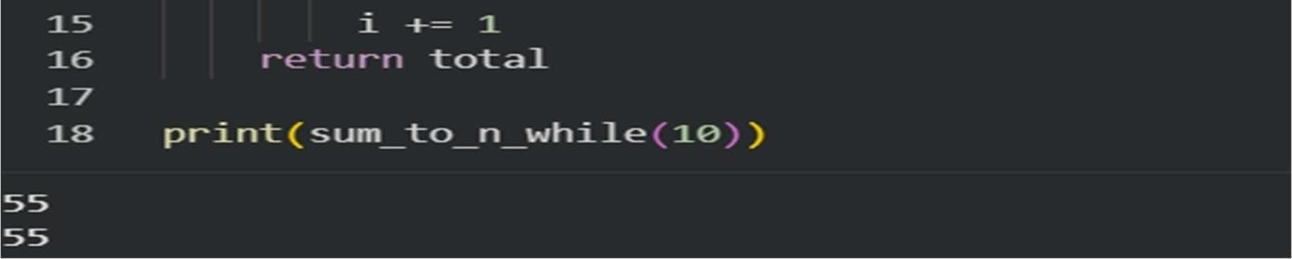
Task Description #5: Classes (Bank Account Class)
Scenario
You are designing a basic banking application.
Task
- Use AI tools to generate a Bank Account class with methods such as deposit(), withdraw(), and check_balance().
- Analyze the AI-generated class structure and logic.
- Add meaningful comments and explain the working of the code.
