Assignment-3.1
Name: S.Vyshnavi
Hall ticket No:2303A51920
Batch:07
Lab Experiment: Prompt Engineering – Improving Prompts and Context Management

Question 1 – Zero-Shot Prompting
Prompt Used
Generate a Python function that checks whether a given number is a palindrome. The function should take a number as input and return True if it is a palindrome, otherwise return False.

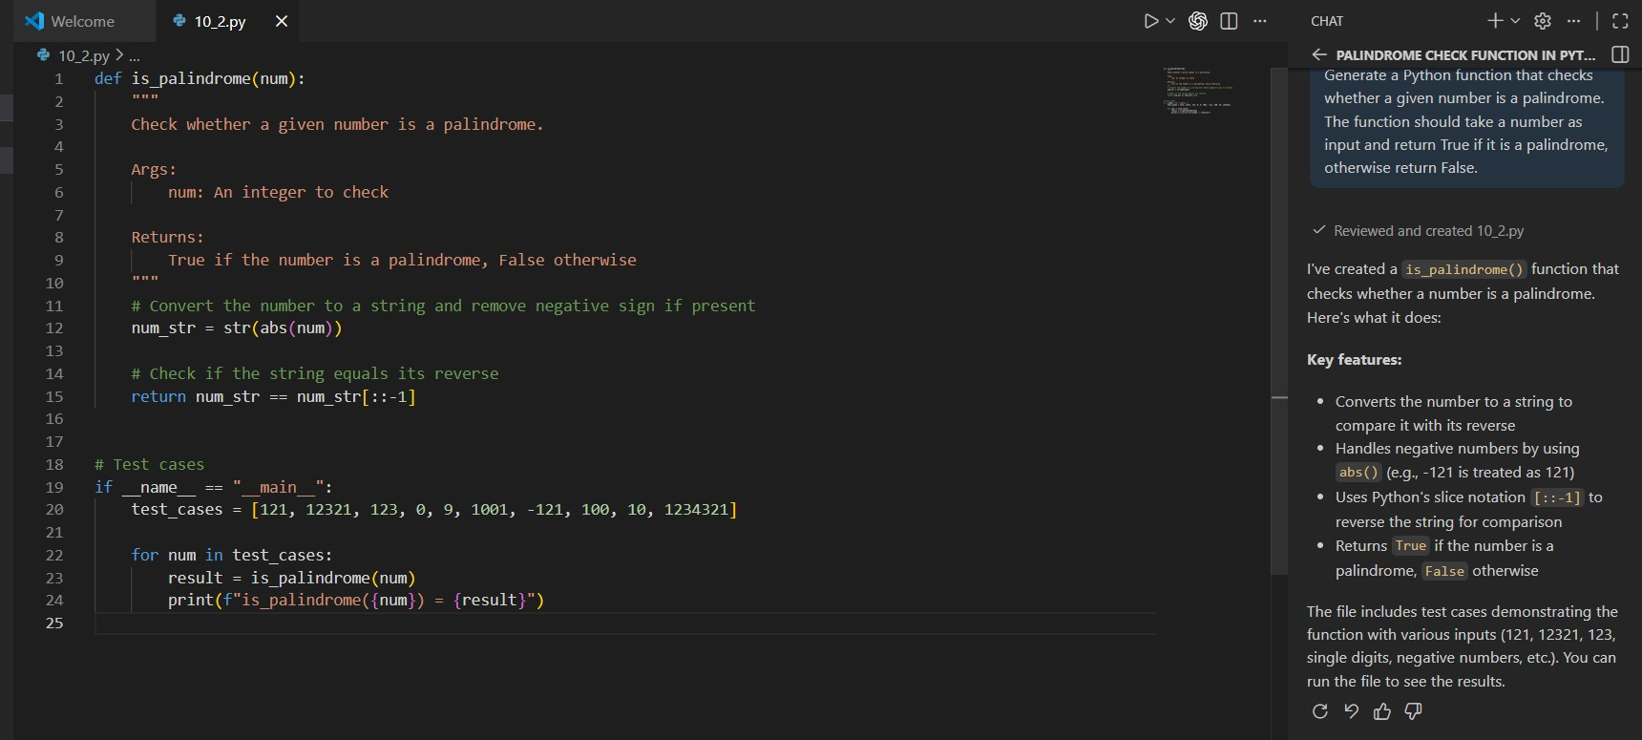
Output:

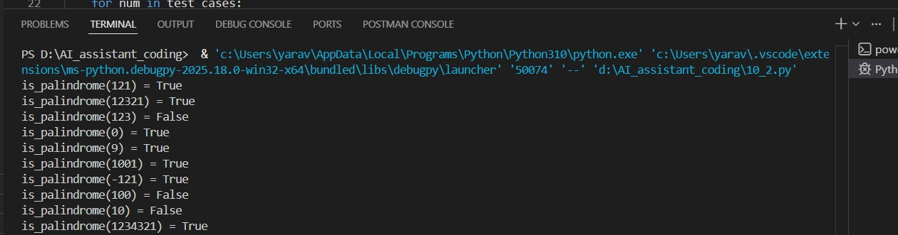

Question 2 – One-Shot Prompting
Example
Input: 5 → Output: 120
Prompt Used
Using this example, generate a Python function that calculates the factorial of a given number.

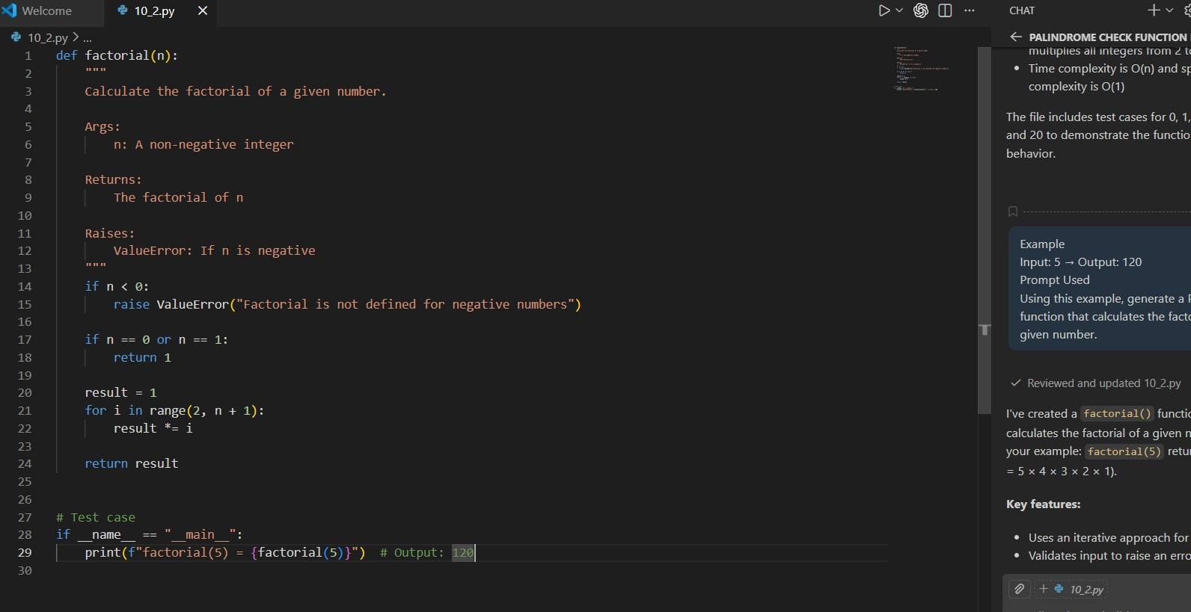
Output:
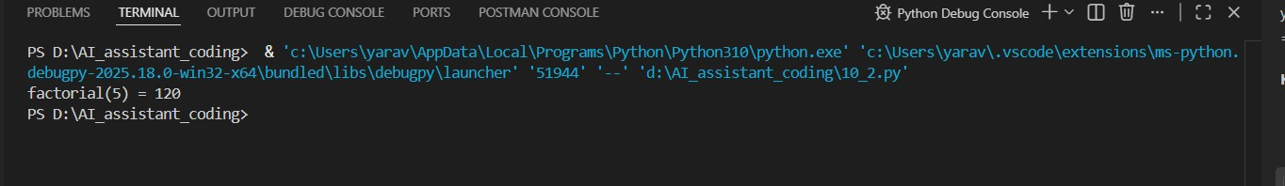
Question 3 – Few-Shot Prompting
Examples
153 → Armstrong Number
370 → Armstrong Number
123 → Not an Armstrong Number

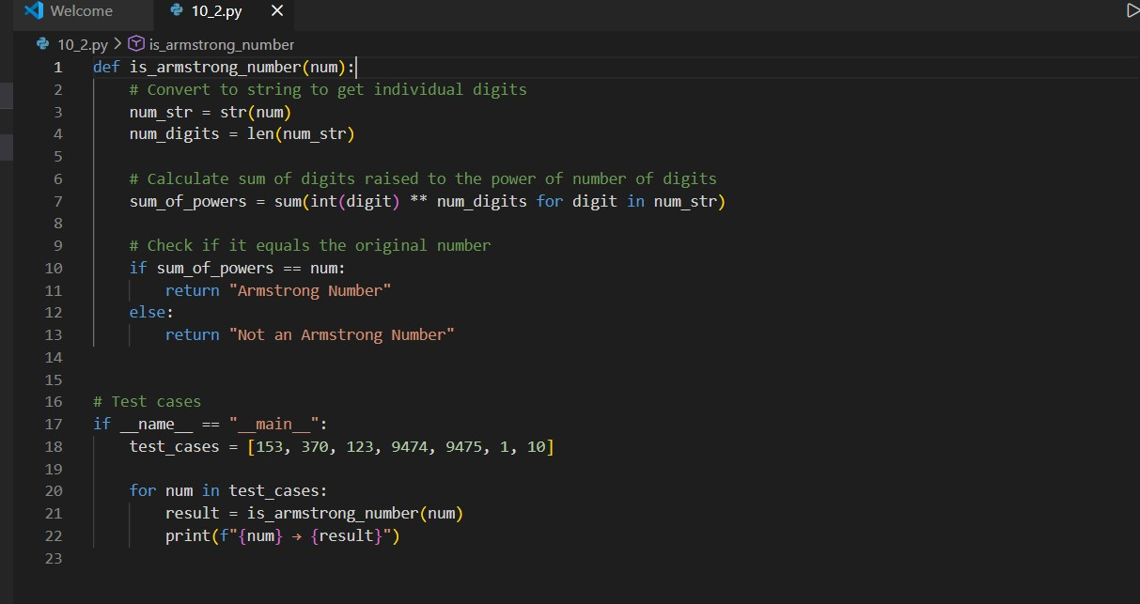

Question 4 – Context-Managed Prompting
Classify number as Prime, Composite, or Neither
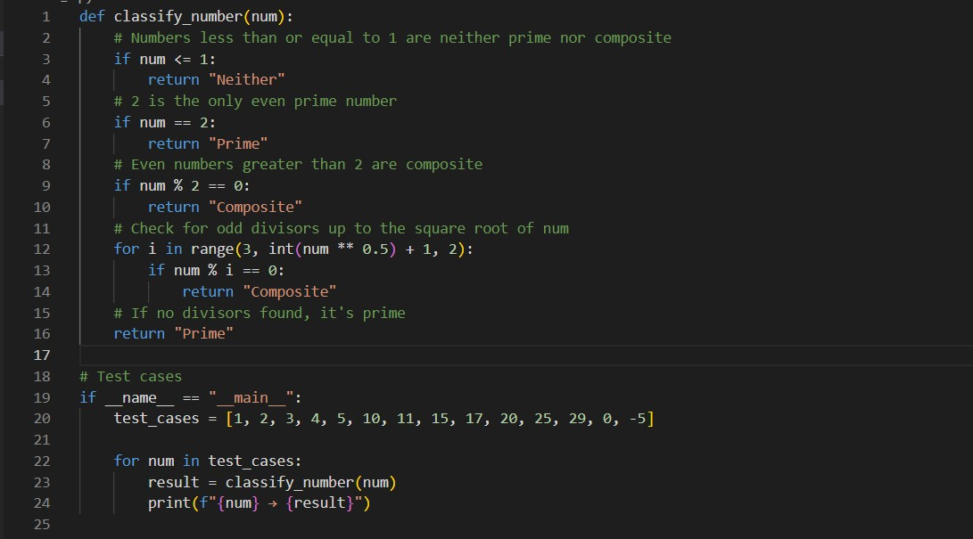
Conclusion
Few-shot and context-managed prompts produce more accurate and optimized code. Examples improve validation, formatting, and logical structure.

