Grain Production Plant

**User Manual**

**16 June 2025**

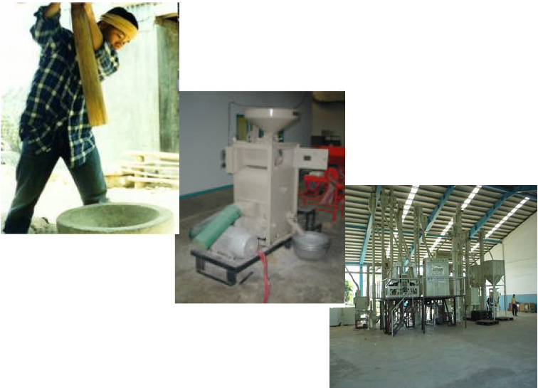

Table of contents

1. Introduction 3

1.1. Scope 3

2. Prerequisites 4

3. Description and Operation 4

3.1. 🔐 Logging Into the Rice Milling Machine Control System 4

3.2. 🔓 Logging Off the Rice Milling Machine Control System 4

3.3. 🔄 Changing the Language via the Language Selector 5

4. Rice Milling Process Overview 5

4.1. Cleaning (CLN) 5

4.2. Break and Pierce (HUL) 6

4.3. Grinding (GRD) 6

4.4. Whitening (WHT) 6

4.5. Sorting (WRT) 6

4.6. Polishing (POL) 7

5. Software Help Window 7

5.1. Event List 7

5.2. Configuration 8

5.3. Manual 8

5.4. About 9

6. Equipment and Tools 9

7. Safety and Environmental Considerations 10

8. Quality Control 10

9. Maintenance and Troubleshooting 10

Table of Figures

Figure 1. Log in page 5

Figure 2. Changing language 5

Figure 3. Steps for rice grain production plant 7

Figure 4. Software Help Window 7

1. Introduction

This SOP outlines the standardized procedures for operating a rice milling plant, ensuring consistent production of high-quality milled rice contain a minimum number of broken kernels. The process includes cleaning, de-husking, whitening, sorting and grading, and polishing, aiming to remove impurities, enhance grain quality, and prepare rice for packaging and distribution.

# Scope

This SOP applies to all personnel involved in the rice milling process, including machine operators, maintenance staff, and quality control personnel. It covers the operation of equipment, safety protocols, and quality assurance measures within the milling facility.

1. Prerequisites

* **Training**: All personnel must complete training on equipment operation, safety procedures, and quality standards.
* **Equipment**: Ensure all milling machinery is installed, calibrated, and maintained according to manufacturer specifications.
* **Raw Material**: Use only high-quality paddy rice that meets the facility's input standards.

1. Description and Operation

# 🔐 Logging Into the Rice Milling Machine Control System

1. Power On the System: Ensure the main power supply to the milling machine and its control panel is turned on.
2. Access the Control Panel: Navigate to the machine's central control panel, typically equipped with a touch screen or physical buttons.
3. Enter Credentials: Input the administrator username and password. These credentials are usually provided by the equipment supplier or system administrator.
4. Authenticate: Press the 'Login' or 'Enter' button to authenticate.
5. Verify Access: Once logged in, verify that the system displays the main dashboard, indicating successful access.

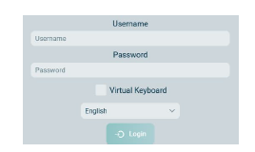

1. Log in page

# 🔓 Logging Off the Rice Milling Machine Control System

1. Access the Control Panel: Navigate to the machine's central control panel.
2. Initiate Log Off: Locate and select the 'Log Off' or 'Logout' option on the screen.
3. Confirm Action: A prompt may appear asking for confirmation to log off. Confirm the action to proceed.
4. Exit: Once logged off, the system will return to the login screen, indicating that the session has ended.

# 🔄 Changing the Language via the Language Selector

**Locate the Language Selector**: Just above the login button, you should see a dropdown menu for language options.

**Select Your Preferred Language**: Click on the dropdown menu you wish to use.

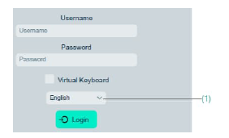

1. Changing language
2. Rice Milling Process Overview

# Cleaning (CLN)

**Objective**: Remove foreign materials such as stones, dust, and weeds from paddy rice to prevent damage to milling equipment and ensure product quality.

**Steps**:

1. Pre-Cleaning: Use sieves and air blowers to remove large debris.
2. De-Stoning: Employ magnetic separators and vibrating screens to eliminate stones.
3. Fine Cleaning: Use air classifiers to remove lighter impurities.

**Note: Cleaning should be performed in a clean environment to prevent re-contamination.**

# Break and Pierce (HUL)

**Objective**: Remove the husk from paddy rice to produce brown rice.

**Steps**:

1. Husking: Pass cleaned paddy through a huller machine to remove the husk.
2. Separation: Use a paddy separator to separate brown rice from any remaining un-hulled paddy.

**Note: Adjust machine settings to minimize breakage and ensure efficient husk removal.**

# Grinding (GRD)

**Objective**: To enhance the appearance and shelf life of white rice by removing residual bran and smoothing the grain surface.

# Whitening (WHT)

**Objective**: Remove the bran layer from brown rice to produce white rice.

**Steps**:

1. Initial Whitening: Pass brown rice through a whitening machine to remove the outer bran layer.
2. Intermediate Whitening: If necessary, pass rice through additional whitening machines to achieve desired whiteness.
3. Final Whitening: Use a friction-type whitener to achieve a polished appearance.

**Note: Monitor the depth of whitening to balance quality and yield.**

# Sorting (WRT)

**Objective**: Classify rice into different grades based on size, shape, and quality.

**Steps**:

1. Length Grading: Use length graders to separate rice into head rice and broken rice categories.
2. Color Sorting: Employ color sorters to remove discolored or defective grains.
3. Weight Grading: Use vibrating sieves to sort rice by weight.

***Note*:** Regularly calibrate sorting equipment to maintain accuracy.

# Polishing (POL)

**Objective**: Enhance the appearance and shelf life of white rice.

**Steps**:

1. Polishing: Pass white rice through a polisher to remove any remaining bran particles and achieve a glossy finish.
2. Drying: If necessary, dry polished rice to reduce moisture content.

*Note*: Ensure polishing does not result in excessive breakage.



1. Steps for rice grain production plant
2. Software Help Window

software help window serves as a crucial interface for users to access essential information and guidance. This window typically includes sections such as **Event List**, **Configuration**, **Manual**, and **About**, each designed to enhance user experience and operational efficiency.

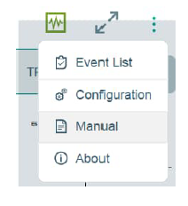

1. Software Help Window

# Event List

**Purpose**: To provide real-time notifications and updates on system activities, alerts, and operational events.

**Key Features**:

* **Real-Time Alerts**: Notify users of critical events like equipment malfunctions, maintenance schedules, or production anomalies.
* **System Logs**: Maintain a chronological record of system activities, user actions, and process changes for accountability and troubleshooting.
* **Customizable Notifications**: Allow users to set preferences for the types of events they wish to be alerted about.

**Benefits**:

* Enhances proactive management by keeping users informed of immediate issues.
* Facilitates quick response to operational disruptions.
* Aids in compliance and auditing through detailed logs.

# Configuration

**Purpose**: To enable users to customize software settings according to the specific needs of the rice milling plant.

**Key Features**:

* **User Preferences**: Set language, theme, and notification preferences.
* **System Settings**: Configure parameters for production processes, inventory management, and reporting.
* **Access Controls**: Define user roles and permissions to ensure secure and appropriate access to system functionalities.

**Benefits**:

* Tailors the software to align with the plant's operational workflows.
* Ensures data security and integrity through controlled access.
* Improves user efficiency by adapting the interface to individual preferences.

# Manual

**Purpose**: To provide comprehensive documentation and guidance on using the software effectively.

**Key Features**:

* **User Guides**: Step-by-step instructions on performing various tasks within the software.
* **FAQs**: Answers to common questions and troubleshooting tips.
* **Video Tutorials**: Visual demonstrations of key features and processes.

**Benefits**:

* Assists users in maximizing the software's capabilities.
* Reduces dependency on external support by providing self-help resources.
* Facilitates onboarding and training of new users.

# About

**Purpose**: To offer information about the software's version, developer, and licensing details.

**Key Features**:

* **Version Information**: Displays the current software version and update history.
* **Developer Details**: Provides contact information for the software development team.
* **Licensing Information**: Outlines the terms of use, licensing agreements, and copyright notices.

**Benefits**:

* Keeps users informed about software updates and support channels.
* Ensures compliance with licensing agreements.
* Builds trust by providing transparency about the software's origins and support.

1. Equipment and Tools

* **Sieves and Air Blowers:** For cleaning.
* **Magnetic Separators and Vibrating Screens:** For de-stoning.
* **Huller Machine:** For dehusking.
* **Paddy Separator:** For separating brown rice from unhulled paddy.
* **Whitening Machines:** For grinding (whitening).
* **Length Graders and Color Sorters:** For sorting and grading.
* **Polisher:** For polishing.

1. Safety and Environmental Considerations

* **Personal Protective Equipment (PPE)**: Operators must wear appropriate PPE, including gloves, masks, and ear protection.
* **Machine Safety**: Ensure all safety guards are in place and operational.
* **Waste Management**: Properly dispose of husk, bran, and other by-products according to environmental regulations.

1. Quality Control

* **Sampling**: Regularly sample rice at each stage of the milling process.
* **Testing**: Perform quality tests, including moisture content, broken grain percentage, and appearance.
* **Documentation**: Maintain records of quality control tests and corrective actions taken.

1. Maintenance and Troubleshooting

* **Routine Maintenance**: Follow manufacturer guidelines for regular maintenance of equipment.
* **Troubleshooting**: In case of equipment malfunction, refer to the manufacturer's manual for troubleshooting steps.
* **Repairs**: Only qualified personnel should perform repairs.