**UCS1611---Internet Programming Lab**

***ASSIGNMENT-7***

Date: 21/04/2021

Name: S. Vyshali

Roll no: 185001202

***LEARNING OBJECTIVES:***

Write a Node.js program which fires an event "help". On firing the event "help", the listener "helper" is called which displays a message "Please help me" to the console.

***ASNMT6.JS:***

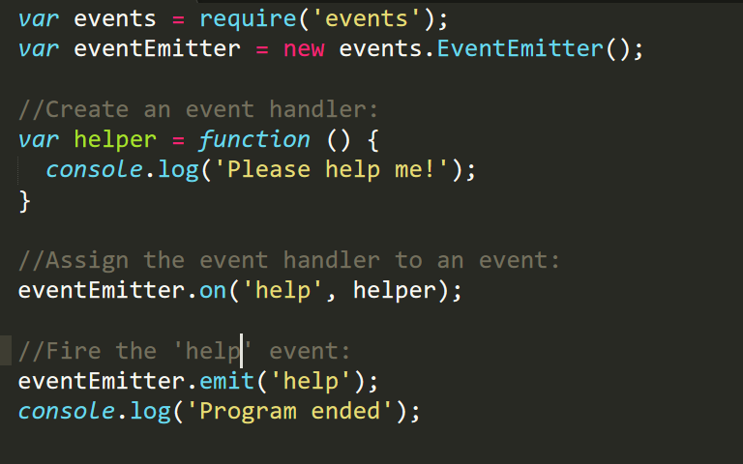

***OUTPUT SCREENSHOT:***

