Article
Research and ex situ Conservation of Underutilized Andean Crops in Peru: A Bibliometric Analysis, National Genebank Inventory, and Conservation Gap Assessment
Victor-Hugo Baldera-Chapoñan ^{1,2,3,}*, Wagner Meza-Maicelo ^{1,2,3}, Yoel Diaz-Saucedo ^{1,3}, Ivan Manrique ⁴, German De La Cruz ⁵, Aquilino Alvarez-Caceres ⁶, Maywa Cecilia Blanco-Zamalloa ⁶, Catalina Jimenez-Aguilar ⁶, Maria Rosario Elsa Valderrama-Valencia ⁷, Angel Mauricio Holguer Mujica Sanchez ⁸, Jorge Alberto Condori-Apfata ³, Jorge Luis Maicelo Quintana ⁹ and Flavio Lozano-Isla ^{1,2,3,}*
Academic Editor: Firstname Lastname
Received: date
Revised: date
Accepted: date
Published: date
Copyright: © 2026 by the authors. Submitted for possible open access publication under the terms and conditions of the Creative Commons Attribution (CC BY) license.
¹ Centro de Investigación e Innovación en Granos y Semillas, Universidad Nacional Toribio Rodríguez de Mendoza de Amazonas (UNTRM), Chachapoyas - Amazonas 01001, Perú.
² Instituto de Investigación para el Desarrollo Sustentable de Ceja de Selva (INDES-CES), Universidad Nacional Toribio Rodríguez de Mendoza de Amazonas (UNTRM), Chachapoyas - Amazonas 01001, Perú
³ Facultad de Ingeniería y Ciencias Agrarias, Universidad Nacional Toribio Rodríguez de Mendoza de Amazonas (UNTRM), Chachapoyas - Amazonas 01001, Perú.
⁴ International Potato Center (CIP), Lima, Perú
⁵ Facultad de Ciencias Agrarias, Universidad Nacional de San Cristóbal de Huamanga (UNSCH), Ayacucho 05000, Perú
⁶ Universidad Nacional de San Antonio Abad del Cusco (UNSAAC), Cusco, Perú.
⁷ Universidad Nacional de San Agustín, Arequipa 04001, Perú
⁸ Universidad Nacional del Altiplano, Puno, Perú
⁹ Facultad de Ingeniería Zootecnista, Agronegocios y Biotecnología, Universidad Nacional Toribio Rodríguez de Mendoza de Amazonas (UNTRM-A), Chachapoyas, Amazonas 01001, Perú
* Correspondence: 7577995921@untrm.edu.pe; flavio.lozano@untrm.edu.pe
Abstract
Orphan crops are plant genetic resources of nutritional, agronomic, cultural, and adaptive value, yet it remains unclear whether ex situ conservation efforts in their regions of origin are commensurate with scientific attention. Focusing on 11 selected crops associated with Peru’s agrobiodiversity, we combined (i) a bibliometric analysis of 157 Scopus records retrieved using species-specific germplasm queries and (ii) a national inventory based on a structured questionnaire (10 of 22 invited custodians; 45.5%) and records from the INIA Germplasm Bank Information System (SIRGE). The inventory comprised 14,694 accessions held at 11 collection sites operated by seven organizations across eight departments, covering 10 of the 11 species; no Salvia hispanica accessions were reported. Three organizations (UNSAAC, INIA, and CIP) held 83.9% of all accessions. Research output and germplasm holdings were positively associated across species (Spearman’s ρ = 0.64, n = 11), although substantial mismatches were observed. Chenopodium quinoa accounted for 50.6% of publications and 28.5% of accessions, whereas Lupinus mutabilis and Oxalis tuberosa represented 22.8% and 14.6% of accessions but only 8.1% and 5.0% of publications, respectively. Lepidium meyenii was represented by 178 accessions but had no eligible publications. Phenotypic characterization was reported for 98.7% of accessions, whereas genomic and biochemical characterization reached maximum coverage values of 8.5% and 18.0%, respectively; 18.2% of accessions were maintained exclusively in field collections. Insufficient funding was identified as the main constraint by custodians (8 of 9 valid responses). Research themes shifted from morphological and taxonomic descriptions toward genetic diversity, molecular characterization, and plant breeding. These findings reveal disparities in scientific attention, institutional holdings, and characterization capacity, providing a baseline for improving documentation, safety duplication, and the sustainable use of these plant genetic resources.
Keywords: agrobiodiversity; bibliometric analysis; ex situ conservation; germplasm collections; plant genetic resources; orphan crops; Andean crops; conservation gaps.

1. Introduction
Contemporary agricultural systems face increasing pressure from population growth, natural resource degradation, biodiversity loss, and climate change, all of which affect agricultural productivity and food security [1–4]. Diversifying agricultural systems through the conservation and sustainable use of plant genetic resources is an important strategy for strengthening agroecosystem resilience and reducing dependence on a limited number of major crops [5,6]. Crop diversity, including the genetic variation maintained within cultivated species and their wild relatives, provides essential material for crop improvement and adaptation to changing environmental conditions [7,8]. Within this diversity, orphan crops represent an underexploited resource for agricultural research and development. These crops are characterized not necessarily by low production or local importance, but by the limited scientific, institutional, and investment attention they have received relative to their potential contributions to food systems [9–13]. Their relevance is associated with their nutritional value, adaptation to specific agroecological conditions, and the genetic variation maintained through farmer selection and cultivation [14–17]. The classification of a crop as orphan or underutilized is also dependent on geographical and institutional scales, since a species may remain important in its region of origin while receiving limited attention from international research and crop improvement programs [9,10].
The Andean region is an important center of crop domestication and diversification, where farming communities have maintained a broad range of cultivated species through traditional selection, seed exchange, and management practices [18,19]. In Peru, nine traditional Andean crops were considered in this study because of their food use, regional relevance, adaptation to local production environments, and comparatively limited representation in research and crop improvement programs: oca (Oxalis tuberosa), ulluco (Ullucus tuberosus), mashua (Tropaeolum tuberosum), arracacha (Arracacia xanthorrhiza), yacón (Smallanthus sonchifolius), maca (Lepidium meyenii), cañihua (Chenopodium pallidicaule), tarwi (Lupinus mutabilis), and kiwicha (Amaranthus caudatus) [20–22]. Quinoa (Chenopodium quinoa Willd.) was included as an Andean comparative species because of its substantial scientific development and international expansion, which provide a contrasting research trajectory among crops associated with the region [23]. Chia (Salvia hispanica), a species of Mesoamerican origin, was incorporated as a non-Andean comparator to examine the representation of its genetic resources in Peruvian collections [24]. Thus, the eleven species constituted the analytical scope of the study, but they were not considered a homogeneous group of orphan crops. This distinction is relevant because the degree of scientific attention and utilization differs among species and depends on their historical, geographical, and institutional trajectories [21,25–27].
The conservation of plant genetic resources is essential for maintaining the genetic variation required for crop improvement, scientific research, and adaptation to changing environmental conditions [7,8,28]. Ex situ conservation through germplasm banks enables the collection, characterization, documentation, regeneration, and maintenance of accessions for research and breeding purposes. Its effectiveness depends on the implementation of appropriate conservation procedures, reliable documentation, adequate infrastructure, trained personnel, and sustained institutional support [28–30]. International assessments have identified persistent limitations in the global conservation system, including insufficient safety duplication, gaps in accession-level information, inadequate characterization, and constraints in financial and technical capacity [31,32]. These limitations can compromise the long-term security of collections and restrict the use of conserved material in research and crop improvement. The conservation of vegetatively propagated species and crops maintained in field collections requires particular attention because their maintenance depends on living plants and suitable growing conditions [31].
Peru harbors substantial plant genetic diversity associated with its contrasting ecological regions and traditional agricultural systems [18,19,33]. Public research institutions, universities, and other organizations maintain germplasm collections of agricultural importance, including accessions of the species examined in this study [34]. Nevertheless, information on the distribution, size, and management of these collections remains dispersed across institutional records and scientific publications. Available studies have mainly addressed the agronomic, morphological, or nutritional characterization of individual species [25,35–37]. A consolidated assessment of the scientific research associated with these crops and the institutional conditions under which their germplasm is conserved is still needed. This information is relevant for identifying differences between research priorities and conservation holdings, as well as for recognizing gaps in characterization, documentation, and long-term conservation.
Bibliometric analyses can be used to examine the development of scientific research, identify the species and topics receiving greater attention, and reveal changes in research priorities over time. When combined with institutional inventories and information provided by collection custodians, these analyses can provide a broader assessment of the relationship between scientific activity and the conservation of plant genetic resources. Such an approach is particularly relevant for countries with high crop diversity, where germplasm collections may be distributed among institutions with different mandates, capacities, and management procedures. An assessment that integrates bibliographic records, accession inventories, and information on collection management can help identify research and conservation gaps that are not apparent when these components are examined separately.
The present study aimed to assess scientific research and the ex situ conservation of selected Andean crops and associated plant genetic resources in Peru. Specifically, it sought to (i) characterize the scientific literature on the eleven selected species through a bibliometric analysis, identifying research trends, thematic development, and the contribution of Peruvian institutions; (ii) document the number and institutional distribution of accessions maintained in germplasm collections; and (iii) assess the conservation and management conditions reported by collection custodians, including conservation methods, characterization activities, documentation practices, institutional capacities, and constraints. By integrating bibliometric evidence with collection inventories and institutional information, this study provides a baseline for identifying gaps and establishing priorities to strengthen the conservation and sustainable use of these plant genetic resources in Peru.

2. Materials and Methods
This study employed a multi-method exploratory-descriptive approach structured into two stages. The first stage consisted of a bibliometric analysis of scientific production related to orphan crops of relevance to Peruvian agriculture, allowing the current state of research and the main themes addressed regarding the conservation and utilization of these plant genetic resources to be identified. The second stage involved the development of a national inventory and an assessment of the status of germplasm banks and conservation strategies associated with these crops through a structured questionnaire administered to researchers and a review of institutional germplasm records, including information available through the Germplasm Bank Information System (SIRGE) of the National Institute for Agrarian Innovation (INIA).

2.1. Extraction and Processing of Bibliometric Data
The Scopus database was selected as the bibliographic information source because of its extensive coverage of peer-reviewed scientific literature, standardized bibliographic records, and frequent use in bibliometric studies and scientific trend analyses [38,39]. The systematic search was conducted on July 6, 2026, at 11:00 UTC−5, using search equations specific to each crop and the TITLE-ABS-KEY field, which retrieves terms appearing in titles, abstracts, and keywords. The search strategies consisted of the scientific name of each species combined with the term “germplasm” (Table 1), with the aim of identifying studies related to the evaluation, conservation, and utilization of genetic resources in Andean crops and underutilized species.
Table 1. Search equations used in the systematic review of orphan crops.
Scientific name | Common name | Search equation
Amaranthus caudatus | Kiwicha | TITLE-ABS-KEY( Amaranthus caudatus AND germplasm )
Arracacia xanthorrhiza | Arracacha | TITLE-ABS-KEY( Arracacia xanthorrhiza AND germplasm )
Chenopodium pallidicaule | Cañihua | TITLE-ABS-KEY( Chenopodium pallidicaule AND germplasm )
Chenopodium quinoa | Quinua | TITLE-ABS-KEY( Chenopodium quinoa AND germplasm )
Lepidium meyenii | Maca | TITLE-ABS-KEY( Lepidium meyenii AND germplasm )
Lupinus mutabilis | Tarwi | TITLE-ABS-KEY( Lupinus mutabilis AND germplasm )
Oxalis tuberosa | Oca | TITLE-ABS-KEY( Oxalis tuberosa AND germplasm )
Salvia hispanica | Chía | TITLE-ABS-KEY( Salvia hispanica AND germplasm )
Smallanthus sonchifolius | Yacón | TITLE-ABS-KEY( Smallanthus sonchifolius AND germplasm )
Tropaeolum tuberosum | Mashua | TITLE-ABS-KEY( Tropaeolum tuberosum AND germplasm )
Ullucus tuberosus | Olluco | TITLE-ABS-KEY( Ullucus tuberosus AND germplasm )
The initial search retrieved 222 scientific records corresponding to the eleven species evaluated. Subsequently, subject-area filters were applied through the Scopus results interface, restricting the results to Agricultural and Biological Sciences and Biochemistry, Genetics and Molecular Biology, which reduced the dataset to 206 documents. Documents classified as reviews were excluded because the analysis focused exclusively on original research and experimental studies, resulting in a total of 201 records for the eligibility assessment stage through title and abstract screening.

2.1.1. Inclusion and Exclusion Criteria
Following the application of bibliographic filters in the Scopus database, titles and abstracts were screened to determine study eligibility. Studies that met the following criteria were included:
- Studies conducted on Andean crops and underutilized species of importance for food security, including Amaranthus caudatus, Arracacia xanthorrhiza, Chenopodium pallidicaule, Chenopodium quinoa, Lepidium meyenii, Lupinus mutabilis, Oxalis tuberosa, Salvia hispanica, Smallanthus sonchifolius, Tropaeolum tuberosum, and Ullucus tuberosus.
- Studies that evaluated germplasm collections, accessions, landraces, cultivars, or genetic materials.
- Studies focused on the phenotypic, morphological, agronomic, physiological, biochemical, or molecular characterization of genetic diversity.
- Studies reporting evaluation methodologies, descriptors used, statistical analyses, or molecular tools employed for the characterization, conservation, or utilization of genetic variability.
Subsequently, at 16:45 UTC−5 on the same day, 160 records meeting the established eligibility criteria were obtained. These records were exported from Scopus in comma-separated values (.csv) format, including bibliographic information, citation data, abstracts, keywords, institutional affiliations, and funding details. The database was then cleaned by identifying duplicate records using the Digital Object Identifier (DOI), resulting in the removal of three duplicate documents (Figure 1). The final database comprised 157 scientific records, which were used for the bibliometric analysis of germplasm conservation, characterization, and utilization in Andean crops and underutilized species [40,41].
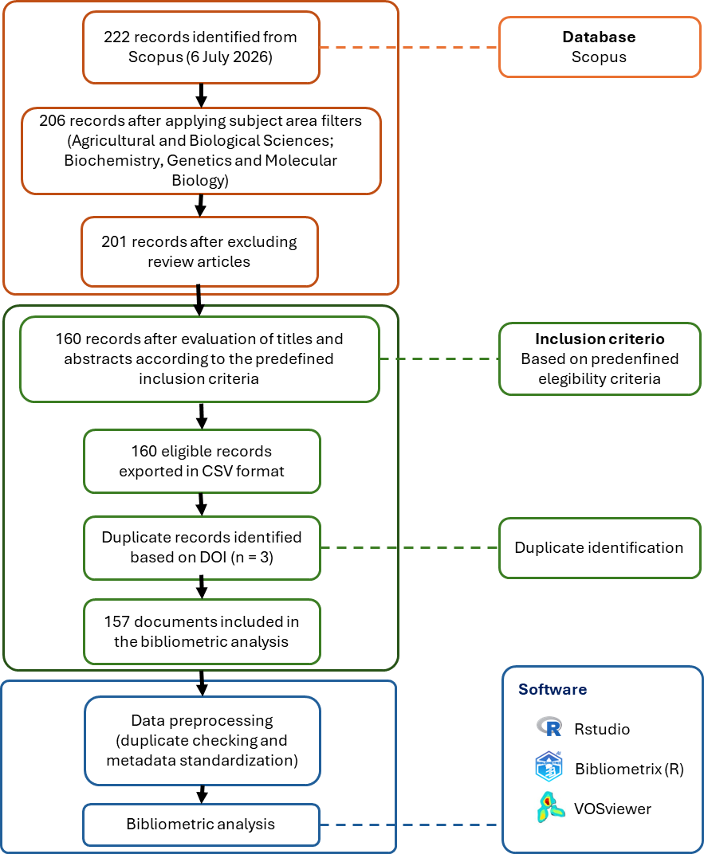
Figure 1. Flowchart of the process for identifying, screening, and cleaning bibliographic records for the bibliometric analysis of orphan crops.

2.2. Germplasm Bank Inventory
A structured questionnaire was developed using the Google Forms platform to collect information on the status of germplasm banks for orphan crops in Peru (Supplementary Material 1). The instrument consisted of closed-ended and multiple-choice questions addressing the participating institution, conserved species, number of accessions, conservation methods and status, types of characterization performed, availability of documented information, and the main limitations affecting collection management.
The questionnaire was distributed by email to 22 researchers responsible for germplasm banks affiliated with universities, research institutes, and public entities involved in the conservation of plant genetic resources (Supplementary Material 2). Responses were obtained from 10 participants (45.5%) who were engaged in activities related to the conservation, characterization, or management of orphan crop germplasm. The species considered were Amaranthus caudatus, Arracacia xanthorrhiza, Chenopodium pallidicaule, Chenopodium quinoa, Lepidium meyenii, Lupinus mutabilis, Oxalis tuberosa, Salvia hispanica, Smallanthus sonchifolius, Tropaeolum tuberosum, and Ullucus tuberosus. The information collected through the questionnaire was complemented with data obtained from the Germplasm Bank of the National Institute for Agrarian Innovation (SIRGE; https://sirge.inia.gob.pe/index) [INIA 34], Records related to the study species were extracted, including information on conserved collections and available accessions. The questionnaire responses and SIRGE records were subsequently consolidated to generate the germplasm bank inventory. The resulting inventory comprised collections from 11 institutions, including institutions represented among the questionnaire respondents and collections identified through the complementary SIRGE records. The information collected through Google Forms was exported to a spreadsheet, where record consistency was assessed, variables were standardized, and a database was organized for subsequent data analysis.

2.3. Statistical analysis
The bibliometric analysis was conducted using the Bibliometrix v5.4.1 package [42] executed in R v4.6.1 [43] through its Biblioshiny graphical interface. This tool was used to process the main data workflow and calculate scientific productivity and impact indicators. The temporal trends in publications and citations were modeled using second-order polynomial regression, with goodness of fit assessed using the coefficient of determination (R²), complemented by Pearson’s correlation coefficient between the annual number of documents and citations. Biblioshiny was used to perform keyword analysis to generate the term-frequency word cloud, thematic trend map, longitudinal thematic evolution diagram divided into four time periods, and thematic map based on centrality and density indicators to classify concepts into basic, motor, niche, and emerging or declining themes. VOSviewer v1.6.21 [44] was specifically used to construct, visualize, and map the contribution and international collaboration networks among countries based on co-authorship, applying a minimum threshold of five interactions per node.

3. Results

3.1. Global scientific production on germplasm of Andean orphan crops, 1989–2026
The analysis of annual scientific production, based on the aggregation of 157 records indexed in Scopus, revealed a temporal pattern characterized by an initial phase of low productivity, followed by a progressive increase in the number of publications and variable citation dynamics (Figure 2). During the period from 1989 to the late 1990s, scientific production remained low, ranging from one to two publications per year, whereas citation counts were relatively high in specific years, such as 1989 and 1998, indicating the presence of contributions with substantial cumulative impact. From the early 2000s onward, a gradual expansion in scientific production was observed, reaching three to six publications annually during the 2000s, accompanied by an increase in citations, with a pronounced peak in 2007 associated with highly influential documents in the field.
Since 2019, a sustained intensification in scientific production was recorded, with values exceeding eight publications per year and a maximum of nearly twenty documents7–11 publications per year and a maximum of 20 documents in 2022, representing the highest point in the series analyzed. Citation counts showed a fluctuating pattern, with notable peaks in 2012 and 2022, whereas a relative decline was observed in the most recent years, attributable to the temporal lag between document publication and citation accumulation. These results confirm a recent expansion of scientific activity and an increase in the impact of the field analyzed.
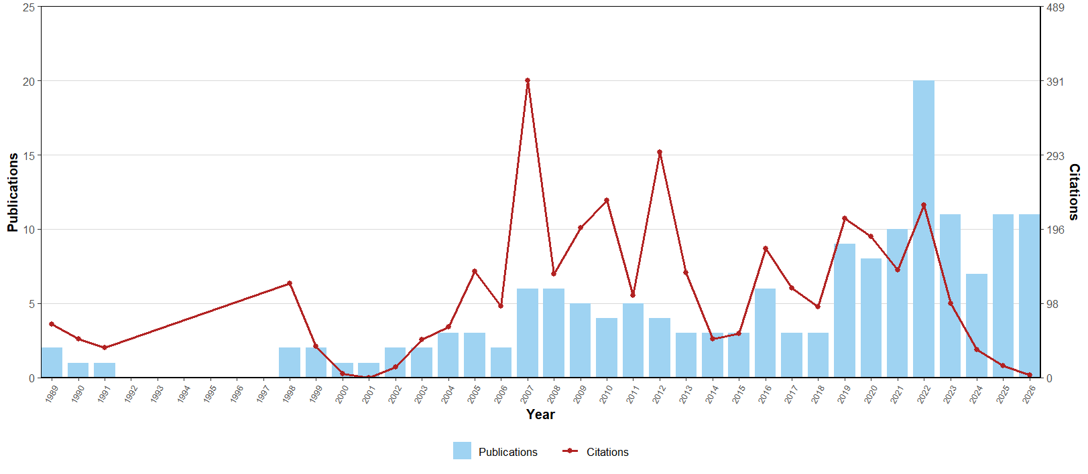
Figure 2. Annual trends in scientific production (light blue bars, left axis) and annual citation volume (red line, right axis) on orphan crops during the 1989–2026 period.

3.1.1. Scientific Production and Collaboration Networks
The international co-authorship network (≥5 collaborations; Figure 3) comprised 16 countries distributed across five collaboration clusters. Cluster 1 (red) included the United States, Peru, Colombia, Bolivia, Belgium, and Denmark. Cluster 2 (green) comprised India, Germany, Italy, and Chile. Cluster 3 (blue) grouped China and Argentina. Cluster 4 (purple) included Spain and Mexico, whereas Cluster 5 (yellow) comprised Ecuador and the Netherlands. The United States and Peru presented the largest nodes and the highest number of links, followed by Colombia, Spain, India, and Germany.
The United States was directly connected to Peru, Colombia, Bolivia, Belgium, Germany, and Spain, whereas Peru maintained links with the United States, Colombia, Bolivia, Belgium, Denmark, and Ecuador. Spain was connected to the United States, Germany, Mexico, Colombia, and Ecuador, while Germany presented links with India, Italy, Chile, the United States, and Spain. China and Argentina formed a cluster with a direct connection between both countries. Mexico showed a strong connection with Spain, whereas Ecuador was linked to Peru, Spain, Denmark, and the Netherlands. (Figure 3).
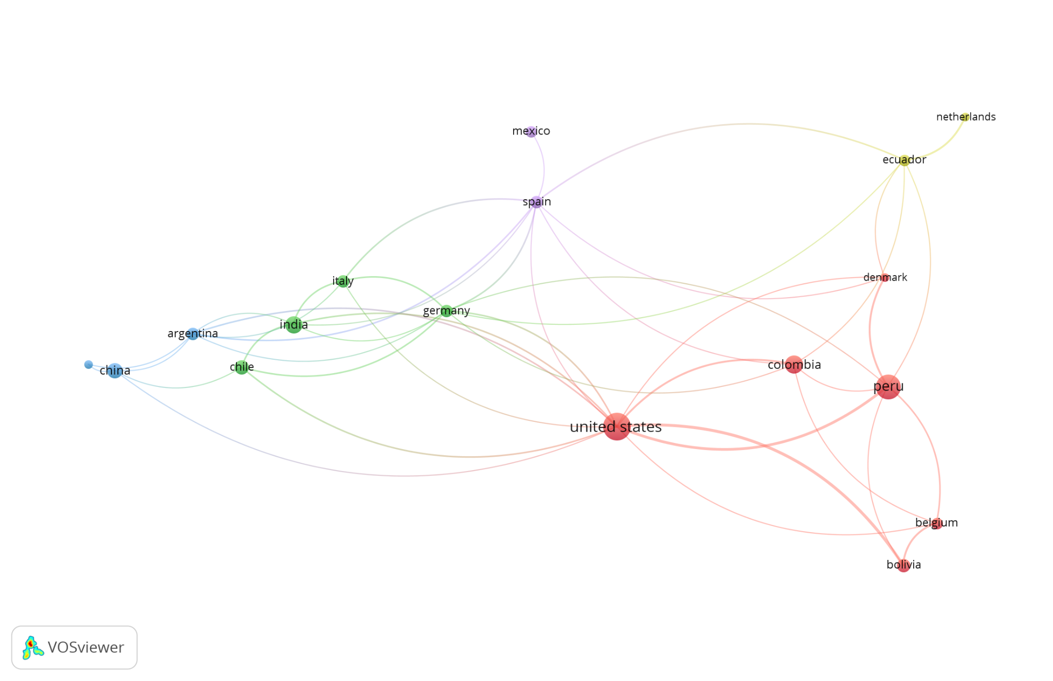
Figure 3. International scientific collaboration network based on country co-authorship in research on orphan crops (1989-2026).Node colors identify the five clusters detected by VOSviewer (red, green, blue, purple, and yellow); node size and link width reflect the number of documents and the strength of co-authorship links, respectively. Only countries with at least five collaborations are shown.
The corresponding authors’ single-country publications (SCP) and multiple-country publications (MCP) showed differences among the main producing countries (Figure 4). Peru recorded the highest number of documents, with a predominance of single-country publications, followed by the United States (15), where internationally collaborative publications represented a substantial proportion of the scientific output. Colombia and India each accounted for 11 documents, with a greater contribution from SCP. China reached 10 publications, whereas Chile recorded nine documents with a relatively balanced distribution between SCP and MCP. Mexico ranked next with seven publications, followed by Argentina with six, and Germany and Italy with five documents each. Belgium and Bolivia presented publications under both collaboration modalities. Denmark, the Czech Republic, and Ecuador were represented exclusively by multiple-country publications, whereas Turkey and Egypt recorded only single-country publications (Figure 4).
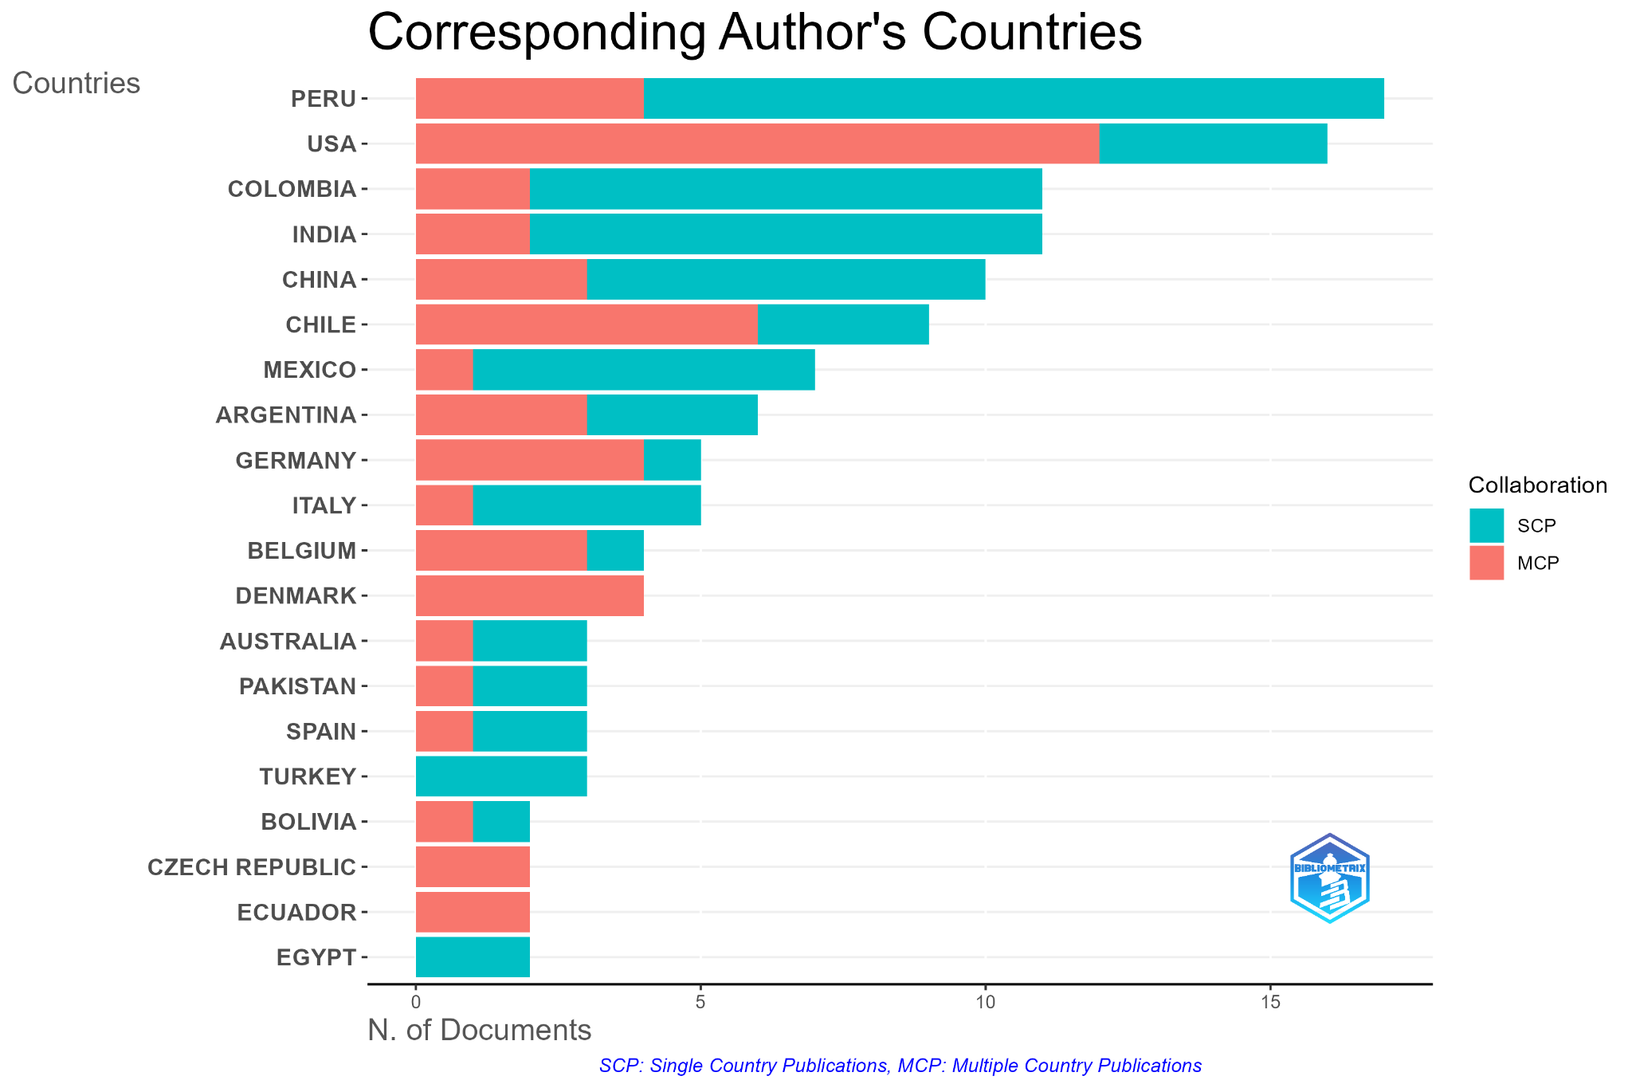
Figure 4. Distribution of scientific production by corresponding author’s country and type of collaboration (single-country [SCP] and multiple-country [MCP]) in research on orphan crops.
The author co-authorship network (≥3 collaborations; Figure 5) identified a collaboration cluster comprising Maughan P. J., Jellen E. N., Stevens M. R., Fairbanks D. J., Coleman C. E., and Bonifacio A. Their publications addressed the genetic characterization of Chenopodium quinoa Willd., Chenopodium pallidicaule, and Amaranthus caudatus, including genetic diversity analyses using SSR and SNP molecular markers, genetic map development, genome sequencing, and population evaluation for plant breeding [45–50,36]. The cluster’s studies also included research on downy mildew resistance, seed protein characterization, and salinity stress responses in tolerant quinoa accessions [51,52]. Other topics included resistance to downy mildew, seed protein characterization, and salinity stress responses in quinoa accessions (Figure 5).
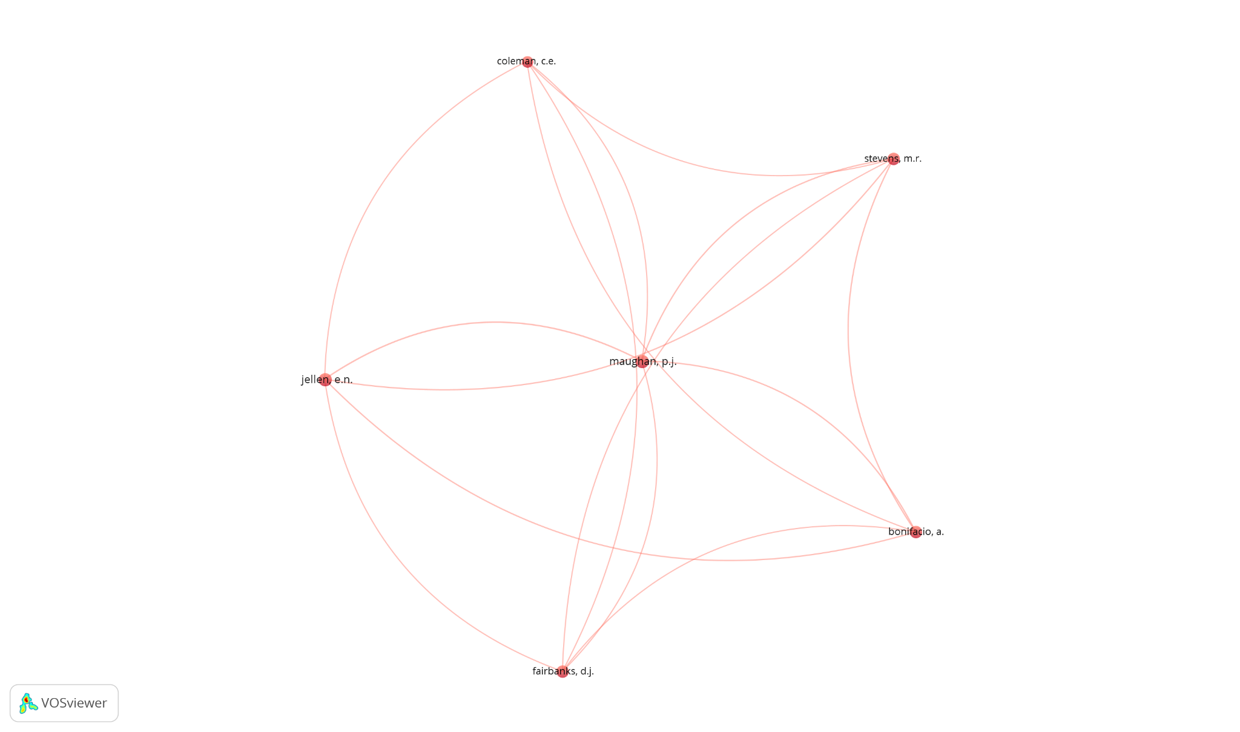
Figure 5. Co-authorship network among authors (≥3 collaborations). Node size is proportional to the number of publications by each author, whereas links represent the frequency of collaboration among them.

3.1.2. Citation analysis
The ten most cited documents identified during the study period are presented in Table 2, with citation counts ranging from 77 to 154. The highest number of citations was recorded for Genetic variability and interrelationships among various morphological and quality traits in quinoa (Chenopodium quinoa Willd.) (154), followed by Extending the range of an ancient crop, Salvia hispanica L.—a new ω3 source (114) and Sampling strategy for a core collection of Peruvian quinoa germplasm (108). The remaining articles received between 77 and 103 citations and addressed genetic diversity, germplasm conservation, nutritional composition, amino acid profiles, functional properties of vegetable amaranth (Amaranthus tricolor L.), and morphological diversity of quinoa (Table 2).
Table 2. Top 10 Most-Cited Documents on Orphan Crops and Germplasm Banks.
Rank | Title | Author | Source | TC | Document
1 | Genetic variability and interrelationship among various morphological and quality traits in quinoa (Chenopodium quinoa Willd.) | Bhargava A;Shukla S;Ohri D | Field Crops Research | 154 | Article
2 | Extending the range of an ancient crop, Salvia hispanica L.-a new ω3 source | Jamboonsri W;Phillips Td;Geneve Rl;Cahill Jp;Hildebrand Df | Genetic Resources And Crop Evolution | 114 | Article
3 | Sampling strategy for a core collection of peruvian quinoa germplasm | Ortiz R;Ruiz-Tapia En;Mujica-Sanchez A | Theoretical And Applied Genetics | 108 | Article
4 | Assessment of genetic diversity patterns in chilean quinoa (Chenopodium quinoa willd.) germplasm using multiplex fluorescent microsatellite markers | Fuentes Ff;Martinez Ea;Hinrichsen Pv;Jellen En;Maughan Pj | Conservation Genetics | 103 | Article
5 | Assessment of genetic diversity in the usda and cip-fao international nursery collections of quinoa (Chenopodium quinoa Willd.) using microsatellite markers | Christensen Sa;Pratt Db;Pratt C;Nelson Pt;Stevens Mr;Jellen En;Coleman Ce;Fairbanks Dj;Bonifacio A;Maughan Pj | Plant Genetic Resources: Characterisation And Utilisation | 96 | Article
6 | Implications of farmers' seed exchanges for on-farm conservation of quinoa, as revealed by its genetic diversity in chile | Fuentes Ff;Bazile D;Bhargava A;Martínez Ea | Journal Of Agricultural Science | 89 | Article
7 | Influence of contrasting environments on seed composition of two quinoa genotypes: Nutritional and functional properties | Miranda M;Vega-Gálvez A;Martínez Ea;López J;Marín R;Aranda M;Fuentes F | Chilean Journal Of Agricultural Research | 82 | Article
8 | Seed composition and amino acid profiles for quinoa grown in washington state | Craine Eb;Murphy Km | Frontiers In Nutrition | 81 | Article
9 | Diversity in phenotypic and nutritional traits in vegetable amaranth (Amaranthus tricolor), a nutritionally underutilised crop | Shukla S;Bhargava A;Chatterjee A;Pandey Ac;Mishra Bk | Journal Of The Science Of Food And Agriculture | 80 | Article
10 | Morphological analysis of quinoa germplasm grown under lowland desert conditions | Fuentes F;Bhargava A | Journal Of Agronomy And Crop Science | 77 | Article
∗ Source: Authors' own elaboration based on data exported from Scopus.

3.1.3. Keyword Analysis
The keyword cloud (Figure 6) showed the highest frequencies for germplasm (53 occurrences), Chenopodium quinoa (47), genetic diversity (35), plant breeding (18), and Amaranthus caudatus (16). Other frequent terms included genetic marker (14), population structure (11), genetic variability (10), molecular markers (6), Amaranthus hypochondriacus (6), Oxalis tuberosa (6), and Solanum tuberosum (5). Additional keywords included morphology, genotype, protein, grain yield, and multivariate analysis.
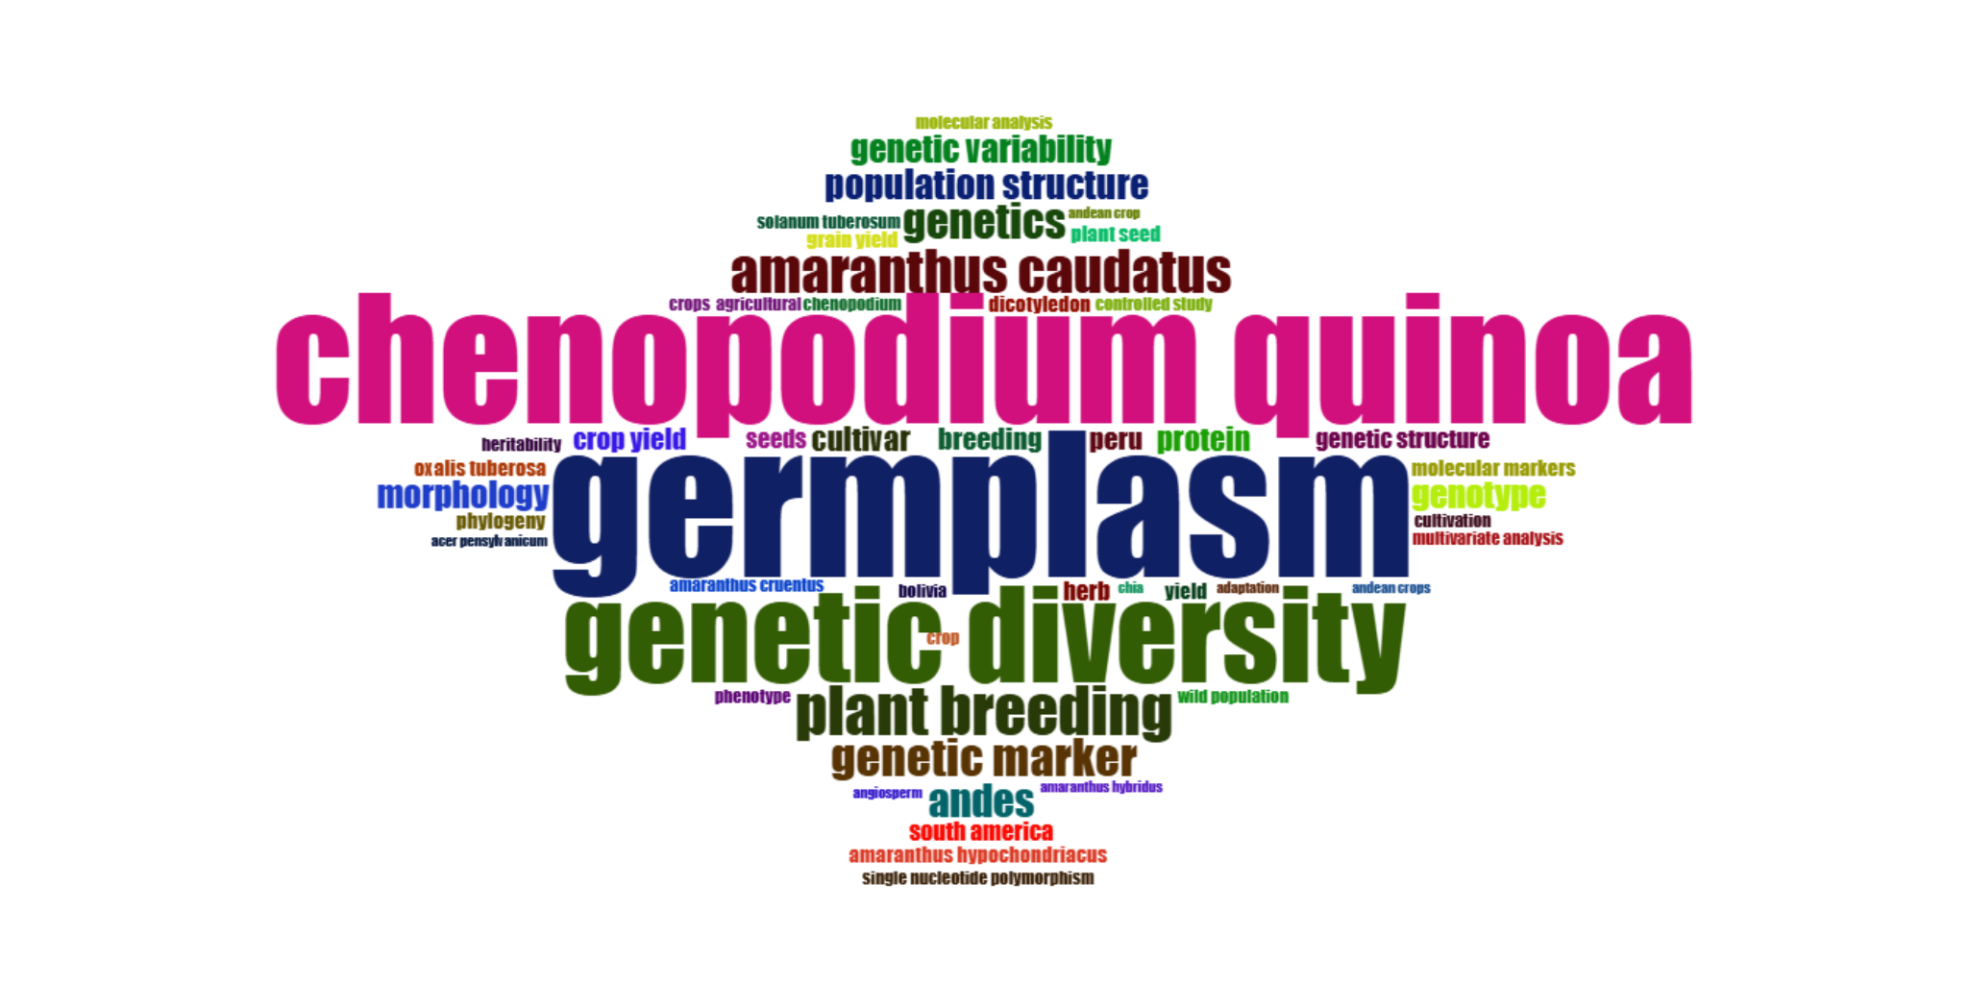
Figure 6. Keyword cloud based on co-occurrence frequency in research on orphan crops (1989–2026).
The thematic trend analysis showed a transition from morphological and regional terms toward molecular approaches and plant breeding. The initial stages were dominated by geographical and taxonomic terms such as Chenopodium, Peru, Amaranthus cruentus, Bolivia, Amaranthus hypochondriacus, and South America, which reached their highest frequency between 2005 and 2007 (Figure 7). Subsequently, Oxalis tuberosa, morphology, phenotype, and cultivar consolidated their presence toward the end of the 2000s.
The period from 2010 to 2015 showed the greatest thematic volume, led by germplasm (highest cumulative frequency), followed by Chenopodium quinoa, genetic diversity, the Andes, Amaranthus caudatus, wild populations, phylogeny, and genetic variability (Figure 7).From 2016 onward, genotype, molecular analysis, multivariate analysis, and population structure became prominent. The most recent keywords were genetic structure, genetics, plant breeding, grain yield, yield, breeding, and molecular markers.
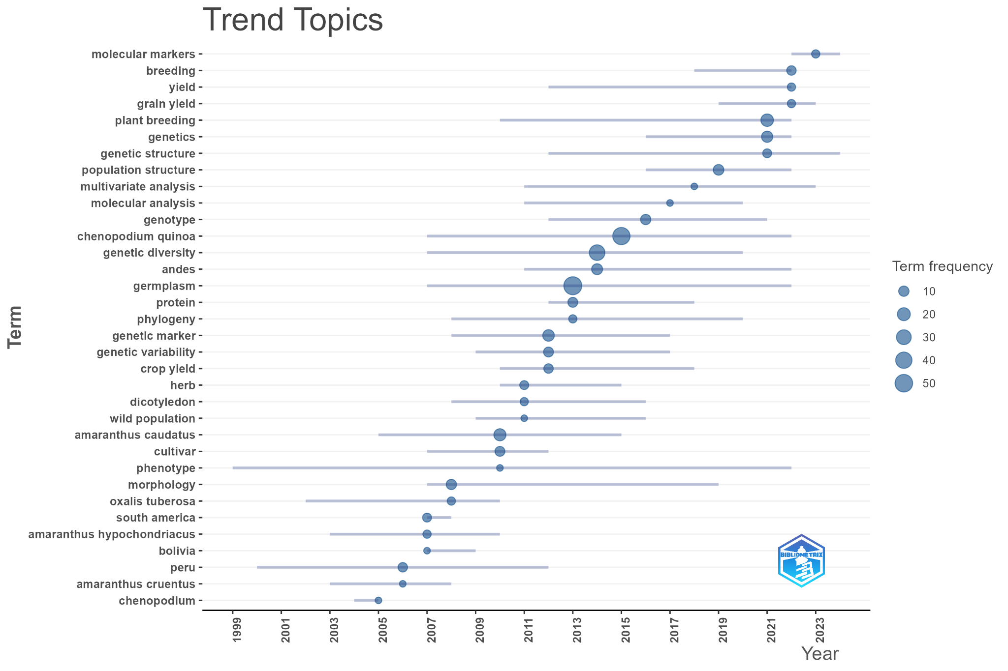
Figure 7. Temporal evolution of trending topics based on the annual frequency and period of occurrence of keywords.
The longitudinal thematic evolution map identified four periods between 1989 and 2026 (Figure 8). The initial period (1989–2010) was represented by the nodes genetic variability, germplasm, phenotype, Chenopodium quinoa, dicotyledon, and Amaranthus caudatus. The subsequent period (2011–2019) converged toward Chenopodium quinoa, with the associated nodes genetics, protein, genotype, cultivation, and genetic differentiation. The stabilization period (2020–2023) was organized around plant breeding, together with germplasm, germplasm characterization, and the Andes. The current period (2024–2026) consolidated around three dominant macrothemes (germplasm, Chenopodium quinoa, and genetic diversity), in which genetic, morphological, and plant breeding approaches converge.
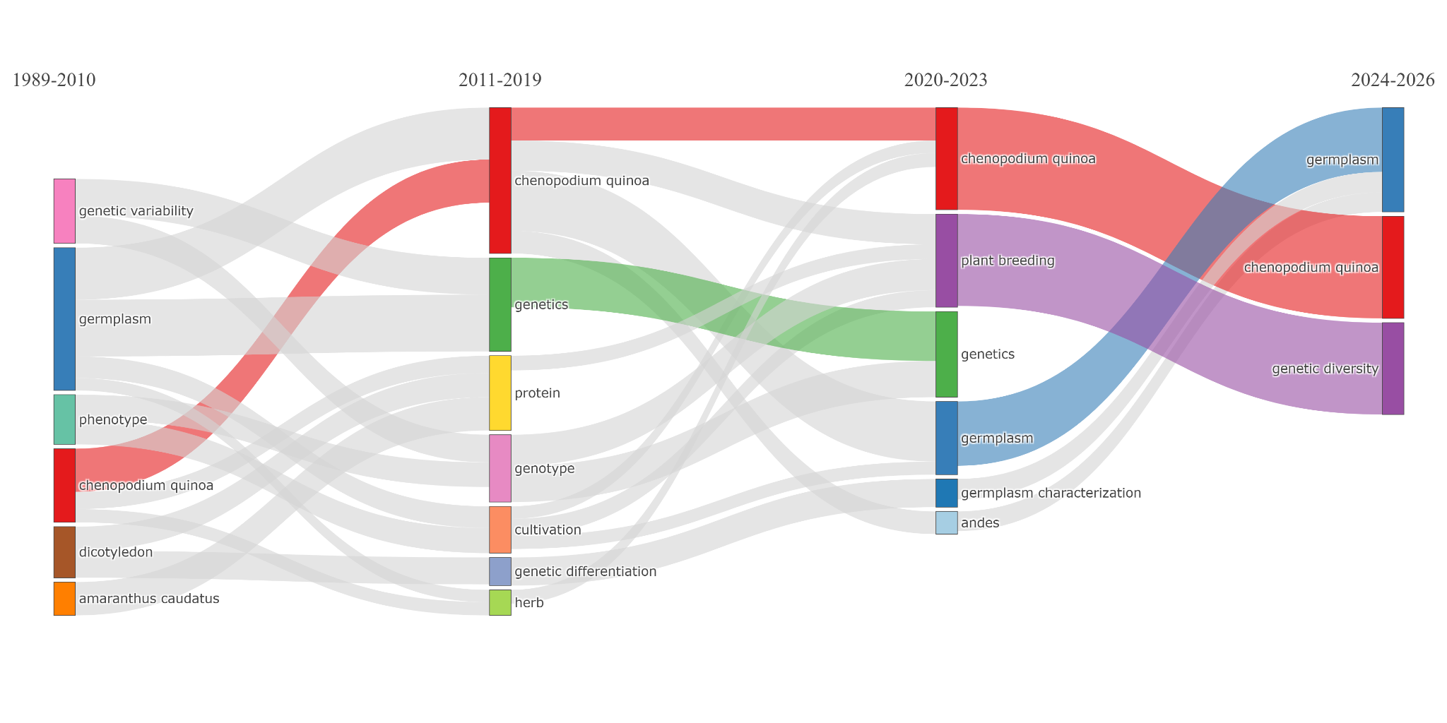
Figure 8. Longitudinal thematic evolution of research on orphan crops structured into four analytical periods.
The thematic map classified the clusters according to their centrality and density (Figure 9). Motor themes comprised cultivation, plant breeding, and crop yield. Basic themes were centered on Chenopodium quinoa, germplasm, and genetic diversity. Niche themes comprised genetic differentiation, molecular analysis, and genetic analysis. Emerging or declining themes included general genetic studies associated with Solanum tuberosum and Oxalis tuberosa, whereas intermediate nodes were related to genotype and genetic variability. Amaranthus caudatus, proteins, and wild populations were also represented.
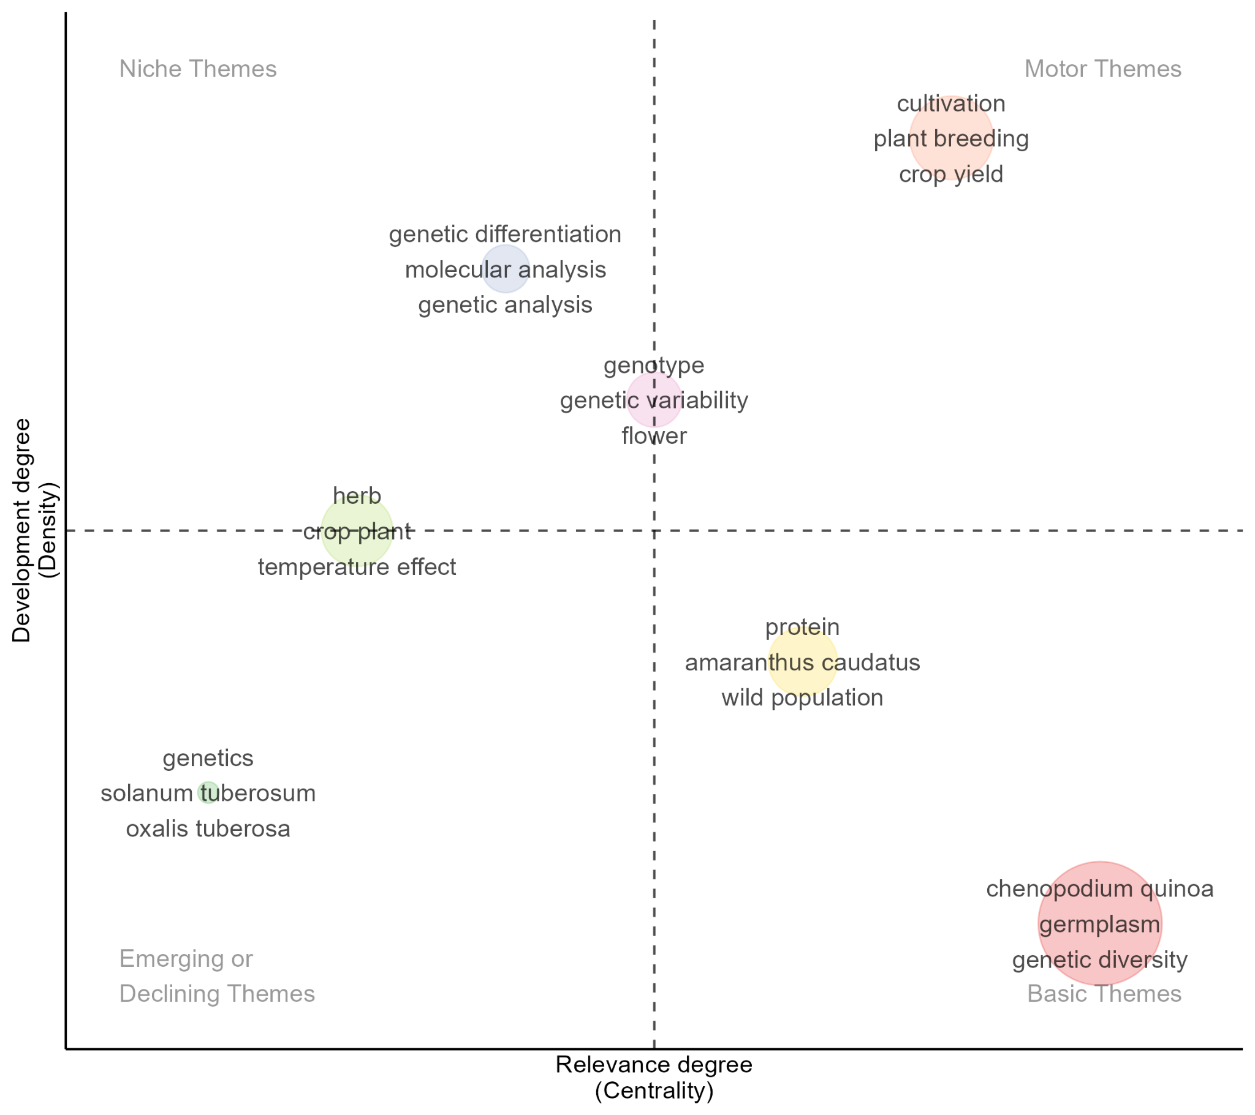
Figure 9. Thematic map of the conceptual structure based on centrality (degree of relevance) and density (degree of development) indicators during the period 1989-2026.

3.2. Status of ex situ collections of Andean orphan crops in Peru
In total, 14,694 reported accession records corresponding to 10 of the 11 evaluated species were recorded across 11 collection sites (operated by seven organizations, five of them INIA experimental stations) located in eight departments of Peru: Cusco, Puno, Lima, Cajamarca, Junín, Amazonas, Ayacucho, and Arequipa (Figure 10). The geographical distribution was markedly heterogeneous, with collections concentrated in Cusco, Puno, and Lima. Cusco accounted for 7,745 accessions, followed by Puno with 3,529 and Lima with 1,902, whereas Cajamarca, Junín, Ayacucho, Amazonas, and Arequipa recorded 602, 436, 270, 198, and 12 accessions, respectively. The five INIA experimental stations belong to a single institution. Grouped accordingly, three organizations hold 83.9% of all accessions: UNSAAC (6,368; 43.3%), INIA (4,053; 27.6%), and CIP (1,902; 12.9%), followed by UNA-Puno (1,893; 12.9%), UNSCH (270; 1.8%), UNTRM (196; 1.3%), and UNSA (12; 0.1%).
In Cusco, the collections were concentrated at the Universidad Nacional de San Antonio Abad del Cusco (UNSAAC) and the Estación Experimental Agraria Andenes (EEA-Andenes), which jointly accounted for 7,745 accessions. EEA-Andenes recorded 941 accessions of Oxalis tuberosa, 224 of Tropaeolum tuberosum, 192 of Ullucus tuberosus, and 20 records of Chenopodium quinoa, whereas UNSAAC held 6,368 accessions, with a high representation of Lupinus mutabilis, Amaranthus caudatus, and Chenopodium quinoa (Figure 10). Puno comprised 3,529 accessions conserved at the Estación Experimental Agraria Illpa (EEA-Illpa) and the Universidad Nacional del Altiplano (UNA-Puno). Chenopodium quinoa was the predominant species, with 2,233 accessions across both institutions, followed by Chenopodium pallidicaule and Lupinus mutabilis. Lima recorded 1,902 accessions, all concentrated at the International Potato Center (CIP), where Oxalis tuberosa, Ullucus tuberosus, and Tropaeolum tuberosum predominated.
The departments of Cajamarca, Junín, Amazonas, Ayacucho, and Arequipa had considerably smaller collections. Cajamarca recorded 602 accessions, Junín 436, Ayacucho 270, Amazonas 198, and Arequipa 12. At the national scale, Chenopodium quinoa had the highest representation, with 4,194 accessions, followed by Lupinus mutabilis with 3,344, Oxalis tuberosa with 2,152, and Amaranthus caudatus with 2,003. Ullucus tuberosus, Chenopodium pallidicaule, Tropaeolum tuberosum, Smallanthus sonchifolius, Arracacia xanthorrhiza, and Lepidium meyenii recorded 998, 613, 610, 318, 284, and 178 accessions, respectively (Figure 10).

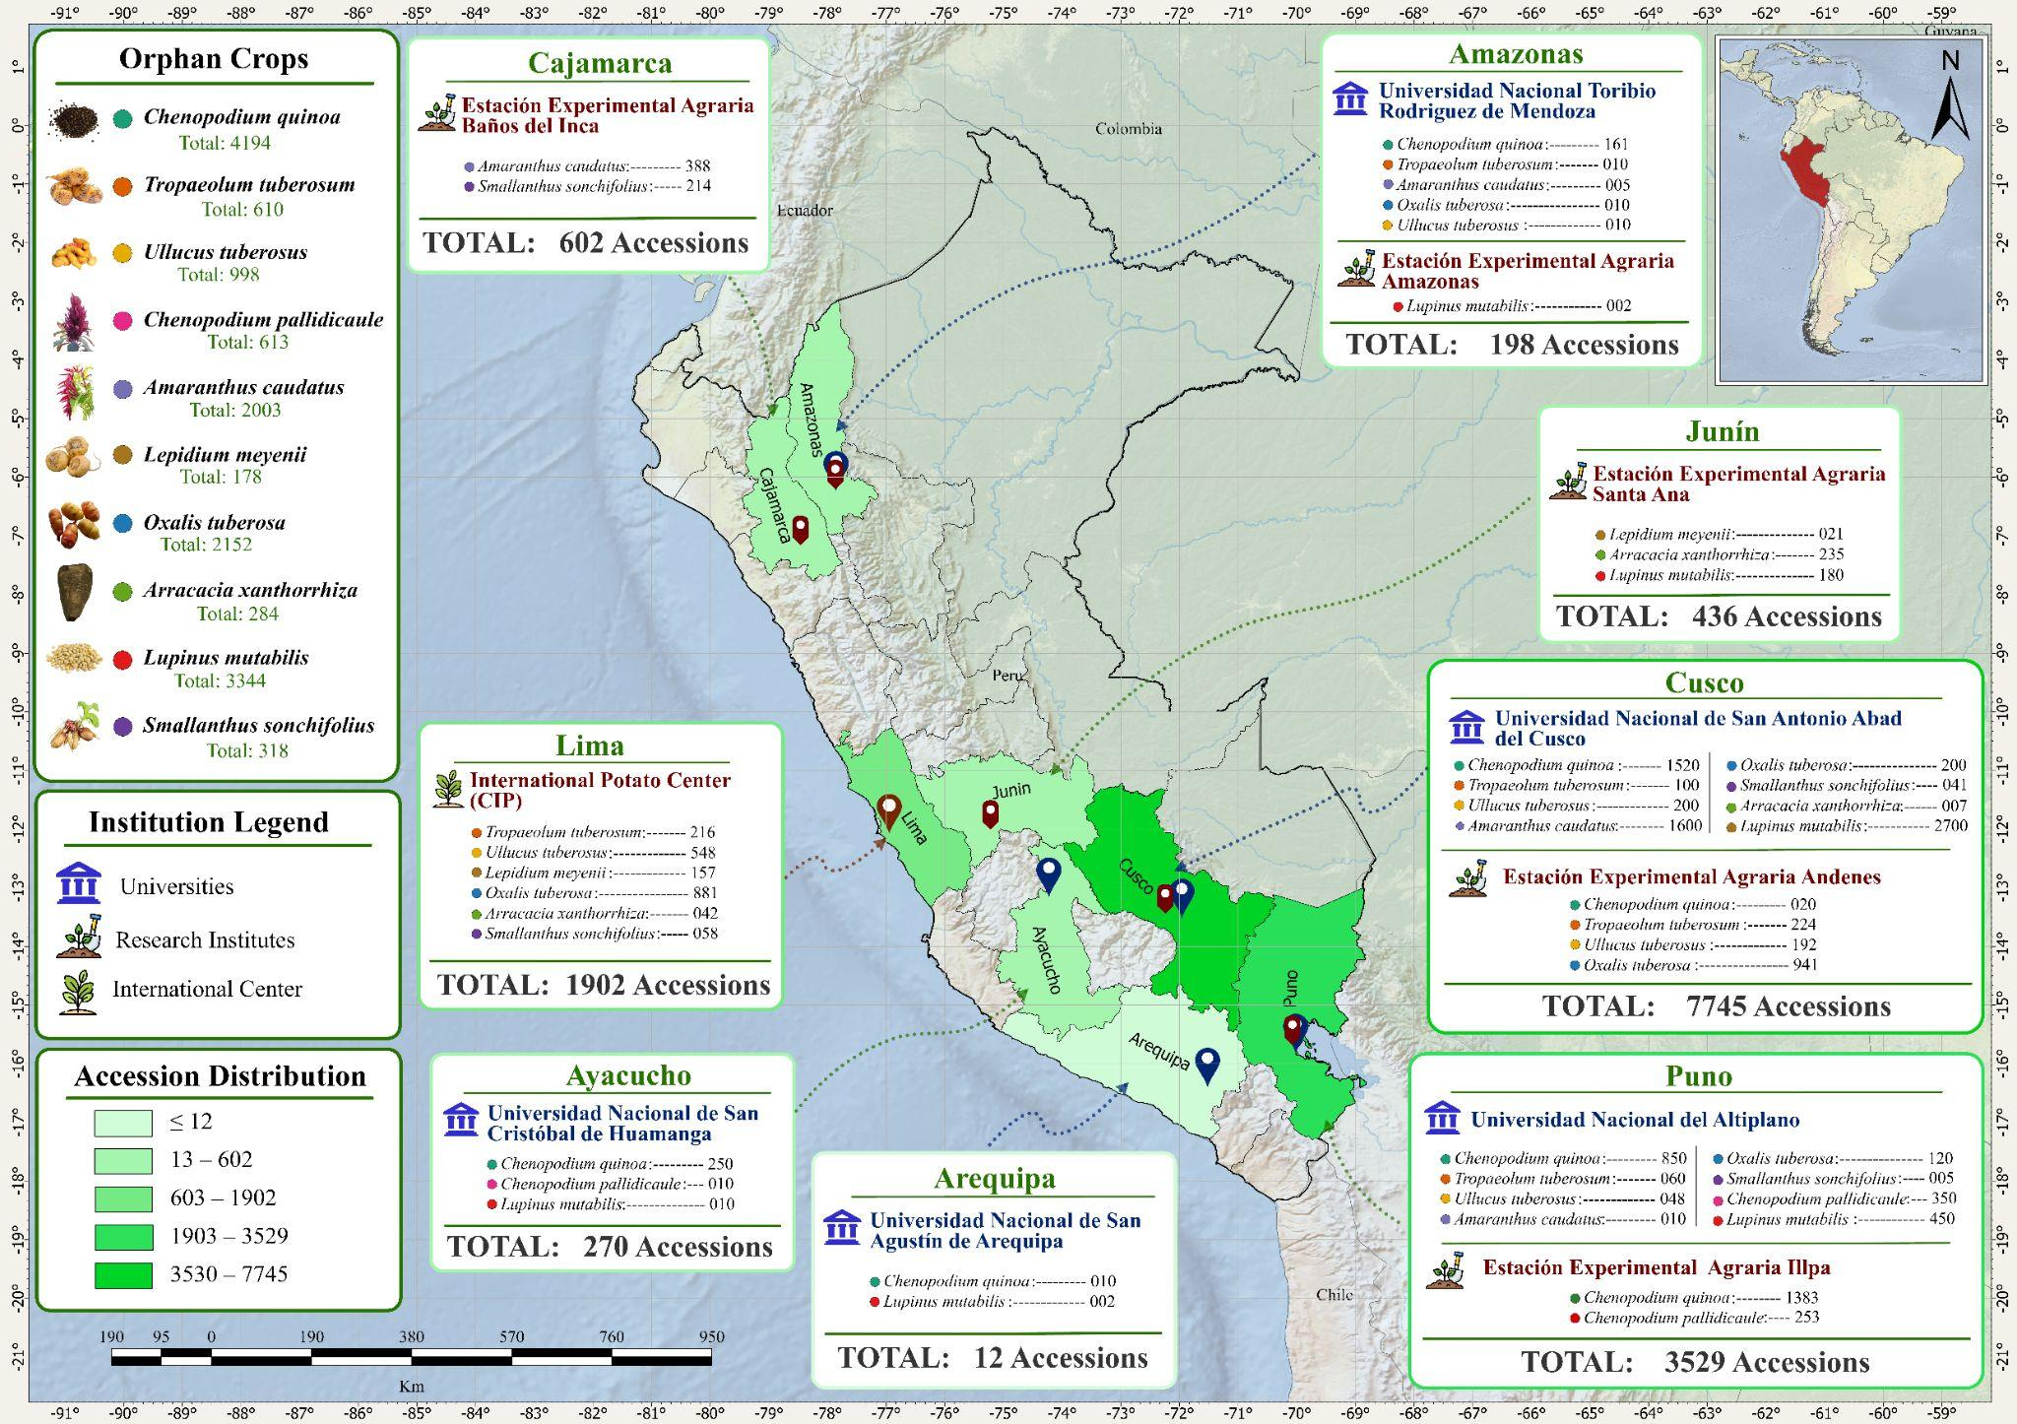
Figure 10. Geographical distribution and biological representativeness of orphan crop accessions conserved in institutional germplasm banks in Peru. Regional coloring indicates the ranges of accession density stored. For each department analyzed, the repository institutions and species composition are detailed.
The conservation of orphan crop germplasm in the evaluated Peruvian institutions involved three modalities: field, seed, and in vitro conservation, which were used either independently or in combination depending on the species and institutional capacity. Field conservation was reported at nine of the 11 collection sites and seed conservation at eight, whereas in vitro conservation was recorded at three collection sites: the International Potato Center (CIP), the Andenes Agricultural Experimental Station (EEA-Andenes), and the Baños del Inca Agricultural Experimental Station (EEA-BI). CIP and EEA-BI combined the three conservation modalities within their collections, while EEA-Andenes combined field and in vitro conservation. The remaining institutions relied on single or combined modalities according to the species maintained (Table 3). Field and in vitro conservation were particularly relevant for the vegetatively propagated species Oxalis tuberosa, Ullucus tuberosus, Tropaeolum tuberosum, and Smallanthus sonchifolius.
Phenotypic characterization was the most widely reported approach among the institutions evaluated. Genomic characterization was reported at CIP, the National University Toribio Rodríguez de Mendoza, the National University of San Cristóbal de Huamanga, and the National University of San Agustín of Arequipa, whereas biochemical characterization was identified at CIP, the National University of the Altiplano, and the National University Toribio Rodríguez de Mendoza. CIP was the only institution in which phenotypic, genomic, and biochemical approaches were reported within the same institutional collection. The remaining institutions relied primarily on phenotypic characterization, with genomic or biochemical analyses applied to selected species (Table 3).
Table 3. Conservation status, characterization methods, and number of accessions of orphan crops maintained in institutions across different regions of Peru.
Region | Genbank/Institution | Species | Germplasm Collection | Accessions (n) | Characterization Performed | Conservation Method | Year | Reference
Amazonas | Estación Experimental Agraria Amazonas | Lupinus mutabilis | Accessions | 2 | Phenotypic | Field | June 2026 | [34]
Amazonas | Universidad Nacional Toribio Rodriguez de Mendoza | Tropaeolum tuberosum | Accessions | 10 | Phenotypic, Biochemical | Seed | June 2026 | Survey
Amazonas | Universidad Nacional Toribio Rodriguez de Mendoza | Ullucus tuberosus | Accessions | 10 | Phenotypic, Biochemical | Seed | June 2026 | Survey
Amazonas | Universidad Nacional Toribio Rodriguez de Mendoza | Amaranthus caudatus | Accessions | 5 | Phenotypic | Seed | June 2026 | Survey
Amazonas | Universidad Nacional Toribio Rodriguez de Mendoza | Oxalis tuberosa | Accessions | 10 | Phenotypic, Genomic | Seed | June 2026 | Survey
Amazonas | Universidad Nacional Toribio Rodriguez de Mendoza | Chenopodium quinoa | Accessions | 161 | Phenotypic, Genomic | Seed and Field | June 2026 | Survey
Arequipa | Universidad Nacional de San Agustín de Arequipa | Chenopodium quinoa | Accessions | 10 | Phenotypic, Genomic | Seed | June 2026 | Survey
Arequipa | Universidad Nacional de San Agustín de Arequipa | Lupinus mutabilis | Accessions | 2 | Phenotypic | Seed | June 2026 | Survey
Ayacucho | Universidad Nacional de San Cristóbal de Huamanga | Chenopodium quinoa | Accessions | 250 | Phenotypic, Genomic | Seed | June 2026 | Survey
Ayacucho | Universidad Nacional de San Cristóbal de Huamanga | Chenopodium pallidicaule | Accessions | 10 |  | Seed | June 2026 | Survey
Ayacucho | Universidad Nacional de San Cristóbal de Huamanga | Lupinus mutabilis | Accessions | 10 |  | Seed | June 2026 | Survey
Cajamarca | Estación Experimental Agraria Baños del Inca | Smallanthus sonchifolius | Accessions | 214 | Phenotypic | Field and in vitro | June 2026 | [34]
Cajamarca | Estación Experimental Agraria Baños del Inca | Amaranthus caudatus | Accessions | 388 | Phenotypic | Seed and Field | June 2026 | [34]
Cusco | Estación Experimental Agraria Andenes | Tropaeolum tuberosum | Accessions | 224 | Phenotypic | Field and in vitro | June 2026 | [34]
Cusco | Estación Experimental Agraria Andenes | Oxalis tuberosa | Accessions | 941 | Phenotypic | Field and in vitro | June 2026 | [34]
Cusco | Estación Experimental Agraria Andenes | Chenopodium quinoa | Varieties | 20 | Phenotypic | Field | June 2026 | [34]
Cusco | Estación Experimental Agraria Andenes | Ullucus tuberosus | Accessions | 192 | Phenotypic | Field and in vitro | June 2026 | [34]
Cusco | Universidad Nacional de San Antonio Abad del Cusco | Chenopodium quinoa | Accessions | 1520 | Phenotypic | Seed | June 2026 | Survey
Cusco | Universidad Nacional de San Antonio Abad del Cusco | Lupinus mutabilis | Accessions | 2700 | Phenotypic | Seed | June 2026 | Survey
Cusco | Universidad Nacional de San Antonio Abad del Cusco | Amaranthus caudatus | Accessions | 1600 | Phenotypic | Seed and Field | June 2026 | Survey
Cusco | Universidad Nacional de San Antonio Abad del Cusco | Tropaeolum tuberosum | Accessions | 100 | Phenotypic | Field | June 2026 | Survey
Cusco | Universidad Nacional de San Antonio Abad del Cusco | Ullucus tuberosus | Accessions | 200 | Phenotypic | Field | June 2026 | Survey
Cusco | Universidad Nacional de San Antonio Abad del Cusco | Oxalis tuberosa | Accessions | 200 | Phenotypic | Field | June 2026 | Survey
Cusco | Universidad Nacional de San Antonio Abad del Cusco | Arracacia xanthorrhiza | Accessions | 7 | Phenotypic | Field | June 2026 | Survey
Cusco | Universidad Nacional de San Antonio Abad del Cusco | Smallanthus sonchifolius | Accessions | 41 | Phenotypic | Field | June 2026 | Survey
Junín | Estación Experimental Agraria Santa Ana | Lepidium meyenii | Accessions | 21 | Phenotypic | Seed and Field | June 2026 | [34]
Junín | Estación Experimental Agraria Santa Ana | Arracacia xanthorrhiza | Accessions | 235 | Phenotypic | Field | June 2026 | [34]
Junín | Estación Experimental Agraria Santa Ana | Lupinus mutabilis | Accessions | 180 | Phenotypic | Seed and Field | June 2026 | [34]
Lima | Centro Internacional de la Papa | Tropaeolum tuberosum | Accessions | 216 | Phenotypic, Genomic | Field and in vitro | June 2026 | Survey
Lima | Centro Internacional de la Papa | Ullucus tuberosus | Accessions | 548 | Phenotypic, Genomic | Field and in vitro | June 2026 | Survey
Lima | Centro Internacional de la Papa | Lepidium meyenii | Accessions | 157 |  | Seed | June 2026 | Survey
Lima | Centro Internacional de la Papa | Oxalis tuberosa | Accessions | 881 | Phenotypic, Biochemical | Field and in vitro | June 2026 | Survey
Lima | Centro Internacional de la Papa | Arracacia xanthorrhiza | Accessions | 42 | Phenotypic, Biochemical | Field and in vitro | June 2026 | Survey
Lima | Centro Internacional de la Papa | Smallanthus sonchifolius | Accessions | 58 | Phenotypic, Genomic, Biochemical | Field and in vitro | June 2026 | Survey
Puno | Estación Experimental Agraria Illpa | Chenopodium quinoa | Accessions | 1383 | Phenotypic | Field | June 2026 | [34]
Puno | Estación Experimental Agraria Illpa | Chenopodium pallidicaule | Accessions | 253 | Phenotypic | Field | June 2026 | [34]
Puno | Universidad Nacional del Altiplano | Chenopodium quinoa | Accessions | 850 | Phenotypic, Biochemical | Seed and Field | June 2026 | Survey
Puno | Universidad Nacional del Altiplano | Tropaeolum tuberosum | Accessions | 60 | Phenotypic | Field | June 2026 | Survey
Puno | Universidad Nacional del Altiplano | Ullucus tuberosus | Accessions | 48 | Phenotypic | Field | June 2026 | Survey
Puno | Universidad Nacional del Altiplano | Chenopodium pallidicaule | Accessions | 350 | Phenotypic, Biochemical | Seed and Field | June 2026 | Survey
Puno | Universidad Nacional del Altiplano | Amaranthus caudatus | Accessions | 10 |  | Seed and Field | June 2026 | Survey
Puno | Universidad Nacional del Altiplano | Oxalis tuberosa | Accessions | 120 | Phenotypic | Field | June 2026 | Survey
Puno | Universidad Nacional del Altiplano | Lupinus mutabilis | Accessions | 450 | Phenotypic, Biochemical | Seed and Field | June 2026 | Survey
Puno | Universidad Nacional del Altiplano | Smallanthus sonchifolius | Accessions | 5 |  | Field | June 2026 | Survey
Note. Information collected through institutional surveys and supplemented with official records from the germplasm banks of the National Institute of Agrarian Innovation (INIA).

3.3. Research effort versus conservation effort: a gap assessment
To test whether conservation effort follows research effort, we compared, for each of the 11 species, the number of species-specific Scopus records with the number of reported accessions (Figure 9A). The two variables were positively associated (Spearman ρ = 0.64, P = 0.033, n = 11; ρ = 0.83, P = 0.003, n = 10 after excluding Salvia hispanica, which is of Mesoamerican origin and has no reported accessions), indicating that crops with more publications tend to have larger collections (Figure 11).
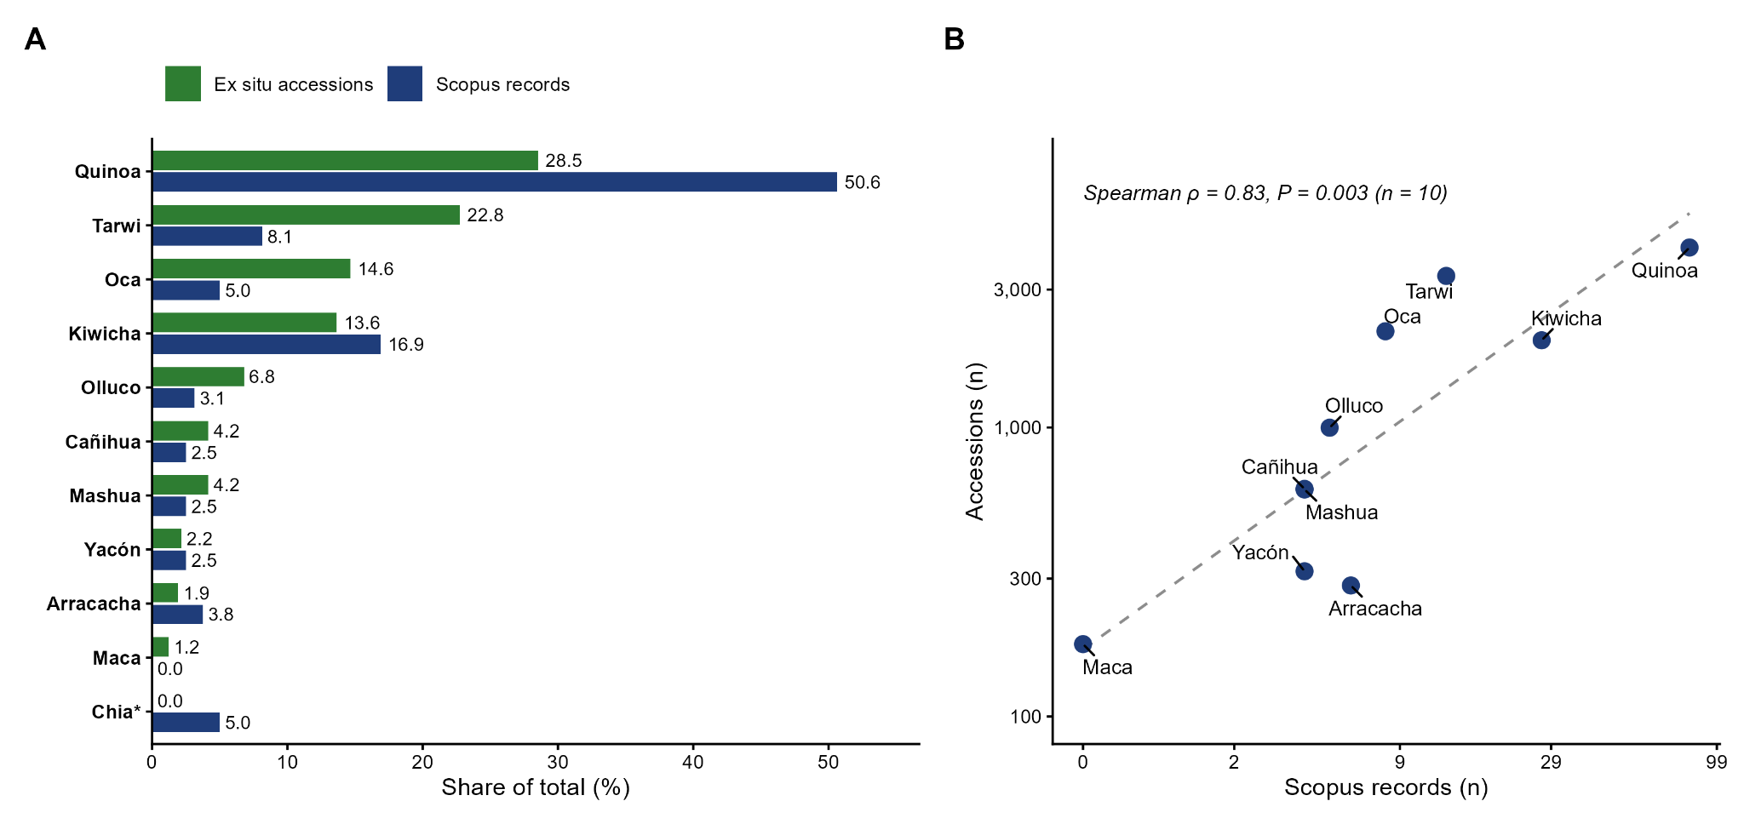
Figure 11. Research effort and conservation effort for 11 orphan crops of Peru. (A) Share of species-specific Scopus records (n = 160; three records were retrieved by more than one search) and share of reported ex situ accessions (n = 14,694) by species. (B) Association between the number of records and the number of accessions (log scales; Spearman rank correlation). *Chia (Salvia hispanica) has records but no reported accessions. Sources: Scopus (accessed 6 July 2026), questionnaire, and SIRGE.
The association nevertheless concealed large departures. Chenopodium quinoa accounted for 50.6% of the records but only 28.5% of the accessions, whereas Lupinus mutabilis (22.8% of accessions; 8.1% of records) and Oxalis tuberosa (14.6%; 5.0%) held proportionally larger collections than their research footprint would predict, with 257 and 269 accessions per record versus 52 for quinoa. Ullucus tuberosus, Chenopodium pallidicaule, and Tropaeolum tuberosum showed a smaller imbalance of the same sign (153–200 accessions per record). Lepidium meyenii (178 accessions at two organizations) had no eligible publication in the dataset, and Salvia hispanica had eight records but no reported accession.
Characterization depth was also uneven. Phenotypic characterization was reported for 98.7% of the accessions, but only 8.5% (1,253 accessions) were held in collections with genomic characterization (CIP, UNTRM, UNSCH, and UNSA) and 18.0% (2,651) in collections with biochemical characterization (CIP, UNA-Puno, and UNTRM); 192 accessions (1.3%) had no characterization reported. Because the questionnaire records the approaches applied by each custodian to each species rather than to each accession, these percentages are upper bounds of accession-level coverage. Genomic characterization was reported for 54.9% of olluco, 35.4% of mashua, 18.2% of yacón, and 10.0% of quinoa accessions, for less than 1% of oca accessions, and for none of the kiwicha, tarwi, cañihua, arracacha, or maca accessions (Table 4).
Conservation security also varied among species. Overall, 49.9% of accessions were maintained under two or more modalities, 31.9% as seed only, and 18.2% in the field only. For the five vegetatively propagated species (oca, olluco, mashua, yacón, and arracacha; 4,362 accessions), 76.0% were held in collections that also use in vitro conservation, but 85.2% of arracacha accessions were maintained in the field only, as were 41.3% of cañihua accessions. Holdings were also concentrated institutionally. Three organizations held 83.9% of the accessions; quinoa was held by six organizations and tarwi by five, whereas arracacha and cañihua were held by only three and maca by only two.

Table 4. Research–conservation gap indicators for 11 orphan crops of Peru. Gap indicators: share of accessions minus share of records >5 percentage points (research gap) or <−5 (research-dominant); ≥40% of accessions in field-only collections; ≥50% of accessions without reported characterization; no accessions. Percentages refer to accessions held in collections where the approach is reported (upper bounds). *Salvia hispanica is a non-Andean reference species.
Species | Scopus records (n) | Accessions (n) | Organizations (n) | Genomic (% acc.) | Biochemical (% acc.) | Field-only (% acc.) | Gap indicator
Quinoa (Chenopodium quinoa) | 81 | 4,194 | 6 | 10 | 20.3 | 33.5 | Research-dominant (records 50.6% vs. accessions 28.5%)
Kiwicha (Amaranthus caudatus) | 27 | 2,003 | 4 | 0 | 0 | 0 | Balanced; no genomic or biochemical characterization reported
Tarwi (Lupinus mutabilis) | 13 | 3,344 | 5 | 0 | 13.5 | 0.1 | Research gap (accessions 22.8% vs. records 8.1%); no genomic characterization
Oca (Oxalis tuberosa) | 8 | 2,152 | 5 | 0.5 | 40.9 | 14.9 | Research gap (accessions 14.6% vs. records 5.0%); genomic <1%
Olluco (Ullucus tuberosus) | 5 | 998 | 5 | 54.9 | 1 | 24.8 | Balanced; highest genomic coverage (54.9%)
Cañihua (Chenopodium pallidicaule) | 4 | 613 | 3 | 0 | 57.1 | 41.3 | Field-only 41.3%; no genomic characterization
Mashua (Tropaeolum tuberosum) | 4 | 610 | 5 | 35.4 | 1.6 | 26.2 | Balanced; genomic 35.4%
Yacón (Smallanthus sonchifolius) | 4 | 318 | 4 | 18.2 | 18.2 | 14.5 | Balanced; small holdings (318)
Arracacha (Arracacia xanthorrhiza) | 6 | 284 | 3 | 0 | 14.8 | 85.2 | Single-modality risk (85.2% field-only)
Maca (Lepidium meyenii) | 0 | 178 | 2 | 0 | 0 | 0 | Documentation gap: no records; 88.2% of accessions uncharacterized
Chia (Salvia hispanica)* | 8 | 0 | 0 | – | – | – | No ex situ accessions reported (non-Andean reference)
Total | 160 | 14,694 | 7 | 8.5 | 18 | 18.2

3.4. Challenges for Conservation
Nine custodians answered the questions on limitations and exchange (Figure 12). Insufficient financial resources was the most frequent limitation (8 of 9 responses), followed by inadequate infrastructure (5; two labels used by respondents were merged), risk of loss of genetic diversity (4), limited access to genetic material (3), logistical challenges for distribution or regeneration (3), technical limitations or insufficient staff training (2), and difficulties in documentation and information management (1). Willingness to exchange germplasm was reported as “yes” by five and “maybe” by four of nine respondents (none declined).
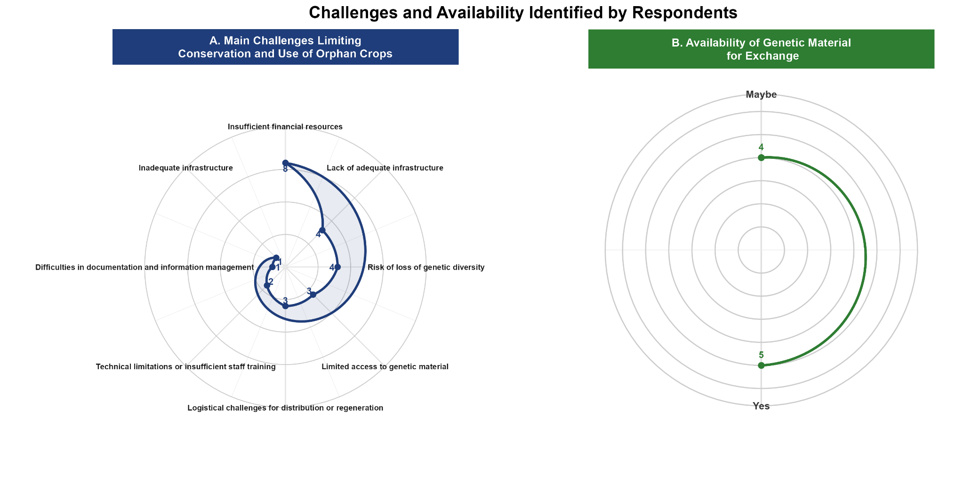
Figure 12. Respondents’ perceptions of the main limitations to the conservation and use of orphan crops (A), assessed using 10 qualitative response options, and of the availability of germplasm for exchange (B). Numerical values represent the number of respondents who selected each response (n = 9 responses with data on limitations and exchange).

4. Discussion

4.1. Research trends and international collaboration
The bibliometric analysis revealed an expansion of scientific research on Andean orphan crops, although scientific production remained strongly concentrated on quinoa. The international co-authorship network showed collaboration among countries with substantial plant genetic resources and countries with established research capacities in genetics, biotechnology, nutritional analysis, and crop improvement. Peru occupied a central position in this network, consistent with its importance as a center of origin and diversification of Andean crops [22,33], including Amaranthus caudatus, Chenopodium pallidicaule, Chenopodium quinoa, Lepidium meyenii, Lupinus mutabilis, Oxalis tuberosa, Smallanthus sonchifolius, Tropaeolum tuberosum, and Ullucus tuberosus. The diversity of these crops has been maintained through traditional agricultural practices and farmer selection, providing genetic resources for research on environmental adaptation, nutritional quality, and crop improvement [53,18,15,19].
The strong connection between Peru and the United States suggests an important international collaboration in the study and utilization of Andean plant genetic resources. European countries also participated in the network; for example, Belgian groups contributed studies on the genetic diversity and conservation of Andean tuber crops [53–55]. The author co-authorship network further identified a research group focused on the genetic characterization and conservation of Andean crops. Its publications addressed genetic diversity in C. quinoa, C. pallidicaule, and A. caudatus using SSR and SNP markers [56–59], genetic map development [60], genome sequencing [61], and the evaluation of breeding populations [62]. Other studies addressed downy mildew resistance [62], seed protein characteristics [63], and salinity responses in quinoa accessions [64]. These research lines demonstrate the contribution of molecular and phenotypic approaches to the characterization and utilization of germplasm. Nevertheless, the predominance of quinoa in the scientific literature indicates an uneven distribution of research effort, with crops such as mashua, olluco, arracacha, maca, and yacón receiving comparatively less attention despite their agricultural and nutritional relevance [10,54,55,27,26].

4.2. Research gaps and thematic evolution
The keyword structure highlighted the central role of germplasm collections in research on Andean crops. Terms such as germplasm, genetic diversity, genetic marker, population structure, and genetic variability reflected the emphasis on assessing genetic variation [65,66]. The co-occurrence of morphology, genotype, protein, grain yield, and multivariate analysis further indicated the relevance of phenotypic and agronomic characterization. The frequent occurrence of C. quinoa and A. caudatus revealed the unequal research attention across the analyzed crops.
The thematic evolution traced a shift from species distribution and morphological description toward molecular characterization and plant breeding. Early studies documented species diversity and established reference collections [67–70], followed by phenotypic and agronomic assessments of accessions [71–73]. Research published between 2010 and 2015 increasingly addressed the conservation and utilization of genetic diversity, whereas studies from 2016 onward incorporated molecular markers, genomic resources, and computational approaches into germplasm characterization and breeding [74–76]. Recent contributions have placed greater emphasis on yield improvement and the integration of genetic information into crop evaluation [36,77].
Quinoa remained a persistent research focus during 2011–2019, reflecting its nutritional properties, environmental adaptability, and relevance to food security [15,23,21]. Studies addressing saponin content and accession identity illustrate the breadth of this research [75,78]. The subsequent prominence of germplasm and genetic diversity indicates sustained interest in accession characterization and resource utilization. The thematic map distinguished conservation and characterization as basic research themes, whereas plant breeding and the application of genetic information occupied more specialized positions.
The predominance of quinoa contrasts with coordinated genomic initiatives targeting multiple underutilized crops. The African Orphan Crops Consortium developed genomic resources for 101 African food crops to support their genetic improvement and utilization [79]. Genomics and machine-learning approaches have also been identified as tools for accelerating orphan crop improvement [17,13]. By comparison, research on Andean crops remains unevenly distributed across species. The genomic characterization of only 8.5% of the accessions inventoried in Peru further illustrates this limitation. Expanding molecular characterization beyond quinoa and establishing coordinated research priorities could improve the scientific value and utilization of collections representing underrepresented crops.

4.3. Ex situ conservation status and institutional gaps
The distribution of accessions among Peruvian institutions revealed a concentration of conserved materials in Cusco, Puno, and Lima. This pattern may reflect differences in institutional trajectories and conservation capacity. The representation of Cusco is consistent with the historical involvement of regional institutions in collecting Andean plant genetic resources, whereas the extensive holdings in Lima highlight the role of institutions located outside major production areas in maintaining and documenting germplasm. The presence of collections in Puno reflects the importance of high-altitude agriculture in the region. These patterns describe the institutional distribution of conserved materials rather than the geographical distribution of genetic diversity.
The smaller collections recorded in Cajamarca, Junín, Ayacucho, Amazonas, and Arequipa should not be interpreted as evidence of lower regional genetic richness. Accession numbers are shaped by collecting history, geographical coverage, institutional priorities, infrastructure, and the capacity to regenerate and maintain materials. They also provide no direct evidence of genetic representativeness because they do not account for duplication, geographical provenance, or genetic differentiation [29]. The greater representation of C. quinoa, L. mutabilis, and A. caudatus reflects their importance in Andean agricultural systems and their inclusion in conservation and characterization programs, but does not necessarily indicate greater genetic variation. The inventory also excludes part of the agrobiodiversity maintained through farmer-managed populations and traditional seed systems, where selection, seed exchange, and adaptation sustain crop diversity under local production conditions [35,54,55,72]. A comprehensive assessment of national conservation coverage requires integrating ex situ records with geographical provenance, accession-level characterization, redundancy assessments, and information on in situ and on-farm management.
The conservation modalities recorded in the inventory reflected differences in species biology and propagation systems. Seed storage, field genebanks, in vitro conservation, and cryopreservation constitute complementary approaches to maintaining plant genetic resources [28]. International standards establish that conservation procedures should be adapted to seed storage behavior and propagation systems, including viability monitoring, regeneration, documentation, distribution, and safety duplication. Vegetatively propagated crops may require complementary in vitro or cryopreservation facilities to back up field collections and reduce the risk of material loss [80–82]. Because the inventory did not include storage conditions, viability records, or evidence of safety duplication, the presence of multiple conservation modalities cannot be interpreted as proof of collection security.
Phenotypic characterization was the most frequently reported approach, indicating that morphological and agronomic descriptors remain the main source of information for documenting the evaluated collections. These data support accession identification, the assessment of observable variation, and the preliminary identification of materials with potentially useful traits. Genomic analyses provide complementary evidence on genetic relationships and population structure, while biochemical characterization contributes information on nutritional and functional properties [65,66]. The uneven use of these approaches across institutions points to gaps in the characterization of Peruvian germplasm. Improving accession-level documentation and expanding molecular and biochemical analyses are particularly relevant for collections with substantial holdings but limited research output.

4.4. Research–conservation gaps and institutional constraints
The positive, albeit imperfect, association between research output and accession numbers indicates that species with more publications tend to have larger germplasm collections. Nevertheless, differences among species show that research and conservation efforts are not necessarily proportional. Quinoa had a greater representation in the scientific literature, whereas tarwi and oca had accession holdings that exceeded their relative representation in published research. This discrepancy highlights opportunities to expand the characterization and use of these collections [14,10,11]. A similar imbalance between research attention and ex situ representation has been reported for underutilized crops in Latin America, where several Andean species maintain substantial accession holdings despite receiving comparatively limited research attention [83]. In Peru, this situation is particularly relevant because the conservation of native crops does not always translate into sustained research, breeding, or the development of improved materials. Participatory breeding initiatives involving underutilized crops in the Peruvian highlands have emphasized the need to combine productivity improvement with the maintenance of genetic diversity, while addressing financial and institutional constraints that limit the continuity and expansion of these programs [84]. The accession holdings identified for tarwi and oca therefore represent an important resource for further research, particularly through the assessment of agronomic and nutritional traits, the evaluation of adaptation to contrasting environments, and the identification of materials with potential value for breeding. Strengthening these activities would help connect the existing conservation effort with the generation of knowledge and the sustainable use of these crops.

4.5. Conservation priorities and international implications
The findings support four priorities for strengthening the conservation and utilization of Andean plant genetic resources in Peru. The first is to expand the characterization of tarwi and oca collections, whose accession holdings are relatively large compared with their representation in the scientific literature. The lack of reported genomic characterization for tarwi highlights the need for genotyping, genetic diversity assessments, and the development of representative core collections [37,84] Previous studies of Peruvian quinoa germplasm provide a methodological reference for designing collections that retain a substantial proportion of the available genetic variation [85]. The second priority concerns arracacha and cañihua collections maintained predominantly in field genebanks, for which safety duplication and complementary conservation strategies are needed. In vitro conservation and cryopreservation offer alternatives for backing up these materials, depending on the biological characteristics and propagation requirements of each species [82,81,86]. Maca collections also require improved passport documentation and accession-level characterization. These measures could reduce the risk of material loss and improve collection management [87,88].
The third priority is to integrate accession information currently dispersed across SIRGE and institutional records. This fragmentation hinders duplicate identification, the assessment of geographical coverage, and the planning of new collecting activities. A national platform with interoperable accession records could facilitate data integration and conservation gap analyses, following approaches developed for other plant genetic resource systems [89,90]. Its implementation would require standardized passport descriptors, institutional data-sharing procedures, and mechanisms for updating accession records. The fourth priority is to integrate ex situ collections with in situ and on-farm conservation. While the former maintain accessions under institutional conditions, farmer-managed populations continue to evolve through selection, seed exchange, and adaptation to local agricultural systems [18,53,91]. The International Treaty on Plant Genetic Resources for Food and Agriculture, the Nagoya Protocol, and Target 4 of the Kunming–Montreal Global Biodiversity Framework provide policy frameworks for guiding conservation, access, and sustainable use [92]. The willingness to exchange germplasm expressed by participating custodians offers an opportunity to strengthen institutional collaboration, although implementation requires clearly defined procedures and adequate technical and financial capacity.
The findings provide a baseline for identifying institutional, taxonomic, and research gaps in the conservation of selected underutilized Andean crops in Peru. Accession inventories and bibliometric indicators alone are insufficient to establish the genetic representativeness or long-term security of collections. Further assessments should integrate accession-level passport data, molecular characterization, viability monitoring, regeneration records, safety duplication, and information on farmer-managed diversity. Coordinating these components would improve the assessment of national conservation coverage and support the sustainable utilization of Andean crops that remain underrepresented in scientific research.

4.6. Limitations and perspectives
This study provides an exploratory assessment of scientific research and germplasm collections of orphan crops in Peru, although several limitations should be acknowledged. The bibliometric analysis relied exclusively on Scopus; consequently, publications indexed in other bibliographic databases were not captured. Germplasm information was obtained from the main institutions responsible for conserving plant genetic resources in the country, although additional collections may be maintained by universities, non-governmental organizations, private foundations, or other entities whose information was not documented or made available during the study period. The extent of duplication among collections could not be established because standardized accession-level information and an integrated national database for cross-institutional comparisons were unavailable.
The bibliographic search relied on the term “germplasm”, which may have excluded publications using alternative terms such as “genebank”, “accession”, “landrace”, and “ex situ”, as well as studies indexed under common crop names. An expanded search incorporating these terms and three additional bibliographic databases is needed to improve coverage. The institutional inventory was based on responses from 10 of the 22 invited custodians (45.5%), nine of whom were co-authors of this study. This participation pattern may have favored collections associated with the research team, while information from other potential custodians remained unavailable. The reported accession count should also be interpreted cautiously because it does not quantify genetic diversity or account for redundancy, provenance, and genetic differentiation. Characterization approaches were documented at the species and institutional levels rather than for individual accessions, preventing an accession-level assessment of characterization coverage. The inventory represents a cross-sectional assessment conducted in June 2026, and the correlation between scientific output and germplasm holdings, calculated across 11 species, should be interpreted as exploratory.
Despite these limitations, this study provides a national assessment integrating scientific production and information on major germplasm collections of selected orphan crops in Peru. The findings establish a baseline for expanding the national inventory, improving collection documentation, and strengthening coordination among institutions responsible for conserving plant genetic resources. A national platform for information exchange among germplasm banks, supported by standardized accession records and molecular characterization, could facilitate the identification of duplicate accessions, improve the management of storage capacity, and support more efficient allocation of conservation resources. These actions could also facilitate the identification of genotypes with promising agronomic traits and promote the conservation, management, and sustainable use of plant genetic resources for food and agriculture in Peru.

5. Conclusions
The bibliometric analysis and national inventory revealed substantial progress in research and conservation of Andean orphan crops in Peru, although both efforts remained unevenly distributed across species and institutions. Research was concentrated on Chenopodium quinoa, whereas Lupinus mutabilis and Oxalis tuberosa had comparatively large collections but received limited scientific attention; Arracacia xanthorrhiza and Chenopodium pallidicaule depended largely on field conservation, and Lepidium meyenii showed gaps in both research and characterization. Although phenotypic characterization was widely implemented, genomic and biochemical assessments remained limited, and 18.2% of accessions were maintained exclusively in the field. These findings identify four priorities: expanding the characterization and use of under-researched collections, establishing safety duplication and complementary in vitro or cryopreservation strategies, developing an interoperable national platform for accession-level information and duplicate identification, and securing sustained funding, which custodians identified as the main constraint. This assessment provides a baseline for strengthening the conservation and sustainable use of these genetic resources, although its interpretation is constrained by the use of a single bibliographic database, a partial sampling frame, and accession counts that do not directly represent genetic diversity.
Author Contributions: Conceptualization: V.-H.B.-C. and F.L.-I.; Data curation: V.-H.B.-C., W.M.-M. and Y.D.-S.; Formal analysis: V.-H.B.-C., Y.D.-S., and F.L.-I.; Funding acquisition: J.L.M.-Q. and F.L.-I.; Investigation: V.-H.B.-C., W.M.-M., and F.L.-I.; Methodology: V.-H.B.-C., W.M.-M., Y.D.-S., and F.L.-I.; Project administration: I.M., G.D.L.C., A.A.-C., M.C.B.-Z., C.J.-A., M.R.E.V.-V., A.M.H.M.S., J.A.C.-A., J.L.M.-Q., and F.L.-I.; Resources: J.L.M.-Q. and F.L.-I.; Software: V.-H.B.-C., Y.D.-S., and F.L.-I.; Supervision: F.L.-I.; Validation: F.L.-I.; Visualization: V.-H.B.-C., W.M.-M., Y.D.-S., and F.L.-I.; Writing–original draft: V.-H.B.-C., W.M.-M., Y.D.-S., and F.L.-I.; Writing-review and editing: All authors.
Funding: The development of this research and the corresponding funding for the processing of the scientific article (APC) were made possible through the support of the Vice-Rectorate for Research of the Universidad Nacional Toribio Rodríguez de Mendoza de Amazonas (UNTRM). The authors acknowledge the technical and financial support provided by Project CUI No. 2590588, “Mejoramiento del servicio de promoción de la ciencia, tecnología e innovación para el Centro de Investigación en Granos y Semillas (CEIGRAS),” of the UNTRM.
Data Availability Statement: The complete dataset and associated analysis code are also publicly available in the GitHub repository: https://github.com/Vyxugo/Germplasm-Banks.git.
Acknowledgments: The authors sincerely thank the Instituto de Investigación para el Desarrollo Sustentable de Ceja de Selva (INDES-CES) and the Universidad Nacional Toribio Rodríguez de Mendoza de Amazonas (UNTRM) for the institutional support provided during the development of this research. The authors also acknowledge the Universidad Nacional de San Antonio Abad del Cusco (UNSAAC), the Centro Internacional de la Papa (CIP), the Universidad Nacional de San Cristóbal de Huamanga (UNSCH), the Universidad Nacional del Altiplano (UNA-Puno), the Universidad Nacional de San Agustín de Arequipa (UNSA), and the Instituto Nacional de Innovación Agraria (INIA) for their contributions to the national assessment of plant genetic resources through the provision of information and institutional expertise. Likewise, the authors thank the researchers and professionals who participated in the survey, even though the information provided on certain crops was not included in the dataset analyzed in this study. Their participation contributed to broadening the national overview of the conservation and management of plant genetic resources.
Conflicts of Interest: The authors declare that they have no conflicts of interest.

References
- Morton, J.F. The Impact of Climate Change on Smallholder and Subsistence Agriculture. Proc. Natl. Acad. Sci. 2007, 104, 19680–19685, doi:10.1073/pnas.0701855104.
- Reidsma, P.; Ewert, F.; Lansink, A.O.; Leemans, R. Adaptation to Climate Change and Climate Variability in European Agriculture: The Importance of Farm Level Responses. Eur. J. Agron. 2010, 32, 91–102, doi:10.1016/j.eja.2009.06.003.
- Muluneh, M.G. Impact of Climate Change on Biodiversity and Food Security: A Global Perspective—a Review Article. Agric. Food Secur. 2021, 10, 36, doi:10.1186/s40066-021-00318-5.
- Mogollón, J.M.; Hadjikakou, M.; Taherzadeh, O.; Ngumbi, E.N.; Van Zanten, H.H.E.; Basu, N.B.; Kortleve, A.J.; Behrens, P. Broad Bidirectional Effects of Global Food Production on the Environment. Nat. Rev. Earth Environ. 2026, 7, 280–293, doi:10.1038/s43017-026-00778-y.
- Hiywotu, A.M.; Hibistu, A.G.; Molla, T.A. Sustainable Agricultural Practices and Their Environmental Impacts: A Structured Review of Effectiveness, Trade-Offs, and Adoption Barriers. Sustain. Futur. 2026, 11, 101877, doi:10.1016/j.sftr.2026.101877.
- Renard, D.; Tilman, D. National Food Production Stabilized by Crop Diversity. Nature 2019, 571, 257–260, doi:10.1038/s41586-019-1316-y.
- Esquinas-Alcázar, J. Protecting Crop Genetic Diversity for Food Security: Political, Ethical and Technical Challenges. Nat. Rev. Genet. 2005, 6, 946–953, doi:10.1038/nrg1729.
- Dempewolf, H.; Eastwood, R.J.; Guarino, L.; Khoury, C.K.; Müller, J.V.; Toll, J. Adapting Agriculture to Climate Change: A Global Initiative to Collect, Conserve, and Use Crop Wild Relatives. Agroecol. Sustain. Food Syst. 2014, 38, 369–377, doi:10.1080/21683565.2013.870629.
- Dawson, I.K.; Guarino, L.; Jaenicke, H. Underutilised Plant Species: Impacts of Promotion on Biodiversity. Position Paper No. 2.; Position Paper; Position Paper No. 2.; Crops for the Future: Serdang, Malasia, 2007; ISBN 978-955-1560-05-9.
- Padulosi, S.; Amaya, K.; Jäger, M.; Gotor, E.; Rojas, W.; Valdivia, R. A Holistic Approach to Enhance the Use of Neglected and Underutilized Species: The Case of Andean Grains in Bolivia and Peru. Sustainability 2014, 6, 1283–1312, doi:10.3390/su6031283.
- Hunter, D.; Borelli, T.; Beltrame, D.M.O.; Oliveira, C.N.S.; Coradin, L.; Wasike, V.W.; Wasilwa, L.; Mwai, J.; Manjella, A.; Samarasinghe, G.W.L.; et al. The Potential of Neglected and Underutilized Species for Improving Diets and Nutrition. Planta 2019, 250, 709–729, doi:10.1007/s00425-019-03169-4.
- Talabi, A.O.; Vikram, P.; Thushar, S.; Rahman, H.; Ahmadzai, H.; Nhamo, N.; Shahid, M.; Singh, R.K. Orphan Crops: A Best Fit for Dietary Enrichment and Diversification in Highly Deteriorated Marginal Environments. Front. Plant Sci. 2022, 13, doi:10.3389/fpls.2022.839704.
- MacNish, T.R.; Danilevicz, M.F.; Bayer, P.E.; Bestry, M.S.; Edwards, D. Application of Machine Learning and Genomics for Orphan Crop Improvement. Nat. Commun. 2025, 16, 982, doi:10.1038/s41467-025-56330-x.
- Mayes, S.; Massawe, F.J.; Alderson, P.G.; Roberts, J.A.; Azam-Ali, S.N.; Hermann, M. The Potential for Underutilized Crops to Improve Security of Food Production. J. Exp. Bot. 2012, 63, 1075–1079, doi:10.1093/jxb/err396.
- Ruiz, K.B.; Biondi, S.; Oses, R.; Acuña-Rodríguez, I.S.; Antognoni, F.; Martinez-Mosqueira, E.A.; Coulibaly, A.; Canahua-Murillo, A.; Pinto, M.; Zurita-Silva, A.; et al. Quinoa Biodiversity and Sustainability for Food Security under Climate Change. A Review. Agron. Sustain. Dev. 2014, 34, 349–359, doi:10.1007/s13593-013-0195-0.
- Chivenge, P.; Mabhaudhi, T.; Modi, A.T.; Mafongoya, P. The Potential Role of Neglected and Underutilised Crop Species as Future Crops under Water Scarce Conditions in Sub-Saharan Africa. Int. J. Environ. Res. Public. Health 2015, 12, 5685–5711, doi:10.3390/ijerph120605685.
- Tadele, Z.; Bartels, D. Promoting Orphan Crops Research and Development. Planta 2019, 250, 675–676, doi:10.1007/s00425-019-03235-x.
- Velásquez-Milla, D.; Casas, A.; Torres-Guevara, J.; Cruz-Soriano, A. Ecological and Socio-Cultural Factors Influencing in Situ Conservation of Crop Diversity by Traditional Andean Households in Peru. J. Ethnobiol. Ethnomedicine 2011, 7, 40, doi:10.1186/1746-4269-7-40.
- Jacobsen, S.-E.; Sørensen, M.; Pedersen, S.M.; Weiner, J. Using Our Agrobiodiversity: Plant-Based Solutions to Feed the World. Agron. Sustain. Dev. 2015, 35, 1217–1235, doi:10.1007/s13593-015-0325-y.
- Andean Roots and Tubers: Ahipa, Arracacha, Maca and Yacon; Hermann, M., Ed.; Promoting the conservation and use of underutilized and neglected crops; IPGRI: Rome, 1997; ISBN 978-92-9043-351-4.
- Repo-Carrasco-Valencia, R.; Basilio-Atencio, J.; Luna-Mercado, G.I.; Pilco-Quesada, S.; Vidaurre-Ruiz, J. Andean Ancient Grains: Nutritional Value and Novel Uses. Biol. Life Sci. Forum 2022, 8, 15, doi:10.3390/blsf2021008015.
- Tapia, M.E.; Fries, A.M. Guia de campo de los cultivos andinos; 1. ed.; FAO [u.a.]: Lima, 2007; ISBN 978-92-5-305682-8.
- Bazile, D.; Jacobsen, S.-E.; Verniau, A. The Global Expansion of Quinoa: Trends and Limits. Front. Plant Sci. 2016, 7, doi:10.3389/fpls.2016.00622.
- Jamboonsri, W.; Phillips, T.D.; Geneve, R.L.; Cahill, J.P.; Hildebrand, D.F. Extending the Range of an Ancient Crop, Salvia Hispanica L.—a New Ω3 Source. Genet. Resour. Crop Evol. 2012, 59, 171–178, doi:10.1007/s10722-011-9673-x.
- Coloma, A.; Flores-Mamani, E.; Quille-Calizaya, G.; Zaira-Churata, A.; Apaza-Ticona, J.; Calsina-Ponce, W.C.; Huata-Panca, P.; Inquilla-Mamani, J.; Huanca-Rojas, F. Characterization of Nutritional and Bioactive Compound in Three Genotypes of Mashua (Tropaeolum Tuberosum Ruiz and Pavón) from Different Agroecological Areas in Puno. Int. J. Food Sci. 2022, 2022, 7550987, doi:10.1155/2022/7550987.
- Luera-Quiñones, S.; Correa, M.J.; Moreno-Rojo, C.; Salvador-Reyes, R.; Paucar-Menacho, L.M. Mashua (Tropaeolum Tuberosum Ruiz & Pavón): Nutritional Composition, Bioactive Compounds, and Functional Potential as an Andean Natural Ingredient. Foods 2025, 14, 4198, doi:10.3390/foods14244198.
- Vera, W.; Quevedo-Olaya, J.L.; Minchán-Velayarce, H.; Samaniego-Rafaele, C.; Rodríguez-León, A.; Salvador-Reyes, R.; Quispe-Santivañez, G.W. From Ethnobotany to Food Innovation: Applications and Functional Potential of Mashua (Tropaeolum Tuberosum). Foods 2025, 14, 4091, doi:10.3390/foods14234091.
- Priyanka, V.; Kumar, R.; Dhaliwal, I.; Kaushik, P. Germplasm Conservation: Instrumental in Agricultural Biodiversity—A Review. Sustainability 2021, 13, 6743, doi:10.3390/su13126743.
- Khoury, C.; Laliberté, B.; Guarino, L. Trends in Ex Situ Conservation of Plant Genetic Resources: A Review of Global Crop and Regional Conservation Strategies. Genet. Resour. Crop Evol. 2010, 57, 625–639, doi:10.1007/s10722-010-9534-z.
- Byrne, P.F.; Volk, G.M.; Gardner, C.; Gore, M.A.; Simon, P.W.; Smith, S. Sustaining the Future of Plant Breeding: The Critical Role of the USDA-ARS National Plant Germplasm System. Crop Sci. 2018, 58, 451–468, doi:10.2135/cropsci2017.05.0303.
- Engels, J.M.M.; Ebert, A.W. A Critical Review of the Current Global Ex Situ Conservation System for Plant Agrobiodiversity. I. History of the Development of the Global System in the Context of the Political/Legal Framework and Its Major Conservation Components. Plants 2021, 10, 1557, doi:10.3390/plants10081557.
- Engels, J.M.M.; Ebert, A.W. A Critical Review of the Current Global Ex Situ Conservation System for Plant Agrobiodiversity. II. Strengths and Weaknesses of the Current System and Recommendations for Its Improvement. Plants 2021, 10, 1904, doi:10.3390/plants10091904.
- Maxted, N.; Vincent, H. Review of Congruence between Global Crop Wild Relative Hotspots and Centres of Crop Origin/Diversity. Genet. Resour. Crop Evol. 2021, 68, 1283–1297, doi:10.1007/s10722-021-01114-7.
- Instituto Nacional de Innovación Agraria Banco de Germoplasma del Instituto Nacional de Innovación Agraria Available online: https://sirge.inia.gob.pe/index (accessed on 3 July 2026).
- Baldera-Chapoñan, V.-H.; De la Cruz, G.; Oliva-Cruz, S.; Lozano-Isla, F. Agromorphological Characterization of Quinoa (Chenopodium Quinoa Willd.) Under Andean–Amazonian Region of Peru. Plants 2025, 14, 3689, doi:10.3390/plants14233689.
- Lozano-Isla, F.; Apaza, J.-D.; Mujica Sanchez, A.; Blas Sevillano, R.; Haussmann, B.I.G.; Schmid, K. Enhancing Quinoa Cultivation in the Andean Highlands of Peru: A Breeding Strategy for Improved Yield and Early Maturity Adaptation to Climate Change Using Traditional Cultivars. Euphytica 2023, 219, 26, doi:10.1007/s10681-023-03155-8.
- Ortega-Quispe, K.; Peña-Elme, E.; Girón-Aguilar, C.; Amaro-Camarena, N.; Rios-Chavarría, C.; Lopez-Pariona, B.; Cerrón-Mercado, F.; Camargo-Hinostroza, S.; Pizarro, S. Phenotypic Variability of Tarwi (Lupinus Mutabilis S.) in Peruvian Germplasm Collections. Genet. Resour. 2026, 7, 41–56, doi:10.46265/genresj.TDIC2170.
- Baas, J.; Schotten, M.; Plume, A.; Côté, G.; Karimi, R. Scopus as a Curated, High-Quality Bibliometric Data Source for Academic Research in Quantitative Science Studies. Quant. Sci. Stud. 2020, 1, 377–386, doi:10.1162/qss_a_00019.
- Donthu, N.; Kumar, S.; Mukherjee, D.; Pandey, N.; Lim, W.M. How to Conduct a Bibliometric Analysis: An Overview and Guidelines. J. Bus. Res. 2021, 133, 285–296, doi:10.1016/j.jbusres.2021.04.070.
- Page, M.J.; McKenzie, J.E.; Bossuyt, P.M.; Boutron, I.; Hoffmann, T.C.; Mulrow, C.D.; Shamseer, L.; Tetzlaff, J.M.; Akl, E.A.; Brennan, S.E.; et al. The PRISMA 2020 Statement: An Updated Guideline for Reporting Systematic Reviews. BMJ 2021, n71, doi:10.1136/bmj.n71.
- Sarkis-Onofre, R.; Catalá-López, F.; Aromataris, E.; Lockwood, C. How to Properly Use the PRISMA Statement. Syst. Rev. 2021, 10, 117, doi:10.1186/s13643-021-01671-z.
- Aria, M.; Cuccurullo, C. Bibliometrix: Comprehensive Science Mapping Analysis 2016, 5.4.1.
- R Core Team R: The R Project for Statistical Computing Available online: https://www.r-project.org/ (accessed on 26 May 2026).
- van Eck, N.J.; Waltman, L. Software Survey: VOSviewer, a Computer Program for Bibliometric Mapping. Scientometrics 2010, 84, 523–538, doi:10.1007/s11192-009-0146-3.
- Fairbanks, D.J.; Burgener, K.W.; Robison, L.R.; Andersen, W.R.; Ballon, E. Electrophoretic Characterization of Quinoa Seed Proteins. Plant Breed. 1990, 104, 190–195, doi:10.1111/j.1439-0523.1990.tb00422.x.
- Vargas, A.; Elzinga, D.B.; Rojas-Beltran, J.A.; Bonifacio, A.; Geary, B.; Stevens, M.R.; Jellen, E.N.; Maughan, P.J. Development and Use of Microsatellite Markers for Genetic Diversity Analysis of Cañahua (Chenopodium Pallidicaule Aellen). Genet. Resour. Crop Evol. 2011, 58, 727–739, doi:10.1007/s10722-010-9615-z.
- Jimenez, F.R.; Maughan, P.J.; Alvarez, A.; Kietlinski, K.D.; Smith, S.M.; Pratt, D.B.; Elzinga, D.B.; Jellen, E.N. Assessment of Genetic Diversity in Peruvian Amaranth (Amaranthus Caudatus and A. Hybridus) Germplasm Using Single Nucleotide Polymorphism Markers. Crop Sci. 2013, 53, 532–541, doi:10.2135/cropsci2012.07.0413.
- Bonnave, M.; Bleeckx, G.; Rojas Beltrán, J.; Maughan, P.; Flamand, M.-C.; Terrazas, F.; Bertin, P. Farmers’ Unconscious Incorporation of Sexually-Produced Genotypes into the Germplasm of a Vegetatively-Propagated Crop (Oxalis Tuberosa Mol.). Genet. Resour. Crop Evol. 2014, 61, 721–740, doi:10.1007/s10722-013-0068-z.
- Bonnave, M.; Bleeckx, T.; Terrazas, F.; Bertin, P. Effect of the Management of Seed Flows and Mode of Propagation on the Genetic Diversity in an Andean Farming System: The Case of Oca (Oxalis Tuberosa Mol.). Agric. Hum. Values 2016, 33, 673–688, doi:10.1007/s10460-015-9646-3.
- Mangelson, H.; Jarvis, D.E.; Mollinedo, P.; Rollano-Penaloza, O.M.; Palma-Encinas, V.D.; Gomez-Pando, L.R.; Jellen, E.N.; Maughan, P.J. The Genome of Chenopodium Pallidicaule: An Emerging Andean Super Grain. Appl. Plant Sci. 2019, 7, doi:10.1002/aps3.11300.
- Benlhabib, O.; Boujartani, N.; Maughan, P.J.; Jacobsen, S.E.; Jellen, E.N. Elevated Genetic Diversity in an F2:6 Population of Quinoa (Chenopodium Quinoa) Developed through an Inter-Ecotype Cross. Front. Plant Sci. 2016, 7, doi:10.3389/fpls.2016.01222.
- Cueva-Flores, L.; Gutierrez-Rosales, R.; Zeballos, O.; Condori-Apfata, J.; Lipa-Mamani, L.; Macedo-Valdivia, D.; Gomez-Pando, L.; Zhang, C.; Jellen, E.N.; Mayta Anco, M.E. Effects of Salt Stress on Tolerant Accessions of Quinoa at the Morphological and Metabolic Levels. Chil. J. Agric. Res. 2024, 84, 56–69, doi:10.4067/S0718-58392024000100056.
- Malice, M.; Bizoux, J.P.; Blas, R.; Baudoin, J.P. Genetic Diversity of Andean Tuber Crop Species in the in Situ Microcenter of Huanuco, Peru. Crop Sci. 2010, 50, 1915–1923, doi:10.2135/cropsci2009.09.0476.
- Bonnave, M.; Bleeckx, G.; Rojas Beltrán, J.; Maughan, P.; Flamand, M.-C.; Terrazas, F.; Bertin, P. Farmers’ Unconscious Incorporation of Sexually-Produced Genotypes into the Germplasm of a Vegetatively-Propagated Crop (Oxalis Tuberosa Mol.). Genet. Resour. Crop Evol. 2014, 61, 721–740, doi:10.1007/s10722-013-0068-z.
- Bonnave, M.; Bleeckx, T.; Terrazas, F.; Bertin, P. Effect of the Management of Seed Flows and Mode of Propagation on the Genetic Diversity in an Andean Farming System: The Case of Oca (Oxalis Tuberosa Mol.). Agric. Hum. Values 2016, 33, 673–688, doi:10.1007/s10460-015-9646-3.
- Mason, S.L.; Stevens, M.R.; Jellen, E.N.; Bonifacio, A.; Fairbanks, D.J.; Coleman, C.E.; McCarty, R.R.; Rasmussen, A.G.; Maughan, P.J. Development and Use of Microsatellite Markers for Germplasm Characterization in Quinoa ( Chenopodium Quinoa Willd.). Crop Sci. 2005, 45, 1618–1630, doi:10.2135/cropsci2004.0295.
- Christensen, S.A.; Pratt, D.B.; Pratt, C.; Nelson, P.T.; Stevens, M.R.; Jellen, E.N.; Coleman, C.E.; Fairbanks, D.J.; Bonifacio, A.; Maughan, P.J. Assessment of Genetic Diversity in the USDA and CIP-FAO International Nursery Collections of Quinoa ( Chenopodium Quinoa Willd.) Using Microsatellite Markers. Plant Genet. Resour. 2007, 5, 82–95, doi:10.1017/S1479262107672293.
- Vargas, A.; Elzinga, D.B.; Rojas-Beltran, J.A.; Bonifacio, A.; Geary, B.; Stevens, M.R.; Jellen, E.N.; Maughan, P.J. Development and Use of Microsatellite Markers for Genetic Diversity Analysis of Cañahua (Chenopodium Pallidicaule Aellen). Genet. Resour. Crop Evol. 2011, 58, 727–739, doi:10.1007/s10722-010-9615-z.
- Jimenez, F.R.; Maughan, P.J.; Alvarez, A.; Kietlinski, K.D.; Smith, S.M.; Pratt, D.B.; Elzinga, D.B.; Jellen, E.N. Assessment of Genetic Diversity in Peruvian Amaranth ( Amaranthus Caudatus and A. Hybridus ) Germplasm Using Single Nucleotide Polymorphism Markers. Crop Sci. 2013, 53, 532–541, doi:10.2135/cropsci2012.07.0413.
- Jarvis, D.E.; Kopp, O.R.; Jellen, E.N.; Mallory, M.A.; Pattee, J.; Bonifacio, A.; Coleman, C.E.; Stevens, M.R.; Fairbanks, D.J.; Maughan, P.J. Simple Sequence Repeat Marker Development and Genetic Mapping in Quinoa (Chenopodium Quinoa Willd.). J. Genet. 2008, 87, 39–51, doi:10.1007/s12041-008-0006-6.
- Mangelson, H.; Jarvis, D.E.; Mollinedo, P.; Rollano‐Penaloza, O.M.; Palma‐Encinas, V.D.; Gomez‐Pando, L.R.; Jellen, E.N.; Maughan, P.J. The Genome of Chenopodium Pallidicaule : An Emerging Andean Super Grain. Appl. Plant Sci. 2019, 7, e11300, doi:10.1002/aps3.11300.
- Benlhabib, O.; Boujartani, N.; Maughan, P.J.; Jacobsen, S.E.; Jellen, E.N. Elevated Genetic Diversity in an F2:6 Population of Quinoa (Chenopodium Quinoa) Developed through an Inter-Ecotype Cross. Front. Plant Sci. 2016, 7, doi:10.3389/fpls.2016.01222.
- Fairbanks, D.J.; Burgener, K.W.; Robison, L.R.; Andersen, W.R.; Ballon, E. Electrophoretic Characterization of Quinoa Seed Proteins. Plant Breed. 1990, 104, 190–195, doi:10.1111/j.1439-0523.1990.tb00422.x.
- Cueva-Flores, L.; Gutierrez-Rosales, R.; Zeballos, O.; Condori-Apfata, J.; Lipa-Mamani, L.; Macedo-Valdivia, D.; Gomez-Pando, L.; Zhang, C.; Jellen, E.N.; Anco, M.E.M. Effects of Salt Stress on Tolerant Accessions of Quinoa at the Morphological and Metabolic Levels. Chil. J. Agric. Res. 2024, 84, 56–69, doi:10.4067/S0718-58392024000100056.
- Barba-Espin, G.; Acosta-Motos, J.R. Crop Genetic Resources: An Overview. Agronomy 2022, 12, 340, doi:10.3390/agronomy12020340.
- Salgotra, R.K.; Chauhan, B.S. Genetic Diversity, Conservation, and Utilization of Plant Genetic Resources. Genes 2023, 14, 174, doi:10.3390/genes14010174.
- Risi, J.C.; Galwey, N.W. The Pattern of Genetic Diversity in the Andean Grain Crop Quinoa (Chenopodium Quinoa Willd). I. Associations between Characteristics. Euphytica 1989, 41, 147–162, doi:10.1007/BF00022424.
- Risi, J.C.; Galwey, N.W. The Pattern of Genetic Diversity in the Andean Grain Crop Quinoa (Chenopodium Quinoa Willd). II. Multivariate Methods. Euphytica 1989, 41, 135–145, doi:10.1007/BF00022423.
- Trognitz, B.R.; Hermann, M.; Carrión, S. Germplasm Conservation of Oca (Oxalis Tuberosa Mol.) through Botanical Seed. Seed Formation under a System of Polymorphic Incompatibility. Euphytica 1998, 101, 133–141, doi:10.1023/A:1018336003573.
- Sun, M.; Chen, H.; Leung, F.C. Low-Cot DNA Sequences for Fingerprinting Analysis of Germplasm Diversity and Relationships in Amaranthus. Theor. Appl. Genet. 1999, 99, 464–472, doi:10.1007/s001220051258.
- Bhargava, A.; Shukla, S.; Ohri, D. Genetic Variability and Interrelationship among Various Morphological and Quality Traits in Quinoa (Chenopodium Quinoa Willd.). Field Crops Res. 2007, 101, 104–116, doi:10.1016/j.fcr.2006.10.001.
- Fuentes, F.; Bhargava, A. Morphological Analysis of Quinoa Germplasm Grown Under Lowland Desert Conditions: Response of Quinoa to Desert Conditions. J. Agron. Crop Sci. 2011, 197, 124–134, doi:10.1111/j.1439-037X.2010.00445.x.
- Chalampuente-Flores, D.; Mosquera-Losada, M.R.; Ron, A.M.D.; Tapia Bastidas, C.; Sørensen, M. Morphological and Ecogeographical Diversity of the Andean Lupine (Lupinus Mutabilis Sweet) in the High Andean Region of Ecuador. Agronomy 2023, 13, 2064, doi:10.3390/agronomy13082064.
- Mangelson, H.; Jarvis, D.E.; Mollinedo, P.; Rollano‐Penaloza, O.M.; Palma‐Encinas, V.D.; Gomez‐Pando, L.R.; Jellen, E.N.; Maughan, P.J. The Genome of Chenopodium Pallidicaule : An Emerging Andean Super Grain. Appl. Plant Sci. 2019, 7, e11300, doi:10.1002/aps3.11300.
- Romero, M.; Mujica Sanchez, A.M.; Pineda, E.; Ccamapaza, Y.; Zavalla, N. Genetic Identity Based on Simple Sequence Repeat (SSR) Markers for Quinoa (Chenopodium Quinoa Willd.). Int. J. Agric. Nat. Resour. 2019, 46, 166–178, doi:10.7764/rcia.v46i2.2144.
- De La Cruz, G.; Saldaña, C.L.; Menéndez, F.; Neyra, E.; Arbizu, C.I. Microsatellite Markers Determine the Genetic Structure and Diversity of Landraces of Quinoa from Ayacucho, Peru. Agronomy 2025, 15, 611, doi:10.3390/agronomy15030611.
- Wei, B.; Wang, X.; Lv, W.; Lu, C.; Li, Y.; Cui, Y.; Wang, M.; Wei, Z.; Li, M.; Zhang, J.; et al. GWAS-Based SNP–Trait Associations and Drought-Stressed Physiological Responses in Quinoa (Chenopodium Quinoa Willd.). Not. Bot. Horti Agrobot. Cluj-Napoca 2026, 54, 14779, doi:10.15835/nbha54114779.
- Salazar, J.; De Lourdes Torres, M.; Gutierrez, B.; Torres, A.F. Molecular Characterization of Ecuadorian Quinoa (Chenopodium Quinoa Willd.) Diversity: Implications for Conservation and Breeding. Euphytica 2019, 215, 60, doi:10.1007/s10681-019-2371-z.
- Jamnadass, R.; Mumm, R.H.; Hale, I.; Hendre, P.; Muchugi, A.; Dawson, I.K.; Powell, W.; Graudal, L.; Yana-Shapiro, H.; Simons, A.J.; et al. Enhancing African Orphan Crops with Genomics. Nat. Genet. 2020, 52, 356–360, doi:10.1038/s41588-020-0601-x.
- Fernández-Poquioma, D.M.; Llaja-Zuta, E.; Hernández-Amasifuen, A.D.; Condori-Apfata, J.A. In Vitro Micropropagation of Native Ulluco (Ullucus Tuberosus Caldas) from the Amazonas Region of Peru. Plants 2026, 15, 959, doi:10.3390/plants15060959.
- Hammond Hammond, S.D.; Viehmannova, I.; Zamecnik, J.; Panis, B.; Hlasna Cepkova, P. Efficient Slow-Growth Conservation and Assessment of Clonal Fidelity of Ullucus Tuberosus Caldas Microshoots. Plant Cell Tissue Organ Cult. PCTOC 2019, 138, 559–570, doi:10.1007/s11240-019-01653-z.
- Sánchez, D.F.; Panta, A.; Tay, D.; Roca, W. CRYOPRESERVATION OF ULLUCO (ULLUCUS TUBEROSUS CAL.) AND OCA (OXALIS TUBEROSA MOL.) SHOOT TIPS USING THE PVS2 DROPLET-VITRIFICATION METHOD. Acta Hortic. 2011, 339–346, doi:10.17660/ActaHortic.2011.908.45.
- Galluzzi, G.; López Noriega, I. Conservation and Use of Genetic Resources of Underutilized Crops in the Americas—A Continental Analysis. Sustainability 2014, 6, 980–1017, doi:10.3390/su6020980.
- Galluzzi, G.; Estrada, R.; Apaza, V.; Gamarra, M.; Pérez, Á.; Gamarra, G.; Altamirano, A.; Cáceres, G.; Gonza, V.; Sevilla, R.; et al. Participatory Breeding in the Peruvian Highlands: Opportunities and Challenges for Promoting Conservation and Sustainable Use of Underutilized Crops. Renew. Agric. Food Syst. 2015, 30, 408–417, doi:10.1017/S1742170514000179.
- Ortiz, R.; Ruiz-Tapia, E.N.; Mujica-Sanchez, A. Sampling Strategy for a Core Collection of Peruvian Quinoa Germplasm. Theor. Appl. Genet. 1998, 96, 475–483, doi:10.1007/s001220050764.
- Nagel, M.; Pence, V.; Ballesteros, D.; Lambardi, M.; Popova, E.; Panis, B. Plant Cryopreservation: Principles, Applications, and Challenges of Banking Plant Diversity at Ultralow Temperatures. Annu. Rev. Plant Biol. 2024, 75, 797–824, doi:10.1146/annurev-arplant-070623-103551.
- Herbold, T.; Engels, J.M.M. Genebanks at Risk: Hazard Assessment and Risk Management of National and International Genebanks. Plants 2023, 12, 2874, doi:10.3390/plants12152874.
- Van Hintum, T.; Wijker, E. Quality Management in a Genebank Environment: Principles and Experiences at the Centre for Genetic Resources, The Netherlands (CGN). Genet. Resour. 2024, 6–12, doi:10.46265/genresj.RFXB3570.
- Ramírez-Villegas, J.; Khoury, C.; Jarvis, A.; Debouck, D.G.; Guarino, L. A Gap Analysis Methodology for Collecting Crop Genepools: A Case Study with Phaseolus Beans. PLoS ONE 2010, 5, e13497, doi:10.1371/journal.pone.0013497.
- Castañeda-Álvarez, N.P.; Khoury, C.K.; Achicanoy, H.A.; Bernau, V.; Dempewolf, H.; Eastwood, R.J.; Guarino, L.; Harker, R.H.; Jarvis, A.; Maxted, N.; et al. Global Conservation Priorities for Crop Wild Relatives. Nat. Plants 2016, 2, 16022, doi:10.1038/nplants.2016.22.
- Fuentes, F.F.; Bazile, D.; Bhargava, A.; Martínez, E.A. Implications of Farmers’ Seed Exchanges for on-Farm Conservation of Quinoa, as Revealed by Its Genetic Diversity in Chile. J. Agric. Sci. 2012, 150, 702–716, doi:10.1017/S0021859612000056.
- Marden, E.; Sackville Hamilton, R.; Halewood, M.; McCouch, S. International Agreements and the Plant Genetics Research Community: A Guide to Practice. Proc. Natl. Acad. Sci. 2023, 120, e2205773119, doi:10.1073/pnas.2205773119.

