Multi-trait selection of promising quinoa (Chenopodium quinoa Willd.) accessions in an Andean valley of Ayacucho, Peru
Sayda Francisca Cerda Tenorio¹; Luighi Vladimir Rios Velasquez¹; Eugenia Rocío Quispe-Medina²; Victor-Hugo Baldera-Chapoñan³,⁴; Flavio Lozano-Isla³,⁴*; Jose David Apaza-Calcina⁵; Germán De la Cruz²*
¹ Facultad de Ciencias Agrarias, Universidad Nacional de San Cristóbal de Huamanga (UNSCH), Ayacucho 05000, Peru
² Escuela Profesional de Agronomía, Facultad de Ciencia Agrarias, Universidad Nacional San Cristóbal de Huamanga (UNSCH), Ayacucho, Perú.
³ Facultad de Ingeniería y Ciencias Agrarias, Universidad Nacional Toribio Rodríguez de Mendoza de Amazonas (UNTRM), Chachapoyas 01000, Peru
⁴ Centro de Investigación e Innovación en Granos y Semillas, Universidad Nacional Toribio Rodríguez de Mendoza de Amazonas (UNTRM), Chachapoyas - Amazonas 01001, Perú.
⁵ Facultad de Ingenierías, Universidad Nacional Intercultural de Quillabamba (UNIQ), Cusco 00800, Peru
* Corresponding author: flavio.lozano@untrm.edu.pe; german.delacruz@unsch.edu.pe

Author | Email | ORCID
Sayda Francisca Cerda Tenorio | 0009-0003-6689-6030 | sayda.cerda.01@unsch.edu.pe
Luighi Vladimir Rios Velasquez | 0009-0001-3695-0812 | luighi.rios.01@unsch.edu.pe
Eugenia Rocío Quispe-Medina | 0009-0002-3195-8388 | eugenia.quispe@unsch.edu.pe
Victor-Hugo Baldera-Chapoñan | 0009-0003-4321-7103 | 7577995921@untrm.edu.pe
Flavio Lozano-Isla | 0000-0002-0714-669X | flavio.lozano@untrm.edu.pe
Jose David Apaza-Calcina | 0000-0001-6198-0530 | jose.apaza@uniq.edu.pe
Germán De la Cruz | 0000-0001-7618-799X | german.delacruz@unsch.edu.pe

DECLARATIONS & STATEMENTS
Acknowledgments
The authors thank Professor Milagros Muñoz Salas for reviewing the English language of the manuscript and Yoel Díaz-Saucedo for preparing the map showing the geographical location of the study area.
Funding
The article processing charge (APC) was covered by the Universidad Nacional Intercultural de Quillabamba (UNIQ).
Data and code availability
All original contributions generated and analyzed in this study are included in the article and its supplementary materials. The reproducible datasets and analytical workflows are provided in Supplementary File 1 and are accessible through the GitHub repository at: https://github.com/Vyxugo/quinoa-germplasm-ayacucho
Author contributions
The study was conceptualized by V.H.B.C., F.L.I., and G.D.C. Data curation was performed by S.F.C.T., L.V.R.V., and V.H.B.C. Formal analysis and software implementation were carried out by V.H.B.C. and F.L.I. Field investigation was conducted by S.F.C.T., L.V.R.V., and E.R.Q.M. Methodology was developed by E.R.Q.M., V.H.B.C., F.L.I., and J.D.A.C., and validation was performed by E.R.Q.M. and J.D.A.C. Funding acquisition and resources were provided by J.D.A.C. and G.D.C. Project administration was the responsibility of G.D.C., and supervision was carried out by F.L.I. and G.D.C. Data visualization was produced by V.H.B.C. and F.L.I. The original draft of the manuscript was written by V.H.B.C., F.L.I., and J.D.A.C., and all authors contributed to the review and editing of the manuscript. All authors read and approved the final manuscript.
Conflict of Interest
The authors declare that they have no conflicts of interest.

ABSTRACT
Quinoa (Chenopodium quinoa Willd.) germplasm collections contain wide phenotypic variation, but identifying promising accessions requires criteria that integrate several agronomic traits. This study characterized the phenotypic diversity of 144 quinoa accessions and compared five multi-trait selection methods for their prioritization. The accessions were evaluated in a 12 × 12 simple lattice design with two replications in Ayacucho, Peru (2,735 m a.s.l.), during the 2022–2023 season, using 28 qualitative and 13 quantitative descriptors. Principal component analysis (PCA), the Elston index, the Mulamba–Mock index, ideotype distance, and Random Forest were applied to grain yield per plant, thousand-grain weight, plant height, and stem diameter, selecting the top 10% of accessions with each method. Mean diversity was 0.49 for Nei's index and 0.89 for the Shannon–Weaver index, with the highest values for panicle, perigonium, and pericarp color. Grain yield per plant ranged from 2.85 to 146.94 g, and repeatability ranged from 0.81 to 0.99. Selection scores were positively correlated among methods (r = 0.37–0.91), but each method favored different trait profiles, revealing a trade-off between grain yield and thousand-grain weight. Twelve consensus accessions were selected by at least three methods, and UNSCH-126-2013, UNSCH-287-2022, and UNSCH-83-2013 were selected by four. Combining different methods through a consensus criterion provides a robust approach for prioritizing quinoa germplasm, and the identified accessions are promising candidates for conservation and use in breeding programs.
Keywords: agromorphological traits; Andean grains; germplasm bank; ideotype; phenotypic diversity; random forest

INTRODUCTION
Quinoa (Chenopodium quinoa Willd.) is an important plant genetic resource for agrobiodiversity conservation and crop improvement because of its phenotypic variation, nutritional value, and capacity to grow under contrasting agroecological conditions (Manjarres-Hernández et al., 2021; Ain et al., 2023; Nepal et al., 2023). This variation offers opportunities to identify accessions with desirable agronomic traits. However, its effective use requires detailed accession characterization and selection criteria that reflect specific breeding objectives (Lozano-Isla et al., 2023; Baldera-Chapoñan et al., 2025). Agromorphological characterization allows differences in plant architecture, phenology, inflorescence traits, and yield components to be documented, providing a phenotypic basis for germplasm evaluation and prioritization (Craine et al., 2023).
Quinoa diversity is evident among accessions associated with different growing environments and selection processes. Based on geographical distribution and the agroclimatic conditions of growing areas, five main ecotypes are recognized: inter-Andean valleys, northern and southern Altiplano in the Andean region, sea-level areas along the coast, and Yungas on the eastern slopes of the Andes (Del Pozo et al., 2023; Baldera-Chapoñan et al., 2025). These ecotypes reflect the influence of altitude, temperature, and water availability on crop adaptation (Del Pozo et al., 2023; Vásquez et al., 2024). While this classification helps describe the ecogeographical diversity of quinoa, it does not directly determine the agronomic performance of individual accessions. Within a germplasm collection, accessions may vary in plant height, branching, panicle dimensions, grain size, and yield, depending on their genetic constitution and the environment in which they are evaluated (Ain et al., 2023; De La Cruz et al., 2025; Matías et al., 2023). These traits can be used to assess phenotypic variability and identify combinations of characteristics for genetic improvement (Craine et al., 2023).
Qualitative and quantitative traits offer complementary information for assessing diversity within germplasm collections. Qualitative traits describe morphological categories, including leaf shape, organ pigmentation, and panicle architecture, while quantitative traits measure characteristics such as plant height, reproductive organ dimensions, thousand-grain weight, and yield. Considering both types of traits provides a clearer picture of phenotypic variation among accessions and reveals which traits show the most distinct differences (Delgado et al., 2024; Baldera-Chapoñan et al., 2025; Checmapocco-Conza et al., 2026). However, phenotypic diversity alone does not determine which accessions are suitable for a given breeding objective, as favorable performance in one trait may be accompanied by less desirable values in others. Multi-trait selection addresses this challenge by combining several attributes into a common criterion for accession prioritization (Ahmed et al., 2023).
Multi-trait selection methods differ in their statistical foundations and how they incorporate agronomic objectives. Principal component analysis (PCA) transforms the original variables into orthogonal components that explain decreasing proportions of the total variance, allowing the multivariate structure of the dataset to be examined (Jolliffe & Cadima, 2016). The Elston index identifies accessions that satisfy predefined thresholds for the target traits (Elston, 1963), while the Mulamba–Mock index combines trait rankings by summing the ranks assigned to each accession (Mulamba & Mock, 1978). Ideotype distance measures the difference between an accession's observed trait profile and a predefined target profile (Crossa et al., 2017; Olivoto & Nardino, 2021). Random Forest uses ensembles of decision trees to model relationships between predictor variables and a response variable. Applying these methods to accession selection requires defining the prediction target and establishing how the predicted values will be used to rank accessions (Breiman, 2001). Given these methodological differences, the same collection of accessions may produce different rankings even when identical traits are considered.
Comparing multi-trait selection methods allows relationships among selection scores, similarities between rankings, and overlap among selected accessions to be examined. Such comparisons help identify accessions that are consistently prioritized across methods and those whose rankings depend on the analytical criteria used. In Ayacucho, the evaluation of quinoa accessions originating from different regions of Peru offers an opportunity to examine how these methods influence germplasm prioritization under the experimental conditions. Agreement among methods may indicate potentially promising candidates, while differences in rankings can reveal accessions associated with specific phenotypic objectives. Both outcomes can inform the initial prioritization of germplasm, although agronomic superiority must be confirmed through experimental validation.
Although different multi-trait selection methods have been applied in germplasm evaluation, it remains unclear whether these approaches produce consistent rankings and identify the same promising quinoa accessions when applied to a common dataset. This uncertainty highlights the need to compare their performance and assess the agreement among selected accessions under the same experimental conditions. This study aimed to: (i) characterize the phenotypic diversity of 144 quinoa accessions using qualitative and quantitative traits; and (ii) compare five multi-trait selection methods, namely PCA, the Elston index, the Mulamba–Mock index, ideotype distance, and Random Forest, to identify promising accessions and assess agreement among the resulting rankings.

MATERIALS AND METHODS

Study area
The field experiment was conducted at the Canaán Agricultural Experimental Station of the National Institute for Agrarian Innovation (INIA), located in the district of Andrés Avelino Cáceres Dorregaray, Huamanga Province, Ayacucho Department, Peru (13°10′02″ S, 74°12′26″ W), at an elevation of 2,735 m above sea level (Figure 1). The crop was evaluated during the 2022–2023 growing season, from December 2022 to August 2023. The experimental soil had a loam texture, with a pH of 7.7, electrical conductivity of 0.149 dS m⁻¹, organic matter content of 1.66%, total nitrogen content of 0.08%, available phosphorus content of 25.2 mg kg⁻¹, and potassium content of 683.7 mg kg⁻¹. The cation exchange capacity was 15.74 cmol(+) kg⁻¹.
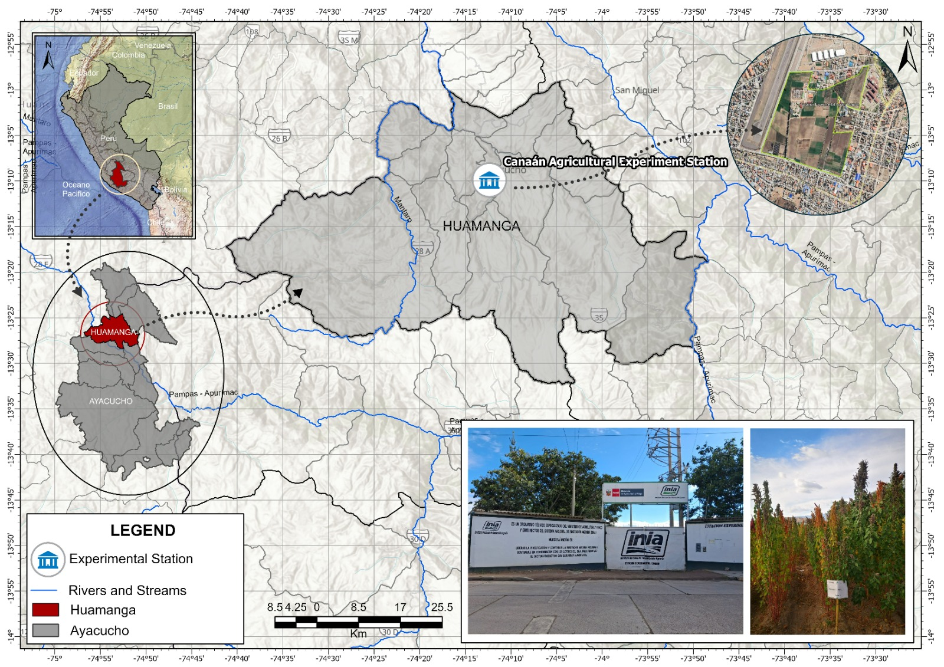
Figure 1. Location of the experimental site at the Canaán Agricultural Experimental Station of the National Institute for Agrarian Innovation (INIA), Andrés Avelino Cáceres Dorregaray district, Huamanga Province, Ayacucho, Peru (13°10′02″ S, 74°12′26″ W; 2,735 m a.s.l.). Insets show the position of Peru in South America, Huamanga Province within the Ayacucho Department, and a satellite view of the station. Photographs show the station entrance and the quinoa field trial during the 2022–2023 growing season.
During this period, the mean temperature was 17.7 °C, with minimum and maximum temperatures of 9.9 and 24.8 °C, respectively, while annual precipitation reached 475.27 mm. Monthly precipitation peaked in March 2023 at approximately 160 mm, followed by a gradual decline to nearly zero between June and November. During the period from December 2022 to November 2023, maximum temperatures ranged from 22 to 27 °C, mean temperatures from 16 to 19 °C, and minimum temperatures from 6 to 12 °C (Figure 2; Supplementary Table 1) .

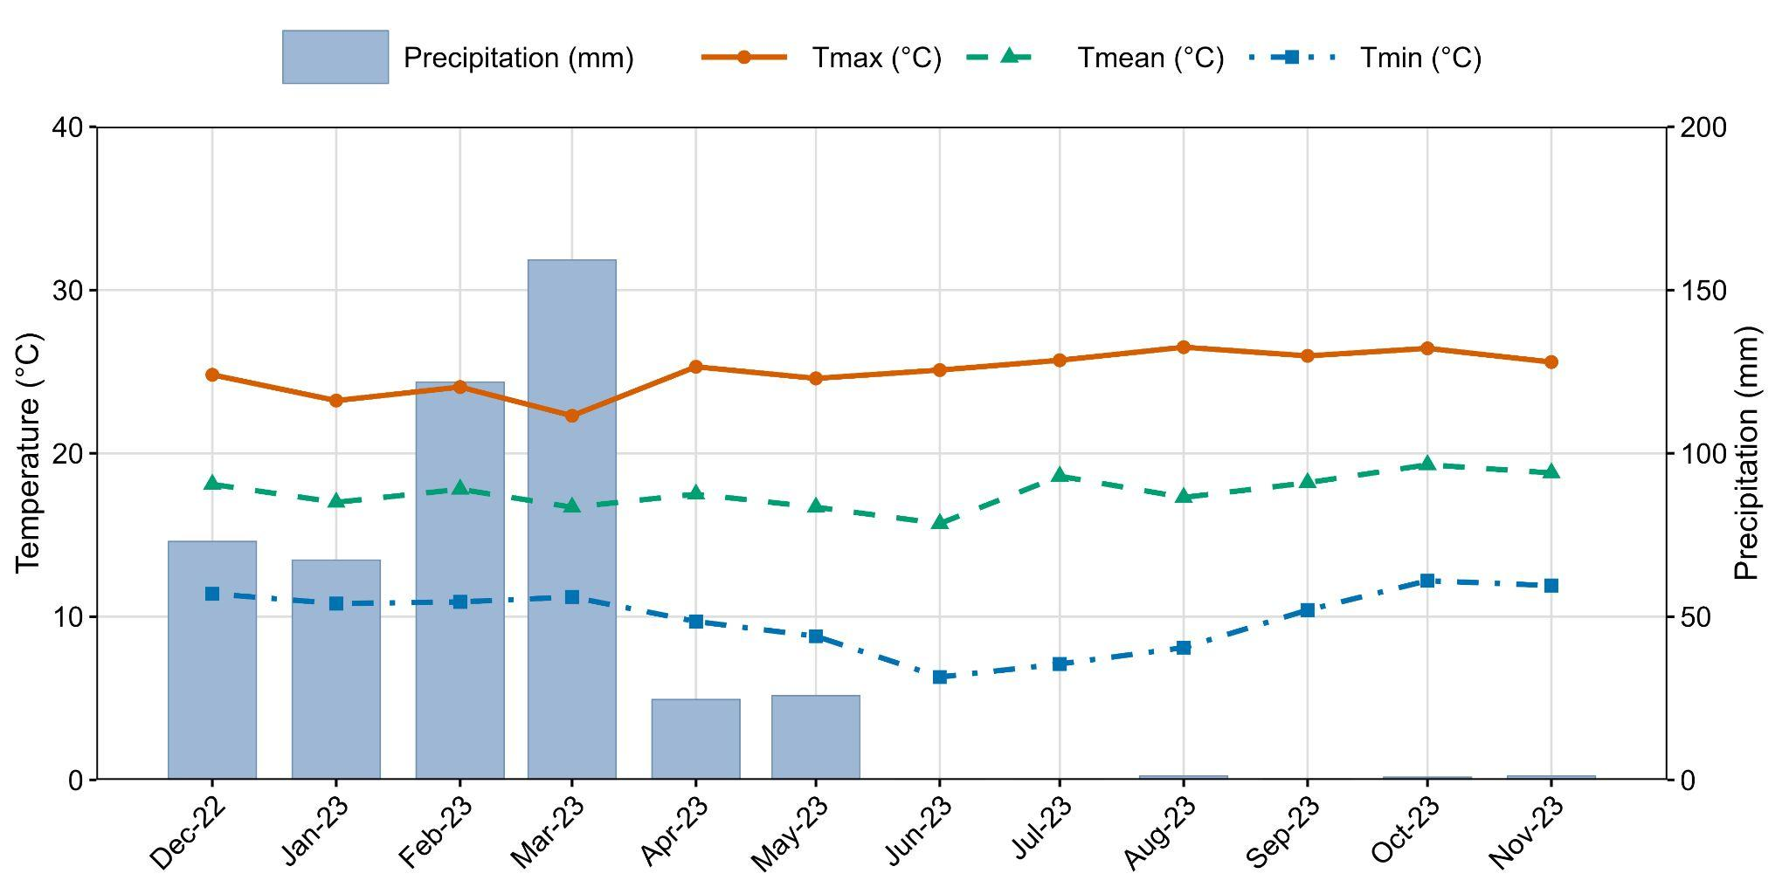
Figure 2. Monthly climatic conditions at the Canaán Agricultural Experimental Station (2,735 m a.s.l.), Ayacucho, Peru, from December 2022 to November 2023, covering the quinoa growing season (December 2022–August 2023). Bars represent monthly precipitation (mm; right axis), and lines represent maximum (Tmax), mean (Tmean), and minimum (Tmin) air temperatures (°C; left axis).

Biological material
A total of 144 quinoa accessions maintained in the Germplasm Bank of the Laboratory of Plant Genetics and Biotechnology, Professional School of Agronomy, National University of San Cristóbal de Huamanga (UNSCH), Ayacucho, Peru, were evaluated. These accessions were collected from Ayacucho, Cusco, Apurímac, and Huancayo. Details on the identification and geographical origin of each accession are provided in Supplementary Table S2.

Field trials and management
The 144 accessions were evaluated in a 12 × 12 simple lattice design with two replications. Each experimental plot measured 3.0 × 2.4 m and consisted of three rows spaced 0.80 m apart. Seeds were sown at a rate of 10 kg ha⁻¹, with a plant density of 20 plants per linear meter.
Field preparation included plowing, harrowing, and mechanized furrow formation. Fertilizers were applied at rates of 80 kg ha⁻¹ of nitrogen (N), 80 kg ha⁻¹ of phosphorus pentoxide (P₂O₅), and 40 kg ha⁻¹ of potassium oxide (K₂O), using urea, diammonium phosphate, and potassium chloride as fertilizer sources. Carbendazim- and mancozeb-based fungicides were applied to control downy mildew caused by Peronospora variabilis. Plants were harvested at physiological maturity, and the harvested material was dried in a drying tunnel, threshed, and cleaned to obtain the grain samples for evaluation.

Morphological characterization
Morphological characterization was performed following the descriptors for quinoa (Chenopodium quinoa Willd.) and its wild relatives established by Bioversity International et al. (2013). A total of 41 descriptors were recorded at the vegetative growth, flowering, and physiological maturity stages and grouped into qualitative or quantitative traits (Supplementary Table S3).
Qualitative descriptors included plant growth density (PLD), growth type (GT), growth habit (GH), main stem shape (SMS), main stem color (MSC), presence of pigmented axils (PPA), presence of stem striations (PST), striation color (STC), presence of branching (PB), primary branch position (PPB), leaf shape (LS), leaf margin (LM), petiole color (PC), leaf blade color (LLC), leaf granule color (LGC), male sterility (MST), panicle color at flowering (PCF) and physiological maturity (PCPM), panicle shape (PS), panicle density (PD), degree of shattering (DH), perigonium appearance (PA), perigonium color (PGC), pericarp appearance (PCA), pericarp color (PCC), episperm appearance (EA), episperm color (EC), and grain shape (GS).
Quantitative descriptors included percentage of lodged plants (LOD; %), number of primary branches (NPB; count), number of leaf teeth (NLT; count), petiole length (PTL; cm), maximum leaf length (MLL; cm), maximum leaf width (MLW; cm), grain yield per plant (SYP; g plant⁻¹), plant height (PH; cm), stem diameter (SD; mm), panicle length (PLr; cm), panicle diameter (PDr; cm), grain diameter (GD; mm), and thousand-grain weight (TSW; g). To reduce border effects, observations were taken from plants in the central row of each experimental unit. Ten plants per experimental unit were evaluated for individual plant measurements.

Statistical analysis
All statistical analyses and the preparation of figures and tables were performed in R v4.6.1 (R Core Team, 2026). Diversity among qualitative traits was estimated using 28 descriptors, considering the number of accessions in each class (Na), the number of observed classes (Nc), and their relative frequencies (fi). These frequencies were used to calculate the effective number of classes (Ne), Nei's diversity index (He; Nei, 1987) (He), and the Shannon–Weaver diversity index (H′; Shannon & Weaver, 1949). Standard errors and 95% confidence intervals were estimated for each index using 2,000 bootstrap resamples, and mean values were calculated across the 28 descriptors.
The 13 quantitative traits were analyzed using linear mixed-effects models implemented through the H2cal() function in the inti package v0.7.6 (Lozano-Isla et al., 2026), which relies on lme4 (Bates et al., 2015). The following model was fitted separately for each trait:
where $y$ represents the observed trait value, and block, sub-block, and geno represent the random effects of block, sub-block, and genotype, respectively. Variance components were used to estimate repeatability, while the best linear unbiased estimates (BLUEs) for each accession were used to calculate the mean, minimum and maximum values, and coefficient of variation for each trait.
Five multi-trait selection methods were applied to the BLUEs of grain yield (SYP), thousand-grain weight (TSW), plant height (PH), and stem diameter (SD) of the 144 accessions. For the index-based methods, traits were rescaled to a 0–1 scale so that higher values are always better; PH was first penalized by its distance to an optimal range (P25–P75) and then inverted. The 14 highest-ranked accessions per method, corresponding to approximately 10% of the accessions evaluated, were selected. Principal component analysis (PCA) was performed on the standardized BLUEs of the four traits using PCA() from FactoMineR v2.17 (Lê et al., 2008); and the PC1 score, oriented so that SYP loaded positively, was used as the selection score. The Elston index was calculated with elston() from st4gi v2.2.2 (Eyzaguirre & Okola, 2026); using SYP and PH. The Mulamba–Mock index was obtained by ranking accessions for each trait with rank() from base R (Wright & Ziegler, 2017); and combining the ranks as a weighted sum. The distance to the ideotype was calculated as the weighted Euclidean distance between each accession and an ideotype with the maximum value for SYP, TSW and SD and the optimal range for PH. In both the Mulamba–Mock index and the ideotype distance, relative weights of 3, 2, 1 and 1 were assigned to SYP, TSW, PH and SD (normalized weights: 0.43, 0.29, 0.14 and 0.14), prioritizing yield and its main components. Finally, Random Forest was implemented using ranger() with 2,000 trees, default mtry, and a fixed seed (123), modeling SYP (response) as a function of TSW, PH and SD (predictors); the out-of-bag (OOB) prediction of SYP for each accession was used as its selection score, and variable importance was assessed by permutation. Pearson’s correlation coefficients among method scores were calculated using cor() from base R and visualized using pairs.panels() from psych v2.6.9 (William Revelle, 2026). Overlap among selected accessions was examined through set intersection, and selection differentials were calculated as standardized differences in means. Consensus was defined as an accession being selected by at least three methods.

RESULTS

Agromorphological variability of quinoa germplasm

Phenotypic diversity of qualitative traits
To identify the morphological traits showing the greatest variation among quinoa accessions, phenotypic diversity was assessed using 28 qualitative descriptors. The mean diversity indices were 0.49 ± 0.04 for Nei's index (He) and 0.89 ± 0.10 for the Shannon–Weaver index (H′). The highest values for both indices were observed for panicle color at physiological maturity (He = 0.86 ± 0.01; H′ = 2.14 ± 0.06), followed by perigonium color (He = 0.84 ± 0.02; H′ = 2.12 ± 0.08) and pericarp color (He = 0.75 ± 0.03; H′ = 1.72 ± 0.08) (Table 1). Yellow was the predominant panicle color at physiological maturity, while cream and pink were the most frequent perigonium colors, and cream predominated in the pericarp (Figure 3, Supplementary Table 4 ).
Episperm color also showed relatively high diversity (He = 0.69 ± 0.03; H′ = 1.49 ± 0.08), with white being the most frequent color. Similar values were recorded for main stem color (He = 0.69 ± 0.03; H′ = 1.44 ± 0.07), with yellow predominating (Supplementary Table 4). Among traits not associated with coloration, plant growth density had the highest Nei's diversity index (He = 0.65 ± 0.01). In contrast, the lowest diversity was observed for the presence of stem striations (He = 0.03 ± 0.02; H′ = 0.07 ± 0.04) and the presence of branching (He = 0.07 ± 0.03; H′ = 0.15 ± 0.05) (Table 1).
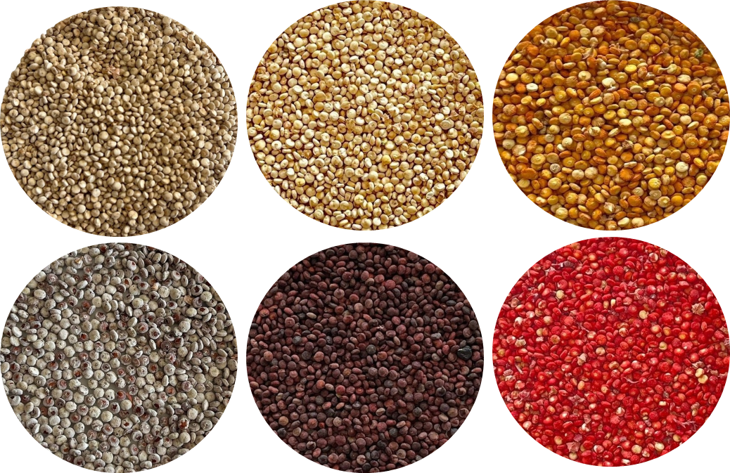
Figure 3. Representative variation in grain color among quinoa accessions from the UNSCH germplasm collection evaluated in Ayacucho, Peru. Top row, from left to right: cream, pale yellow, and golden yellow-orange grains; bottom row: white grains with reddish spots, dark reddish-brown grains, and red grains.

Table 1. Number of observed classes, effective number of classes, and Nei's (He) and Shannon–Weaver (H′) phenotypic diversity indices, with bootstrap standard errors and 95% confidence intervals, for 28 qualitative traits evaluated in 144 quinoa accessions in Ayacucho, Peru.
Qualitative trait | Nc | Ne | He ± SE | He 95% CI | H′ ± SE | H′ 95% CI
Planting density | 3 | 2.84 | 0.65 ± 0.01 | 0.61–0.66 | 1.07 ± 0.02 | 1.02–1.09
Growth type | 2 | 1.96 | 0.49 ± 0.01 | 0.46–0.50 | 0.68 ± 0.01 | 0.65–0.69
Growth habit | 4 | 1.46 | 0.32 ± 0.05 | 0.22–0.40 | 0.60 ± 0.07 | 0.43–0.73
Main stem shape | 2 | 1.98 | 0.49 ± 0.01 | 0.47–0.50 | 0.69 ± 0.01 | 0.66–0.69
Main stem color | 7 | 3.18 | 0.69 ± 0.03 | 0.62–0.74 | 1.44 ± 0.07 | 1.27–1.55
Presence of pigmented axils | 3 | 1.86 | 0.46 ± 0.04 | 0.38–0.53 | 0.78 ± 0.06 | 0.65–0.87
Presence of stem striations | 2 | 1.03 | 0.03 ± 0.02 | 0.00–0.07 | 0.07 ± 0.04 | 0.00–0.15
Striation color | 4 | 2.26 | 0.56 ± 0.02 | 0.51–0.59 | 0.91 ± 0.05 | 0.80–1.00
Presence of branching | 2 | 1.07 | 0.07 ± 0.03 | 0.01–0.13 | 0.15 ± 0.05 | 0.04–0.25
Primary branch position | 2 | 1.18 | 0.15 ± 0.04 | 0.08–0.23 | 0.29 ± 0.06 | 0.17–0.39
Leaf shape | 2 | 1.91 | 0.48 ± 0.02 | 0.42–0.50 | 0.67 ± 0.02 | 0.62–0.69
Leaf margin | 3 | 1.68 | 0.40 ± 0.04 | 0.31–0.49 | 0.73 ± 0.06 | 0.59–0.85
Petiole color | 3 | 1.6 | 0.37 ± 0.04 | 0.28–0.45 | 0.67 ± 0.07 | 0.53–0.79
Leaf blade color | 2 | 1.56 | 0.36 ± 0.04 | 0.28–0.43 | 0.55 ± 0.04 | 0.45–0.62
Leaf granule color | 4 | 2.9 | 0.65 ± 0.02 | 0.61–0.68 | 1.14 ± 0.04 | 1.04–1.21
Presence of male sterility | 2 | 1.64 | 0.39 ± 0.04 | 0.31–0.45 | 0.58 ± 0.04 | 0.49–0.64
Panicle color at flowering | 4 | 2.51 | 0.60 ± 0.02 | 0.55–0.64 | 1.05 ± 0.06 | 0.93–1.14
Panicle color at physiological maturity | 12 | 6.93 | 0.86 ± 0.01 | 0.82–0.87 | 2.14 ± 0.06 | 1.96–2.21
Panicle shape | 3 | 1.92 | 0.48 ± 0.04 | 0.39–0.55 | 0.84 ± 0.06 | 0.71–0.94
Panicle density | 3 | 2.69 | 0.63 ± 0.02 | 0.58–0.65 | 1.04 ± 0.03 | 0.97–1.08
Degree of dehiscence (shattering) | 3 | 2.39 | 0.58 ± 0.02 | 0.52–0.62 | 0.96 ± 0.04 | 0.86–1.02
Perigonium appearance | 2 | 1.65 | 0.39 ± 0.03 | 0.32–0.45 | 0.58 ± 0.04 | 0.50–0.64
Perigonium color | 14 | 6.21 | 0.84 ± 0.02 | 0.80–0.86 | 2.12 ± 0.08 | 1.92–2.21
Pericarp appearance | 2 | 1.53 | 0.35 ± 0.04 | 0.27–0.41 | 0.53 ± 0.04 | 0.44–0.60
Pericarp color | 11 | 4.01 | 0.75 ± 0.03 | 0.69–0.79 | 1.72 ± 0.08 | 1.52–1.83
Episperm appearance | 2 | 1.55 | 0.35 ± 0.04 | 0.28–0.42 | 0.54 ± 0.04 | 0.45–0.61
Episperm color | 8 | 3.18 | 0.69 ± 0.03 | 0.62–0.73 | 1.49 ± 0.08 | 1.30–1.61
Grain shape | 3 | 2.34 | 0.57 ± 0.02 | 0.52–0.61 | 0.94 ± 0.04 | 0.84–1.00
Mean ± SE | 4.07 ± 0.62 | 2.39 ± 0.26 | 0.49 ± 0.04 | 0.41–0.57 | 0.89 ± 0.10 | 0.69–1.09

Note. Nc = number of observed classes; Ne = effective number of classes; He = Nei's diversity index; H′ = Shannon–Weaver diversity index; SE = standard error; CI = confidence interval. Standard errors and 95% confidence intervals were estimated using 2,000 bootstrap resamples.

Variability of quantitative traits
To characterize differences in growth, morphology, and yield among the 144 quinoa accessions, variation was assessed across 13 quantitative traits. The highest coefficients of variation were recorded for the percentage of lodged plants (CV = 104.26%) and grain yield per plant (CV = 92.04%). Lodging ranged from 0 to 68.37%, with a mean of 11.43%, while grain yield per plant ranged from 2.85 to 146.94 g, with a mean of 26.33 g. Considerable variation was also observed in stem diameter (mean = 11.42 mm; range = 4.20–26.56 mm), plant height (mean = 124.69 cm; range = 58.51–197.62 cm), and panicle length (mean = 41.69 cm; range = 13.45–80.45 cm). Among grain-related traits, thousand-grain weight averaged 2.81 g (range = 1.50–4.39 g), whereas grain diameter showed the lowest coefficient of variation (CV = 7.42%), with a mean of 1.93 mm (range = 1.57–2.24 mm) (Table 2).
Repeatability estimates ranged from 0.81 for the percentage of lodged plants to 0.99 for the number of leaf teeth. High repeatability was also recorded for maximum leaf width and thousand-grain weight (0.98 each), grain diameter (0.96), and plant height (0.95). Grain yield per plant, stem diameter, and panicle length showed repeatability estimates of 0.83, 0.93, and 0.84, respectively (Table 2).
Table 2. Mean, minimum, maximum, coefficient of variation (CV), and repeatability of 13 quantitative traits evaluated in 144 quinoa accessions in Ayacucho, Peru, during the 2022–2023 growing season. Descriptive statistics were calculated from the best linear unbiased estimates (BLUEs) of each accession.
Quantitative trait | Mean | Min | Max | CV(%) | Repeatability
Percentage of lodged plants (%) | 11.43 | 0 | 68.37 | 104.26 | 0.81
Number of primary branches | 13.61 | 4.68 | 32.66 | 37.19 | 0.85
Number of leaf teeth | 9.56 | 1.09 | 23.64 | 52.4 | 0.99
Petiole length (cm) | 4.27 | 2.03 | 7.04 | 25.86 | 0.95
Maximum leaf length (cm) | 6.32 | 3.66 | 9.5 | 21.8 | 0.94
Maximum leaf width (cm) | 5.37 | 1.59 | 9.68 | 30.12 | 0.98
Seed yield per plant (g/plant) | 26.33 | 2.85 | 146.94 | 92.04 | 0.83
Plant height (cm) | 124.69 | 58.51 | 197.62 | 24.48 | 0.95
Stem diameter (mm) | 11.42 | 4.2 | 26.56 | 40.19 | 0.93
Panicle length (cm) | 41.69 | 13.45 | 80.45 | 27.33 | 0.84
Panicle diameter (cm) | 10.65 | 3.25 | 25.7 | 52.44 | 0.86
Grain diameter (mm) | 1.93 | 1.57 | 2.24 | 7.42 | 0.96
Thousand-grain weight (g) | 2.81 | 1.5 | 4.39 | 20.67 | 0.98
Note. Mean = mean value; Min = minimum value; Max = maximum value; CV = coefficient of variation.

Comparison of multi-trait selection methods
Because multi-trait selection methods differ in their statistical foundations, the same germplasm collection may yield different sets of promising accessions depending on the criterion applied. To determine whether the five methods prioritized the same quinoa accessions and favored similar combinations of agronomic traits, they were compared based on the overlap among the 14 accessions selected by each method (Figure 4).
The major overlap occurred between PCA and ideotype distance, with nine accessions selected by both methods. PCA and Random Forest shared seven accessions, while the other method combinations had between one and eight accessions in common (Figure 4 A). Selection differentials differed across methods and traits (Figure 4 B). Ideotype distance produced the highest differential for grain yield per plant (SYP; 2.22), while PCA showed the highest values for plant height (PH; 1.55) and stem diameter (SD; 1.75), along with a differential of 1.84 for SYP. The Mulamba–Mock index yielded the highest differential for thousand-grain weight (TSW; 1.14), compared with 0.27 for PCA and 0.43 for ideotype distance. Random Forest showed positive differentials for SYP (1.31), PH (1.48), and SD (1.36), but a negative differential for TSW (−0.09). Similarly, the Elston index produced positive differentials for SYP (1.73), PH (0.63), and SD (0.70), while TSW showed a negative value (−0.10).
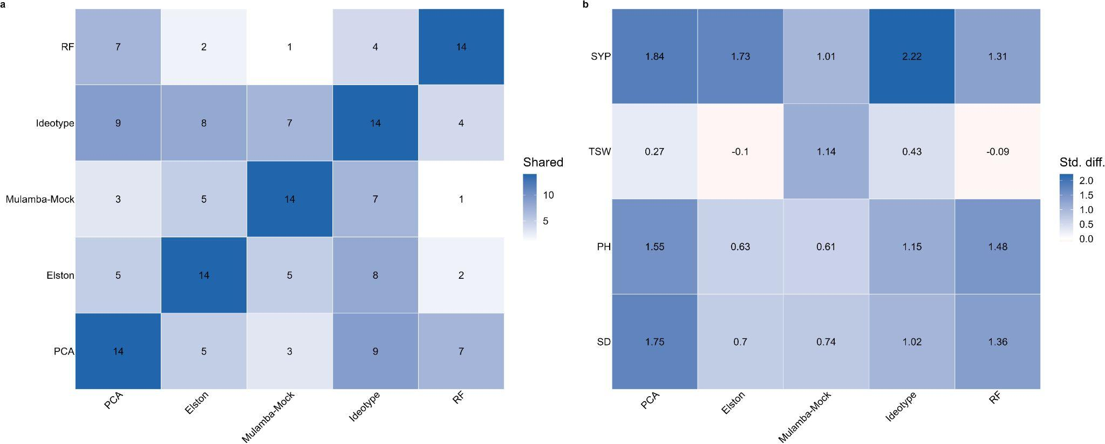
Figure 4. Agreement and expected trait gains among five multi-trait selection methods applied to 144 quinoa accessions. (A) Number of accessions shared between pairs of methods among the 14 accessions (10%) selected by each method; diagonal values indicate the total number of accessions selected per method. (B) Standardized selection differentials for grain yield per plant (SYP), thousand-grain weight (TSW), plant height (PH), and stem diameter (SD) obtained with each method. PCA, principal component analysis; RF, Random Forest.
Twelve accessions were selected by at least three of the five methods and were classified as consensus accessions (Table 3). Of these, UNSCH-126-2013, UNSCH-287-2022, and UNSCH-83-2013 were selected by four methods. The remaining nine accessions (UNSCH-1-2013, UNSCH-10-2013, UNSCH-125-2013, UNSCH-129-2013, UNSCH-25-2013, UNSCH-56-2013, UNSCH-57-2013, UNSCH-61-2013, and UNSCH-72-2013) were identified by three methods. Ideotype distance selected 11 of the 12 consensus accessions, followed by PCA with nine.
Grain yield among the consensus accessions ranged from 45.64 g per plant in UNSCH-10-2013 to 146.94 g per plant in UNSCH-61-2013. Plant height ranged from 115.19 cm in UNSCH-1-2013 to 191.56 cm in UNSCH-61-2013, and TSW from 2.40 g in UNSCH-72-2013 to 4.05 g in UNSCH-125-2013. Three accessions (UNSCH-1-2013, UNSCH-10-2013, and UNSCH-125-2013) had TSW values above 3.00 g but grain yields below 55 g per plant. By comparison, UNSCH-56-2013, UNSCH-57-2013, and UNSCH-61-2013 had grain yields between 80.78 and 146.94 g per plant, with TSW values ranging from 2.72 to 2.86 g. UNSCH-61-2013 had the highest grain yield in the collection, while UNSCH-287-2022 recorded the greatest panicle length.
The 14 accessions listed also differed in their qualitative traits (Table 3). Pericarp color was cream in six accessions (43%), golden yellow in five (36%), yellow in two (14%), and light brown in one (7%; UNSCH-287-2022) (Supplementary Figure 1a). Panicle density was intermediate or compact in five accessions each (36%), and lax in four (29%) (Supplementary Figure 1b). Nine accessions (64%) had a simple growth habit, four (29%; UNSCH-1-2013, UNSCH-10-2013, UNSCH-56-2013, and UNSCH-287-2022) showed branching up to the second third, and one (7%; UNSCH-25-2013) had an undefined main panicle (Supplementary Figure 1c). Glomerulate panicles were recorded in nine accessions (64%), amaranthiform panicles in four (29%; UNSCH-25-2013, UNSCH-61-2013, UNSCH-70-2013, and UNSCH-218-2015), and an intermediate panicle shape in one (7%; UNSCH-1-2013) (Supplementary Figure 1d). UNSCH-61-2013, the accession with the highest grain yield, had a golden-yellow pericarp, compact panicle density, simple growth habit, and amaranthiform panicle shape (Supplementary Table S5).
Table 3. Selection frequency and agronomic performance of the 14 quinoa accessions most frequently selected by five multi-trait selection methods, showing the methods that selected each accession and the BLUEs for grain yield per plant (SYP; g plant⁻¹), thousand-grain weight (TSW; g), plant height (PH; cm), and stem diameter (SD; mm).
Accession | N | PCA | Elston | Mulamba-Mock | Ideotype | RF | SYP | TSW | PH | SD
UNSCH-287-2022 | 4 | ✓ | ✓ | ✓ | ✓ |  | 108.87 | 2.87 | 148.86 | 13.14
UNSCH-83-2013 | 4 | ✓ | ✓ |  | ✓ | ✓ | 71.92 | 2.79 | 162.65 | 17.11
UNSCH-126-2013 | 4 | ✓ | ✓ | ✓ | ✓ |  | 90.81 | 3.14 | 141.07 | 16.9
UNSCH-57-2013 | 3 | ✓ |  |  | ✓ | ✓ | 80.78 | 2.86 | 172.77 | 19.58
UNSCH-125-2013 | 3 | ✓ |  | ✓ | ✓ |  | 54.07 | 4.05 | 160.19 | 21.55
UNSCH-129-2013 | 3 |  | ✓ | ✓ | ✓ |  | 61.8 | 2.94 | 150.23 | 16.03
UNSCH-25-2013 | 3 | ✓ | ✓ |  | ✓ |  | 83.99 | 2.47 | 169.42 | 19.06
UNSCH-72-2013 | 3 | ✓ | ✓ |  |  | ✓ | 71.23 | 2.4 | 167.13 | 18.41
UNSCH-61-2013 | 3 | ✓ |  |  | ✓ | ✓ | 146.94 | 2.72 | 191.56 | 21.32
UNSCH-10-2013 | 3 |  | ✓ | ✓ | ✓ |  | 45.64 | 3.67 | 142.31 | 12.39
UNSCH-56-2013 | 3 | ✓ |  |  | ✓ | ✓ | 100 | 2.72 | 188.48 | 16.92
UNSCH-1-2013 | 3 |  | ✓ | ✓ | ✓ |  | 49.05 | 3.49 | 115.19 | 12.74
UNSCH-70-2013 | 2 |  |  | ✓ |  | ✓ | 41.34 | 3.13 | 150.45 | 16.7
UNSCH-218-2015 | 2 |  |  | ✓ | ✓ |  | 55.55 | 3.4 | 170.31 | 13.13
Note. N indicates the number of selection methods that identified each accession. The methods included the Elston index, the Mulamba–Mock index, principal component analysis (PCA), ideotype distance, and Random Forest (RF). The table presents the 14 accessions selected by at least two methods (N ≥ 2), including all consensus accessions (N ≥ 3) and the two accessions with N = 2. SYP: grain yield; TSW: thousand-grain weight; PH: plant height; SD: stem diameter.
Pearson correlations among the five selection methods were positive and significant (p < 0.001), with coefficients ranging from 0.37 to 0.91 (Figure 5). Mulamba–Mock and ideotype distance had the strongest correlation (r = 0.91), followed by PCA and Random Forest (r = 0.87), PCA and ideotype distance (r = 0.86), and Elston and ideotype distance (r = 0.81). The lowest correlations were found between Elston and Random Forest (r = 0.37), Mulamba–Mock and Random Forest (r = 0.55), and PCA and Elston (r = 0.60). Elston and Random Forest scores had more positively skewed distributions, while Mulamba–Mock scores were spread over a wider range (Figure 5).
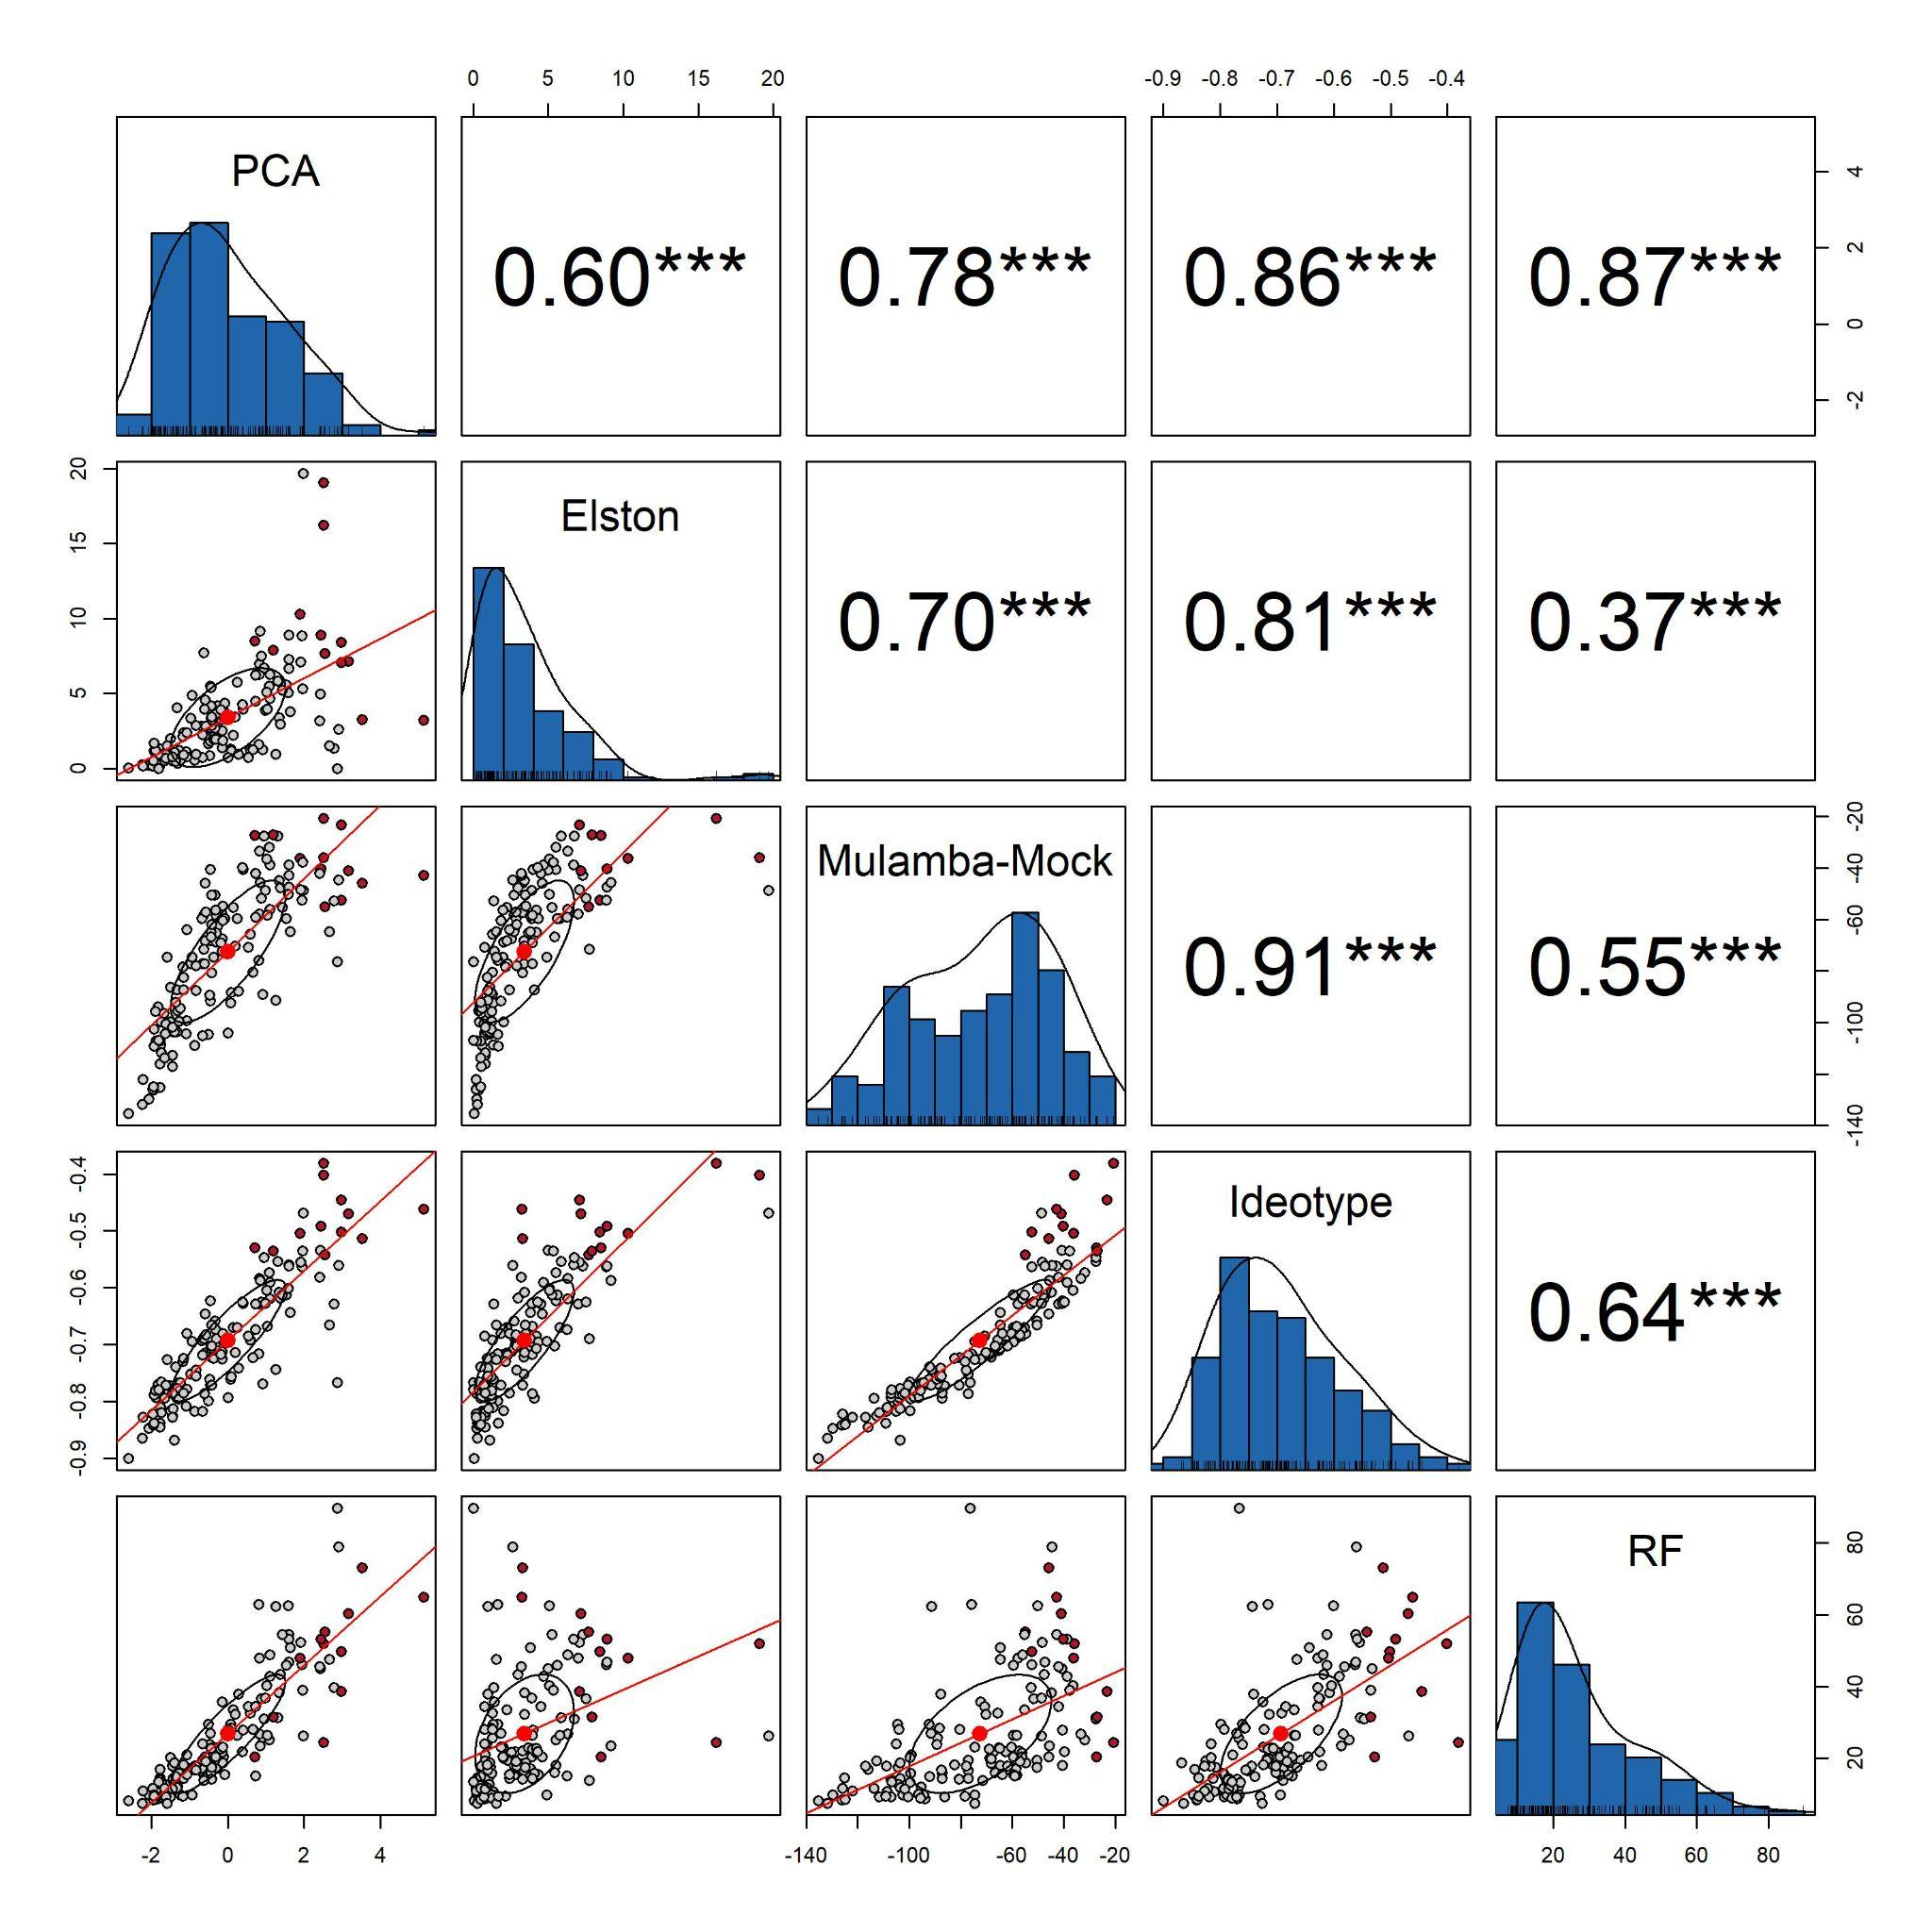
Figure 5. Distribution of and relationships among selection scores of 144 quinoa accessions obtained with five multi-trait selection methods: principal component analysis (PCA), Elston index, Mulamba–Mock index, ideotype distance, and Random Forest (RF). Diagonal histograms show the distribution of scores for each method; scatterplots in the lower triangle show pairwise relationships, with consensus accessions (selected by at least three methods) shown as red points; values in the upper triangle are Pearson correlation coefficients. Asterisks indicate statistical significance (p < 0.001).

DISCUSSION
Quinoa germplasm banks conserve a large share of the genetic diversity of the crop, but this diversity becomes useful for breeding only when accessions are characterized and prioritized using breeding criteria (Ruiz et al., 2014; Zurita-Silva et al., 2014). This study combined the phenotypic characterization of 144 accessions conserved at UNSCH with a comparison of five multi-trait selection methods under the conditions of the inter-Andean valley of Ayacucho. The results show that the collection is diverse, mainly in pigmentation and yield-related traits, and that the choice of selection method changes which accessions are prioritized. Nevertheless, a small group of accessions was consistently identified regardless of the method used, providing a practical starting point for the use of this germplasm in breeding.

Phenotypic diversity of the quinoa germplasm collection
The collection showed intermediate diversity in qualitative traits; traits related to color, especially of the panicle at maturity, the perigonium, and the pericarp, concentrated most of the variation, whereas traits describing plant architecture, such as stem striations and branching, were almost uniform across accessions (Table 1; Figure 3). Among quantitative traits, grain yield per plant and lodging varied the most, while grain size remained comparatively stable. Most quantitative traits also showed high repeatability, indicating that differences among accessions were consistent between replications and were mainly attributable to the accessions rather than to experimental error (Table 2).
The predominance of color traits in the phenotypic diversity agrees with characterizations of Andean collections in Ecuador, Colombia, and Peru, where panicle and grain color were among the most polymorphic descriptors (Manjarres-Hernández et al., 2021; Delgado et al., 2024; Baldera-Chapoñan et al., 2025). Pigmentation in quinoa is associated with the betalain pathway, for which candidate regulatory genes have been identified in the quinoa genome (Jarvis et al., 2017). In addition, Andean farmers have historically maintained grain and panicle colors according to local preferences and uses (Ruiz et al., 2014). Both factors help explain why color classes remain highly diverse within local collections. In contrast, the low diversity observed for architecture traits suggests that most accessions share a similar plant structure, possibly reflecting farmer selection for plants with a well-defined main panicle that facilitates harvest.
The wide range of grain yield per plant is consistent with other germplasm evaluations in which yield was the most variable agronomic trait (Bhargava et al., 2007; Craine et al., 2023). Yield is a complex trait that integrates plant growth, panicle development, and grain filling, and it is strongly influenced by the environment (Bertero et al., 2004; Vásquez et al., 2024). The large variation in lodging may be related to differences in plant height and stem robustness, since tall plants with heavy panicles are more prone to falling. On the other hand, the low variation in grain diameter agrees with previous reports describing grain size as a relatively stable trait in quinoa (Bertero et al., 2004). The high repeatability of most traits indicates that the estimated values are reliable for ranking accessions within this environment, which supports their use as input for multi-trait selection.

Agreement and divergence among multi-trait selection methods
The five methods agreed in general terms, since all selection scores were positively correlated, but they did not select the same accessions (Figure 4A; Figure 5). Ideotype distance showed the greatest agreement with the other methods, sharing many accessions with PCA and showing the strongest association with the Mulamba–Mock index, whereas the Elston index and Random Forest produced the most distinct rankings. Each method also favored a different trait profile; some mainly increased yield and plant size, while the Mulamba–Mock index gave more weight to grain weight (Figure 4B). Despite these differences, twelve accessions were selected by most methods, which makes them robust candidates for further evaluation (Table 3).
These differences reflect how each method defines a superior accession. PCA ranks accessions along the main axis of variation, which in this collection was probably dominated by yield, plant height, and stem diameter, and therefore favored large and vigorous plants (Jolliffe & Cadima, 2016). The Mulamba–Mock index sums the ranks of all traits and gives them equal importance, which explains why it was the only method that markedly improved thousand-grain weight (Mulamba & Mock, 1978). Ideotype distance rewards accessions that approach the best value for all traits simultaneously, resulting in the highest gain in yield and an intermediate position relative to the other methods (Olivoto & Nardino, 2021). The Elston index penalizes accessions with low values in any trait relative to a minimum threshold, making it sensitive to traits with limited variation (Elston, 1963). Random Forest, depends on the response variable used for training and captures nonlinear relationships, so its rankings follow the traits that best predict that response rather than a balanced profile (Breiman, 2001). Similar discrepancies among selection indices have been reported in quinoa and other crops, where the choice of index modified both the selected genotypes and the expected genetic gains (Olivoto & Nardino, 2021; Ahmed et al., 2023, Lozano-Isla et al, 2023).
The negative gains in thousand-grain weight obtained with the Elston index and Random Forest reveal a trade-off between yield and grain size. Within the consensus group, the highest yielding accessions had intermediate grain weight, whereas accessions with heavier grains yielded less (Table 3). This pattern is common in quinoa, in which yield depends more on the number of grains produced than on their individual weight (Bertero et al., 2004; Vásquez et al., 2024). For this reason, combining several methods and retaining the accessions selected by most of them reduces the dependence on a single criterion and provides a more robust basis for germplasm prioritization. Accessions UNSCH-126-2013, UNSCH-287-2022, and UNSCH-83-2013 combined high yield, adequate grain weight, and vigorous plants, whereas UNSCH-61-2013 stood out for its yield potential and could be used as a parent in crosses aimed at increasing productivity.

Limitations and perspectives
This study was conducted at a single location during one growing season; therefore, the results describe the performance of the accessions under the conditions of Ayacucho and do not allow the genotype × environment interaction to be estimated. Because quinoa shows interaction with the environment for yield and grain size (Bertero et al., 2004), the consensus accessions should be validated in multi-environment and multi-year trials before being recommended. In addition, the repeatability estimated here reflects consistency between replications within one environment and may overestimate the heritability expected across environments. The multi-trait selection was based on four traits with equal importance; incorporating phenology, tolerance to downy mildew, and grain quality attributes such as saponin and protein content would better represent breeding objectives (Zurita-Silva et al., 2014; Stanschewski et al., 2021). Finally, combining phenotypic data with molecular markers would help determine whether the phenotypic diversity observed reflects genetic diversity and would support the design of crosses among complementary accessions (De La Cruz et al., 2025). Despite these limitations, to our knowledge, this is the first study in quinoa to compare multivariate selection methods that include a machine learning approach such as Random Forest alongside classical selection indices. This comparison provides a methodological basis for future germplasm evaluations and for integrating machine learning tools into quinoa breeding programs.

CONCLUSIONS
The 144 quinoa accessions of the UNSCH germplasm collection exhibited substantial phenotypic diversity under the environmental conditions of Ayacucho, Peru, particularly in pigmentation traits such as panicle color at physiological maturity, perigonium color, and pericarp color. Grain yield per plant and lodging showed the greatest variability among quantitative traits, while the high repeatability estimates for most traits indicated consistent phenotypic differences that could be exploited in selection. The five multi-trait selection methods produced positively correlated rankings but differed in the accessions prioritized and their associated trait profiles. Ideotype distance showed the greatest agreement with the other methods, whereas the Elston index and Random Forest generated the most distinct rankings and showed limitations in improving thousand-grain weight, suggesting a potential trade-off between grain yield and grain weight. Combining the five methods through a consensus criterion reduced dependence on individual selection approaches and identified twelve promising accessions. Among these, UNSCH-126-2013, UNSCH-287-2022, and UNSCH-83-2013 were selected by four methods, while UNSCH-61-2013 exhibited the highest grain yield per plant. This study provides a comprehensive phenotypic assessment of the UNSCH quinoa germplasm collection and demonstrates the value of integrating conventional multi-trait selection indices with machine learning approaches to identify promising Andean germplasm, supporting its conservation and utilization in quinoa breeding programs.

REFERENCES
Ahmed, S. R., Ali, Z., Ijaz, I., Khan, Z., Gul, N., Pervaiz, S., Alharby, H. F., Tan, D. K. Y., Tariq, M. S., Ghaffar, M., Bibi, A., & Hakeem, K. R. (2023). Multi-Trait Selection of Quinoa Ideotypes at Different Levels of Cutting and Spacing. Sustainability, 15(14), 11446. https://doi.org/10.3390/su151411446
Ain, Q. T., Siddique, K., Bawazeer, S., Ali, I., Mazhar, M., Rasool, R., Mubeen, B., Ullah, F., Unar, A., & Jafar, T. H. (2023). Adaptive mechanisms in quinoa for coping in stressful environments: An update. PeerJ, 11, e14832. https://doi.org/10.7717/peerj.14832
Baldera-Chapoñan, V.-H., De la Cruz, G., Oliva-Cruz, S., & Lozano-Isla, F. (2025). Agromorphological Characterization of Quinoa (Chenopodium quinoa Willd.) Under Andean–Amazonian Region of Peru. Plants, 14(23), 3689. https://doi.org/10.3390/plants14233689
Bates, D., Mächler, M., Bolker, B., & Walker, S. (2015). Fitting Linear Mixed-Effects Models Using lme4. Journal of Statistical Software, 67(1), 1–48. https://doi.org/10.18637/jss.v067.i01
Bioversity International, Food and Agriculture Organization of the United (FAO), Fundación PROINPA, Instituto Nacional de Innovación Agropecuaria y Forestal (INIAF), & International Fund for Agricultural (FIDA). (2013). Descriptores para quinua (Chenopodium quinoa Willd.) y sus parientes silvestres. Bioversity International. https://hdl.handle.net/10568/72610
Breiman, L. (2001). Random Forests. Machine Learning, 45(1), 5–32. https://doi.org/10.1023/A:1010933404324
Checmapocco-Conza, L. E., Huamani-Aymara, F. L., Anculle-Arenas, A., Bustamante-Muñoz, J. L., Jellen, E. N., & Mayta-Anco, M. E. (2026). Characterization and Agromorphological Variation in 27 Accessions of Chenopodium quinoa Within the Arid Coastal Zone of Peru. Plants, 15(8), 1147. https://doi.org/10.3390/plants15081147
Craine, E. B., Davies, A., Packer, D., Miller, N. D., Schmöckel, S. M., Spalding, E. P., Tester, M., & Murphy, K. M. (2023). A comprehensive characterization of agronomic and end-use quality phenotypes across a quinoa world core collection. Frontiers in Plant Science, 14. https://doi.org/10.3389/fpls.2023.1101547
Crossa, J., Pérez-Rodríguez, P., Cuevas, J., Montesinos-López, O., Jarquín, D., Campos, G. de los, Burgueño, J., González-Camacho, J. M., Pérez-Elizalde, S., Beyene, Y., Dreisigacker, S., Singh, R., Zhang, X., Gowda, M., Roorkiwal, M., Rutkoski, J., & Varshney, R. K. (2017). Genomic Selection in Plant Breeding: Methods, Models, and Perspectives. Trends in Plant Science, 22(11), 961–975. https://doi.org/10.1016/j.tplants.2017.08.011
De La Cruz, G., Saldaña, C. L., Menéndez, F., Neyra, E., & Arbizu, C. I. (2025). Microsatellite Markers Determine the Genetic Structure and Diversity of Landraces of Quinoa from Ayacucho, Peru. Agronomy, 15(3), 611. https://doi.org/10.3390/agronomy15030611
Del Pozo, A., Ruf, K., Alfaro, C., Zurita, A., Guerra, F., & Sagredo, B. (2023). Traits associated with higher productivity and resilience to drought-prone Mediterranean environments of coastal-lowland quinoa (Chenopodium quinoa Willd.). Field Crops Research, 299, 108985. https://doi.org/10.1016/j.fcr.2023.108985
Delgado, H., Tapia, C., Manjarres-Hernández, E. H., Borja, E., Naranjo, E., & Martín, J. P. (2024). Phenotypic Diversity of Quinoa Landraces Cultivated in the Ecuadorian Andean Region: In Situ Conservation and Detection of Promising Accessions for Breeding Programs. Agriculture, 14(3), 336. https://doi.org/10.3390/agriculture14030336
Elston, R. C. (1963). A Weight-Free Index for the Purpose of Ranking or Selection with Respect to Several Traits at a Time. Biometrics, 19(1), 85–97. https://doi.org/10.2307/2527573
Eyzaguirre, R., & Okola, B. (2026). st4gi: Statistical tools for genetic improvement. https://github.com/reyzaguirre/st4gi
Jolliffe, I. T., & Cadima, J. (2016). Principal component analysis: A review and recent developments. Philosophical Transactions of the Royal Society A: Mathematical, Physical and Engineering Sciences, 374(2065), 20150202. https://doi.org/10.1098/rsta.2015.0202
Lê, S., Josse, J., & Husson, F. (2008). FactoMineR: A Package for Multivariate Analysis. Journal of Statistical Software, 25(1), 1–18. https://doi.org/10.18637/jss.v025.i01
Lozano-Isla, F., Apaza, J.-D., Mujica Sanchez, A., Blas Sevillano, R., Haussmann, B. I. G., & Schmid, K. (2023). Enhancing quinoa cultivation in the Andean highlands of Peru: A breeding strategy for improved yield and early maturity adaptation to climate change using traditional cultivars. Euphytica, 219(2), 26. https://doi.org/10.1007/s10681-023-03155-8
Lozano-Isla, F., Diaz-Saucedo, Y., Baldera-Chapoñan, V.-H., Kistner, M. B., QuipoLab, & Inkaverse. (2026). inti: Tools and Statistical Procedures in Plant Science. https://CRAN.R-project.org/package=inti
Manjarres-Hernández, E. H., Arias-Moreno, D. M., Morillo-Coronado, A. C., Ojeda-Pérez, Z. Z., & Cárdenas-Chaparro, A. (2021). Phenotypic Characterization of Quinoa (Chenopodium quinoa Willd.) for the Selection of Promising Materials for Breeding Programs. Plants, 10(7), 1339. https://doi.org/10.3390/plants10071339
Matías, J., Rodríguez, M. J., Cruz, V., Calvo, P., Granado-Rodríguez, S., Poza-Viejo, L., Fernández-García, N., Olmos, E., & Reguera, M. (2023). Assessment of the changes in seed yield and nutritional quality of quinoa grown under rainfed Mediterranean environments. Frontiers in Plant Science, 14, 1268014. https://doi.org/10.3389/fpls.2023.1268014
Mulamba, N. N., & Mock, J. J. (1978). Improvement of yield potential of the Eto Blanco maize (Zea mays L.) population by breeding for plant traits. Egyptian Journal of Genetics and Cytology, 7, 40–51.
Nei, M. (1987). Molecular evolutionary genetics. Columbia Univ. Press.
Nepal, N., Condori‐Apfata, J. A., Gaire, R., Anco, M. E. M., Scofield, S., Zhang, C., & Mohammadi, M. (2023). Phenotypic and genotypic resources for the USDA quinoa ( Chenopodium quinoa ) genebank accessions. Crop Science, 63(5), 2685–2698. https://doi.org/10.1002/csc2.21037
Olivoto, T., & Nardino, M. (2021). MGIDI: Toward an effective multivariate selection in biological experiments. Bioinformatics, 37(10), 1383–1389. https://doi.org/10.1093/bioinformatics/btaa981
R Core Team. (2026). R: A Language and Environment for Statistical Computing. R Foundation for Statistical Computing. https://www.R-project.org/
Shannon, C., & Weaver, W. (1949). The Mathematical Theory of Communication. University of Illinois Press.
Stanschewski, C. S., Rey, E., Fiene, G., Craine, E. B., Wellman, G., Melino, V. J., S. R. Patiranage, D., Johansen, K., Schmöckel, S. M., Bertero, D., Oakey, H., Colque-Little, C., Afzal, I., Raubach, S., Miller, N., Streich, J., Amby, D. B., Emrani, N., Warmington, M., … Tester, M. (2021). Quinoa Phenotyping Methodologies: An International Consensus. Plants, 10(9), 1759. https://doi.org/10.3390/plants10091759
Vásquez, S. C., del Pozo, A., Castillo, D., Matus, I., Gómez-Pando, L., Zamudio-Ayala, D., Mignone, C. M., Bertero, H. D., & Calderini, D. F. (2024). The critical period for yield and grain protein determination in quinoa (Chenopodium quinoa Willd.). Field Crops Research, 306, 109207. https://doi.org/10.1016/j.fcr.2023.109207
William Revelle. (2026). psych: Procedures for Psychological, Psychometric, and Personality Research. Northwestern University. https://CRAN.R-project.org/package=psych
Wright, M. N., & Ziegler, A. (2017). ranger: A Fast Implementation of Random Forests for High Dimensional Data in C++ and R. Journal of Statistical Software, 77(1). https://doi.org/10.18637/jss.v077.i01
Zurita-Silva, A., Fuentes, F., Zamora, P., Jacobsen, S.-E., & Schwember, A. R. (2014). Breeding quinoa (Chenopodium quinoa Willd.): Potential and perspectives. Molecular Breeding, 34(1), 13–30. https://doi.org/10.1007/s11032-014-0023-5

