**LINK:** <https://youtu.be/2S1YA5B61tc>

**Project Scope and Overview**

The goal is to continue the exercise from previous module to operationalize the ML Model to ensure consumer access. Like any service (say API) this will have an endpoint. The dataset as previous case will use the bank marketing set. The outcome is to provide a pipeline and pipeline endpoint.

The process involves key steps – creating a model, deploying, and pipeline setup. This is part of module 2 assignment

**Project flow (Architecture)**

Step 1 : Authentication steps : Create a Service principal (exhibit 1)

Step 2: Auto ML experiment: This is same as previous module, (exhibit set 2 A,B, C)

Step 3 : Logging using AppInsight (exhibit set 3)

Step 4: Swagger (Exhibit set 4)

Step 5: Consume Model (Exhibit 5)

Step 6: Create, Publish Pipeline Consume Pipeline. (Exhibit set 7)

Authenticate

Pipeline

Consume

Swagger

Auto ML

AppInsight

Service Principal creation (Exhibit 1)

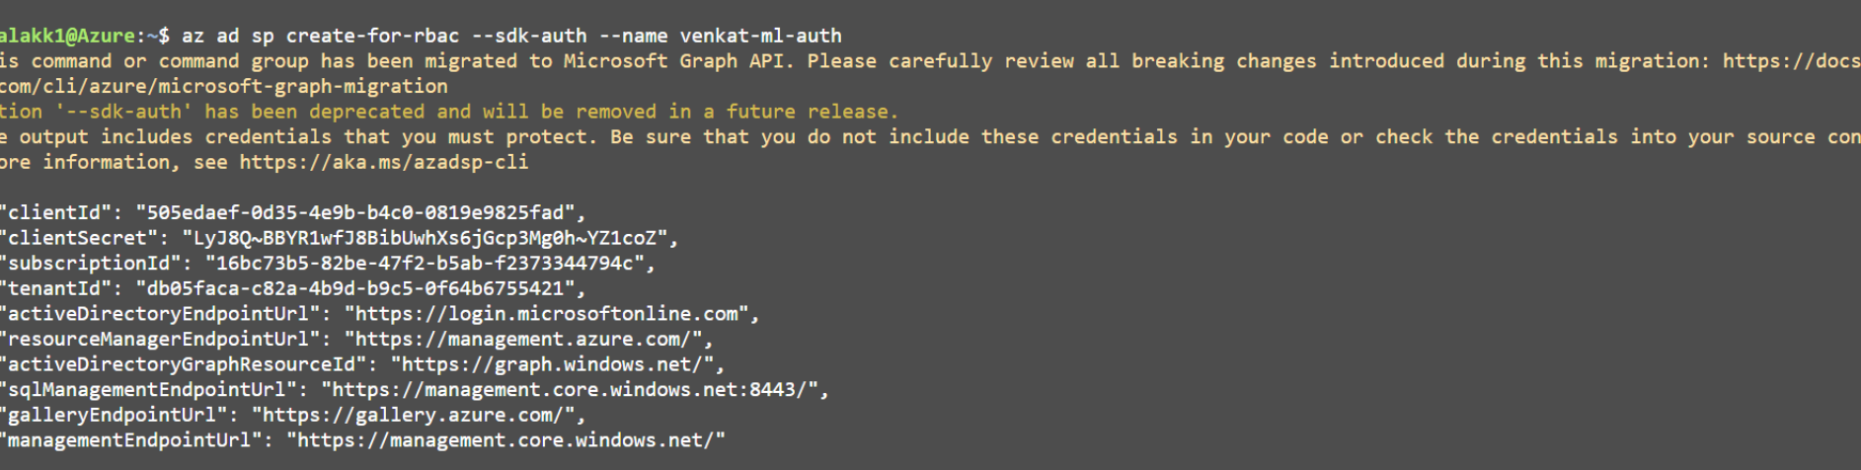

Auto ML setup (Exhibit 2-A) -Data Set

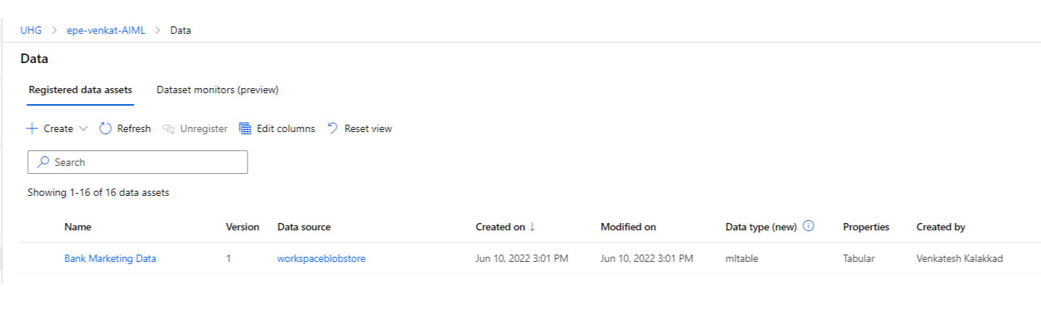

ML Job completed (Exhibit 2B)

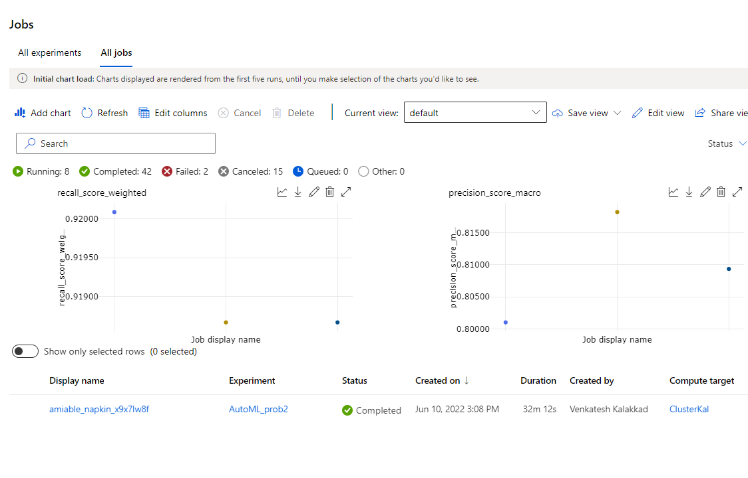

Exhibit 2C Best Model

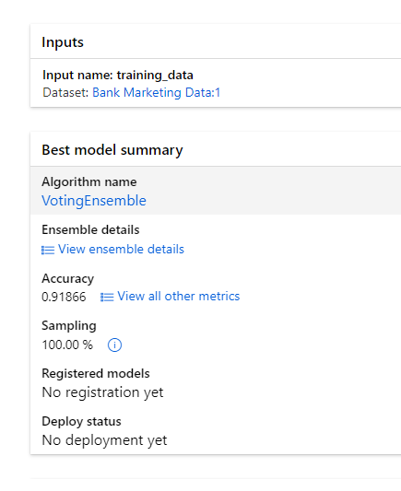

**AppInsight Exhibit 3 A**

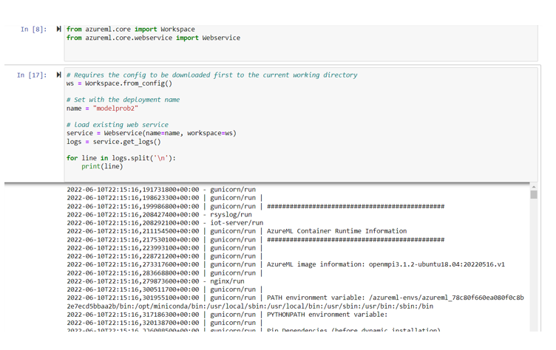

2022-06-10T22:15:16,191731800+00:00 - gunicorn/run

2022-06-10T22:15:16,198623300+00:00 | gunicorn/run |

2022-06-10T22:15:16,199986800+00:00 | gunicorn/run | ###############################################

Exhibit 3B

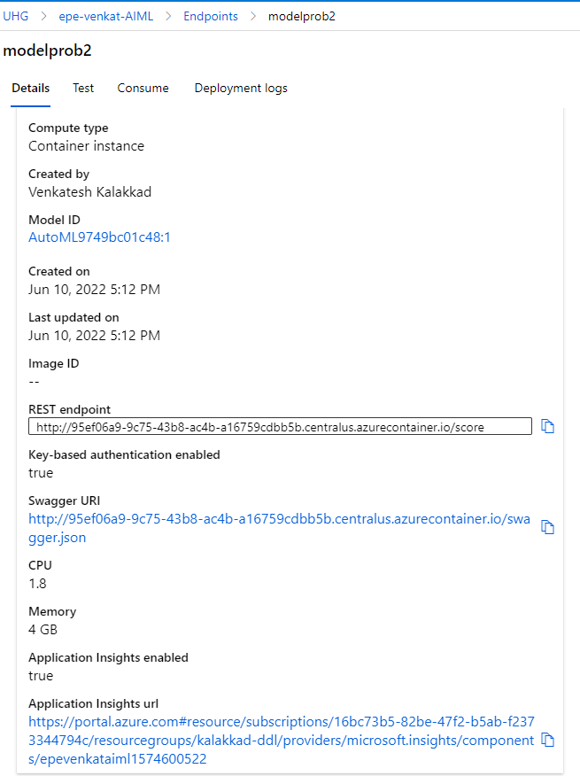

Swagger Exhibits 4.1

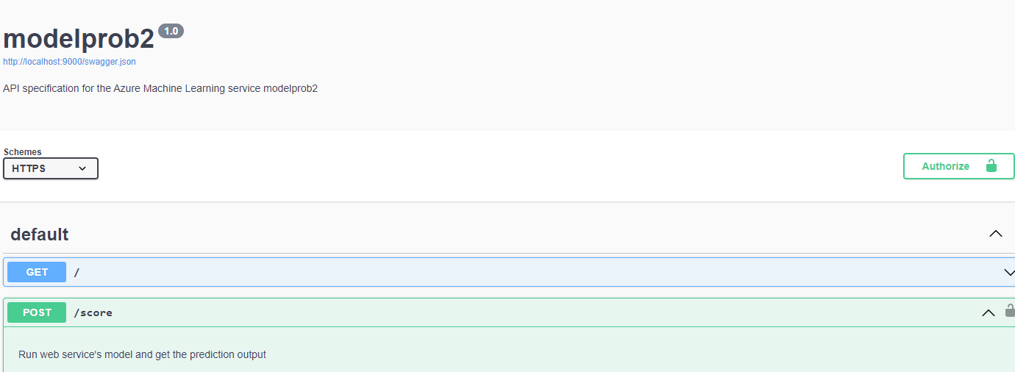

4.2- Request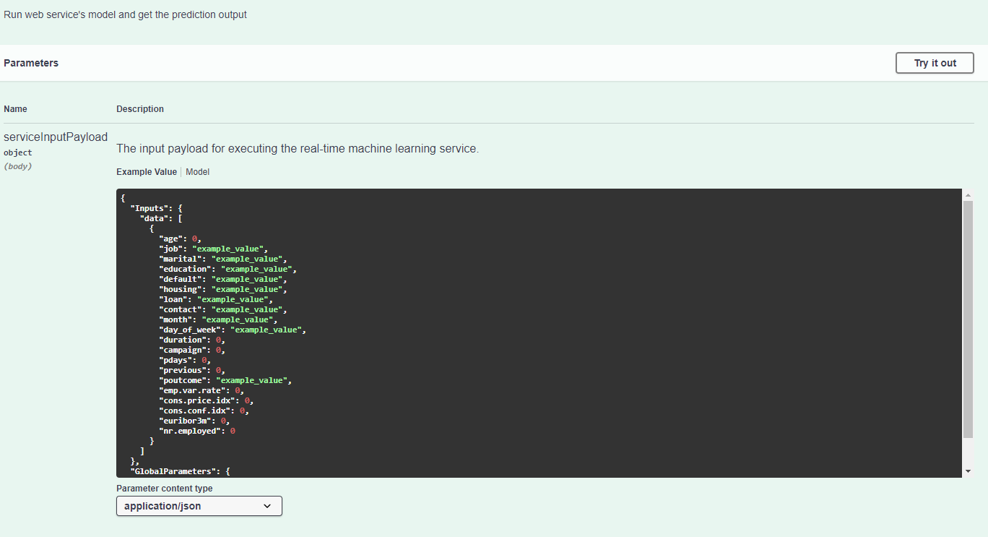

Response 4.3

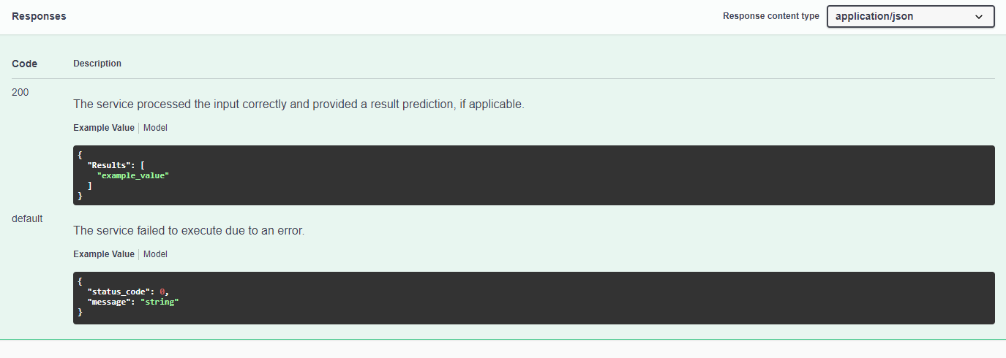

Exhibit 5 Consumer Model (endpoints.py)

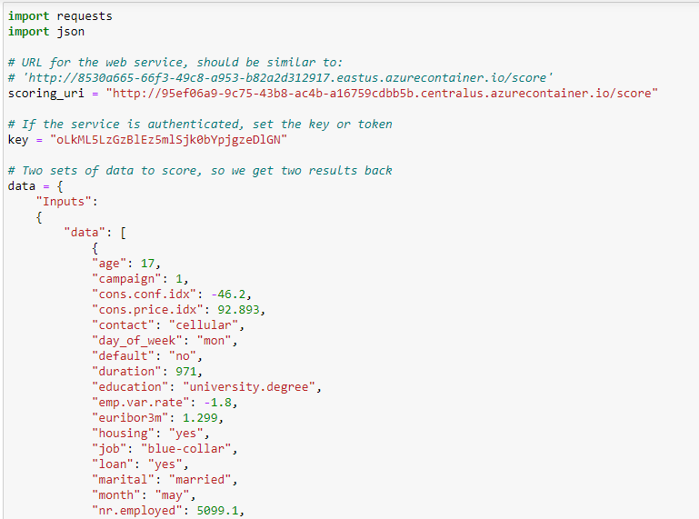

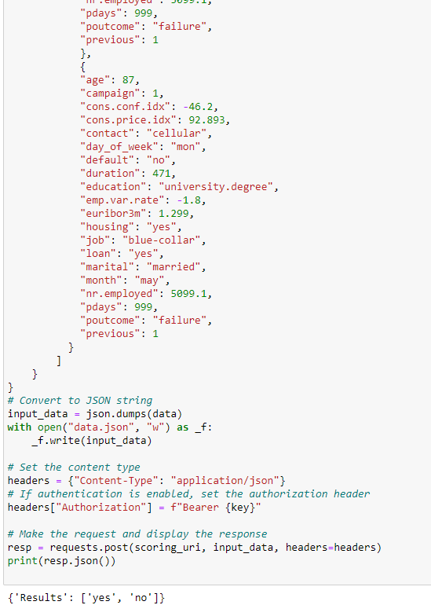

Exhibit Set 6 :Pipeline

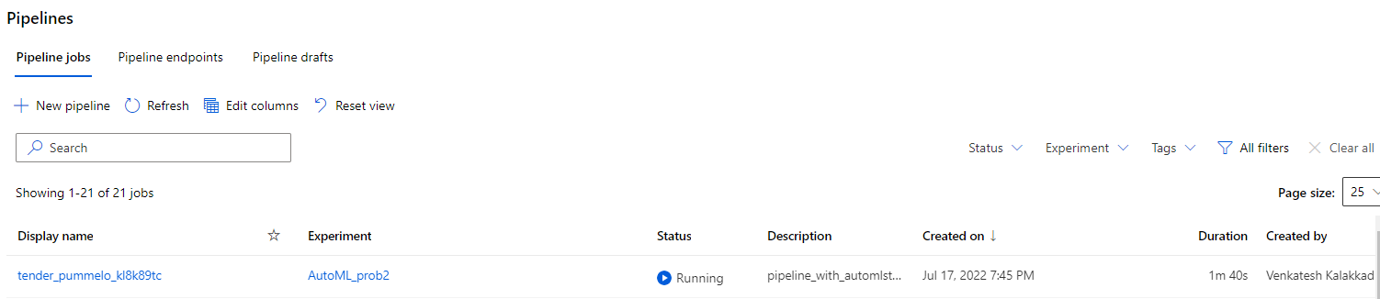

**Pipeline endpoint**

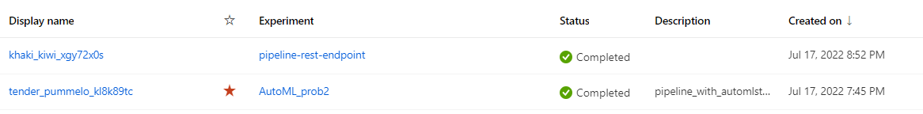

https://centralus.api.azureml.ms/pipelines/v1.0/subscriptions/16bc73b5-82be-47f2-b5ab-f2373344794c/resourceGroups/kalakkad-ddl/providers/Microsoft.MachineLearningServices/workspaces/epe-venkat-aiml/PipelineRuns/PipelineEndpointSubmit/Id/f08b580f-3d1d-4acb-9d72-abffdd118c4e

**Bankmarketing dataset with AutoML module**

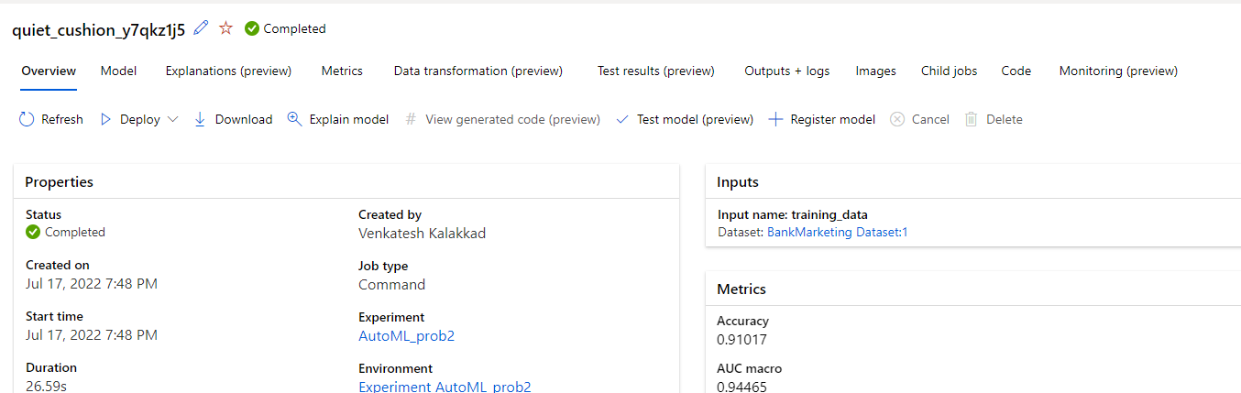

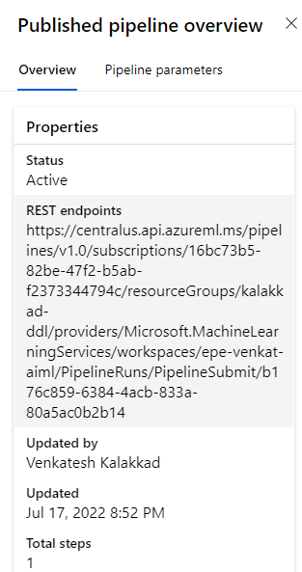

**Run widget steps**

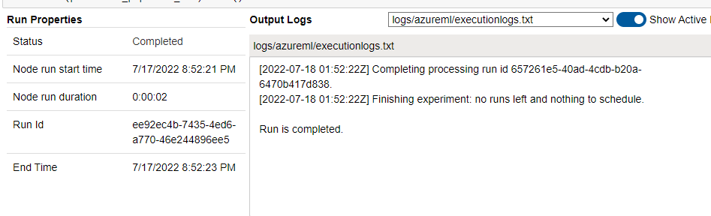

**Scheduled run** 