**Pipeline created**

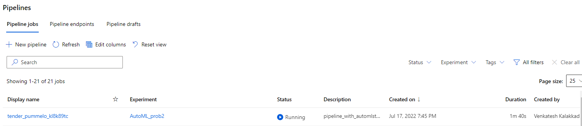

**Pipeline endpoint**

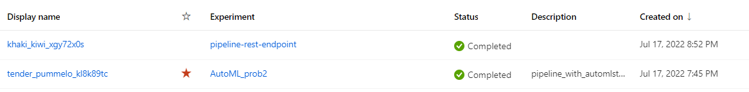

https://centralus.api.azureml.ms/pipelines/v1.0/subscriptions/16bc73b5-82be-47f2-b5ab-f2373344794c/resourceGroups/kalakkad-ddl/providers/Microsoft.MachineLearningServices/workspaces/epe-venkat-aiml/PipelineRuns/PipelineEndpointSubmit/Id/f08b580f-3d1d-4acb-9d72-abffdd118c4e

**Bankmarketing dataset with AutoML module**

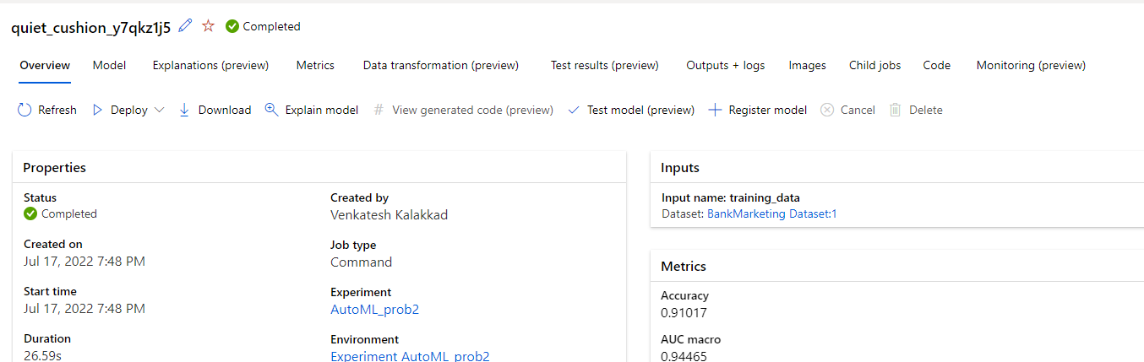

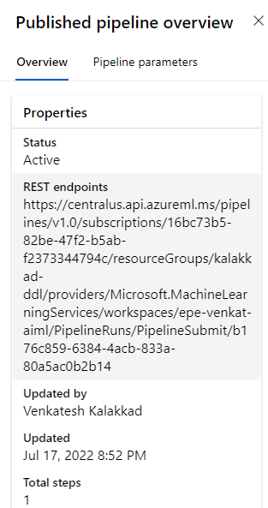

**Run widget steps**

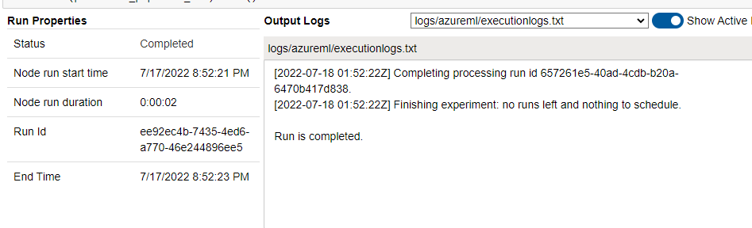

**Scheduled run** 