- Simple Web Server
- A simple web server to display a static HTML page
- Requirements: go 1.14+

- Getting Started:
- Create a Go file named as “web_server.go”.
- Again, create folder name as “static” and keep HTML files in it (index.html, form.html).
- Write html code in index.html, which will be the output if our root route. And in form.html write labels and some text values that we are going to used in our form.
- Import packages that we need in web_server.go file.
- Create formhandler functions to handle all the routes.
- Connect the server to the port 8080.

- Root Route(/) - URL: localhost:8080/
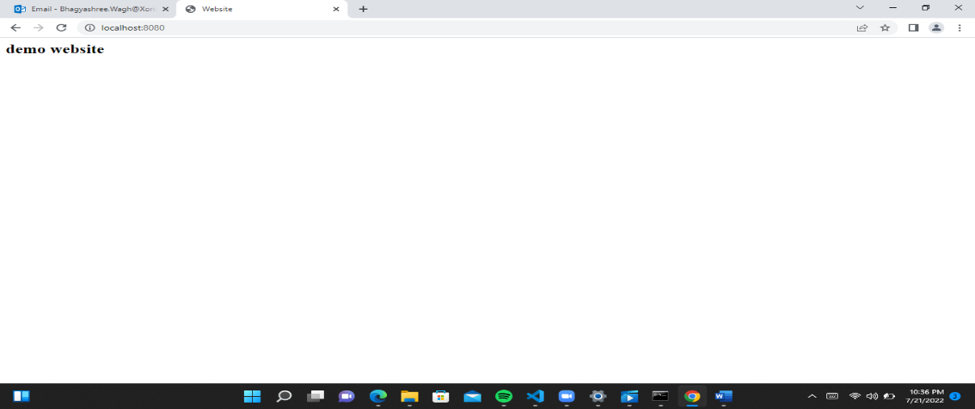

- HelloHandler – URL: localhost:8080/hello
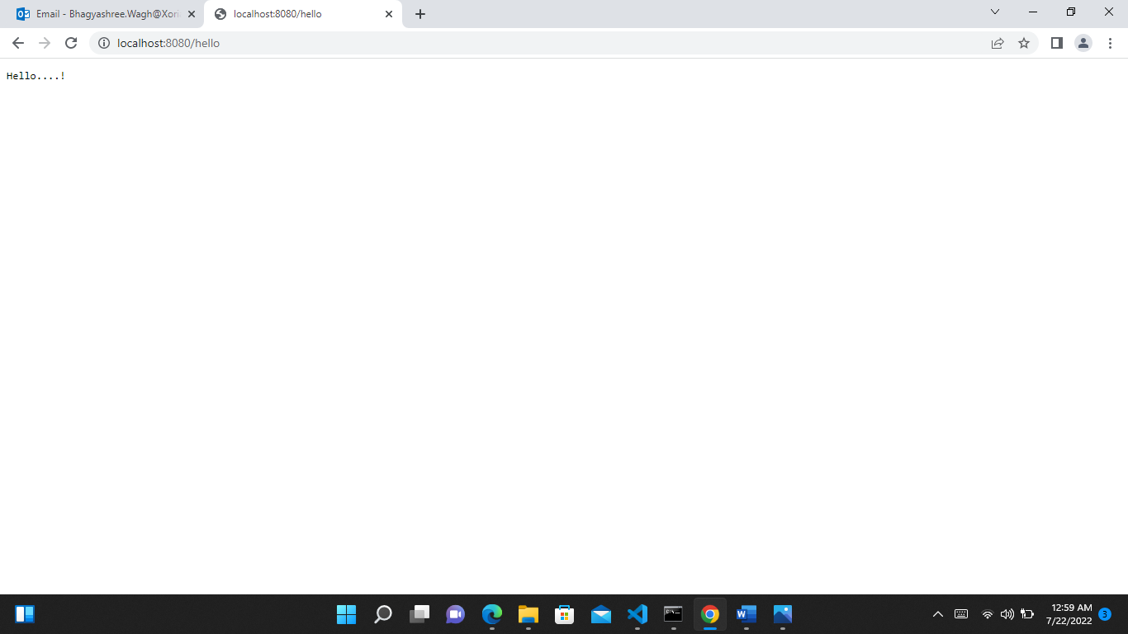

- Form - URL: localhost:8080/form.html
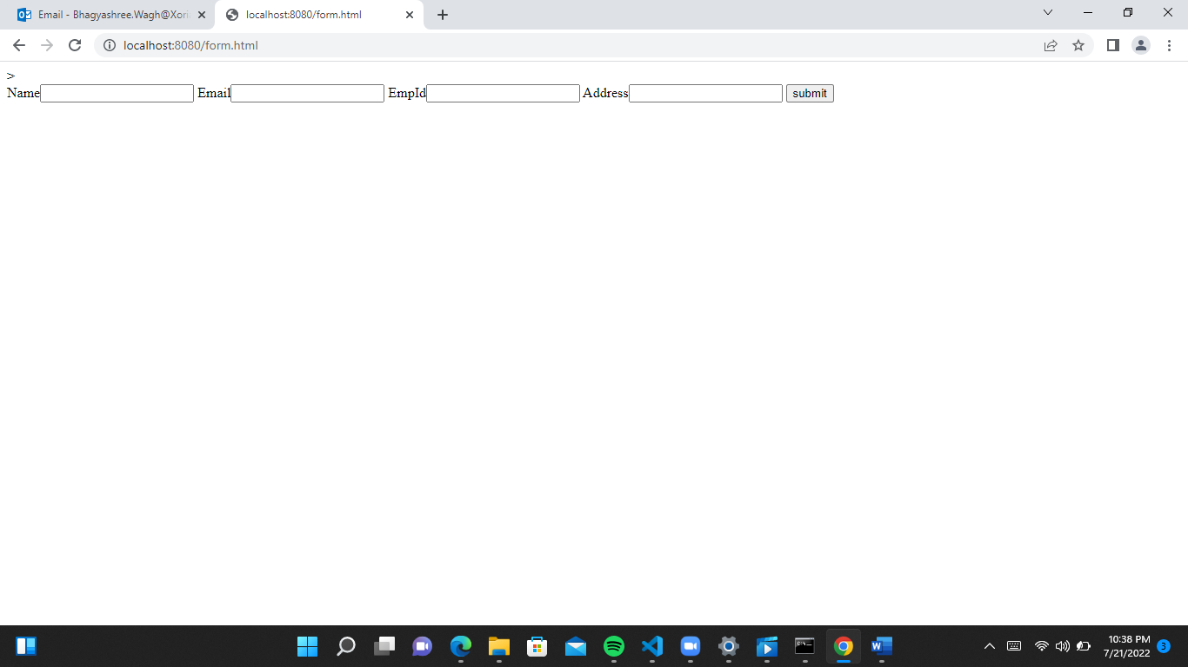

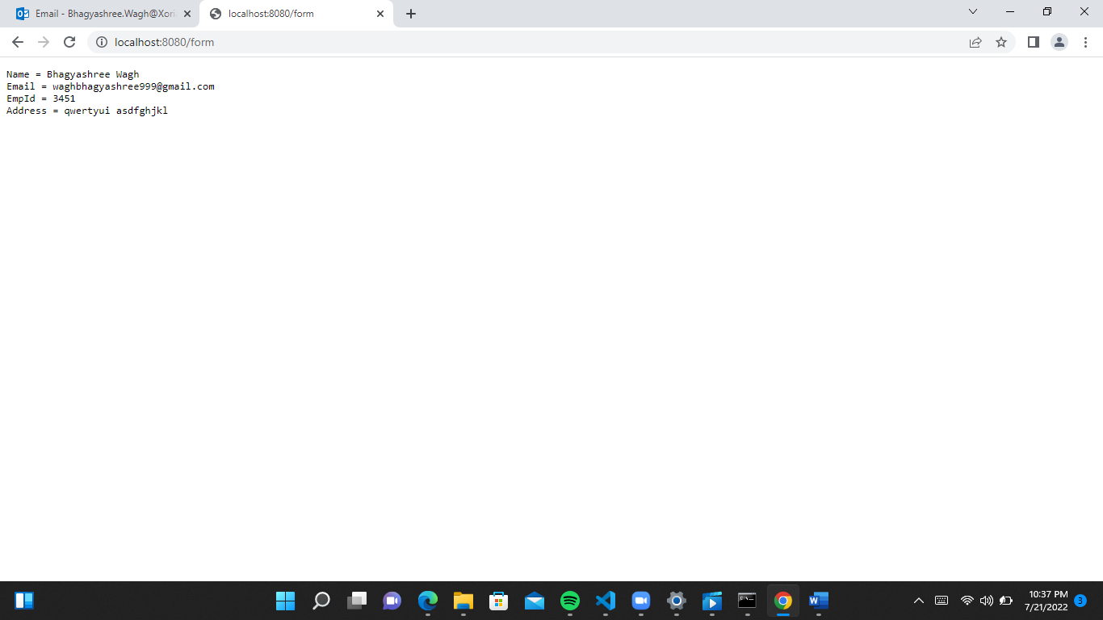

Successfully Posted

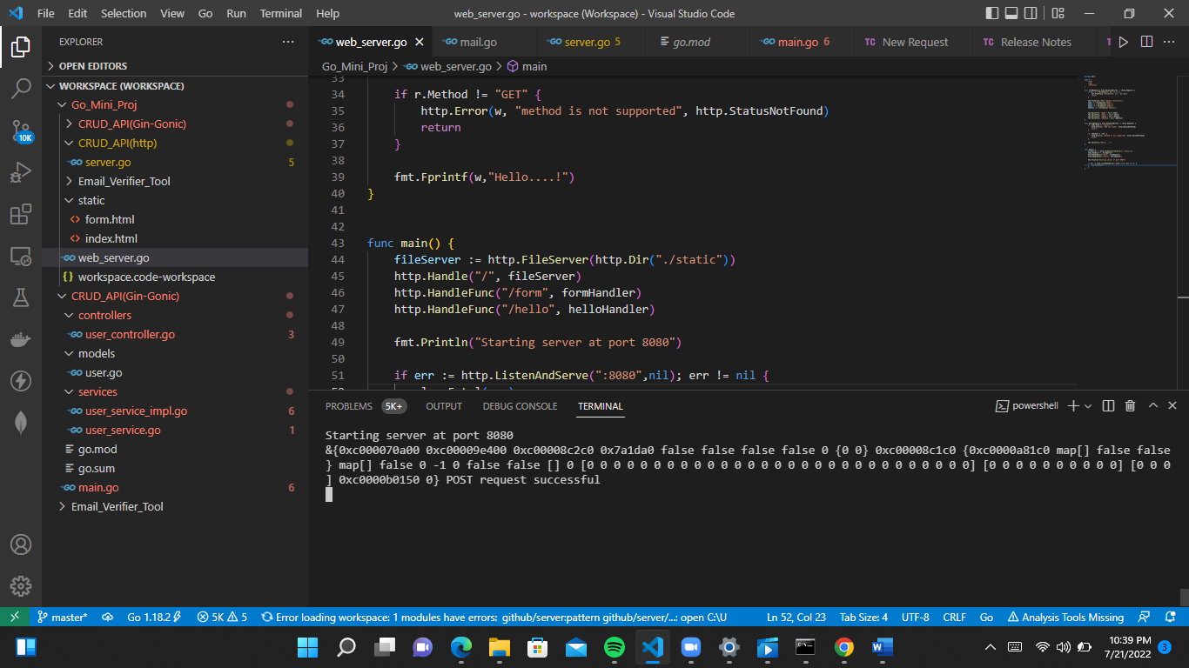

- CRUD API With Mongo Using GIN GONIC

Prerequisite: A mongodb account to host database.
Postman or any API testing application of your choice.

Getting Started:
- Initialize a GO module to manage project dependencies by running command below:
- mkdir crud_api && cd crud_api

- Proceed to install the required dependencies with:
go mod init crud_api
- Framework for building web applications:
go get -u github.com/gin-gonic/gin
- Driver for connecting to MongoDB:
go.mongodb.org/mongo
- Libraries for managing environment variables:
driver/mongo github.com/joho/godotenv
- Library for validating structs and fields:
github.com/go-playground/validator/v10

Server get connected successfully…
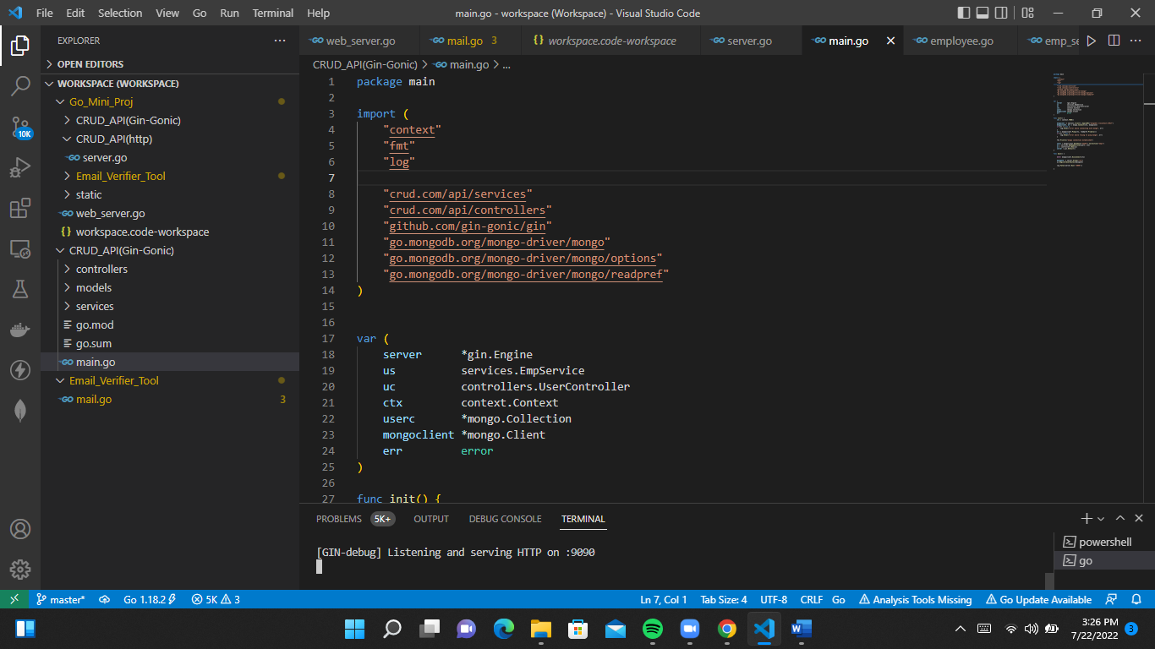

Build Database:
Create- URL: http://localhost:9090/v1/employee/create
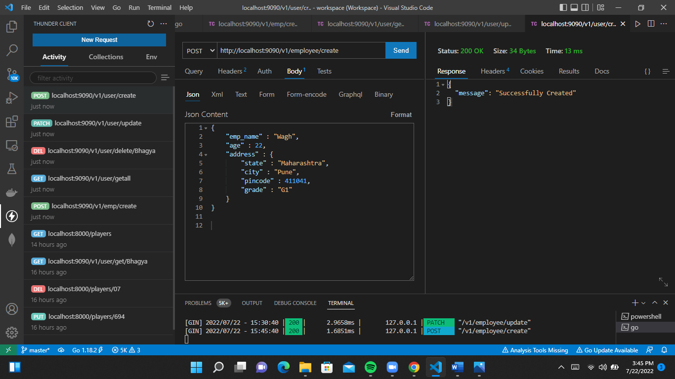

Get - URL: http://localhost:9090/v1/employee/get/BhagyaW
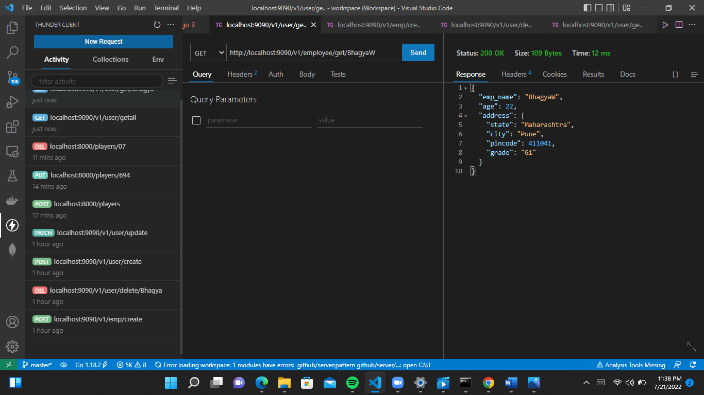

Getall - URL: http://localhost:9090/v1/employee/getall 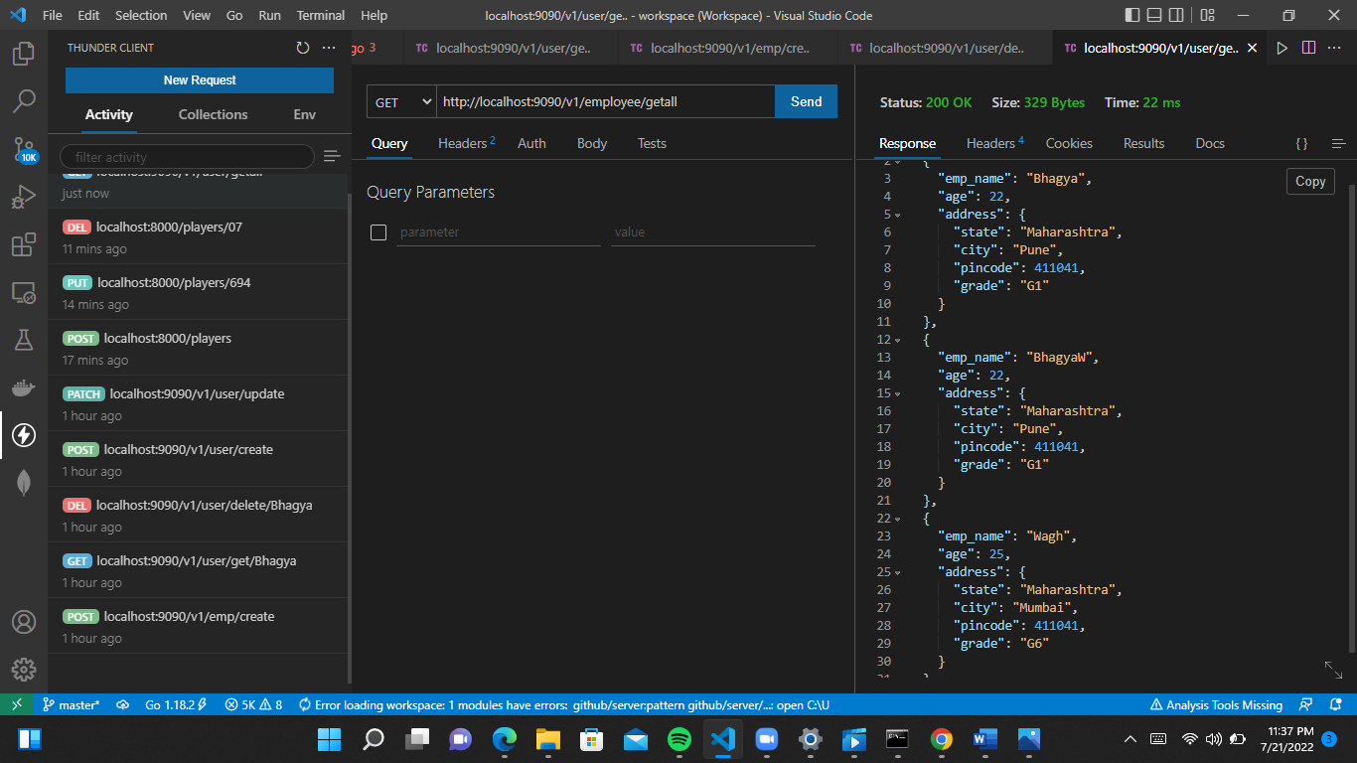

Update - URL: http://localhost:9090/v1/employee/update
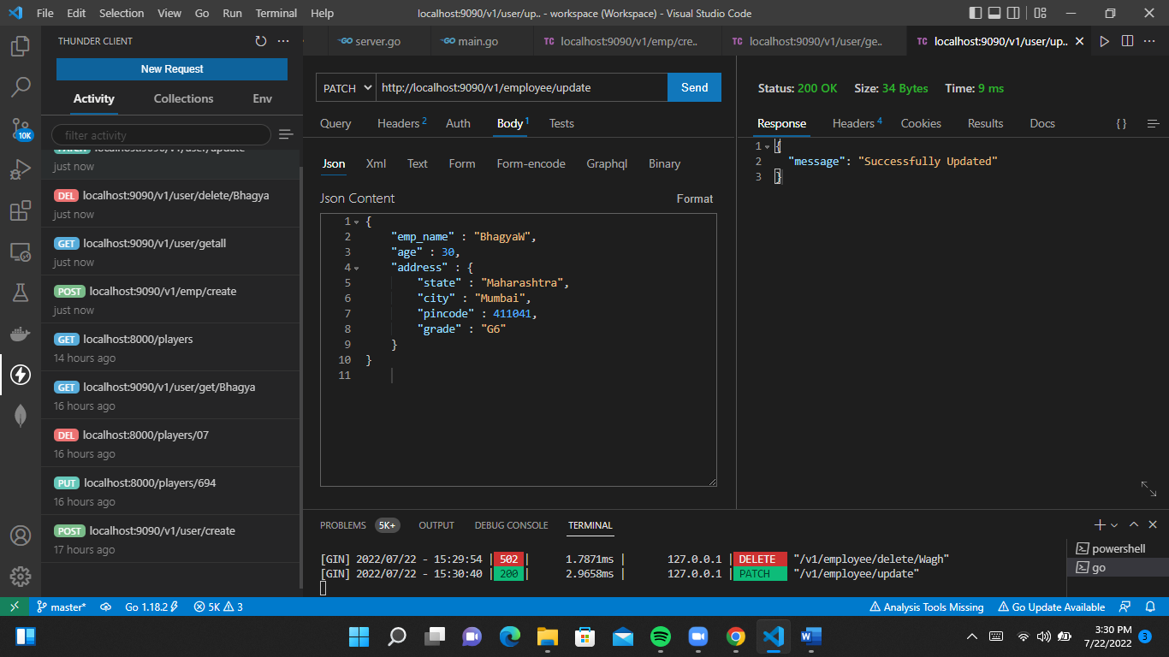

Delete - URL: http://localhost:9090/v1/employee/delete/Wagh
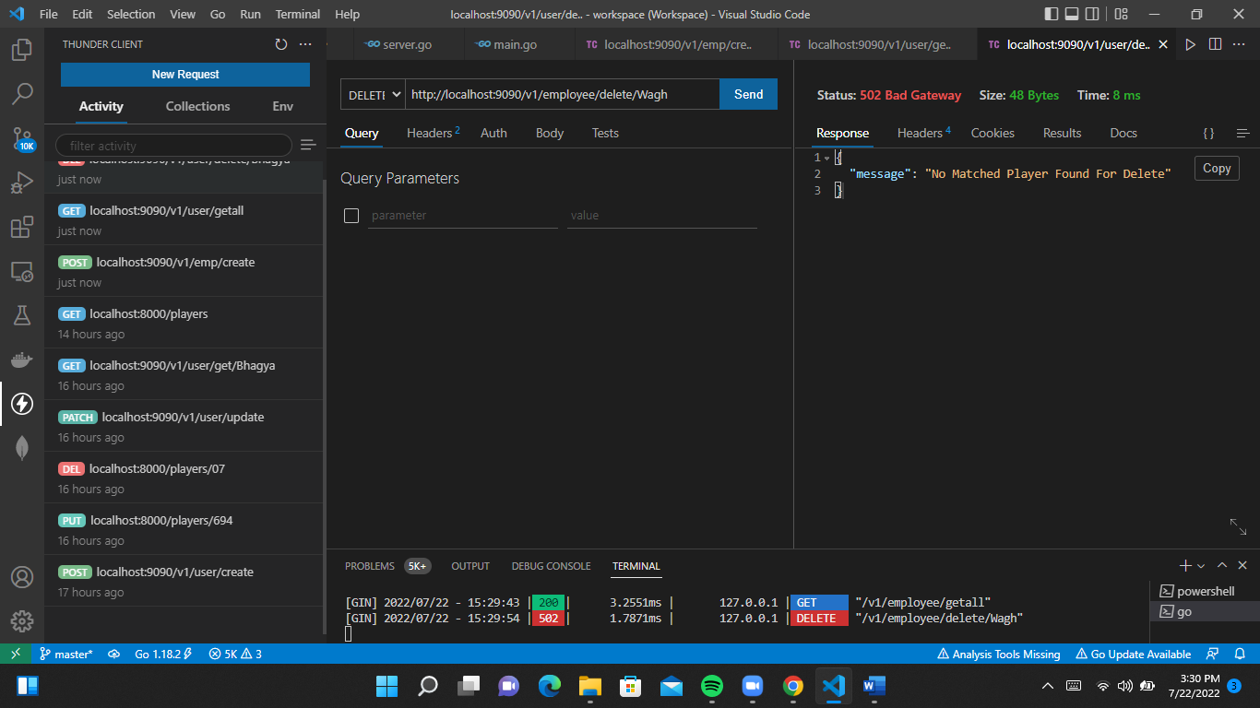
- CRUD API With Mongo Using HTTP
Prerequisite: You will need GO version 1.14+ installed in your machine.
Postman or any API testing application of your choice.

Getting Started:

Server get connected successfully…
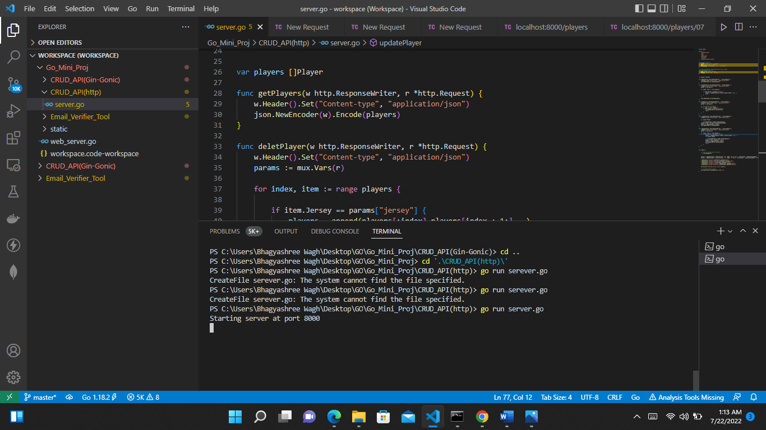

Build Database:
Get all Players: http://localhost:8000/players
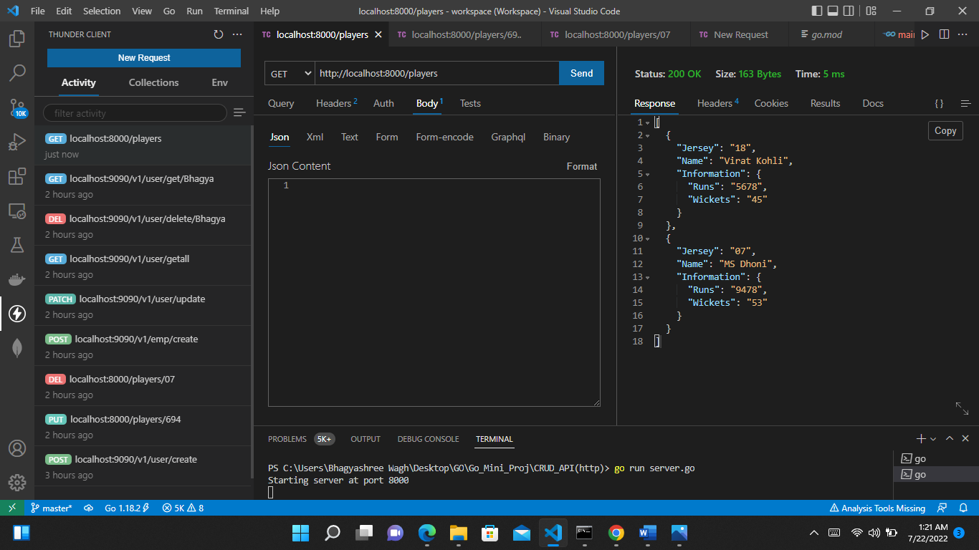

Get Player by Jersey no : http://localhost:8000/players/07
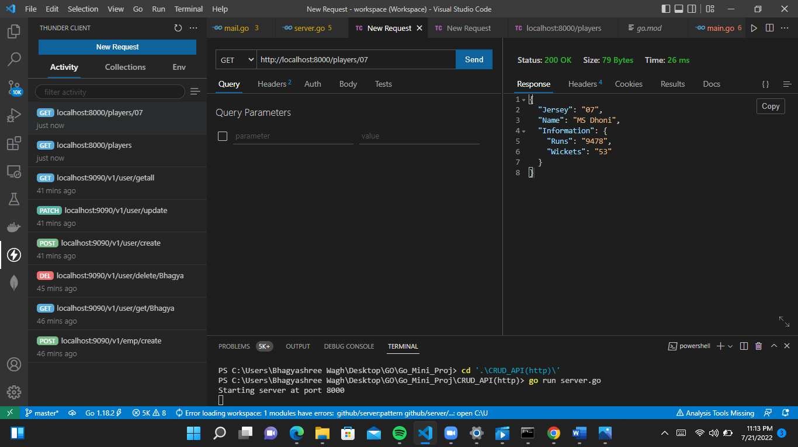

Create Player: http://localhost:8000/players
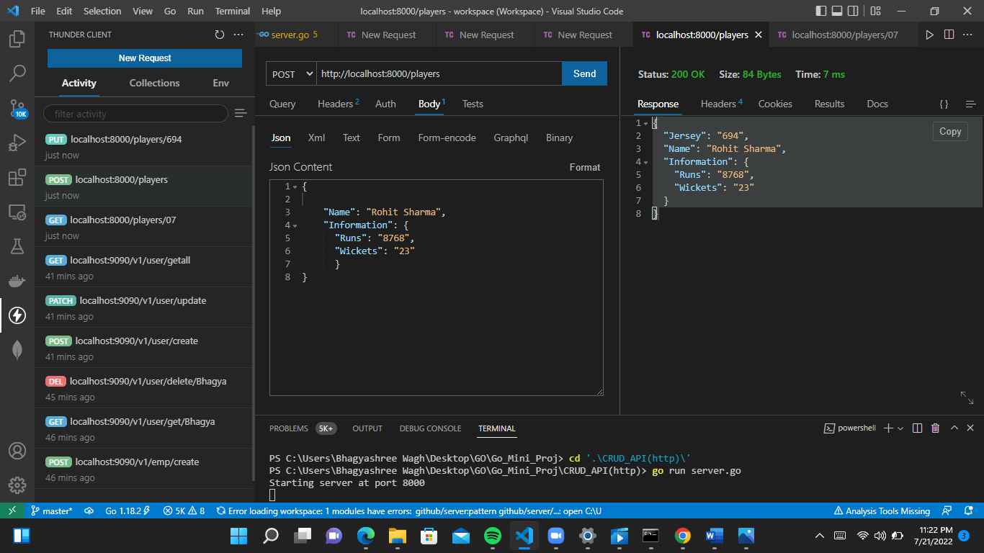

Update Player by Jersey no : http://localhost:8000/players/694
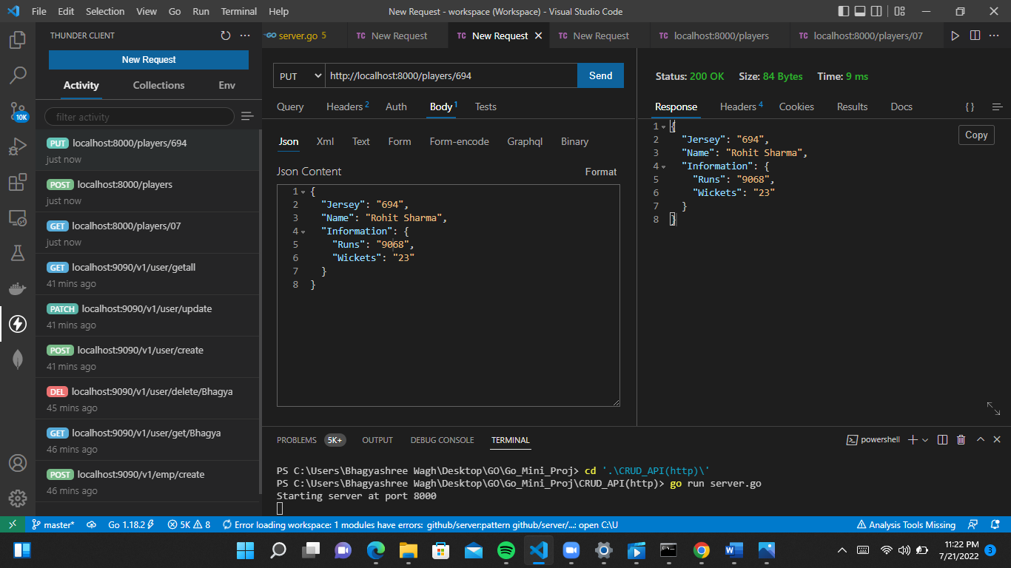

Delete Player by Jersey no : http://localhost:8000/players/694
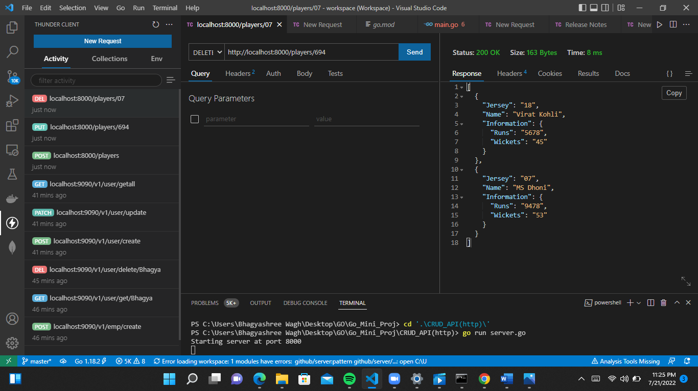

- Email Verifier Tool
A go library for email verification without sending any email.

Features:
- Email Address Validation: validates is a string contains a valid email.
- MX Validation: checks the MX records for the given domain name.
- SPF Validation: validates the origin of email messages.
- DMARC: controls what happens if a message fails authentication tests.

Getting Started:
- Run commands:-
cd '.\Email_Verifier_Tool\'
go run mail.go
