左编译运行，右源代码

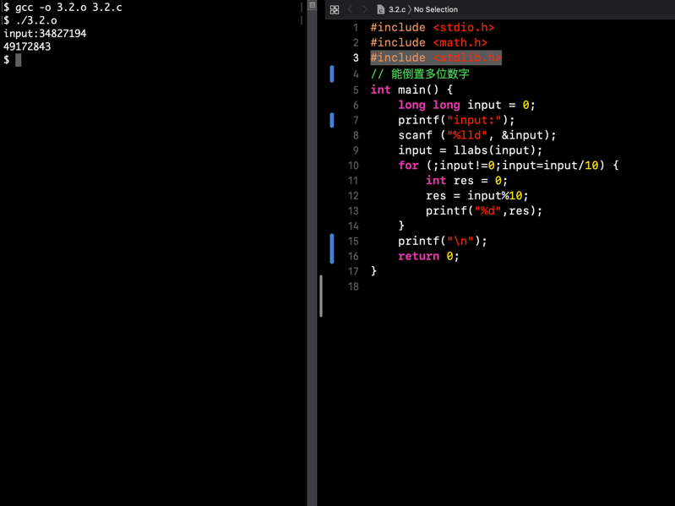

3.2

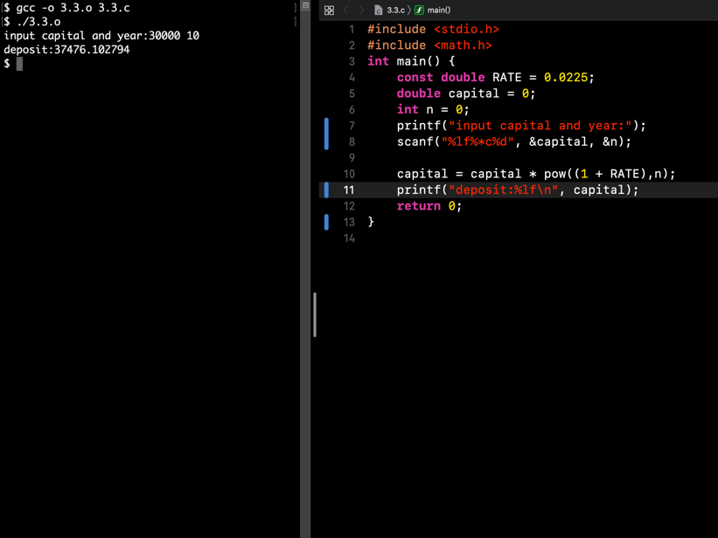

3.3

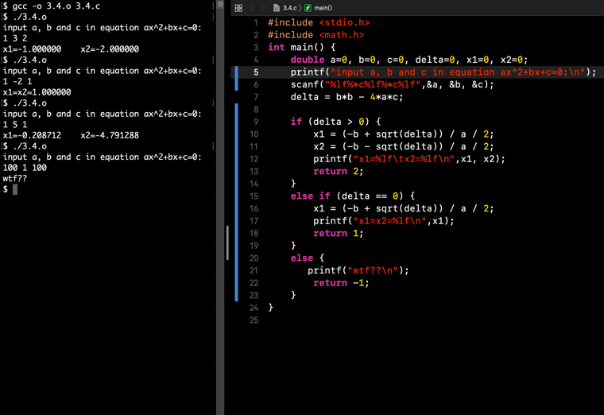

3.4

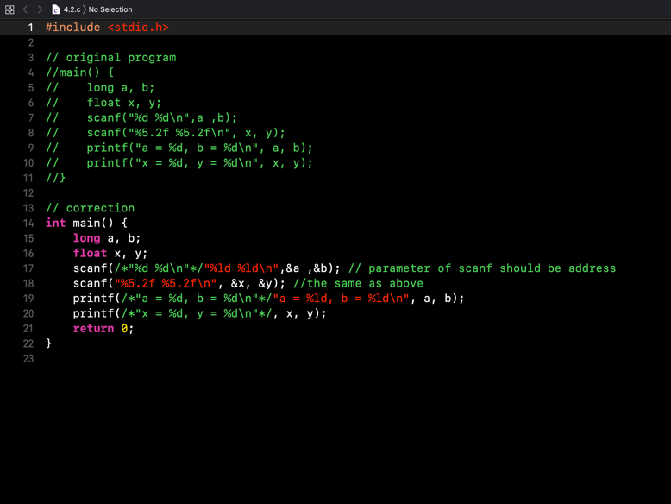

4.2

4.3答案

(1)

12 34

(1)

12 34

(1)

12 34

(2)

1 ,2 ,34

(3)

scanf("%c,%c,%d", &a, &b, &c);

(4)

'1','2',34

(5)

scanf("%c%\*c%c%\*c%d", &a, &b, &c);