**程序部分：左源代码，右运行**

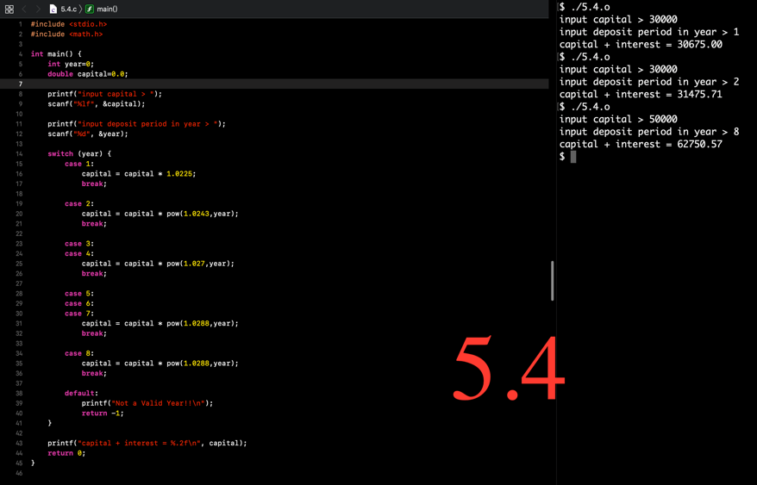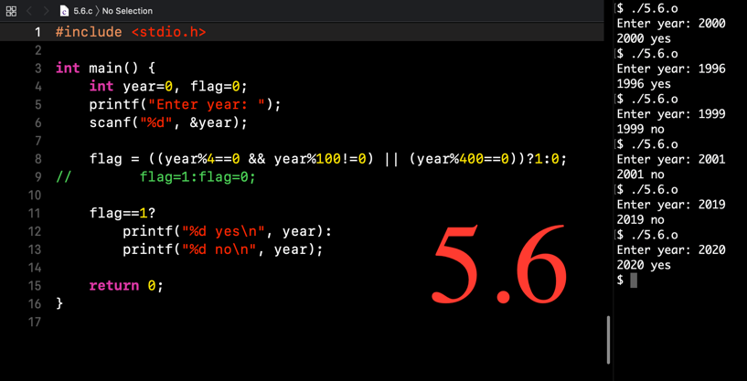

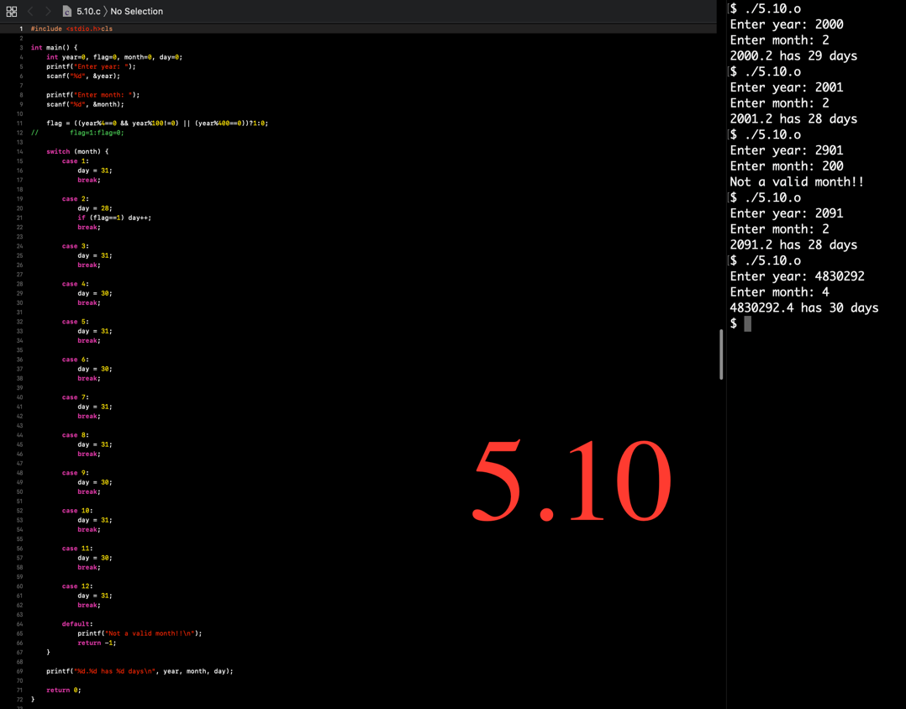

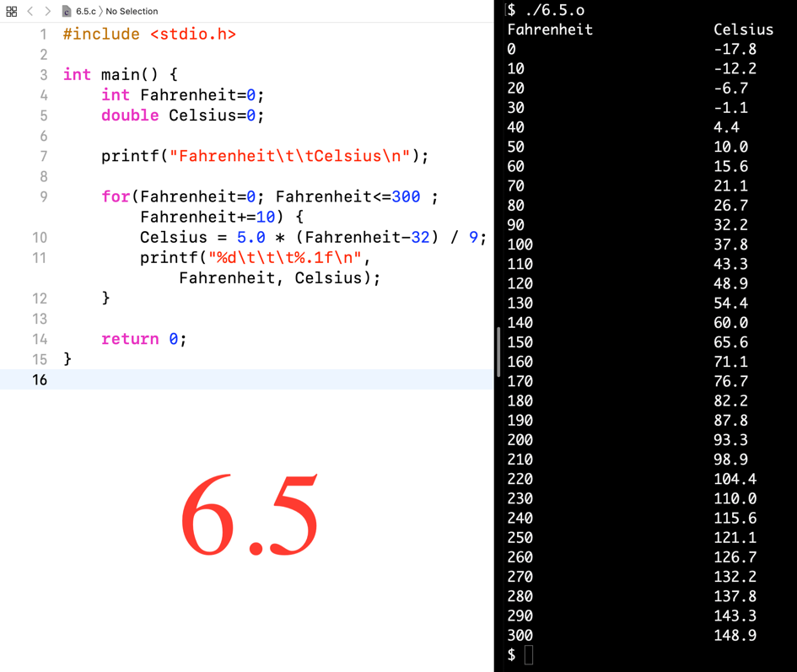

**答案部分**

5.5

(1)

(year%4==0 && year%100!=0) || (year%400==0)

(2)

flag==1

6.1(1)：**以“|”为窗口左边界**

| ******

| ******

| ******

| ******

6.1(2)

k = 3, n = 3

6.1(3)

k = 4, n = 0

6.2(3)

(1)

term或者term=0

(2)

a * pow(10,(i-1)) * (n-i+1)

6.2(5)

(1)

&x

(2)

-term * x * x / (n+1) / (n+2)

(3)

count++

(4)

fabs(term) >= 0.00001