Chapter7-程序源代码与运行结果

7.4

// Source Codes:

#include <stdio.h>

**long** getLCM(**int** a, **int** b) {

**int** lcm=0;

**if**(a>b) lcm = a;

**else** lcm = b;

**while**(lcm%a!=0 || lcm%b!=0) lcm++;

**return** lcm;

}

**int** main() {

**int** integer1=0, integer2=0;

printf("input two integers > ");

scanf("%d%*c%d", &integer1, &integer2);

printf("The Least Common Mutiple of the two is: %ld\n", getLCM(integer1, integer2));

**return** 0;

}

// Results:

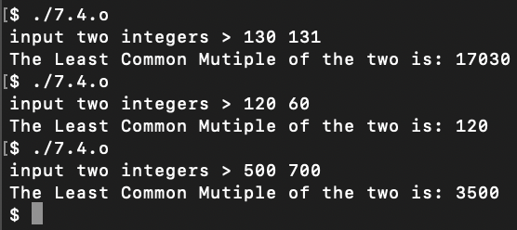

7.7(3)

// Source Codes:

#include <stdio.h>

**int** GCD(**int** a, **int** b) {

**int** result=0;

**if** (a>b) result=GCD(a-b, b);

**else** **if** (a<b) result=GCD(a, b-a);

**else** **return** a;

**return** result;

}

**int** main() {

**int** a=0, b=0;

printf("input a, b > \n");

**while**(1) {

scanf("%d%*c%d", &a, &b);

**if**(a>0 && b>0) **break**;

**else** {

printf("invalid input! retry!\n");

**while**(getchar()!='\n');

}

}

printf("GCD of a, b: %d\n", GCD(a,b));

**return** 0;

}

// Results:

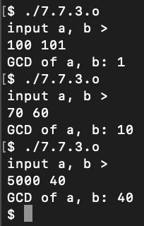

7.8

// Source Codes:

#include <stdio.h>

**int** main() {

**int** x=1;

**int** operate=0;

**int** i=0;

**for** (x=1 ; ; x++) {

operate = x;

**for** (i=1 ; i<=5 ; i++) {

**if** (operate%4!=0) **goto** NEXTSTEP;

operate = operate / 4 * 5 + 1;

}

**break**;

NEXTSTEP:

;

// putchar('n');putchar('\n');

}

printf ("%d\n", operate);

**return** 0;

}

// Results:

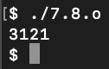

7.9

// Source Codes:

#include <stdio.h>

**int** askAge(**int** PersonNum) {

**if** (PersonNum==1) **return** 10;

**else** **return** askAge(PersonNum-1)+2;

}

**int** main() {

printf ("The Age of 5th person is : %d\n", askAge(5));

**return** 0;

}

// Results:

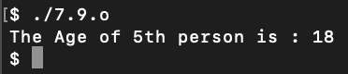

7.11

// Source Codes:

#include <stdio.h>

#include <stdlib.h>

#include <time.h>

**int** main() {

**int** flag=0, Win=0;

**int** i=0;

srand(time(**NULL**));

**if** (rand()%2!=0) {

printf("Computer first!\n");

flag = 1;

}

**else** printf("User first!\n");

**if**(flag) {

**if** (rand()%2==0){

i += 1;

printf ("Computer Added 1 , now goes to %d\n", i);

}

**else** {

i += 2;

printf ("Computer Added 2 , now goes to %d\n", i);

}

}

**for** (; i<=30 ;) {

**int** Add=0;

**for** (Add=0 ; ; ){

printf("Add one or Two? ");

scanf ("%d", &Add);

**if** (Add!=1 && Add!=2) {

printf ("input '1' or '2'!\n");

Add = 0;

**while**(getchar()!='\n');

**continue**;

}

**break**;

}

**if**(Add==1) i+=1;

**else** **if**(Add==2) i+=2;

printf ("Added %d , now goes to %d\n", Add, i);

**if** (i>=30) {

Win=0;

**break**;

}

**if** ((30-i)%3==2) {

i += 2;

Add = 2;

}

**else** **if** ((30-i)%3==1) {

i += 1;

Add = 1;

}

**else** {

**if** (rand()%2==0){

i += 1;

Add = 1;

}

**else** {

i+=2;

Add = 2;

}

}

printf ("Computer Added %d , now goes to %d\n", Add, i);

**if** (i>=30) {

Win=1;

**break**;

}

}

**if** (Win==0) printf("Congratulations! You won!\n");

**else** printf("The great programmer won!\n");

**return** 0;

}

// Results:

