Chapter9-程序源代码与运行结果

9.1

(1) 函数`int swap(int *x, int *y)`可以实现主调函数内的两数交换功能。

原因：形参为指向主函数内变量的指针，故swap函数可通过直接访问内存的方式对主调函数内的变量进行操作，达到改变主调函数内变量的目的。

(2) 函数`int swap(int x, int y)`不能实现主调函数内的两数交换功能。

原因：主调函数调用此函数时，把实参的值复制了一份给形参。改变形参只能改变swap函数内部形参的值，而不能改变主调函数内的变量值。

9.2

// Source Codes:

#include <stdio.h>

#define MAX_SIZE 30

**void** inputNumber(**int** *p, **const** **char**\* prompt) {

printf(prompt);

**while**(!scanf("%d", p)) {

printf(prompt);

**while**(getchar()!='\n');

}

**return**;

}

**void** swap(**int** *x, **int** *y) {

**int** temp = *x;

*x = *y;

*y = temp;

}

**void** swap_array(**int** size, **int** x[], **int** y[]) {

**int** i=0;

**for** (i=0 ; i<size ; i++) swap(x+i, y+i);

}

**int** main() {

**int** size=0, a[MAX_SIZE]={0}, b[MAX_SIZE]={0};

inputNumber(&size, "input array size > ");

**if** (size>MAX_SIZE) {

printf ("%d.\n", MAX_SIZE);

size = MAX_SIZE;

}

**int** i=0;

**for** (i=0 ; i<size ; i++) inputNumber(&a[i], "(a) ");

**for** (i=0 ; i<size ; i++) inputNumber(&b[i], "(b) ");

printf ("Original a and b :\n");

**for** (i=0 ; i<size ; i++) printf ("%d ", a[i]);

putchar('\n');

**for** (i=0 ; i<size ; i++) printf ("%d ", b[i]);

putchar('\n');

swap_array(size, a, b);

printf ("Swapped a and b :\n");

**for** (i=0 ; i<size ; i++) printf ("%d ", a[i]);

putchar('\n');

**for** (i=0 ; i<size ; i++) printf ("%d ", b[i]);

putchar('\n');

**return** 0;

}

// Results:

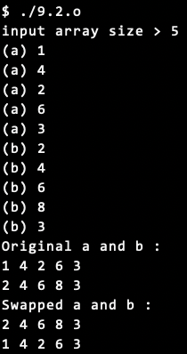 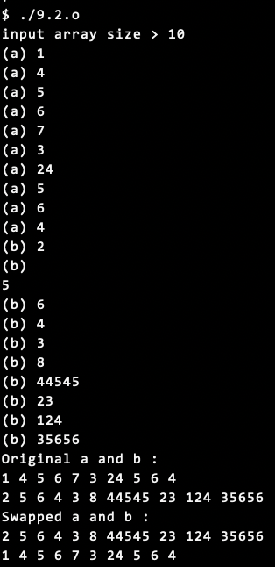 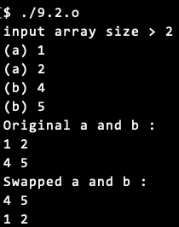

9.3

// Source Codes:

#include <stdio.h>

**void** inputNumber(**int** *p, **const** **char**\* prompt) {

printf(prompt);

**while**(!scanf("%d", p)) {

printf(prompt);

**while**(getchar()!='\n');

}

**return**;

}

**int** max(**int** a[10]) {

**int** i=0, max=-1, maxLoc=-1;

**for** (i=0 ; i<10 ; i++) **if** (a[i]>max) {

max = a[i];

maxLoc = i;

}

**return** maxLoc;

}

**int** min(**int** a[10]) {

**int** i=0, min=99999, minLoc=-1;

**for** (i=0 ; i<10 ; i++) **if** (a[i]<min) {

min = a[i];

minLoc = i;

}

**return** minLoc;

}

**int** main() {

**int** maxLoc=0, minLoc=0, i=0, a[10];

**for** (i=0 ; i<10 ; i++) inputNumber(&a[i], "(input) ");

printf ("Original :\n");

**for** (i=0 ; i<10 ; i++) printf("%d ", a[i]);

putchar('\n');

maxLoc = max(a);

minLoc = min(a);

**int** swap = a[maxLoc];

a[maxLoc] = a[minLoc];

a[minLoc] = swap;

printf ("Swapped :\n");

**for** (i=0 ; i<10 ; i++) printf("%d ", a[i]);

putchar('\n');

**return** 0;

}

// Results:

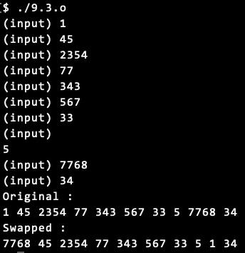 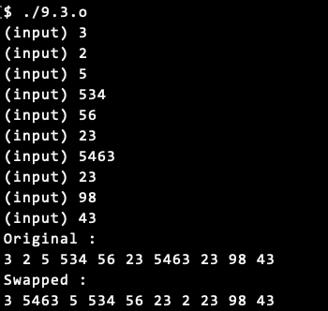 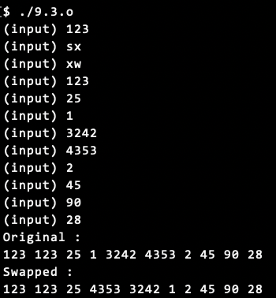

9.4(1)

// Source Codes:

#include <stdio.h>

#include <stdbool.h>

**void** inputNumber(**int** *p, **const** **char**\* prompt) {

printf(prompt);

**while**(!scanf("%d", p)) {

printf(prompt);

**while**(getchar()!='\n');

}

**return**;

}

**bool** RN(**int** year) {

**return** ((year%4==0 && year%100!=0) || (year%400==0)) ? **true** : **false**;

}

**int** DayofYear(**int** year, **int** month, **int** day) {

**bool** rn = RN(year);

**for** ( ; month>1 ; month--) {

**if** (month==5 || month==7 || month==10 || month==12) day+=30;

**else** **if** (month==2 || month==4 || month==6 || month==8 || month==9 || month==11) day+=31;

**else** **if** (month==3) {

**if** (rn) day+=29;

**else** day+=28;

}

}

**return** day;

}

**int** main() {

**int** year=0, month=0, day=0;

inputNumber(&year, "input year > ");

inputNumber(&month, "input month > ");

inputNumber(&day, "input day > ");

printf("%d/%02d/%02d is the NO. %d day in the year.\n", year, month, day, DayofYear(year, month, day));

**return** 0;

}

// Results:

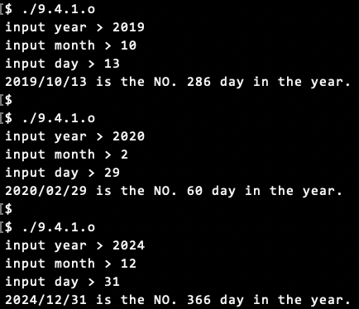

9.4(2)

// Source Codes:

#include <stdio.h>

#include <stdbool.h>

**void** inputNumber(**int** *p, **const** **char**\* prompt) {

printf(prompt);

**while**(!scanf("%d", p)) {

printf(prompt);

**while**(getchar()!='\n');

}

**return**;

}

**bool** RN(**int** year) {

**return** ((year%4==0 && year%100!=0) || (year%400==0)) ? **true** : **false**;

}

**void** MonthDay(**int** year, **int** yearDay, **int** *pmonth, **int** *pDay) {

**bool** rn = RN(year);

**int** dayAddition = 0, prevDayAddition = 0;

*pmonth = 0;

**while** (**true**) {

(*pmonth)++;

prevDayAddition = dayAddition;

**if** (*pmonth==1 || *pmonth==3 || *pmonth==5 || *pmonth==7 || *pmonth==8 || *pmonth==10 || *pmonth==12) {

dayAddition += 31;

}

**else** **if** (*pmonth==4 || *pmonth==6 || *pmonth==9 || *pmonth==11) {

dayAddition += 30;

}

**else** **if** (*pmonth==2) {

**if** (rn) dayAddition += 29;

**else** dayAddition += 28;

}

**else** {

printf ("Too many days!\n");

*pmonth = -1;

*pDay = -1;

**return**;

}

**if** (*pDay<=dayAddition && *pDay>prevDayAddition) **break**;

}

*pDay = *pDay - prevDayAddition;

**return**;

}

**int** main() {

**int** year=0, yearDay=0;

inputNumber(&year, "input year > ");

inputNumber(&yearDay, "Calaulate day NO. > ");

**int** returnDay=yearDay, returnMonth=0;

MonthDay(year, yearDay, &returnMonth, &returnDay);

printf("The date of NO. %d day in %d is %d/%02d/%02d.\n", yearDay, year, year, returnMonth, returnDay);

**return** 0;

}

// Results:

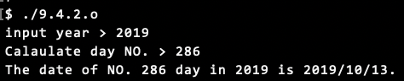

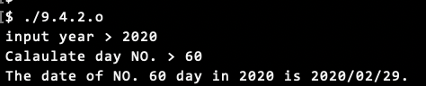

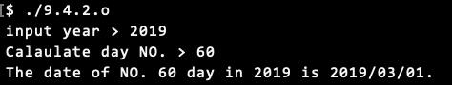

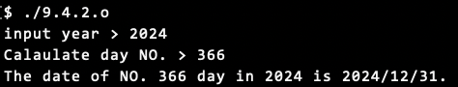

9.4(3)

// Source Codes:

#include <stdio.h>

#include <stdbool.h>

**void** showMenu() {

printf ("1. Year/Month/Day -> yearDay\n"

"2. yearDay -> Year/Month/day\n"

"3. exit\n");

**return**;

}

**void** inputNumber(**int** *p, **const** **char**\* prompt) {

printf(prompt);

**while**(!scanf("%d", p)) {

printf(prompt);

**while**(getchar()!='\n');

}

**return**;

}

**bool** RN(**int** year) {

**return** ((year%4==0 && year%100!=0) || (year%400==0)) ? **true** : **false**;

}

**int** DayofYear(**int** year, **int** month, **int** day) {

**bool** rn = RN(year);

**for** ( ; month>1 ; month--) {

**if** (month==5 || month==7 || month==10 || month==12) day+=30;

**else** **if** (month==2 || month==4 || month==6 || month==8 || month==9 || month==11) day+=31;

**else** **if** (month==3) {

**if** (rn) day+=29;

**else** day+=28;

}

}

**return** day;

}

**void** MonthDay(**int** year, **int** yearDay, **int** *pmonth, **int** *pDay) {

**bool** rn = RN(year);

**int** dayAddition = 0, prevDayAddition = 0;

*pmonth = 0;

**while** (**true**) {

(*pmonth)++;

prevDayAddition = dayAddition;

**if** (*pmonth==1 || *pmonth==3 || *pmonth==5 || *pmonth==7 || *pmonth==8 || *pmonth==10 || *pmonth==12) {

dayAddition += 31;

}

**else** **if** (*pmonth==4 || *pmonth==6 || *pmonth==9 || *pmonth==11) {

dayAddition += 30;

}

**else** **if** (*pmonth==2) {

**if** (rn) dayAddition += 29;

**else** dayAddition += 28;

}

**else** {

printf ("Too many days!\n");

*pmonth = -1;

*pDay = -1;

**return**;

}

**if** (*pDay<=dayAddition && *pDay>prevDayAddition) **break**;

}

*pDay = *pDay - prevDayAddition;

**return**;

}

**int** main() {

**while** (**true**) {

showMenu();

**int** cmd = 0;

inputNumber(&cmd, "Please enter your choice > ");

**int** year=0, month=0, day=0;

**int** /*year=0,*/ yearDay=0, returnDay=0, returnMonth=0;

**switch** (cmd) {

**case** 1:

inputNumber(&year, "input year > ");

inputNumber(&month, "input month > ");

inputNumber(&day, "input day > ");

printf("%d/%02d/%02d is the NO. %d day in the year.\n", year, month, day, DayofYear(year, month, day));

**break**;

**case** 2:

inputNumber(&year, "input year > ");

inputNumber(&yearDay, "Calaulate day NO. > ");

returnDay=yearDay, returnMonth=0;

MonthDay(year, yearDay, &returnMonth, &returnDay);

printf("The date of NO. %d day in %d is %d/%02d/%02d.\n", yearDay, year, year, returnMonth, returnDay);

**break**;

**case** 3:

printf ("Exit.\n");

**goto** END;

**default**:

printf ("%d : Command not found.\n", cmd);

**break**;

}

putchar ('\n');

}

END:

**return** 0;

}

// Results:

