Chapter11-程序源代码与运行结果

13.2

// Source Codes:

#include <stdio.h>

**typedef** **struct** {

**int** year;

**int** month;

**int** day;

} DATE;

**typedef** **struct** {

**long** ID;

**char** Name[10];

**char** Sex;

DATE Birthday;

**int** Score[4];

} STUDENT;

**int** main() {

freopen("./score.txt", "w", stdout);

**int** i, j, sum[30] = {0};

STUDENT stu[30] = {{100310121, "王刚", 'M', {1991, 5, 19}, {72, 83, 90, 82}},

{100310122, "李小明", 'M', {1992, 8, 20}, {88, 92, 78, 78}},

{100310123, "王丽红", 'F', {1991, 9, 19}, {98, 72, 89, 66}},

{100310124, "陈莉莉", 'F', {1992, 3, 22}, {87, 95, 78, 90}}

};

**for** (i=0 ; i<4 ; i++) {

sum[i] = 0;

**for** (j=0 ; j<4 ; j++) sum[i] += stu[i].Score[i];

printf ("%-10ld%8s%3c%6d/%02d/%2d%4d%4d%4d%4d%6.1f\n",

stu[i].ID,

stu[i].Name,

stu[i].Sex,

stu[i].Birthday.year,

stu[i].Birthday.month,

stu[i].Birthday.day,

stu[i].Score[0],

stu[i].Score[1],

stu[i].Score[2],

stu[i].Score[3],

sum[i]/4.0);

}

**return** 0;

}

// Result:

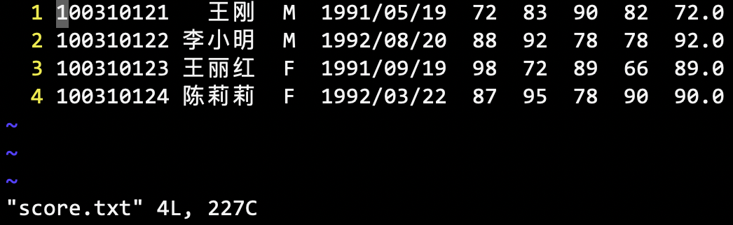

13.4

// Source Codes:

#include <stdio.h>

**int** main() {

**char** c = 0;

**char** source[100]={0}, destination[100]={0};

FILE *fp;

FILE *fp_out;

scanf ("%100s", source);

scanf ("%100s", destination);

fp_out = fopen(destination, "wb");

**if** ((fp=fopen(source, "rb")) == **NULL**) {

printf("cp: %s: No such file.\n", source);

**return** -1;

}

**while** (!feof(fp)) {

fread(&c, 1, 1, fp);

fwrite(&c, 1, 1, fp_out);

}

**return** 0;

}

// Results:

TEXT FILE:



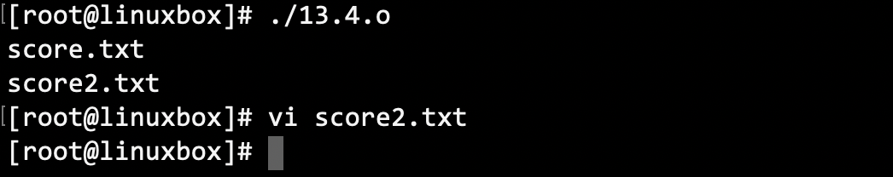

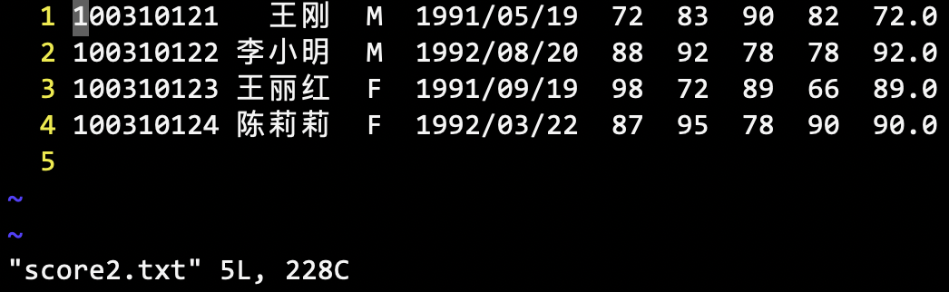

BINARY FILE:

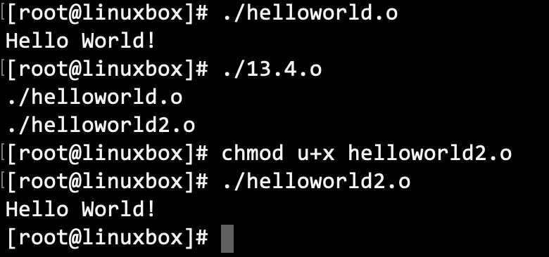

13.5

// Source Codes:

#include <stdio.h>

**int** main() {

**char** c = 0;

**char** source[100]={0}, destination[100]={0};

FILE *fp;

FILE *fp_out;

scanf ("%100s", source);

scanf ("%100s", destination);

**if** ((fp=fopen(source, "rb")) == **NULL**) {

printf("cat: %s: No such file.\n", source);

**return** -1;

}

**if** ((fp_out=fopen(destination, "ab")) == **NULL**) {

printf("cat: %s: No such file.\n", source);

**return** -2;

}

**while** (!feof(fp)) {

fread(&c, 1, 1, fp);

fwrite(&c, 1, 1, fp_out);

}

**return** 0;

}

// Results:

