Các thương hiệu

1. Coach
2. Backpack (Balo)

# CHARTER BACKPACK

STYLE NO: C2286

SGD 950

## DESCRIPTION

FOR ADVENTURES NEAR AND FAR, OUR CHARTER IS DESIGNED TO MAKE EVERY JOURNEY, COMMUTE AND ERRAND FEEL LIKE A FIRST-CLASS EXPERIENCE. THE CHARTER BACKPACK IS AN OLD-SCHOOL SILHOUETTE CRAFTED OF POLISHED PEBBLE LEATHER. THE STRUCTURED INTERIOR HAS A PADDED TECH SLEEVE AND MULTIFUNCTION POCKETS FOR KEEPING YOUR PHONE, CHARGERS AND OTHER ESSENTIALS ORGANIZED.

## DETAILS

• Polished pebble leather

• Inside zip, cell phone and multifunction pockets

• Inside tech sleeve

• Double zip closure, fabric lining

• Top handle with 6.5cm drop

• Outside zip pocket

• Adjustable shoulder straps

• Fits a 38cm laptop

• 30cm (L) x 40cm (H) x 12.5cm (W)

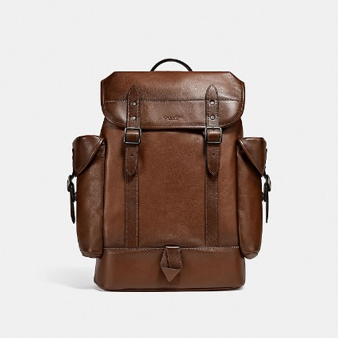

# HITCH BACKPACK

STYLE NO: C2675

SGD 1,295

## DESCRIPTION

COMBINING EFFORTLESS STYLE AND MAJOR FUNCTIONALITY, OUR HITCH TAKES YOU TO WORK, WEEKENDS AND EVERYWHERE IN BETWEEN. CRAFTED OF SOFT SPORT CALF LEATHER, THIS ORGANIZED BACKPACK HAS SPACE FOR A 15” LAPTOP, INTERIOR MULTIFUNCTION POCKETS TO HOLD SMALL ACCESSORIES, AND EXTERIOR SIDE POCKETS FOR EASY ACCESS TO ESSENTIALS. IT’S A COMFORTABLE LIGHTWEIGHT STYLE WITH A DURABLE MICROFIBER LINING AND SPACER MESH BACKING.

## DETAILS

• Sport calf leather

• Inside zip, cell phone and multifunction pockets

• Inside laptop sleeve

• Drawstring and snap closures, fabric lining

• Top handle with 6.5cm drop

• Outside snap pockets

• Adjustable shoulder straps

• Fits a 38cm laptop

• 31cm (L) x 42cm (H) x 14.5cm (W)

1. Tote

# 

# FIELD TOTE 40 WITH HORSE AND CARRIAGE PRINT

STYLE NO: C8446

SGD 950

## DESCRIPTION

FROM BUSY WEEKDAYS TO FUN-FILLED WEEKENDS, OUR GENEROUSLY SIZED FIELD TOTE 40 HAS SPACE TO HOLD EVERYTHING YOU NEED AND MORE—WITH ROOM FOR A 15" LAPTOP AND A ZIP POCKET TO HOLD SMALL ESSENTIALS. THIS VERSATILE CARRYALL IS CRAFTED OF STURDY CANVAS FEATURING OUR HORSE AND CARRIAGE MOTIF AND BADGE. ATTACH THE SPORTY WEBBING STRAP TO WEAR ON THE SHOULDER OR CROSSBODY.

## DETAILS

• Printed coated canvas and polished pebble leather

• Inside zip pocket

• Snap closure, fabric lining

• Handles with 15cm drop

• Detachable strap with 60cm drop for shoulder or crossbody wear

• Fits a 38cm laptop

• 40cm (L) x 36.5cm (H) x 20cm (W)

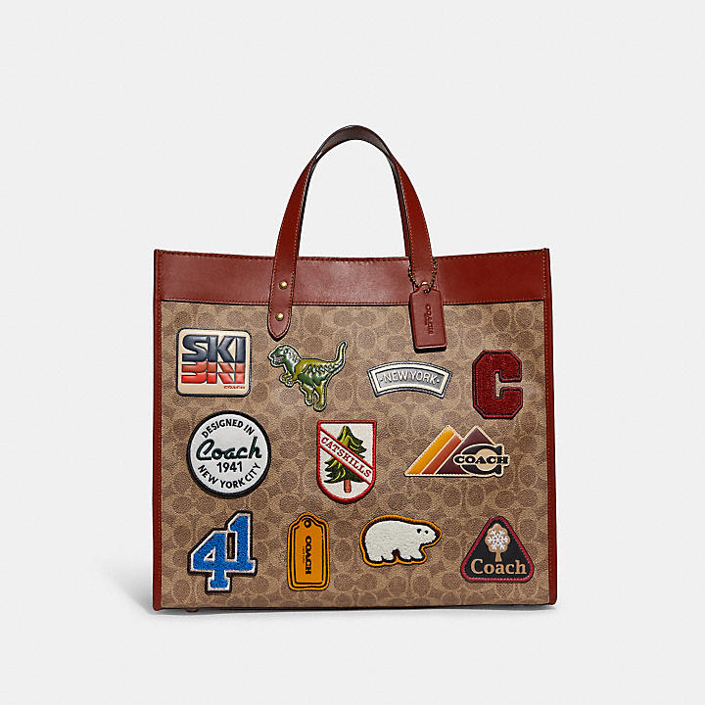

# FIELD TOTE 40 IN SIGNATURE CANVAS WITH PATCHES

STYLE NO: C6676

SGD 1,100

## DESCRIPTION

FROM BUSY WEEKDAYS TO FUN-FILLED WEEKENDS, OUR GENEROUSLY SIZED FIELD TOTE 40 HAS SPACE TO HOLD EVERYTHING YOU NEED AND MORE—WITH ROOM FOR A 15” LAPTOP AND AN INSIDE ZIP POCKET TO SECURE SMALL ESSENTIALS. THIS VERSATILE CARRYALL IS CRAFTED OF REFINED LEATHER AND OUR SIGNATURE CANVAS DETAILED WITH WHIMSICAL ALPINE-INSPIRED COACH PATCHES. ATTACH THE SPORTY WEBBING STRAP TO WEAR ON THE SHOULDER OR CROSSBODY.

## DETAILS

• Signature coated canvas and refined calf leather

• Inside zip pocket

• Snap closure, fabric lining

• Handles with 15cm drop

• Detachable strap with 60cm drop for shoulder or crossbody wear

• Fits a 38cm laptop

• 40cm (L) x 36.5cm (H) x 20cm (W)

1. Sling bags

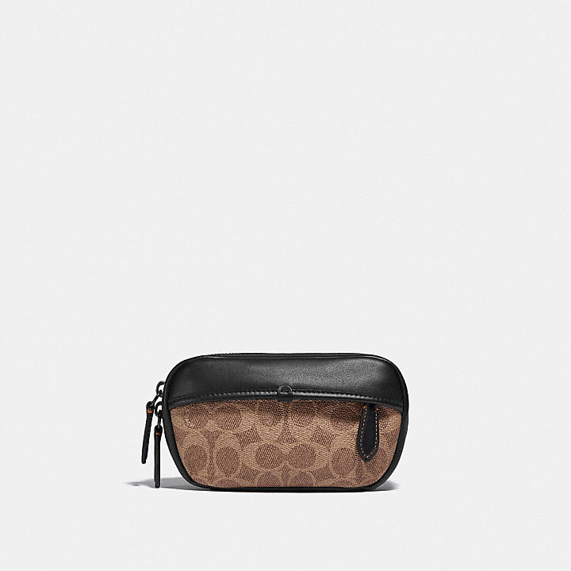

# CHARTER MINI SLING IN SIGNATURE CANVAS

STYLE NO: C2596

SGD 375

## DESCRIPTION

FOR ADVENTURES NEAR AND FAR, OUR CHARTER IS DESIGNED TO MAKE EVERY JOURNEY, COMMUTE AND ERRAND FEEL LIKE A FIRST-CLASS EXPERIENCE. CRAFTED OF OUR SIGNATURE CANVAS AND REFINED LEATHER, THE MINI SLING HOLDS A PHONE, NOTEPADS AND OTHER SMALL ESSENTIALS. WEAR THE HANDS-FREE DESIGN AT THE WAIST OR CROSSBODY.

## DETAILS

• Signature coated canvas and refined calf leather

• Zip closure, fabric lining

• Outside zip pocket

• Adjustable strap for wear at waist

• 17cm (L) x 10cm (H) x 4cm (W)

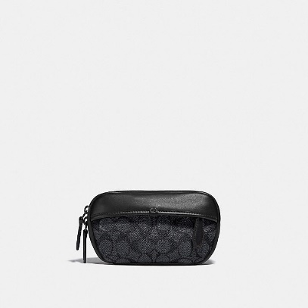

# CHARTER MINI SLING IN SIGNATURE CANVAS

STYLE NO: C2596

SGD 375

## DESCRIPTION

FOR ADVENTURES NEAR AND FAR, OUR CHARTER IS DESIGNED TO MAKE EVERY JOURNEY, COMMUTE AND ERRAND FEEL LIKE A FIRST-CLASS EXPERIENCE. CRAFTED OF OUR SIGNATURE CANVAS AND REFINED LEATHER, THE MINI SLING HOLDS A PHONE, NOTEPADS AND OTHER SMALL ESSENTIALS. WEAR THE HANDS-FREE DESIGN AT THE WAIST OR CROSSBODY.

## DETAILS

• Signature coated canvas and refined calf leather

• Zip closure, fabric lining

• Outside zip pocket

• Adjustable strap for wear at waist

• 17cm (L) x 10cm (H) x 4cm (W)

1. Crossbody bags

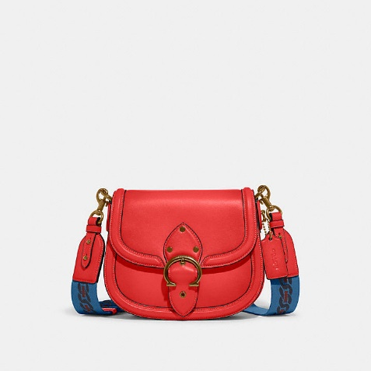

# BEAT SADDLE BAG

STYLE NO: C3738

SGD 995

## DESCRIPTION

MADE FOR GOING PLACES AND DOING THINGS, OUR BEAT BAG IS INSPIRED BY THE HEARTBEAT OF NEW YORK CITY. CRAFTED OF OUR BUTTERY SOFT GLOVETANNED LEATHER, THE SADDLE BAG FEATURES INSIDE MULTIFUNCTION POCKETS, AN OUTSIDE POCKET FOR EASY ACCESS TO ESSENTIALS AND A SECURE SNAP CLOSURE ACCENTED WITH OUR COACH BUCKLE. ENDLESSLY VERSATILE, THE BAG CAN BE WORN ON THE SHOULDER OR CROSSBODY FOR CONVENIENT HANDS-FREE WEAR.

## DETAILS

• Glovetanned leather

• Inside zip and slip pockets

• Snap closure, fabric lining

• Outside open pocket

• Detachable strap with 61cm drop for shoulder or crossbody wear

• Includes interchangeable webbing strap with 63cm drop

• 22.5cm (L) x 18cm (H) x 6cm (W)

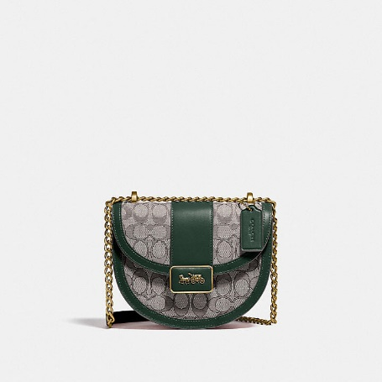

# ALIE SADDLE BAG IN SIGNATURE TEXTILE JACQUARD

STYLE NO: C5865

SGD 695

## DETAILS

• Signature textile jacquard and refined calf leather

• One credit card slot

• Inside multifunction pocket

• Bar buckle closure, leather lining

• Handles convert to shoulder strap with 54.5cm drop

• 20cm (L) x 16cm (H) x 7.5cm (W)

## Chloe’

## Backpack

Sheltersuit & Chloé backpack in upcycled printed canvas & calfskin leather

US$ 867

## DETAILS

Backpack in upcycled printed canvas & calfskin leather   
Carry: backpack & hand

- 1 inside main compartment  
- 1 flat inside pocket with a metal hook closure  
- 1 inside zippered pocket  
- 1 outside zippered pocket  
- 1 outside side flat pocket  
- Inside drawstring closure  
- Clip closure  
- Canvas & silk lining which is unique to every bag  
- Adjustable shoulder strap for a backpack carry  
  
- Width: 10.8" (27.5 cm)  
- Depth: 6.9" (17.5 cm)  
- Height: 17.1" (43.5 cm)  
  
Top handle: 3.5" (9 cm)  
  
Made with repurposed and upcycled leather and canvas.  
Respect care instructions on the leaflet.  
  
Color: deep ocean  
Item code: CHC21WS480F8549Y

## DESCRIPTION

A thoughtful and impactful piece, crafted with high-quality reused materials and delivered in an exclusive eco-friendly box. This drawstring backpack in calfskin and upcycled printed canvas features a casual and playful allure. It was designed as part of a creative collaboration between Chloé and Sheltersuit. Each piece is unique and reveals its own distinctive mix of prints and colors on the inside, which will differ from the photos on chloe.com (shown for illustration purposes only).

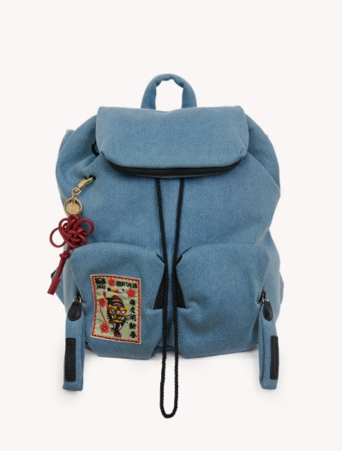

# **JOY RIDER BACKPACK**

US$ 389

DETAILS

Backpack in denim with embroidered patch & smooth cowhide leather key ring  
Carry: hand, shoulder & back

- 1 roomy main compartment with cotton drawstring closure  
- Zippered pocket and 2 flat pockets inside  
- 2 zippered front pockets  
- 1 zippered pocket on the flap  
- Removable smooth cowhide key ring  
- Top handle  
- Adjustable & comfortable straps in soft padded nylon  
- Gold-toned engraved See By Chloé medal  
- Gold brass finish  
- 100% Cotton canvas lining  
  
- Width: 11.8" (30 cm)  
- Height: 15.4" (39 cm)  
- Depth: 6.3" (16 cm)

Color: denim  
Item code: CHS22SS840B2545D

## DESCRIPTION

## This backpack is made of fabric. It has been treated to make it water-repellent; however, contact with humidity/rain/heat should be limited. We recommend that you take special care with white or light-colored fabrics to avoid staining. Avoid rubbing the product against rough surfaces and protect it from sources of humidity/light/heat/liquid/grease.

## Tote

## 

# **MEDIUM WOODY TOTE BAG**

Medium Woody tote bag in cotton canvas & shiny calfskin with Woody ribbon

US$ 984

DESCRIPTION

Crafted from subtly speckled cotton canvas detailed with shiny calfskin strips, this medium Woody tote bag is a spacious day-to-evening bag with a strong summer attitude. The roomy inside compartment includes a practical flat pocket.  
  
The bag's sharp, modern lines are emphasized by the contrasting vertical leather strips and the signature Chloé logo ribbon carried over from the Maison's Woody mule. Carry this tote bag comfortably on the shoulder.

DETAILS

Tote bag in cotton canvas & shiny calfskin with Woody ribbon  
Carry: shoulder

- 2 long handles  
- 1 spacious main compartment  
- 1 internal flat pocket  
Comes with a dust bag  
  
- Width: 14.6" (37 cm)  
- Height: 10.2" (26 cm)  
- Depth: 4.7" (12 cm)  
- Strap drop: 8.7" (22 cm)

Color: white & brown  
Item code: CHC21US383E6690U

## 

# **MARCIE HANDBAG**

Marcie leather handbag in multicolor suede & shiny calfskin

US$ 2,251

DESCRIPTION

This iconic Marcie leather handbag is a roomy and practical day bag crafted from multicolor suede and shiny calfskin for a graphic effect. Clean lines and a contoured design enhance the slouchy silhouette, while hand-wrapped leather handles add crafty detail. The detachable strap allows for casual, cross-body styling.

DETAILS

Leather handbag in multicolor suede & shiny calfskin  
Carry: hand, long shoulder & cross-body

- 1 Roomy compartment  
- 1 Front slip pocket hidden by the flap  
- 1 Internal zippered pocket  
- Removable leather strap  
- Antique gold finishing  
- Cotton lining  
Comes with a dust bag  
  
- Width: 14.2" (36 cm)  
- Height: 11" (28 cm)  
- Depth: 4.7" (12 cm)  
- Min. strap drop: 18.5" (47 cm)  
- Max. strap drop: 20.5" (52 cm)

Color: Motty Grey  
Item code: CHC22US660H1423W

## Crossbody bags

## 

# **MARA CROSS-BODY BAG**

US$ 531

DESCRIPTION

This shoulder bag is made of real leather. We recommend that you take the greatest care to prevent premature scratches and wear. Any imperfections or variations in colour and/or appearance must not be considered as faults but are what makes the product beautiful.

DETAILS

Cross-body shoulder bag in bi-colour smooth cowhide leather  
Carry: cross-body & long shoulder

- Magnetic closure  
- 1 roomy main compartment  
- 1 flat card slot inside  
- 1 adjustable & removable strap  
- Light gold finish  
- 100% cotton canvas lining  
Comes with a dust bag  
  
- Width: 22 cm  
- Height: 18 cm  
- Depth: 9 cm  
- Min. strap length: 53.5 cm  
- Max. strap length: 58.5 cm

Colour: cement beige  
Item code: CHS19WSA2963024H

## 

# **KATTIE CROSS-BODY BAG**

US$ 2,045

DESCRIPTION

Crafted from shiny calfskin for a sensual feel, this Kattie cross-body bag combines a sleek, masculine silhouette with a bold jewelry signature. The flap design is highlighted by the articulated bracelet in three iconic Chloé materials for rich texture: brass, wood and leather. The elegant gusset construction ensures a roomy main compartment, while the concealed magnet closure complements the clean lines. Carry this day-to-evening bag in hand by the bracelet handle, or on the shoulder or cross-body with the adjustable and removable strap.

DETAILS

Kattie cross-body bag in shiny calfskin  
Carry: hand, cross-body & shoulder

- Magnet closure  
- 2 main compartments  
- 1 inner flat pocket  
- Adjustable & removable strap  
- Nappa lining  
Comes with a dust bag  
  
- Width: 7.8" (19.7 cm)  
- Height: 5.7" (14.5 cm)  
- Depth: 2.8" (7 cm)  
- Min. strap drop: 15.7" (40 cm)  
- Max. strap drop: 20.9" (53 cm)

Color: autumnal brown  
Item code: CHC22SS500G14211

## Louis Vuitton

## backpack

## 

M45973

# BACKPACK MULTIPOCKET



**$3,600.00**

For his second Louis Vuitton collaboration, the Japanese designer Nigo has updated the Multipocket backpack with his Monogram Drip look: the iconic Monogram pattern on black denim “flowing” across fine-grained Taurillon leather. This practical bag features multiple pockets and a main compartment large enough for a laptop, plus a bright red heart-shaped tag for an eye-catching signature touch.

Detailed Features

11.8 x 15.7 x 6.1 inches  
(length x Height x Width)

* Black Monogram denim and Taurillon leather
* Cowhide leather trim
* Textile lining
* Palladium-color hardware
* Signature leather heart tag
* Adjustable shoulder straps
* Zipped main compartment with two leather pulls
* Inside flat pocket
* Two zipped front pockets
* Name tag
* Handle:Single

## 

M45335

# DEAN BACKPACK



**$2,640.00**

The Dean backpack in Monogram Macassar emanates premium sportswear allure. Large enough to hold a laptop, it has three inside pockets plus a zipped front pocket to keep everything neatly organized and easily accessible. And it’s packed with refined details, like hot-stamped leather corners and an embossed Louis Vuitton flower pattern on the back

Detailed Features

12.2 x 16.3 x 6.1 inches  
(length x Height x Width)

* Monogram Macassar coated canvas and cowhide leather
* Cowhide-leather trim
* Textile lining
* Matte black hardware
* Adjustable shoulder straps
* Inside flat pocket
* Inside duo flat pocket
* Front zipped pocket
* Handle:Single

## Tote

## 

M45733

# WEEKEND TOTE GM



**$2,980.00**

The Week-End Tote in Monogram Macassar canvas is inspired by Louis Vuitton’s historic Week-End bag. Perfect for a day in the city or a weekend getaway, it offers a high-capacity main compartment plus a handy outside phone pocket. And it’s easy to carry with its adjustable strap and flat handles that fit comfortably on the shoulder.

Detailed Features

15.2 x 11.4 x 4.3 inches  
(length x Height x Width)

* Monogram Macassar coated canvas
* Cowhide leather trim
* Textile lining
* Black hardware
* Large main compartment
* Inside flat pocket with zipped compartment
* Front phone pocket
* Strap:Removable, adjustable
* Strap drop: 15.4 inches
* Strap drop max: 30.7 inches
* Handle:Double

M46016

# ONTHEGO MM

**$3,850.00**

This Onthego MM tote features a stitched motif that echoes the quilted interior of Louis Vuitton’s original trunks. The Monogram Empreinte leather is first printed, then embossed and embroidered with the pattern, to create a rich, crafted effect. A statement piece of the season, the bag is a versatile companion that lends itself to a variety of carry styles.

## Detailed Features

13.8 x 10.6 x 5.5 inches  
(length x Height x Width)

* Crème Beige / Black
* Embroidered embossed supple grained cowhide leather
* Supple smooth cowhide-leather trim
* Microfiber lining (Black)
* Gold-color hardware
* Inside flat zipped pocket
* Inside double pocket
* Handle:Double

## Sling

## 

N41719

# AVENUE SLING BAG



**$1,900.00**

**This item has very limited availability online and in select stores.**  
  
The Avenue Sling Bag in Damier Graphite canvas fits urban lifestyles perfectly: compact and sporty, with a cool and casual attitude. Its “smart” strap adjusts for left- or right-side carry. The body-friendly shape and the two zipped compartments keep valuables close and secure.

## Detailed Features

7.87 x 12.2 x 3.94 inches  
(length x Height x Width)

* Coated Damier Graphique canvas
* Textile lining
* Silver-colour metallic pieces
* Two zipped compartments
* Outside zipped pocket
* 2 inside flat pockets

## Crossbody

## 

M45777

# MULTI POCHETTE ACCESSOIRES

**$2,980.00**

The Multi Pochette Accessoires cross-body bag takes on a striking aspect in embossed black Monogram Empreinte leather, overprinted with the Monogram motif in a cream color. Just the right size to carry a woman’s essentials, this two-in-one bag keeps things organized with its removable pouches. It’s comfortable to wear thanks to its suppleness and light weight.

## Detailed Features

9.8 x 5.7 x 1.8 inches  
(length x Height x Width)

* Removable Large Pochette: L 25.0 x H 14.5 x W 4.5 cm
* Removable Small Pochette: L 20.0 x H 12.5 x W 4.0 cm
* Black/Cream
* Embossed supple grained cowhide leather
* Cowhide-leather trim
* Microfiber lining
* Gold-color hardware
* Inside flat pocket in the Large Pochette
* Strap:Removable, adjustable
* Strap drop: 10.6 inches
* Strap drop max: 18.5 inches
* Chain:Removable
* Chain drop: 12.6 inches

## 

M45730

# DUO MESSENGER



**$2,640.00**

The Duo Messenger bag is a modern cross-body bag made from navy blue Monogram Shadow leather, with a a detachable coin purse on the strap. The leather’s discreetly embossed Monogram pattern is amplified by the light blue Monogram print. The Duo in Monogram Shadow is for leather lovers looking for a subtle touch of color.

## Detailed Features

10.2 x 7.3 x 2 inches  
(length x Height x Width)

* Navy Blue
* Monogram Shadow cowhide leather
* Cowhide-leather trim
* Textile lining
* Black hardware
* Small coin purse
* Front zipped pocket
* Inside flat pocket
* Strap:Not removable, adjustable
* Strap drop: 31.9 inches
* Strap drop max: 48.4 inches

1. Dior
   1. Backpack

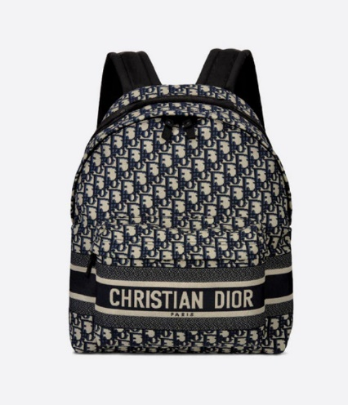

# **DIORTRAVEL BACKPACK Blue Dior Oblique Jacquard**

Reference: M6104STZQ_M928

US$ 2,600.00

DESCRIPTION

The DiorTravel backpack combines hallmark House elements with a modern and practical design. Made with blue water-repellant Dior Oblique technical jacquard, it is embellished with a 'CHRISTIAN DIOR' signature on the front. The large zipped flap opens with ease to access all the essentials. The large backpack can be carried over the shoulder or on the back thanks to its handle and straps.

* 'CHRISTIAN DIOR' signature on the front
* Adjustable shoulder straps
* Front zip pocket
* Dust bag included
* Made in Italy

SIZE & FIT

* Dimensions: 35 x 41 x 15 cm / 14 x 16 x 6 inches

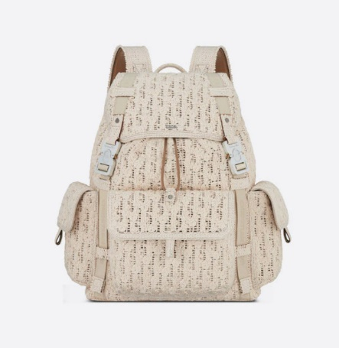

# **DIOR HIT THE ROAD BACKPACK Cream Dior Oblique Macramé**

Reference: 1ESBA165RPS_H19E

US$ 2,500.00

DESCRIPTION

The Dior Hit The Road Backpack is a new style this season that combines modernity with the House's couture spirit. Showcasing Dior's outstanding savoir-faire, the style is crafted in cream Dior Oblique Macramé. Adorned with two 'CHRISTIAN DIOR' nylon jacquard bands, the design has a spacious main compartment, a large flap pocket on the front and two flap pockets on the sides. The practical backpack will lend the finishing touch to all casual outfits.

* Cream Dior Oblique Macramé
* Interior embossed with 'DIOR' signature
* 'CHRISTIAN DIOR' nylon jacquard bands
* Flap and drawstring closure
* Aluminum buckles with 'Christian Dior' signature and 'CD' initials
* Adjustable shoulder straps in padded technical mesh
* Top handle
* Padded technical mesh-reinforced back with 'DIOR' signature
* Front pocket and side flap pockets
* Interior laptop compartment
* Dust bag included

SIZE & FIT

* Dimensions: 43 x 51 x 20 cm / 17 x 20 x 8 inches
* The main compartment's size is suitable for a 15-inch laptop computer, documents and a tablet
* The side pockets are ideal for an iPhone 12 Pro Max
  1. Tote

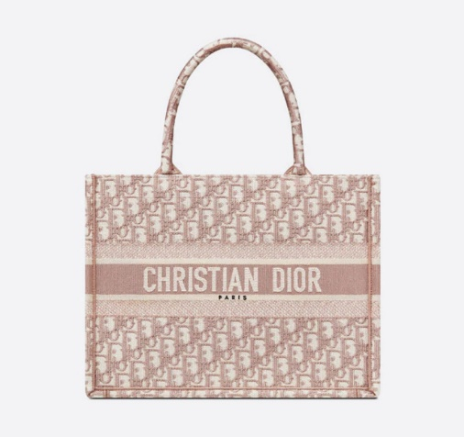

# **MEDIUM DIOR BOOK TOTERose Des Vents Toile de Jouy Embroidery**

Reference: M1296ZTDT_M912

US$ 3,100.00

DESCRIPTION

Introduced by Maria Grazia Chiuri, Creative Director of Christian Dior, the Dior Book Tote has become a staple of the Dior aesthetic. Designed to hold all the daily essentials, the style is fully embroidered with a Rose des Vents Toile de Jouy motif and adorned with a 'CHRISTIAN DIOR' signature on the front. The medium tote exemplifies the House's signature savoir-faire and may be carried by hand or worn over the shoulder.

* 'CHRISTIAN DIOR' signature on the front
* Dust bag included
* Made in Italy

SIZE & FIT

* Dimensions: 36.5 x 28 x 17.5 cm / 14.5 x 11 x 7 inches
* The size is suitable for a 16-inch laptop computer

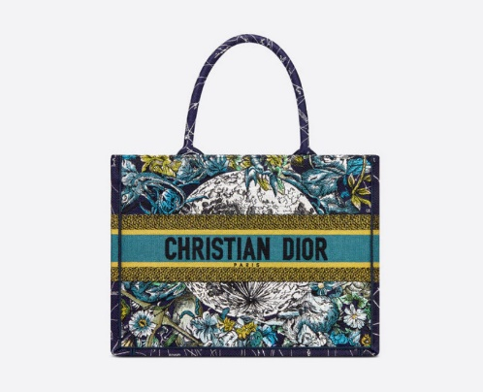

# **MEDIUM DIOR BOOK TOTEBlue Dior Constellation Embroidery**

Reference: M1296ZRHP_M928

US$ 2,550.00

DESCRIPTION

Introduced by Maria Grazia Chiuri, Creative Director of Christian Dior, the Dior Book Tote has become a staple of the Dior aesthetic. Designed to hold all the daily essentials, the style is fully embroidered with the blue Dior Constellation motif, imagined by artist Pietro Ruffo, and further adorned with the three-tone 'CHRISTIAN DIOR' signature on the front. The medium tote exemplifies the House's signature savoir-faire and may be carried by hand or worn over the shoulder.

* 'CHRISTIAN DIOR' signature on the front
* Dust bag included
* Made in Italy

SIZE & FIT

* Dimensions: 36.5 x 28 x 17.5 cm / 14.5 x 11 x 7 inches
* The size is suitable for a 16-inch laptop computer
  1. Sling

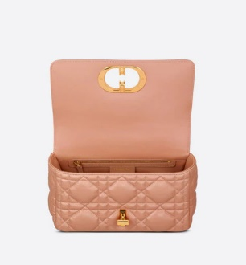

# **MEDIUM DIOR CARO BAGRose Des Vents Padded Macrocannage Calfskin**

Reference: M9242UNGK_M49P

US$ 4,500.00

DESCRIPTION

The Dior Caro bag combines modernity with timeless elegance. The design is crafted in Rose des Vents calfskin and is distinguished by its original quilted-effect Macrocannage stitching. The bag features a flap adorned with an antique gold-finish metal 'CD' twist clasp, inspired by the seal of a Christian Dior perfume bottle. The detachable chain shoulder strap with 'CD' signature links allows the medium bag to be carried by hand or worn over the shoulder and may be replaced by one of the House's wide embroidered straps for day or evening attire.

* Flap closure with 'CD' twist clasp
* Embossed '30 MONTAIGNE' signature on the back
* Adjustable, removable 'CD' chain link strap with 'Christian Dior' military-inspired buckle
* Two removable links with an X-shaped center notch allow the chain to be opened.
* Interior zip pocket and patch pocket
* Back pocket
* The bag may be paired with different embroidered straps
* Dust bag included
* Made in Italy

SIZE & FIT

* Dimensions: 25 x 12 x 7 cm / 10 x 4.5 x 3 inches

# **SADDLE BAGBeige Multicolor Mizza Embroidery**

Reference: M0446CRHM_M918

US$ 3,600.00

DESCRIPTION

Maria Grazia Chiuri brings a fresh update to the iconic Saddle bag. The design is fully embroidered with the beige multicolor Mizza motif, inspired by a leopard pattern from the House archives. The legendary style features a Saddle flap with a magnetic 'D' stirrup clasp and boasts an antique gold-finish metal 'CD' signature on each side of the handle. The bag can be carried by hand or worn over the shoulder and may be customized with different shoulder straps.

* Magnetic 'D' stirrup closure
* 'CD' signature on the strap
* Back pocket
* Dust bag included
* Made in Italy

SIZE & FIT

* Dimensions: 25.5 x 20 x 6.5 cm / 10 x 8 x 3 inches