Microfinance Management System: Human Resource II

(Time and Attendance, Leave Management, Performance

Management, and Social Recognition with

Automated Evaluation Analytics and

Rule-Based Machine Learning)

A Capstone

Presented to the Faculty of

The College of Computer Studies

Bestlink College of the Philippines

In Partial Fulfillment

Of the Requirements for the Degree of

Bachelor of Science in Information Technology

John Lennon D. Aguilor

Steffano B. Dizo

Restituto III M. Murillo

Rhyss Adrian G. Torres

Wendel G. Ureta

2024

APPROVAL SHEET

This capstone is entitled MICROFINANCE MANAGEMENT SYSTEM: HUMAN RESOURCE II (TIME AND ATTENDANCE, LEAVE MANAGEMENT, PERFORMANCE MANAGEMENT, AND SOCIAL RECOGNITION WITH AUTOMATED EVALUATION ANALYTICS AND

RULE-BASED MACHINE LEARNING). prepared and submitted by, JOHN

LENNON AGUILOR, STEFFANO DIZO, RESTITUTO III MURILLO, RHYSS ADRIAN TORRES, WENDEL URETA, in partial fulfillment of the requirements for the degree of Bachelor of Science in Information Technology, has been examined and is recommended for acceptance and approval Oral Defense.

**ROMMEL J. CONSTANTINO**

Adviser

### CAPSTONE REVIEW PANEL

Approved by the Committee on Oral Examination with a grade of**:**

Mr. Romeo S. Alix Jr. Mr. Glenox O. Luzong

Member Member

Mr. Junnel E. Avestro

Chair

Accepted and approved in partial fulfillment of the requirements for the degree of Bachelor of Science in Information Technology.

### ROSICAR E. ESCOBER, Ph. D

Dean, College of Computer Studies

Date of Oral Defense: November 20, 2024

# ACKNOWLEDGMENT

The researchers would like to express their heartfelt thanks and gratitude to the following persons who, in one way or another, has contributed much, and extended willingness and support needed to make this research possible:

**Dr. Maria M. Vicente,** President/CEO of Bestlink College of the Philippines, for her kindness and generosity for founding this school and affording less privileged students with an opportunity to continue their studies and pursue their dreams.;

**Ms. Edith M. Vicente**, Executive Vice President, for providing the needed information to complete this research;

**Dr. Charlie I. Cariño**, Vice President for Academic Affairs, for his support and encouragement to make this thesis writing possible;

**Engr. Diosdado T. Lleno,** Vice President for Administration and

Finance, for his words of encouragement and motivation;

**Dr. Joy Evelyn A. Ignacio,** Director, Center for Research and Development, for her good heart to extend her help needed by the researchers.

**Dr. Rosicar E. Escober**, Dean, College of Computer Studies of

Bestlink College of the Philippines, for providing a guideline documentation in capstone project.

**Mr. Rommel J. Constantino**, Program Head, Bachelor of Science in knowledge Technology, who is also our research adviser, for his continuous supervision, for giving us all the information we needed about the project, and for helping us finish it.

**Mr. Ronald G. Roldan Jr,** Research Coordinator, for helping us in improving our research and guiding us in completing this project.

**Families and Friends**, for all of the material and emotional assistance that helped the researchers to overcome every challenge, particularly during the most challenging time that motivated them to finish their study.

And above all, to the **Almighty God**, for the strength and knowledge that allowed this research study to be finished.

### DEDICATION

This business research study is wholeheartedly dedicated first and foremost to the researchers, for executing dedication, time, effort, motivation, sacrifice, and courage to make this conducting study a fruitful and successful piece of work.

To our beloved parents who have been our inspiration and gave us strength when we thought of giving up, which continually provide their moral, spiritual, emotional and financial support.

To each sibling and circle of friends who shared their words of advice and encouragement to finish this study.

To the research advisers and professors, for extending help by giving guidance, supervision, time and wisdom to the researchers in conducting this business research study.

And lastly, above all, to our Almighty God, for giving guidance, strength, power of mind, protection, skills and for giving us a healthy life. All of these we offer to you.

# ABSTRACT

|  |  |
| --- | --- |
| Title: | MICROFINANCE MANAGEMENT SYTEM: HUMAN  RESOURCE II (TIME AND ATTENDANCE, LEAVE  MANAGEMENT, PERFORMANCE MANAGEMENT, AND  SOCIAL RECOGNITION WITH AUTOMATED EVALUATION  ANALYTICS AND RULE-BASED MACHINE LEARNING) |
| Authors: | AGUILOR, JOHN LENNON |
|  | DIZO, STEFFANO |
|  | MURILLO, RESTITUTO III |
|  | TORRES, RHYSS ADRIAN |
|  | URETA, WENDEL |
| Degree: | Bachelor of Science in Information Technology |
| Major: | Information Management, Information Security, Network |

Administrative

This study focuses on the adoption of technology in human resources, microfinance management system. With the using of four features Time and Attendance, Leave Management, Performance

Management and Social Recognition. Also, by applying Automated Evaluation Analytics and Rule-Based Machine Learning, the proposed system enhances decision-making and operational efficiency.

The implementation of the Time and Attendance module, will ensures the accurate tracking of employees’ attendance and work hours efficiently. The leave management feature helps employee to file much easier. The performance management, also help the employee to know that they are lacking inside the work place and gaining developments. Lastly the social recognition gives the top contributor employee more credit for their hard-work in the company.

# TABLE OF CONTENTS

**Page**

**TITLE PAGE 1**

**APPROVAL SHEET** **2**

**ACKNOWLEDGMENT** **3**

**DEDICATION ABSTRACT** **6**

**TABLE OF CONTENTS** **8**

**LIST OF TABLES** **10**

**LIST OF FIGURES** **11**

**LIST OF APPENDICES** **12**

**Chapter** **1**

**INTRODUCTION**

Background of the Capstone Project 14

Context and Scope 16

Problem Statement 19

Objectives and Goals 20

Significance and Relevance 22

Structure of the Documents 23

**Chapter** **2**

**LITERATURE REVIEW**

Overview of the Agile Scrum Methodology 25

Enterprise Architecture Concept 27

Microservice Architecture 29

Related Literature 30

Integration of Information System in Enterprise Environments 34

**Chapter 3**

**METHODOLOGY**

Agile Scrum Method in Projects 36

Roles and Responsibilities 37

Sprint Cycles 38

Scrum Artifacts 45

Integration Approach for Information System 85

## LIST OF TABLES

### Table Page

Table 1: Illustrate Objectives and Goals 20

Table 2: Illustrate Roles and Responsibilities 37

Table 3: Sprint Cycles 38

Table 4: Product Backlog (Time and Attendance) 45

Table 5: Product Backlog (Performance Management) 51

Table 6: Product Backlog (Leave Management) 54

Table 7: Product Backlog (Social Recognition) 57

Table 8: Illustrate The EIS Information Security 60

Table 9: Illustrate The EIS Standard 66

Table 9: Illustrate The Backlog for Integration 70

Table 10: Illustrate the UI/UX 71

Table 11: Illustrate The Backlog for Analytics 74

Table 12: Illustrate The Sprint Backlog 76

## LIST OF FIGURES

### Table Page

Figure 1: Illustrate The Sprint Cycle 37

Figure 2: Illustrate The Microservices Diagram 84

Figure 3: Illustrate The Communication Pattern

Figure 4: Illustrate The Data Flow Diagram

Figure 5: Illustrate The CI/CD Pipeline 85

Figure 6: Illustrate The Infrastructure as Code

Figure 7: Illustrate The BPA Top-Level 1

Figure 8: Illustrate The BPA Top-Level 2 89

Figure 9: Illustrate The BPA Top-Level 3

Figure 10: Illustrate The API Gateway

Figure 11: Illustrate The Use Case Diagram 92

Figure 12: Illustrate The Sequence Diagram 90

Figure 13: Illustrate The Sequence Diagram 91

## LIST OF APPENDICES

|  |  |
| --- | --- |
|  |  |
| Appendix A | Process Diagram |
| Appendix B | User Surveys |
| Appendix C | User Stories and User Cases |
| Appendix D | Sample Date |
| Appendix E | Stakeholder Interview Transcripts |
| Appendix F | System Performance Test Result |
| Appendix G | Data Security Measures |
| Appendix H | Mobile Application Prototype |
| Appendix I | Adviser Acceptance (Functional) |
| Appendix J during defense) | Panel Evaluation and Signature (plus photo ops |
| Appendix K  Consumption) | Capacity Planning (Estimates on Storage |
| Appendix L interviews | Pilot Companies’ Background with proofs of |
| Appendix M | Cloud Copy of the Codes (1 year validity) |
| Appendix N | IMRAD Format Summary |
| Appendix O | Comparison of the EIS to existing EIS’s (5 pages) |

Chapter 1

# INTRODUCTION

BACKGROUND OF THE CAPSTONE PROJECT

In Philippines where the access to traditional way of banking is limited, Microfinance organization offers small loans, saving choices, investment options, and other financial services for people with low income and individuals or groups who doesn’t have access to traditional banking systems. (Jumpah et al., Gakpo et al., 2021) As part of the poverty reduction in Ghana, the Association of Credit Unions in collaboration with governmental Organization, (NGO’s) creates microfinance schemes and makes financial assistance accessible to the poor, particularly Ghanaian women.

The administration of microfinance operations particularly human resources has grown in significance as the industry develops and expands. By investigating the complex connection between human resource management and microfinance management systems, this study emphasizes the important part that human resources play in maintaining the success of microfinance organizations. As the microfinance companies develops, the administration of its operations—particularly the of human resources has become more essential.

The present study highlights the essential part that human resources play in promoting the success of microfinance organizations through investigating the complex interaction between microfinance management systems and human resource management.

Microfinance Management System: Human Resource II project is a web-based system that offers several HR services, including time and attendance, leave management, performance management and social recognition. However, they struggle with productivity due to various issues encountered such as manual data collection, manual evaluation and giving right social recognition. In order to address these issues, the project team created a web-based system that facilitates and manages the organization by reducing time-consuming tasks and automating evaluations in order to improve accuracy of the information gathered.

# CONTEXT AND SCOPE

Microfinance institutions perform an essential part in providing financial services to areas with limited access. promoting financial security and business. Our system aims to aid the employees when it comes to providing reports. We offer automation to lessen the task of the employee. The scope of our project includes the automation on generating reports while focusing on accuracy of the data.

# SCOPE

Time and Attendance

1. Employee Tracking - automatically records working hours, overtime, and employee absences.
2. Report Generation – monthly generation of time in/out and attendance.

Leave Management

1. Leave Request - makes it easier for employees to request and handle leaves (paid, sick, annually etc.) through automated processes.
2. Leave Balance Tracking - keeps track of the amount of leave days that each employee remains with available and immediately changes balances.

Performance Management

1. Performance Appraisal - analyzing employee productivity according to established criteria.
2. Performance Development - evaluating what has to be learned and

developed in order to perform effectively.

Social Recognition

1. Employee Engagement - encourages employees through corporate acknowledgment, peer recognition, and incentives from the company.
2. Integration - is able to be connected to the performance management system and provide rewards according to accomplishments and achievements.

LIMITATION

Time and Attendance

1. Cost - It can be expensive to implement and maintain a time and attendance system, particularly for bigger companies.
2. Data Accuracy - The accurateness of a time and attendance record is dependent on the quality of data input and the reliability of the hardware technology implemented.

Leave Management

1. Leave Fraud - an employee can fake the reason for a leave request since the system can’t collect proof.
2. Delayed approvals - some leave request may experience possible delay in their request due to admin activity.

Performance Management

1. Subjectivity - Subjective performance reviews might result in biases and discrepancies.
2. Resistance to Change – Employee resistance to performance management changes is possible, especially if they feel that the adjustments are burdensome or unfair.

Social Recognition

1. Limited Reach - Engagement and participation from employees are necessary for a social recognition program to be effective, but this can be challenging in larger companies.
2. Cost - It can be expensive to establish and maintain social recognition, particularly for organizations with limited financial resources.

# PROBLEM STATEMENT

Company’s nowadays faces problem in handling the employee’s data, including:

* Low level data management, resulting to inaccurate and incomplete employee information.
* Manual and poor attendance management makes it difficult for the company to track their employees time and attendance.
* Manual processing of leave requests requires more effort on employees and HR personnel making it more time consuming, increasing risk mistakes, miscalculation of leave balances and

difficult to track leave history.

* Inaccurate and biased performance evaluations due to manual assessment processes results in unfair employee evaluations.
* Lack of social recognition in the workplace often results in reduce / decrease employee motivation and productivity.

Our project seeks to resolve these challenges by creating a system that automates generation of employee time and attendance sheet, optimizes leave scheduling and leave request, implement fair performance evaluation, generates proper social recognition and create an accurate report.

# OBJECTIVES AND GOALS

The Microfinance Management System Human Resource II directly aids several of the corporate goals and objectives. The following table lists the business goals and achievements that the Microfinance Management System Project aids and how it aids them:

Table 1: Goals and Objective

|  |  |
| --- | --- |
| Goal and Objectives | Description |
| Accurate Reports | Creating a web-based tool that has accurate report base on the data  gathered on employees and ensures follow standardized  format. |
| Automation | Reduces the time and effort in managing/creating reports. |
| Digitalize Leave Process | Digitalizing the leave request process, this solution minimizes manual effort, reduces the risk of errors, and enhances tracking  capabilities. |
| Automated Evaluation | Implementing an automated  evaluation based on the company’s criteria / rule, reduces bias and improper evaluation to employee. |
| Recognition Platform | Giving proper social recognition to  good and high-performing employees to boost their motivation, productivity, and morale and encourage other  employees to work hard. |
| Centralize Employee Information | Create an integrated database for all employee records, promoting easy access and updates while  maintaining the security of data. |

# SIGNIFICANCE AND RELEVANCE

Microfinance Management System: Human Resources II (Time and

Attendance, Leave Management, Performance Management, and Social

Recognition with Automated Evaluation Analytics and Rule-Based Machine Learning is significant and beneficial because it aims to solve modern features such providing accurate data in attendance time-in and time-out, automated generation of reports, easier leave request and employees can see their performance and can receive peer recognition that can boost the performance of employee’s. this project is highly important in human resource department striving to fulfill the demand of employees for easier and convenient process of data.

EMPLOYEE – By having this system technology the employees can use the features that the we created. Also, by having designated portal for all employee of the company. They can easily track their time-in, time-out and attendance record, track their performance record for them to know their performance rating. They can also file a request for leave for them to balance their work life to their personal life and track their leave balance within the system. Lastly, they can receive social recognition based on their performance status that can boost their self-esteem and morale.

COMPANY – this system can help the company; by having this current technology the company can achieve accurate data gathering for their employee, and easier generating of monthly reports. It

FUTURE RESEARCHER - the future researcher can use our study and serve as a new starting point for curious new researcher endeavors. Our findings may help them to develop new approaches for computer and technological problems.

# STRUCTURE OF THE DOCUMENT

Chapter 1 Provides the project background, problem statement, goal and objectives, significance and relevance of the Microfinance Management System Human Resource.

The background of a project

Gives the reason and context for initiating a specific project. It describes t he situations, challenges, and current state of events deemed the project required and clarifies the larger context in which it will function.

Problem Statement

Contains the problem or issue that a project or study aims to solve in a manner that is simple and straightforward. It outlines the precise issue that needs to be fixed and describes the difference between the existing state and what is expected state. Typically, the problem statement outlines the problem's characteristics, consequences, and the need for a solution.

Goals and Objectives

You will learn that a goal in this context is a broad, long-term conclusion or vision that you hope to accomplish with your project or endeavor. Conversely, the goals are the precise, quantifiable steps you take to get there. When combined, these components form a cohesive plan: the aim establishes your general course, and the goals offer the specific actions required to reach it.

Chapter 2 contains an overview of relevant literature, related literature and other existing system to define the context and bring out any gaps that the study aims to address.

Chapter 3 explains the process workflows and technology framework used in the system's design, development, and implementation.

CHAPTER 2

# RELATED STUDIES AND LITERATURE REVIEW

## AGILE SCRUM METHODOLOGY

Zingoni, M. (2021). *In IGI Global eBooks* (pp. 276–290). This chapter focuses on the issues that an organization's implementation of the agile scrum approach presents in terms of human resources. The majority of human resource functions need to be developed with specific regard for the dynamic pace, cross-functional composition, and self-directed team

style.

[Shuting Xu](https://ieeexplore.ieee.org/author/37086833185) et al (2023, March 11). *Integrating Scrum Project Management in Information Technology Capstone Course.* Agile project management has replaced the traditional Waterfall as the main project management method in IT industry. Scrum is the most popular Agile framework, which may greatly improve productivity.

[Faisal Hayat](https://ieeexplore.ieee.org/author/37086149097) et al., (2019, July 1). *The Influence of Agile Methodology (Scrum) on Software Project Management*. The software business places a strong emphasis on software project management. It covers a variety of procedures and subject areas. The requirements of the project directly affect the three constraints of the software project: time, money, and scope.

Agile methodology is an iterative approach to software project development that minimizes risk, allows for frequent changes, and is delivered quickly. Agile-based software projects also heavily rely on software project management. Software project management is impacted by agile approach across ten knowledge domains. We surveyed a variety of software

organizations for this study, and the results indicate that nearly all of them employ agile development, or Scrum, which improves software project management.

Hema, V., et al. (2020) *Scrum: An Effective Software Development Agile Tool.*The world is surviving these days thanks to software goods, according to the IOP Conference Series Materials Science and Engineering. The creation of software is a difficult task, and in today's cutthroat market, software must be developed quickly to stay competitive. Using the conventional software development models, such as the waterfall and spiral models, is insufficient. One of the useful Agile Methodology techniques that we suggested in this instance is the SCRUM TOOL. Agile is a technique that is progressive and iterative in nature. It provides software developers with an operational framework for conventional software development methods, such as the waterfall model. While traditional models work well for small products with static requirements, they are not appropriate for products with dynamic requirements, for which

SCRUM approach is advised.

[Kwete Mwana Nyandongo](https://ieeexplore.ieee.org/author/37089721078)[, Mmule Rebecca Madumo(](https://ieeexplore.ieee.org/author/37089721518)2022b, June

19).IEEE Conference Publication. This study examines and evaluates the effectiveness of Scrum, a well-liked agile project management system, and calculates the likelihood that it will be successfully implemented. From the positive standpoint, the survey monkey was utilized to gather data for the survey, and descriptive statistics were employed to analyze the results. The findings highlight the many advantages of Scrum techniques, as well as the difficulties encountered during implementation. They also pinpoint the success elements that need to be taken into account when putting the Scrum framework into practice. It also identifies the essential traits that an agile team needs to embrace in order to use scrum successfully.

## ENTERPRISE ARCHITECTURE CONCEPTS

Beese, Jannis; Haki, Kazem; Schilling, Raphael; Kraus, Martin; Aier, Stephan; Winter, Robert (2023*) European journal of information systems, Vol.32 (1), p.92-105.* Large organizations frequently use enterprise architecture management (The Enterprise Management Architecture to reduce duplication and inconsistency while coordinating local information system development efforts in accordance with organization-wide strategic objectives. Many organizations still have trouble making an effect from they’re The Enterprise Management Architecture (activities, despite the fact that EAM tools and procedures have improved over the past ten years. In order to further anchor EAM throughout the company, we outline how enterprise architects at Commerzbank, a significant global bank, used a control mechanism portfolio view. This method goes beyond the formal, top-down driven mechanisms that are primarily covered in EAM literature by enabling the deliberate fusion of a broad variety of distinct formal and informal EAM control mechanisms. Additionally, these portfolios of The Enterprise Architecture Management System management mechanisms offer a useful way to intentionally realign EAM in response to significant strategic changes. The use of this viewpoint is illustrated by following the development of EAM at Commerzbank over a ten-year period (2008–2018) in the face of a difficult and competitive environment. This led to a number of significant strategic realignments, which necessitated commensurate EAM changes. We think that these carefully thought-out and varied EAM control mechanism portfolios also give other big organizations a practical way to carry out EAM more successfully.

## MICROSERVICE ARCHITECTURE

Taibi, D., Lenarduzzi, V., & Pahl, C. (2020). Architectural patterns for microservices: A systematic mapping study. Journal of Systems and Software, 158, 110-122. The architectural approach known as microservices is becoming more and more common. However, there is still a shortage of knowledge regarding the adoption of an architectural style based on microservices. The purpose of this article is to describe several microservice architectural style patterns and the guiding concepts behind their creation. In order to find documented microservices usage and derive common patterns and principles from these use cases, researchers carried out methodical mapping research. These offer two significant additions. First, researchers found a number of generally accepted microservice design patterns that were mentioned in the case studies they found. Second, researchers provided a summary of the benefits, drawbacks, and lessons discovered for every pattern from the case studies in a catalogue formatted according to a standard framework. They can draw the conclusion that, for a set of accepted principles, distinct architecture patterns appear for various migration, orchestration, storage, and deployment settings.

## RELEVANT STUDIES AND RESEARCH

FOREIGN

Fomude et al., (2020). *Open Journal of Business and Management,* this study examines how graduate volunteer performance is affected by human resources management processes using a case study of Cameroonian microfinance institutions. This study provides an overview of the ways in

which the previously mentioned human resources management practices—performance appraisal, training and development, and motivation and compensation—may enhance or have an impact on

graduate volunteers' performance within an organization, enabling them to ultimately accomplish their goals and objectives while communicating positive outcomes that will benefit the organization as a whole.

Bawah, M., Sadiq, M. A., & Antwi, J. (2023). *Saudi Journal of Business and Management Studies, 8(03), 38–45.* It is impossible to overestimate the importance of microfinance organizations to the economy. It is obvious that microfinance organizations provide the assistance required to improve the targeted groups' production. The purpose of this study is to evaluate how well microfinance programs in the Sagnarigu Municipality address the difficult demands of women in human resource development.

Das, R. (2021). *In IGI Global eBooks (pp. 129–140).* Microfinance has been increasingly significant globally over the years. In many developing and undeveloped nations, reducing poverty is considered as a top priority, which explains why microfinance is becoming more and more important. Because micro finance institutions were usually very small organizations, they did not have a clear human resources policy or structure. The size of the organizations and the margins that micro finance institutions produce have both increased in the past few years. Examining the problems and difficulties with human resource management in India's microfinance sector

is the aim of this chapter.

### LOCAL

Bhattee, Y. (2024b, January 23) *Navigating Change: Digital Evolution in HR Administration in the Philippines.* The business environment in the Philippines is dynamic and challenging. Experts in human resources (HR) are beginning to use digital tools more and more to facilitate their work. Using technology to replace antiquated paper-based methods is revolutionizing HR work processes. Numerous benefits of this adjustment are particularly helpful in the Philippines.

G, Aleksandr (2024, September 19). *The Future of HR in the Philippines: How AI is Transforming Workforce Management.* In today's rapidly evolving business landscape, technology plays a pivotal role in transforming various aspects of human resource management (HRM). From streamlining administrative tasks to enhancing employee engagement and improving decision-making, HR technology solutions are revolutionizing the way HR professionals operate. This article explores the latest trends and innovations in HR technology, highlighting the significant impact they have on modern HRM practices.

Bhattee, Y. (2024b, January 23) *Navigating Change: Digital Evolution in HR Administration in the Philippines*. In the Philippines, digital technology use in human resources is having a major impact. Applicant tracking systems (ATS), Earned Wage Access (EWA) platforms, and human resource management systems (HRMS) are examples of tools that are becoming more and more common. These technologies offer numerous major benefits. [1] Using digital technologies allows human resources staff in the Philippines to work more efficiently and accurately, spending less time on routine chores and more time on strategic initiatives. By reducing the amount of manual labor, automation speeds up and improves the accuracy of human resources operations. [2] Better Analytics and Data Management Digital tools facilitate more effective analytics and data management for employees. This is particularly important in the Philippines, where the success of businesses depends on knowing the different workforce demographics and handling them well. [3] Better Employee Experience: Digital HR solutions contribute to a better employee experience in the Philippines, where employee happiness and involvement are highly valued. Self-service websites for things like benefits and vacation scheduling, as well as digital means to start working, are not only convenient—they are essential to maintaining employee satisfaction. [4]

Cost Reduction: In the cost-conscious business environment of the Philippines, using digital techniques can result in significant cost savings. Businesses can make better use of their resources by reducing the demand for physical storage, labor-intensive administrative tasks, and manual

labor.

Franco, E. et al., Advanced Macro ergonomics and Sociotechnical Approaches for Optimal Organizational Performance (2021). This chapter's goal is to use a machine learning-based intelligent model to the implementation of macro-ergonomic approaches in HR operations using the ISO 12207 standard. In order to accomplish the goal, a technique for building a Java language algorithm is used to choose the most qualified candidate for a certain post. Algorithm J48 and decision trees are used in machine learning. According to the results, the model can be used to find the best candidates for a position, save time during the hiring process, maximize human resources, and lessen work-related stress.

## INTEGRATION OF INFORMATION SYSTEMS IN ENTERPRISE ENVIRONMENTS

The integration of information systems in the EIS: MICROFINANCE

MANAGEMNET SYSTEM: HUMAN RESOUCES II TIME AND

ATTENDANCE MANAGEMENT, LEAVE MANAGEMENT, PERFORMANCE MANAGEMENT, AND SOCIAL RECOGNITION

MANAGEMENT, WITH ATAUTOMATED EVALUATION ANALYTICS AND

RULE-BASED MACHINE LEARNING. is essential for optimizing efficiency and guaranteeing smooth data transfer. Organizations can increase overall efficiency, improve decision-making, and streamline procedures by integrating various systems together.

**Recruitment Management:** Integrating with recruitment so that the onboarding process can be improved by managing and transferring newly hired employees' information more easily.

**Training Management:** Integrating with, the training management system, So that employee training records can be linked to performance management, enabling better assessment and development of skills.

**Succession Planning:** Integrating with, the succession planning system, So that we can identify and prepare internal candidates for key roles, ensuring a smooth transition when position become available.

**Competency Management:** Integrating with, competency management system, so that we can assess and enhance employee performance based on defined competencies and skills.

**Payroll Management:** Integrating with, the payroll system,

So that time and attendance data can be accurately reflected in payroll calculations, ensuring timely and correct employee compensation. **Employee Self-Service:** Integrating with, the employee self-service can view and track their leave balances, file leave requests, access attendance records, review performance ratings, and view social recognition, enhancing transparency and empowerment.

**Compensation Planning and Administration System:** Integrating with, the compensation planning and administration system,

So that we can align social recognition programs with employee compensation, promoting a culture of appreciation and engagement.

CHAPTER 3

# METHODOLOGY

## AGILE SCRUM METHODOLOGY IN THE PROJECT

The implementation of Agile Scrum for the Microfinance Management System (HR II) will result in a comprehensive web-based solution that effectively manages HR functions. This includes streamlined processes for tracking time and attendance, managing leave requests, conducting performance evaluations, and promoting social recognition among employees. This approach not only aligns with the objectives of adaptability and accessibility but also ensures the delivery of a high-quality solution that

addresses the evolving needs of HR departments in microfinance

institutions.

## ROLES AND RESPONSIBILITIES

Table 2:

|  |  |  |
| --- | --- | --- |
| Name | Role | Description |
| **Murillo, Restituto III M.** | Project Manager | Manages the team and ensures the productivity of the project. |
| **Wendel G. Ureta** | Programmer | - Responsible in creating programs, system architecture, and system design - Responsible in programming, debugging, and troubleshooting the system or software |
| **Aguilor, Lennon D.** | Project executive  Support  Programmer | -The project executive support is the second in charge of the project such as the strategies of what needs to be done. |
|  |  | - He/she also aims to monitor the progress of the project. |
| **Dizo, Steffano B.** | Document Analyst | * In charge of revising and analyzing the document * Provides the needed information and handles the other tasks |
| **Torres, Rhyss**  **Adrian** | Research Analyst | Provides the needed Information and handles other Tasks. |

## SPRINT CYCLES

Table 3:

|  |  |  |  |
| --- | --- | --- | --- |
| **Sprint** | **Assignee** | **Duration** | **Objective** |
| Start of meeting | Restituto | 1-2 hours | Communication with the team  created |
| Creating the title | Team members | 2-3 hours | Creating a good  title |

|  |  |  |  |
| --- | --- | --- | --- |
| Approval of title | Wendel and  Steffano | 1 hour | Going to  research adviser for approval |
| Team meeting | All members | 1 hour | Discussion of what when to  start the system and the research paper |
| Creating of system | Wendel,  sterffano, restituto,  lennon | 4 hours | Creating user  interface for the system (testing  the better  design) |
| Team meeting | All members | 2 hours | Assigning of each task for  chapter 1 |
| Meeting 1 | Cluster programmers | 2 hours | Planning for  system UI |

|  |  |  |  |  |
| --- | --- | --- | --- | --- |
| Meeting 2 |  | Team members | 1 hour | Planning for the system layout or flow of process |
| Meeting 3 |  | All members | 1 hour | Assigning task for each member |
| Starting of system |  | Wendel,  Lennon and  Restituto | 48 hours | Starting of  system process and design |
| Starting documentation  (chapter 1) | of | Steffano | 168 hours | Composing the  first chapter of the capstone |
| Meeting 4 |  | All cluster members | 1-2 hours | Checking of each work of  groups |
| Creating of system |  | Wendel | 48 hours | Creating the employee registration and admin log in |

|  |  |  |  |
| --- | --- | --- | --- |
| Creating of system | Wendel and  Lennon | 8 hours | System CRUD |
| Creating of system | Wendel,  Lennon and  Restituto | 48 hours | Creating of  performance management module |
| Creating of system | Wendel,  Lennon and  Restituto | 48 hours | Creating of leave  management module |

|  |  |  |  |
| --- | --- | --- | --- |
| Creating of system | Wendel,  Lennon and  Restituto | 48 hours | Creating of  social recognition module |
| Starting of document  (chapter 2) | Steffano | 168 hours | Researching for  RRL |
| Creating of system | Wendel,  Lennon and  Restituto | 48 hours | Creating of time and attendance module |
| Meeting 5 | Cluster programmers | 1 hour | Checking of each group  system progress |
| Checking of all  documents | Steffano | 2 hours | Checking and  suggestions for the documents |
| Creating of system | Restituto,  Wendel,  Lennon | 48 hours | Trying to make the attendance module, user  friendly |
| Meeting 6 | Cluster lead programmer | 2 hours | Teaching all programmers |

|  |  |  |  |
| --- | --- | --- | --- |
|  |  |  | how to deploy in domain |
| Working on chapter 1 and 2 | Steffano,  Lennon,  Wendel,  Restituto | 7 hours | finishing the documents that are not finished yet |
| Creating of system | Lennon,  Wendel | 24 hours | Updating the  user interface of the system |
| Creating of system | Wendel | 15 hours | Creating reset password |
| Meeting 7 | Cluster, lead programmer | 1 hour | Checking for the new update in all sub_system |
| Creating of system | Restituto,  Lennon,  Wendel | 48 hours | Updating all modules of the system |
| Team meeting | Steffano, lennon, wendel, restiuto | 2 hours | Assigning task for creating  chapter 3 |
| Starting of document  (chapter 3) | Steffano, lennon, wendel | 72 hours | starting the tasks assigned in Chapter 3 that  need to be  finished |
| Creating of system | Lennon,  Wendel | 50 hours | Trying to deploy the system in domain again |
| Meeting 8 | Lead programmer | 3 hours | Checking of all system if it is ready to present |

## SCRUM ARTIFACTS

PRODUCT BACKLOG (User Stories)

Table 3: Time and Attendance

|  |  |  |  |  |  |
| --- | --- | --- | --- | --- | --- |
| User  Story No. | User  Stories | User  Priorities | Reference  Requirements | Revised  Priority | Status |
| 1 | As a user, I want to see my daily time in/out record    Create a dashboard where user can view  their daily time and attendance |  |  |  | Ongoing |

|  |  |  |  |  |  |
| --- | --- | --- | --- | --- | --- |
| 2 | As a user I want to see my monthly time in/out record    Create a dashboard where user can view  their  monthly time and attendance |  |  |  | Ongoing |
| 3 | As a user, I want to  download my own  QR code |  |  |  | Ongoing |

|  |  |  |  |  |  |
| --- | --- | --- | --- | --- | --- |
|  | Create a download button where employees can download their own  QR |  |  |  |  |
| 4 | As a user, I want to use my QR code  for my in/out.    Create a scanner to record the |  |  |  | Ongoing |
|  | in and out of the employee. |  |  |  |  |
| 5 | As an admin, I want to see the record of attendance of each employee.    Create attendance record system. |  |  |  | Ongoing |

Table 4: Performance Management

|  |  |  |  |  |  |
| --- | --- | --- | --- | --- | --- |
| User  Story No. | User Stories | User  Priorities | Reference  Requirements | Revised  Priority | Status |
| 6 | As a user, I want to be evaluated using a criterion    Create an evaluation  with criteria |  |  |  | Ongoing |
| 7 | As a user I want to see the evaluation |  |  |  | Ongoing |
|  | Crate a view my evaluation  for  employee |  |  |  |  |
| 8 | As an admin, I want to evaluate the employee based on  their  performance    Create an evaluation form with 1-5 star ratings |  |  |  | Ongoing |

Table 5: Leave Management

|  |  |  |  |  |  |
| --- | --- | --- | --- | --- | --- |
| User  Story No. | User  Stories | User  Priorities | Reference  Requirements | Revised  Priority | Status |
| 9 | As a user, I want to file leave request through web    Create an input where employee  can file leave through web |  |  |  | Ongoing |
| 10 | As user, I want to |  |  |  | Ongoing |

|  |  |  |  |  |  |
| --- | --- | --- | --- | --- | --- |
|  | select the reason for my leave request    Create an output where employee’s can modify their leave request |  |  |  |  |
| 11 | As user, I want to know if my request is granted or denied |  |  |  | Ongoing |
|  | Create a notification side where employee’s  get notified |  |  |  |  |
| 12 | As user, I want to know my leave balances    Create a dashboard to show their leave balances |  |  |  | Ongoing |

Table 6: Social Recognition

|  |  |  |  |  |  |
| --- | --- | --- | --- | --- | --- |
| SOCIAL RECOGNITION | |  | | | |
| 13 | As user, I want to see the top performing employees    Create a dashboard to view the top performers |  |  |  | Ongoing |
| 14 | As a user, I want to  download my social recognition certificate |  |  |  | Ongoing |
|  | Create a download  button to download  the certificate |  |  |  |  |

Table 7: Product Backlog for EIS Information Security

|  |  |  |  |  |
| --- | --- | --- | --- | --- |
|  | Product Backlog for EIS Information Security | | | |
| User Story No. | User Story | User Top  Priority | Revision  Priority | Status |
| 15 | As a System Developer, I must be able to implement user authentication to verify the |  |  |  |

|  |  |  |  |  |
| --- | --- | --- | --- | --- |
|  | user such as their email and password.    Create a login authentication consisting of an email and password. |  |  |  |
| 16 | As a System Developer, I must implement strong password with minimum of 10 characters.    Implement a password  validation that |  |  |  |

|  |  |  |  |  |
| --- | --- | --- | --- | --- |
|  | requires the user to make a password with minimum of 10 characters. |  |  |  |
| 17 | As a system developer, I must able to encrypt the users’ password.    Implement hashing password functions. |  |  |  |
| 18 | As a system developer, I must implement |  |  |  |
|  | access control defining their roles and responsibilities within the system.    Implement access control on their account. |  |  |  |

Table 8: Product Backlog for EIS Standard

|  |  |  |  |  |
| --- | --- | --- | --- | --- |
|  | Product Backlog for EIS Standard | | |  |
| User Story No. | User Story | User Top  Priority | Revision  Priority | Status |
| 19 | As aSystem Developer, I want to create a suitable |  |  |  |

|  |  |  |  |  |
| --- | --- | --- | --- | --- |
|  | dashboard  for the system    Create a suitable dashboard |  |  |  |
| 20 | As aSystem Developer, I want to create a responsive web    Make the web system responsive |  |  |  |
| 21 | As a System Developer, I want to create a |  |  |  |

|  |  |  |  |  |
| --- | --- | --- | --- | --- |
|  | sidebar navigation menu that provides easy access to the various modules of the system.    Create a side bar navigation for modules |  |  |  |
| 22 | As a System Developer, I want to create a user-friendly background and font |  |  |  |

|  |  |  |  |  |
| --- | --- | --- | --- | --- |
|  | Make the font and background  user-friendly |  |  |  |
| 23 | As a System Developer**,** I want to create a search functionality that allows users to quickly find information within the application.    Create a search bar |  |  |  |
| 24 | As a System Developer, I want to create a toggle button to hide or show the navigation menu of the system.    Create a navigation bar for menu of system |  |  |  |

Table 9: Product Backlog for EIS Integration

|  |  |  |  |  |
| --- | --- | --- | --- | --- |
| Product Backlog for EIS Integration | | | |  |
| User Story  Number | User Story | User Top  Priority | Revision  Priority | Status |
| 25 | As system developer, I want to integrate with recruitment  management  for newly hired employees |  |  |  |
| 26 | As system developer, I want to integrate with training  management  for |  |  |  |

|  |  |  |  |  |
| --- | --- | --- | --- | --- |
|  | performance management |  |  |  |
| 27 | As system developer, I want to integrate with succession planning for  filling roles. |  |  |  |
| 28 | As system developer I want to integrate with competency management  for  performance management |  |  |  |
| 29 | As system developer, I want to |  |  |  |

|  |  |  |  |  |
| --- | --- | --- | --- | --- |
|  | integrate with payroll for time and attendance |  |  |  |
| 30 | As system developer, I want to integrate in employee  self-service for time and attendance and leave management  to allow employees view and  track their leave balance, file leave |  |  |  |
|  | request, view attendance record, performance rating and social recognition |  |  |  |
| 31 | As system developer, I want to integrate to compensation planning and administration for social recognition |  |  |  |

Table 10: UI/UX (ICONS, COLOR, ETC)

|  |  |  |  |  |
| --- | --- | --- | --- | --- |
| UI/UX (ICONS, COLOR, ETC) | | | | |
| User Story  Number | User Story | User Top  Priority | Revision  Priority | Status |
| 32 | As an admin, I want the login page to clearly present the options for admin and employee  login, making it easy for users to select the correct one. |  |  |  |
| 33 | As an admin, I |  |  |  |

|  |  |  |  |  |
| --- | --- | --- | --- | --- |
|  | want to add placeholders on the labels of the login form to help users easily understand the required information. |  |  |  |
| 34 | As an admin, I want to use user-friendly colors, fonts, and icons throughout the dashboard  for better clarity and |  |  |  |

|  |  |  |  |  |
| --- | --- | --- | --- | --- |
|  | user experience. |  |  |  |
| 35 | As an admin, I want the navigation menu to be easy to see and access, so I can quickly move between dashboard sections. |  |  |  |
| 36 | As an admin, I want clear  titles for  each dashboard  section to |  |  |  |
|  | quickly understand  their purpose. |  |  |  |
| 37 | As an admin, I want the dashboard  to be responsive so it looks good on all devices. |  |  |  |

Table 11: Product Backlog for Analytics

|  |  |  |  |
| --- | --- | --- | --- |
|  | Product Backlog for Analytics | |  |
| User Story  Number | User Story Task | User Story  Priority | Status |
| 2 | As **HR**, I want to see the records |  | Ongoing |
|  | of time and attendance of employee’s |  |  |
| 3 | As **HR**, I want to see the total employees of each department |  | Ongoing |
| 6 | As **HR**, I want to see the leave request status of employee through chart |  | Ongoing |

SPRINT BACKLOGS

Table 12: Sprint 1

|  |  |  |  |  |
| --- | --- | --- | --- | --- |
| SPRINT 1 | | | |  |
| USER  STORY # | USER  STORIES | TASK | USER  STORY  POINTS | RESPONSIBLE  TEAM |
| 1 | Create a dashboard where user can view  their daily time and attendance | 1.Planning  2.Designing  3.Coding  4.Testing  5.Documenting |  |  |
| 2 | Create a dashboard where user can view  their  monthly time and attendance | 1.Planning  2.Designing  3.Coding  4.Testing  5.Documenting |  |  |

|  |  |  |  |  |
| --- | --- | --- | --- | --- |
| 3 | Create a download button where employees can download their own  QR | 1.Planning  2.Designing  3.Coding  4.Testing  5.Documenting |  |  |
| 4 | Create a scanner to record the in and out of the employee. | 1.Planning  2.Designing  3.Coding  4.Testing  5.Documenting |  |  |
| 5 | Create attendance record system. | 1.Planning  2.Designing  3.Coding  4.Testing  5.Documenting |  |  |

|  |  |  |  |  |
| --- | --- | --- | --- | --- |
| 6 | Create an evaluation with criteria | 1.Planning  2.Designing  3.Coding  4.Testing  5.Documenting |  |  |
| 7 | Crate a view my evaluation  for  employee | 1.Planning  2.Designing  3.Coding  4.Testing  5.Documenting |  |  |
| 8 | Create an evaluation form with 1-5-star ratings | 1.Planning  2.Designing  3.Coding  4.Testing  5.Documenting |  |  |
| 9 | Create an input where employee  can file leave | 1.Planning  2.Designing  3.Coding  4.Testing  5.Documenting |  |  |
|  | through web |  |  |  |
| 10 | Create an output where employees can modify their leave request | 1.Planning  2.Designing  3.Coding  4.Testing  5.Documenting |  |  |

Table 13: Sprint 2

|  |  |  |  |  |
| --- | --- | --- | --- | --- |
|  |  | SPRINT 2 | |  |
| USER  STORY  # | USER  STORIES | TASK | USER  STORY  POINTS | RESPONSIBLE  TEAM |
| 11 | Create an output where employees can modify their leave request | 1.Planning  2.Designing  3.Coding  4.Testing  5.Documenting |  |  |

|  |  |  |  |  |
| --- | --- | --- | --- | --- |
| 12 | Create a dashboard to show their leave balances | 1.Planning  2.Designing  3.Coding  4.Testing  5.Documenting |  |  |
| 13 | Create a dashboard to view the top performers | 1.Planning  2.Designing  3.Coding  4.Testing  5.Documenting |  |  |
| 14 | Create a download  button to download the  certificate | 1.Planning  2.Designing  3.Coding  4.Testing  5.Documenting |  |  |
| 15 | Create a login authentication consisting of an email and password. | 1.Planning  2.Designing  3.Coding  4.Testing  5.Documenting |  |  |

|  |  |  |  |  |
| --- | --- | --- | --- | --- |
| 16 | Implement a password  validation that requires the user to make a password with minimum of 10 characters. | 1.Planning  2.Designing  3.Coding  4.Testing  5.Documenting |  |  |
| 17 | Implement hashing password functions. | 1.Planning  2.Designing  3.Coding  4.Testing  5.Documenting |  |  |
| 18 | Implement access control on their account. | 1.Planning  2.Designing  3.Coding  4.Testing  5.Documenting |  |  |
| 19 | Create a suitable dashboard | 1.Planning  2.Designing  3.Coding  4.Testing  5.Documenting |  |  |
| 20 | Make the web system responsive | 1.Planning  2.Designing  3.Coding  4.Testing  5.Documenting |  |  |

Table 14: Sprint 3

|  |  |  |  |  |
| --- | --- | --- | --- | --- |
| SPRINT 3 | | | |  |
| Leave Management | | | |  |
| USER  STORY # | USER  STORIES | TASK | USER  STORY  POINTS | RESPONSIBLE  TEAM |
| 21 | Create a side bar navigation for modules | 1.Planning  2.Designing  3.Coding  4.Testing |  |  |
|  |  | 5.Documenting |  |  |
| 22 | Make the front and background userfriendly | 1.Planning  2.Designing  3.Coding  4.Testing  5.Documenting |  |  |
| 23 | Create a search bar | 1.Planning  2.Designing  3.Coding  4.Testing  5.Documenting |  |  |
| 24 | Create a navigation bar for menu of system | 1.Planning  2.Designing  3.Coding  4.Testing  5.Documenting |  |  |

## MICROSERVICES ARCHITECTURE

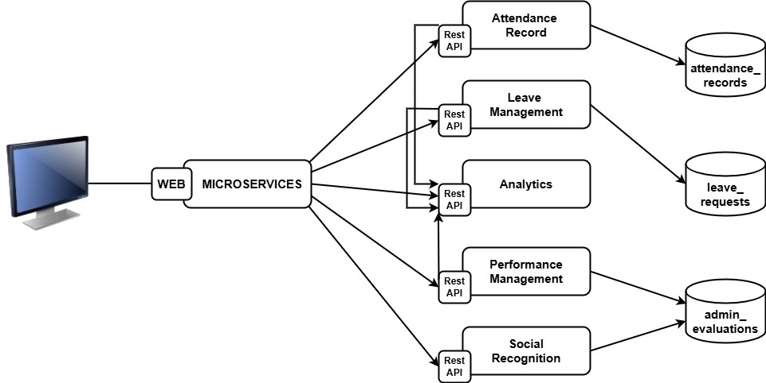

Diagram 1

## DEVOPS IMPLEMENTATION

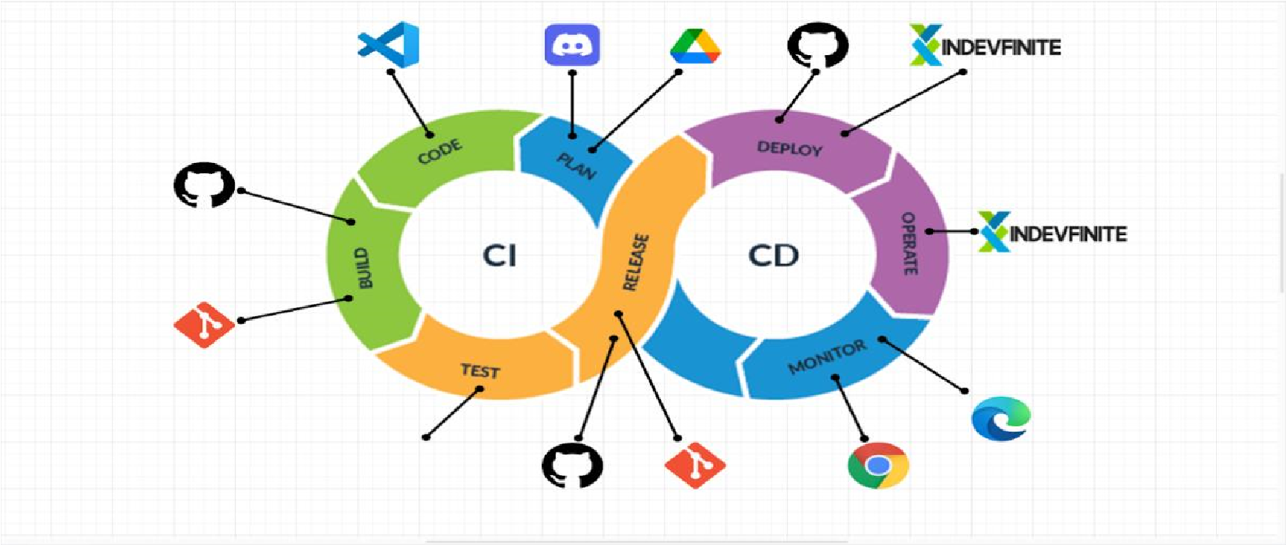

### Diagram 2

Table 15: CI/CD

|  |  |  |
| --- | --- | --- |
| **Tools** | **Purpose** | **Role in CI/CD Pipeline and DevOps** |
| Discord | Planning | Used for communication and collaboration within the team. It serves as a platform for discussing our tasks, sharing updates, and coordinating activities in real time. |
| Google  Drive | Planning | Acts as a document management and  task organization tool. It allows us to store and share project files, maintain project plans, and track task progress, enabling easy access for all team members. |
| Visual  Studio Code | Coding | It provides syntax highlighting, Git integration, debugging tools, and support for extensions, making it an efficient and flexible IDE for our project. |
| Git and  Github | Building | A platform for version control, where each version of our code changes is stored, tracked, and managed. GitHub’s integration with Git enables collaboration through pull requests, branches, and |

|  |  |  |
| --- | --- | --- |
|  |  | commits, and helps maintain code versions and history. |
| Manual  Testing | Testing | Involves manually running through test cases, scenarios, or workflows in the system to find bugs and ensure the code behaves as expected. We test the system locally, using browsers like Google Chrome or Microsoft Edge, to find bugs or issues in our system. |
| Git and  Github | Releasing | Git is used to manage version control locally, while GitHub is used to share code remotely. Once code is ready for production, GitHub acts as the platform for releasing new versions by tagging releases and managing production-ready code. |
| Github | Deployment | GitHub stores the code that is deployed to Indevfinite, but the actual deployment is manual. Once the code is ready, you pull |
|  |  | the latest version from GitHub and deploy it to the live server on Indevfinite. |
| Indevfinite | Deployment | Used to host the production version of our project. |
| Indevfinite | Operating | Indevfinite also serves as the operational environment for our system. It handles requests from users, manages application uptime, and serves the website or app to  visitors. |
| Google  Chrome and  Microsoft  Edge | Monitoring | Used to manually monitor the status of the project by visiting the site and checking if it's live, responsive, and functioning as expected. |

NETWORK TOPOLOGY

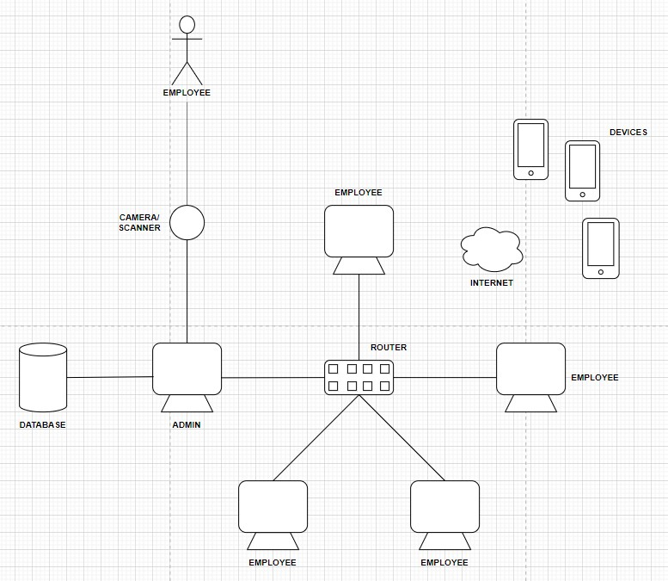

Diagram 3

## INNOVATION INTEGRATION

BPA LEVEL2

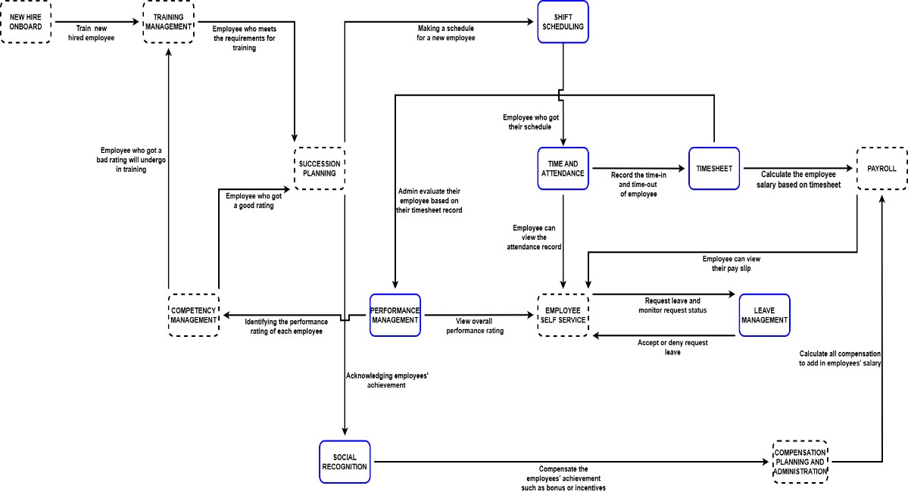

Diagram 4

ADDITIONAL CONSIDERATION

## Admin Sequence Diagram

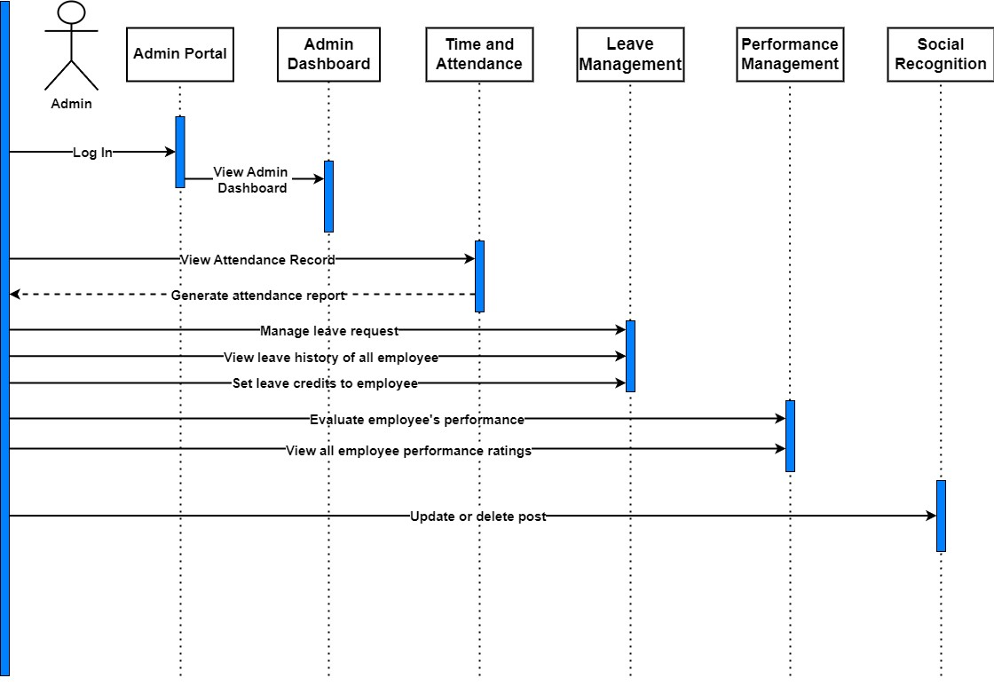

Diagram 5

## Employee Sequence Diagram

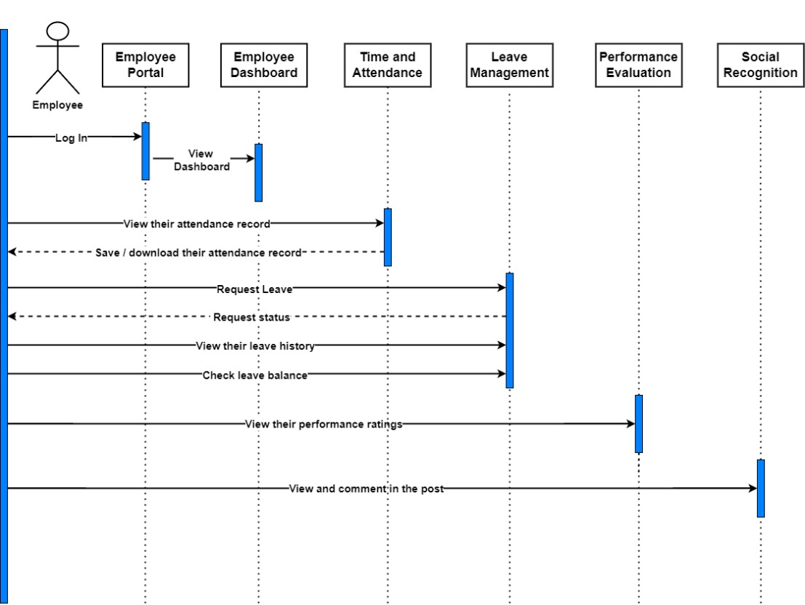

Diagram 6

## Use Case Diagram

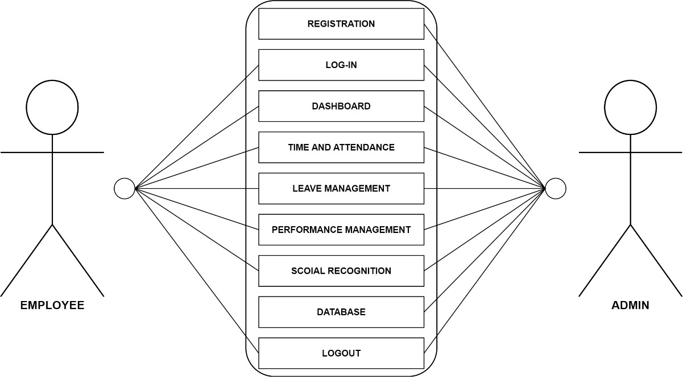

Diagram 7

**REFERENCES**

**AGILE SCRUM METHODOLOGY OVERVIEW**

Zingoni, M. (2021). Human Resource Management in Agile Scrum

Processes. In *IGI Global eBooks* (pp. 276–290). https://doi.org/10.4018/978-1-6684-3873-2.ch016

*Integrating Scrum Project Management in Information Technology*

*Capstone Course*. (2023, March 11). IEEE Conference Publication | IEEE

Xplore. https://ieeexplore.ieee.org/abstract/document/10402164

*The Influence of Agile Methodology (Scrum) on Software Project Management*. (2019, July 1). IEEE Conference Publication | IEEE Xplore. https://ieeexplore.ieee.org/abstract/document/8935813

Hema, V., Thota, S., Kumar, S. N., Padmaja, C., Krishna, C. B. R., &

Mahender, K. (2020). Scrum: An Effective Software Development Agile

Tool. *IOP Conference Series Materials Science and Engineering*, *981*(2),

022060. https://doi.org/10.1088/1757-899x/981/2/022060

*Assessing the effectiveness of the scrum framework and its successful implementation*. (2022b, June 19). IEEE Conference Publication | IEEE

Xplore. https://ieeexplore.ieee.org/document/10033259

**ENTERPRISE ARCHITECTURE CONCEPT**

*Strategic alignment of enterprise architecture management - how portfolios of control mechanisms track a decade of enterprise transformation at Commerzbank - Articles - UW-Madison Libraries*. (n.d.b).

https://search.library.wisc.edu/article/cdi_crossref_primary_10_1080_096

0085X_2022_2085200

**RELATED LITERATURE**

Fomude, A. H., Kang, S., Abangbila, L., Ganiyu, S. A., Mukete, N., &

Meena, M. E. (2020). The Impact of Human Resource Management

(HRM) Practices on Graduate Volunteer Performance: A Case Study of

Microfinance Institutions in Cameroon. Open Journal of Business and

Management, 08(05), 2226–2247. https://doi.org/10.4236/ojbm.2020.85136

Bhattee, Y. (2024b, January 23). *Navigating Change: Digital Evolution in HR Administration in the Philippines*.

https://www.linkedin.com/pulse/navigating-change-digital-evolution-hr administration-yuvraj--85glc

G, A. (2024, September 19). The Future of HR in the Philippines: How AI is Transforming Workforce Management.

https://www.linkedin.com/pulse/future-hr-philippines-how-ai-transformingworkforce-gonzalestdu8c#:~:text=In%20the%20Philippines%2C%20where%20the,resilient% 20in%20a%20competitive%20environment.

Franco, E. C., Cazarez, J. a. D., & Zezzatti, C. a. O. O. (2018).

Implementation of an Intelligent Model Based on Machine Learning in the

Application of Macro-Ergonomic Methods in a Human Resources Process Based on ISO 12207. In *Advances in logistics, operations, and management science book series* (pp. 261–285). https://doi.org/10.4018/978-1-5225-7192-6.ch014