**Microfinance Management System: Human Resource II**

**(Time and Attendance, Leave Management, Performance**

**Management, and Social Recognition with**

**Automated Evaluation Analytics and**

**Rule-Based Machine Learning)**

An Information Security Compilation

In Partial Fulfillment

Of the Requirements for Data Privacy and Security:

Bachelor of Science in Information Technology

**PROPONENTS:**

Steffano B. Dizo

Wendel G. Ureta

**December 2024**

# ABSTRACT

Title  **MICROFINANCE MANAGEMENT SYSTEM: HUMAN RESOURCE II (TIME AND ATTENDANCE, LEAVE MANAGEMENT, PERFORMANCE MANAGEMENT AND SOCIAL RECOGNITION WITH AUTOMATED EVALUATION ANALYTICS AND RULE – BASED MACHINE LEARNING)**

Authors **DIZO, STEFFANO B.**

**URETA, WENDEL G.**

Degree **BACHELOR OF SCIENCE IN INFORMATION TECHNOLOGY**

Major **INFORMATION SECURITY**

Date of Completion **DECEMBER 2024**

In Philippines where the access to traditional way of banking is limited, Microfinance organization offers small loans, saving choices, investment options, and other financial services for people with low income and individuals or groups who doesn’t have access to traditional banking systems. (Jumpah et al., Gakpo et al., 2021) As part of the poverty reduction in Ghana, the Association of Credit Unions in collaboration with governmental Organization, (NGO’s) creates microfinance schemes and makes financial assistance accessible to the poor, particularly Ghanaian women.

The administration of microfinance operations particularly human resources has grown in significance as the industry develops and expands. By investigating the complex connection between human resource management and microfinance management systems, this study emphasizes the important part that human resources play in maintaining the success of microfinance organizations. As the microfinance companies develops, the administration of its operations—particularly the of human resources has become more essential.

The present study highlights the essential part that human resources play in promoting the success of microfinance organizations through investigating the complex interaction between microfinance management systems and human resource management.

Microfinance Management System: Human Resource II project is a web-based system that offers several HR services, including time and attendance, leave management, performance management and social recognition. However, they struggle with productivity due to various issues encountered such as manual data collection, manual evaluation and giving right social recognition. In order to address these issues, the project team created a web-based system that facilitates and manages the organization by reducing time-consuming tasks and automating evaluations in order to improve accuracy of the information gathered.

# TABLE OF CONTENTS

**ABSTRACT 2**

**TABLE OF CONTENTS 5**

**1. Product Backlog for EIS Information Security 6**

**2. Sprint Backlog for Information Security 8**

**2.1.1 Information Security 13**

**3. Information Security 15**

**3.1.1 Privacy and Security 15**

**Appendices: 16**

**Appendix A Sprint Burndown Charts for Information Security 16**

**Appendix B Information Security Screenshots 17**

# Product Backlog for EIS Information Security

|  |  |  |  |  |
| --- | --- | --- | --- | --- |
| **EIS IS No.** | **EIS IS Stories** | **EIS IS Priority** | **Revision Priority** | **Status** |
|  | As a System Developer, I must implement user authentication to verify users' email and password. | 1 | 1 | Done |
|  | As a System Developer, I need to inform the users about their invalidinputs using validation alerts so that they can correct their data and ensure a smooth user experience. | 1 | 1 | Done |
|  | As a System Developer, I need to strengthen the security of user accounts to prevent unauthorized access and hacking. | 1 | 1 | Done |
|  | As a System Developer, I must able to encrypt the users’ password. | 1 | 1 | Done |
|  | As a System Developer, I must implement access control according to the user’s role and responsibility within the system. | 1 | 1 | Done |
|  | As a System Developer, I want to secure the system and database from SQL injection attacks by implementing proper input validation and parameterized queries, so that unauthorized users cannot exploit vulnerabilities to gain access or manipulate sensitive data. | 1 | 1 | Done |
|  | As a System Developer, I need to protect the system from unauthorized access through direct URL entry in the browser. | 1 | 1 | Done |
|  | As a System Developer, I need to inform the user if someone trying to access their account | 1 | 1 | Ongoing |

Table 1: Product Backlog - EIS Information Security

# Sprint Backlog for Information Security

|  |  |  |  |  |
| --- | --- | --- | --- | --- |
| **IS Story No.** | **IS Stories** | **Task** | **Timeline** | **Responsible Team Member/s** |
| **1** | As a SystemDeveloper, I want to create a login form to authenticate users. | Planning | 12 hours | Aguilor, Lennon  Dizo, Steffano  Murillo, Restituto III  Ureta, Wendel |
| Designing | Aguilor, Lennon  Murillo, Restituto III  Ureta, Wendel |
| Coding | Aguilor, Lennon  Ureta, Wendel |
| Testing | Aguilor, Lennon  Dizo, Steffano  Murillo, Restituto III  Torres, Rhyss  Ureta, Wendel |
| Documenting | Dizo, Steffano |
| **2** | As a System Developer, I want an input validation. | Planning | 10 hours | Aguilor, Lennon  Ureta, Wendel |
| Designing | Aguilor, Lennon |
| Coding | Ureta, Wendel |
| Testing | Aguilor, Lennon  Dizo, Steffano  Murillo, Restituto III  Ureta, Wendel |
| Documenting | Dizo, Steffano  Torres, Rhyss |
| **3** | As a System Developer, I want a strong password authentication to secure users’ accounts. | Planning | 12 hours | Dizo, Steffano  Ureta, Wendel |
| Designing | Aguilor, Lennon  Ureta, Wendel |
| Coding | Aguilor, Lennon  Ureta, Wendel |
| Testing | Murillo, Restituto III  Torres, Rhyss |
| Documenting | Dizo, Steffano  Ureta, Wendel |
| **4** | As a System Developer, I want password hashing implemented in the system so that user passwords are securely stored and cannot be accessed in the event of a data breach. | Planning | 8 hours | Dizo, Steffano  Ureta, Wendel |
| Designing | Ureta, Wendel |
| Coding | Ureta, Wendel |
| Testing | Aguilor, Lennon  Dizo, Steffano  Torres, Rhyss |
| Documenting | Dizo, Steffano  Murillo, Restituto |
| **5** | As a System Developer, I want an access control in the system based on the users’ roles. | Planning | 20 hours | Dizo, Steffano  Ureta, Wendel |
| Designing | Aguilor, Lennon  Ureta, Wendel |
| Coding | Murillo, Restituto III  Ureta, Wendel |
| Testing | Dizo, Steffano  Ureta, Wendel |
| Documenting | Dizo, Steffano  Torres, Rhyss |
| **6** | As a System Developer, I want to secure the system and database from SQL injection attacks by implementing proper input validation and parameterized queries, so that unauthorized users cannot exploit vulnerabilities to gain access or manipulate sensitive data. | Planning | 15 hours | Dizo, Steffano  Ureta, Wendel |
| Designing | Aguilor, Lennon  Ureta, Wendel |
| Coding | Ureta, Wendel |
| Testing | Dizo, Steffano  Ureta, Wendel |
| Documenting | Dizo, Steffano  Murillo, Restituto III  Torres, Rhyss |
| **7** | As a System Developer, I want to protect the system from unauthorized access through direct URL entry in the browser. | Planning | 14 hours | Aguilor, Lennon  Dizo, Steffano  Murillo, Restituto III  Ureta, Wendel |
| Designing | Aguilor, Lennon  Ureta, Wendel |
| Coding | Murillo, Restituto III  Ureta, Wendel |
| Testing | Murillo, Restituto III  Torres, Rhyss  Ureta, Wendel |
| Documenting | Dizo, Steffano  Torres, Rhyss |
| **8** | As a System Developer, I want to inform the user if someone attempts to log into their account multiple times. | Planning | 20 hours | Dizo, Steffano  Ureta, Wendel |
| Designing | Ureta, Wendel |
| Coding | Ureta, Wendel |
| Testing | Aguilor, Lennon  Murillo, Restituto  Ureta, Wendel |
| Documenting | Dizo, Steffano  Torres, Rhyss |

Table 2: Sprint Backlog - Information Security

### **Information Security**

|  |  |  |  |  |  |  |  |  |  |  |  |  |  |  |  |
| --- | --- | --- | --- | --- | --- | --- | --- | --- | --- | --- | --- | --- | --- | --- | --- |
| **Sprint 1 Backlog** | | **Sprint 1 (2 weeks)** | | | | | | | | | | | | | |
| **#** | **User Stories** | **1** | **2** | **3** | **4** | **5** | **6** | **7** | **8** | **9** | **10** | **11** | **12** | **13** | **14** |
| **1** | As a SystemDeveloper, I want to create a login form to authenticate users. |  |  |  |  |  |  |  |  |  |  |  |  |  |  |
| **TOTAL** | | **94** | | | | | | | | | | | | | |

Table3: Sprint 1 Burndown Chart - Information Security

# Information Security

### **Privacy and Security**

This portion will provide further details on the security measures, regulations, and protocols that have been put in place to safeguard the confidential information and data of Marvineth from potential breaches and other harmful cybersecurity threats.

* **Validation**
* **Password Hashing**
* **SQL Injection Protection**
* **Strong Password**
* **Log – in Attempt Notification**
* **Direct URL Access Control Protection**

# Appendices:

## **Appendix A Sprint Burndown Charts for Information Security**

Figure 1: User Stories - Sprint 1

## **Appendix B Information Security Screenshots**

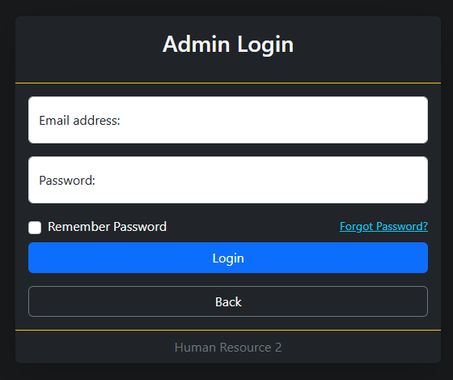**LOG IN FORM**

* + - 1. Username Text Field
      2. Password
      3. Login Button
      4. Remember me to keep signed in
      5. Forgot Password

**INPUT VALIDATION**

* + - 1. User Authentication
      2. Validation

**PASSWORD HASHING**

1. Password Hashing

**SQL INJECTION PROTECTION**

1. SQL Injection Protection using Prepared Statement
2. User inputs treated as data, not executable SQL code

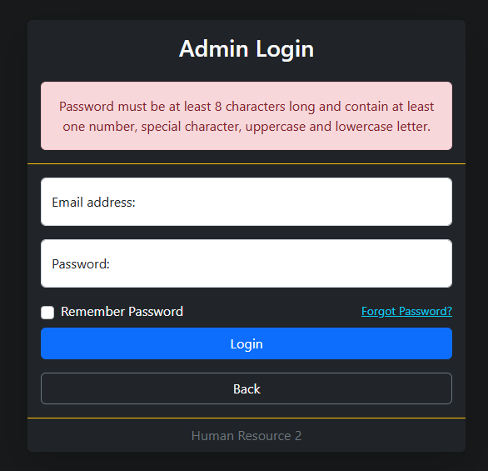**STRONG PASSWORD**

1. Requiring 8 character and contain at least one number, special character, uppercase and lowercase letter in creating a password.

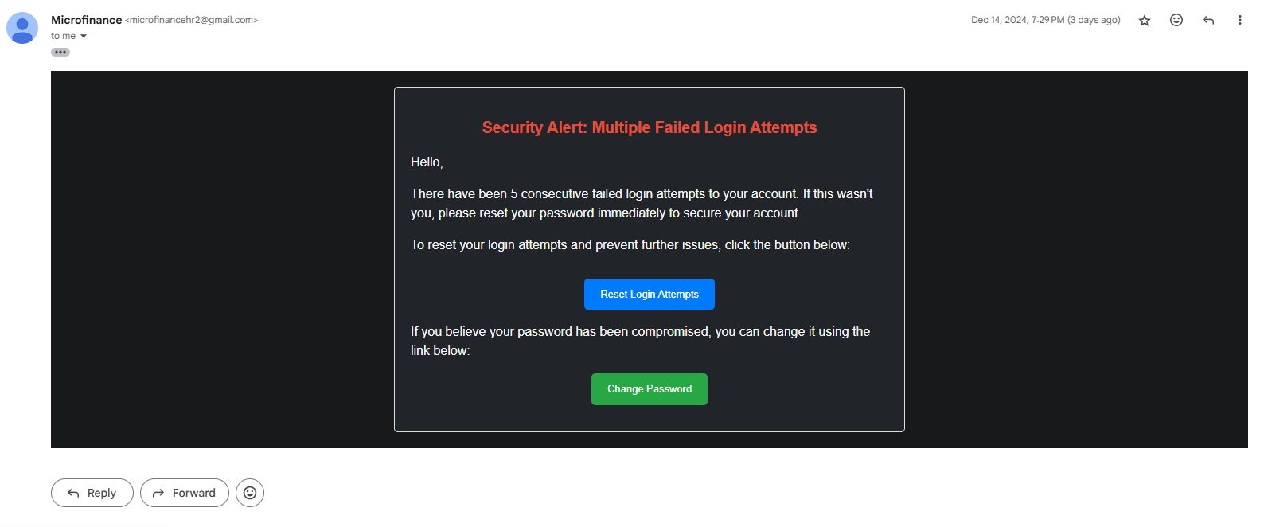**LOG IN ATTEMPT NOTIFICATION**

1. Notification for multiple log in attempts

**DIRECT URL INJECTION PROTECTION**

1. Prevent unauthorized users from accessing specific pages or

resources directly by entering their URLs

2. Use Session-Based Authentication