|  |  |  |  |  |
| --- | --- | --- | --- | --- |
| Product Backlog for EIS Information Security | | | | |
| User Story No. | User Story | User Top Priority | Revision Priority | Status |
| 1 | As a System Developer, I must implement user authentication to verify users' email and password.  Create a login authentication consisting of an email and password. |  |  |  |
| 2 | As a System Developer, I need to strengthen the security of user accounts to prevent unauthorized access and hacking.  Implement a strong password policy to enhance account security. |  |  |  |
| 3 | As a System Developer, I need to inform the users about their invalidinputs using validation alerts so that they can correct their data and ensure a smooth user experience.  Implement a validation. |  |  |  |
| 4 | As a System Developer, I must able to encrypt the users’ password.  Implement hashing password functions. |  |  |  |
| 5 | As a System Developer, I must implement access control according to the user’s role and responsibility within the system.  Implement an  access control based on their role. |  |  |  |
| 6 | As a System Developer, I want the system to be secure from SQL injection attacks so that unauthorized users cannot access the system by exploiting vulnerabilities.  Implement parameterized queries so that SQL injection vulnerabilities are prevented. |  |  |  |
| 7 | As a System Developer, I need to protect the system from unauthorized access through direct URL entry in the browser.  Implement Direct URL Access Protection. |  |  |  |
| 8 | As a System Developer, I need to inform the user if someone trying to access their account  Implement a login attempt to notify the legitimate users if someone trying to access their account. |  |  |  |

SECURITY

VALIDATION

PASSWORD HASHING

SQL INJECTION PROTECTION

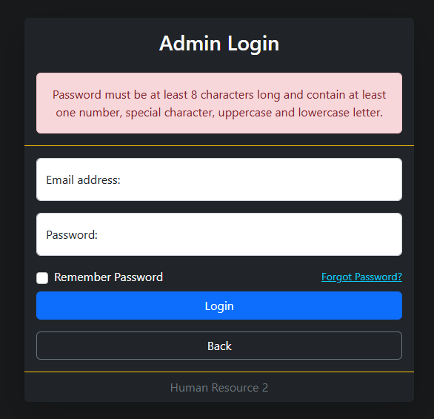

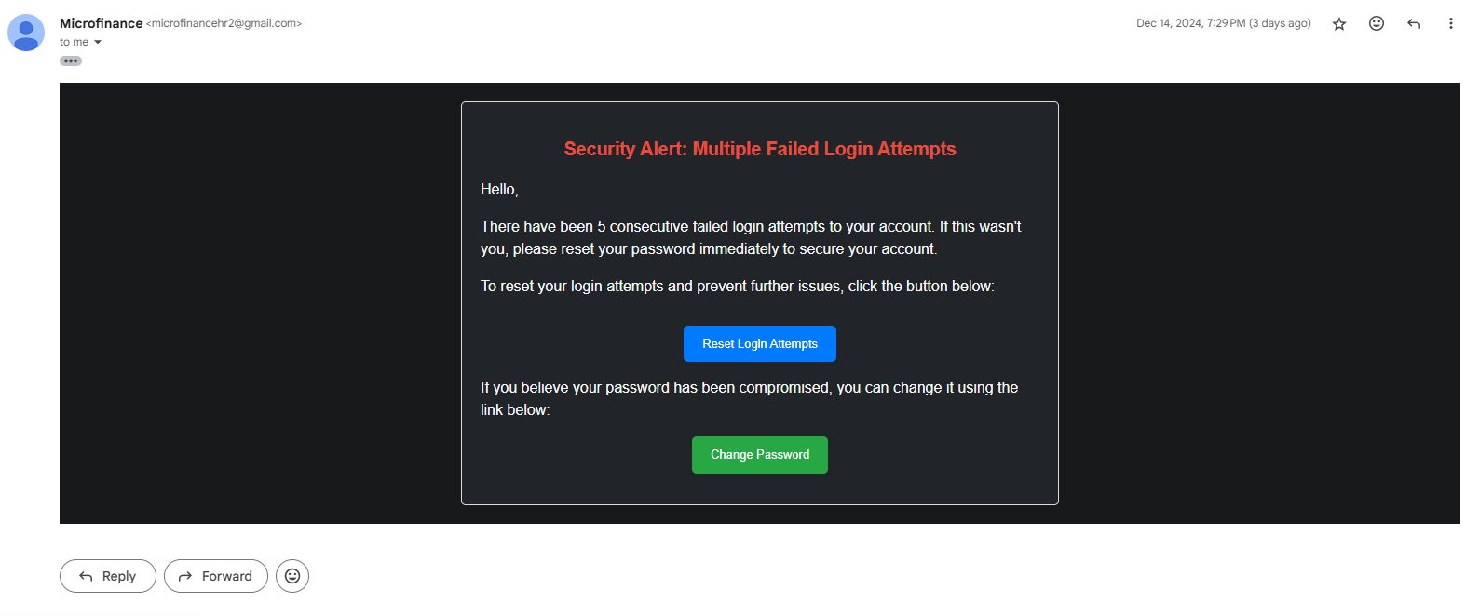 STRONG PASSWORD

LOGIN ATTEMPT NOTIFICATION

DIRECT URL ACCESS PROTECTION

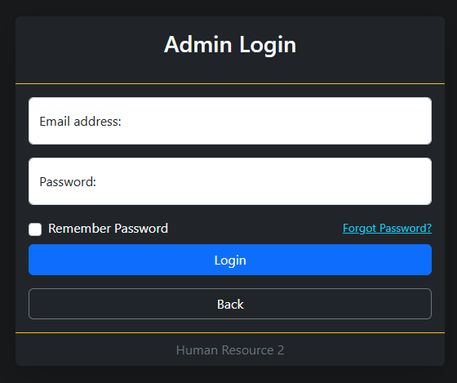

LOGIN