数据获取
一、Using Given Source of the data：
Since we need to crawl down the dataset of zhihu which including the information of user(ids,url,follower_number,followee_number), questions(ids,url,txt), topics(ids,url,txt). But all of the information are coming from a basic seeds.
According the research https://github.com/simoncos/zhihu-analysis-python we are inspired to crawl down the data with the seed of one user. The writer can crawl the followee of the user and then the followee’s user. After three iteration the writer have crawl down the information of 26161 users, 4612110 follow relations between users , 2245143 questions, 1655414 relations between users and questions, 5414129 relations between users and topics.
The writer have also form a database, the sql scipts of forming the database are shown below.
CREATE TABLE `Following` (
`id` integer NOT NULL,
`user_url` text NOT NULL,
`followee_url` text NOT NULL,
PRIMARY KEY(id)
);
CREATE TABLE `Question` (
`id` integer NOT NULL,
`question_id` text NOT NULL,
`topic` text NOT NULL,
PRIMARY KEY(id)
);
CREATE TABLE `UserQuestion` (
`id` integer NOT NULL,
`user_url` text NOT NULL,
`question_id` text NOT NULL,
PRIMARY KEY(id)
);
CREATE TABLE `UserTopic` (
`id` integer NOT NULL,
`user_url` text NOT NULL,
`topic` text NOT NULL,
PRIMARY KEY(id)
);
CREATE TABLE `User` (
`id` integer NOT NULL,
`user_url` text NOT NULL UNIQUE,
`user_id` text NOT NULL,
`followee_num` int NOT NULL,
`follower_num` int NOT NULL,
`answer_num` int NOT NULL,
`agree_num` int NOT NULL,
`thanks_num` int NOT NULL,
`layer` smallint,
`is_crawled` smallint,
PRIMARY KEY(id)
);
We are able to analysis the attributes of the table with the sql scipts.
But during our own crawling procedure, the iteration had caused many broke down of the programme, since the writer’s crawling programme is based on python2, we cannot reuse it thoroughly. Because of the programme are not focused on data acquirement or crawling it selves, we decided to use the database of the writer in our foundation and analysis of the network. But we are designing the recommend system , we have made our own crawling programme.
When we are using the database of the writer, we first used the sqlite-python pack to depact the database to the csv, which is more easy for python’s analysis and more directly to see. The head of the csv are shown below:
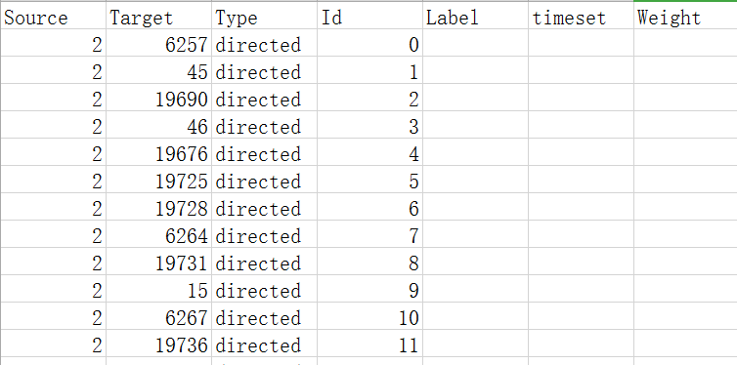
图 1edge
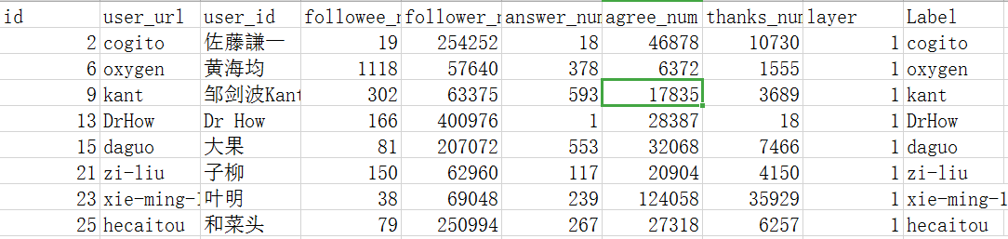
图 2node
The heads of the csv are decided by the network drawing tools Gephi’s acquirement. After some testing of the limits and the using of the Gephi, we decided to import the nodes of the user whose follower numbers are greater than 50K and 100K. And the label of the nodes are selected to the user_url since Gephi can not print Chinese word.
二、Crawling Down Procedure
Since the recommended system needs a fresh data, we cannot use the given dataset. We can only crawl down the up to date data.
Crawling down the data is a complicated job. Because of the vast demand of the data analysis as well as the anti-crawl system of zhihu, we have design dozens of crawl scipts for the programme. In summary they can be devided in to three part: Crawl down the text due to the url or ids, crawl down one user’s interaction with topic and the recent activities.
The crawl down procedure is:
- Get the web url of the website need to crawl
- Crawl down all html text of the website by python_requests pack
- Use the regular expression to pick up the exact pattern wanted
- Afterwards analysis.
The most difficult part of the procedure is regular expression. Because the html text crawl down is not totally equal to the elements show in the website browser, we had to crawl down the entire texts first and then developed the regular expressions by notepad++. But the html text is very lengthy and there is manyinfluence of the greedy and ingreedy influence of the regulations.
But our crawls programme have one fatal errors, is the incapability of crawling the dynamic refresh website. Because of this questions, we cannot get many data of one user’s recent activities. The way to solve this problem is to analysis the json code which contain the following refresh elements’ url. But the analysis is too complicated so we only focus on all the data we can get.
The results of crawling are shown below:
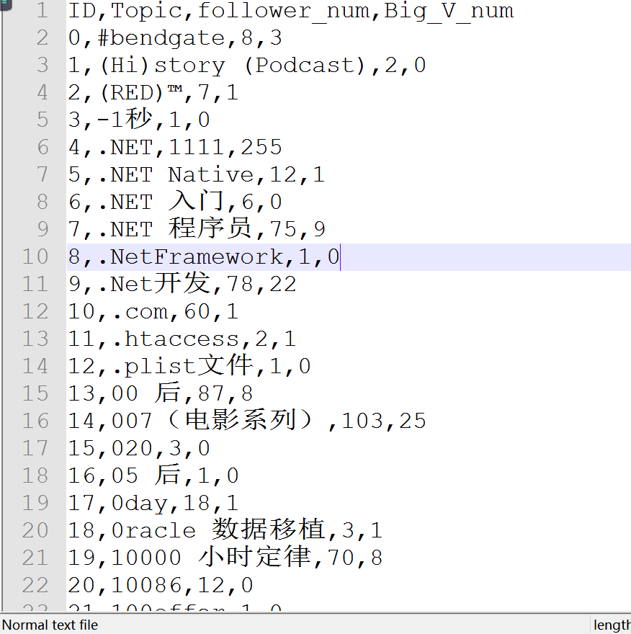
图 3topics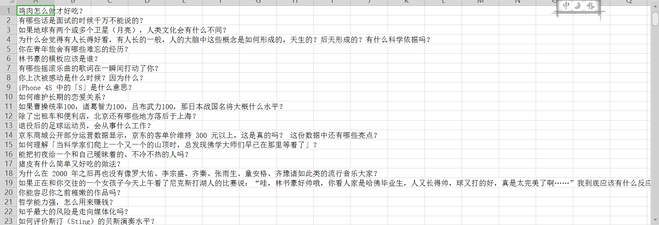
图 4question
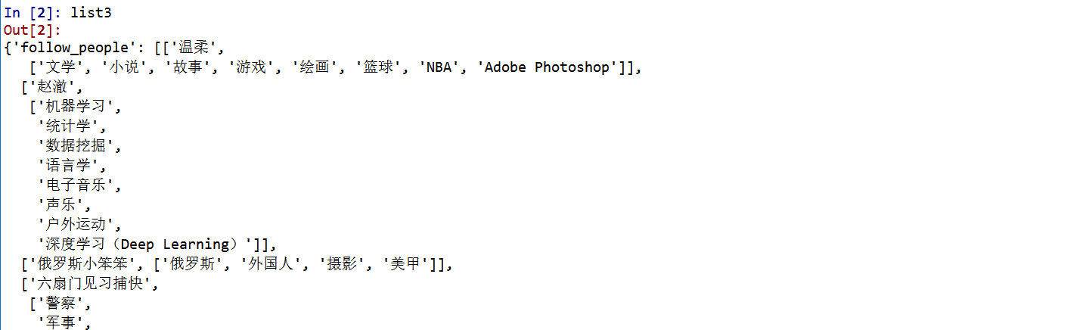
图 5user's topics
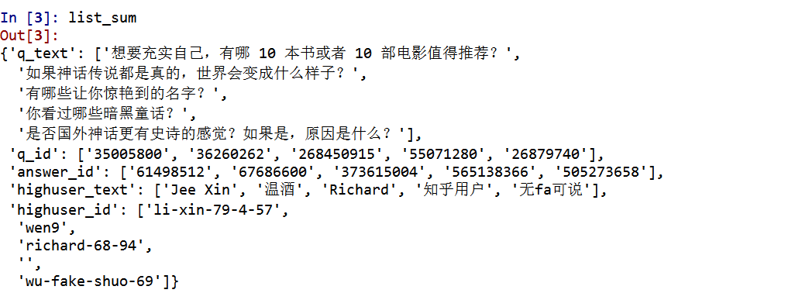
图 6the top answer of a topics
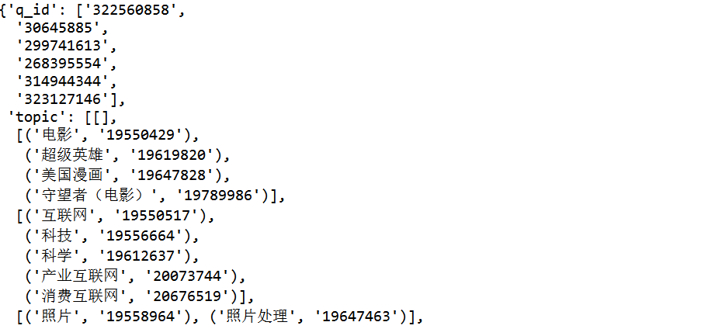
图 7the recent activities of a user

