Assignment 5

Courtney Hagen

W0263284

NETW1500

Table of Contents

Introduction 3

Change Management Logs 3

Introduction 3

Change Management Log for Server 3

Change Management Log for Workstation 3

Task 1 3

Introduction to Task 1 3

DHCP Configuration Table 3

Task 2 3

Introduction to Task 2 3

Screenshots 4

Task 3 11

Introduction to Task 3 11

Screenshots 11

Questions 17

Questions Introduction 17

Question 1 17

# Introduction

The purpose of this document is to reflect the changes to the Windows Server 2016 virtual machine by adding DHCP and a printer share.

# Change Management Logs

## Introduction

The purpose of this section is to reflect the changes made to both the server and the workstation VMs.

## Change Management Log for Server



## Change Management Log for Workstation



# Task 1

## Introduction to Task 1

The purpose of this section is to show a table demonstrating the DHCP configurations for the server.

## DHCP Configuration Table

|  |  |
| --- | --- |
| New IP Scope | NETW1500 |
| Description of Scope: | New DHCP Scope for NETW1500 |
| Network IP Range: Start: | 192.168.208.1 |
| End: | 192.168.208.254 |
| Exclusions: Servers: | 192.168.208.10-19 |
| Exclusions: Networking Devices: | 192.168.208.220-254 |
| For reference only: Printers: | 192.168.208.20-40 |
| For reference only: Clients DHCP: | 192.168.208.50-219 |
| Netmask | /24 |
| Lease Duration Period | 7 days, 0 hours, 0 minutes |

# Task 2

## Introduction to Task 2

The purpose of this section is to demonstrate adding the DHCP role to the server.

## Screenshots

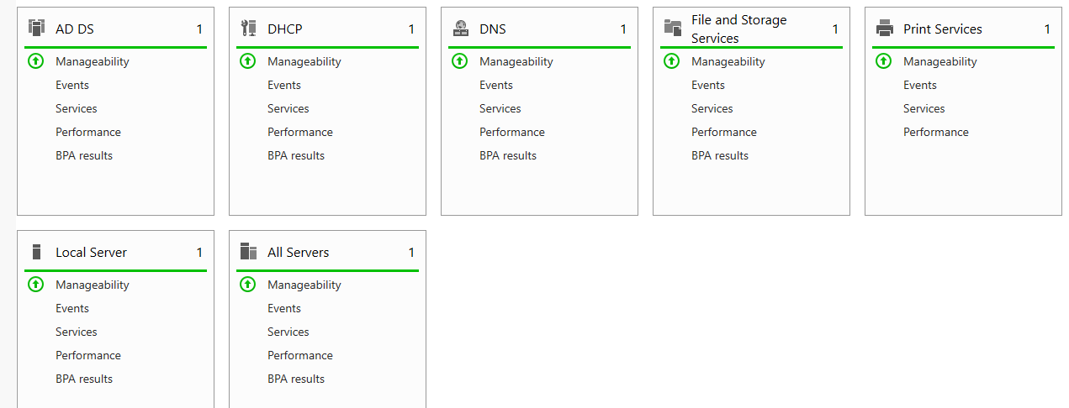

This screenshot demonstrates that all services were started prior to continuing.

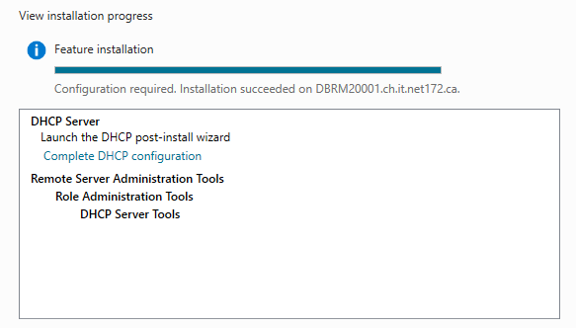

This demonstrates that the DHCP server was installed along with configuration and the required features needed to do so.

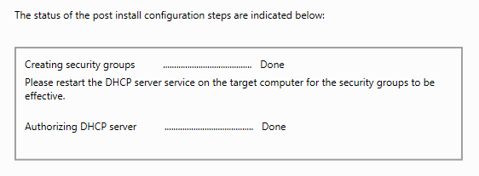

This demonstrates that the post-deployment configuration was completed.

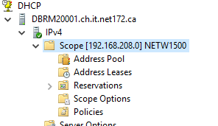

This screenshot shows that the new scope was added.

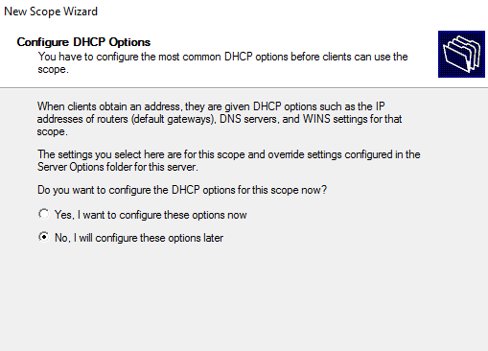

This screenshot shows that I choose to configure the DHCP options later.

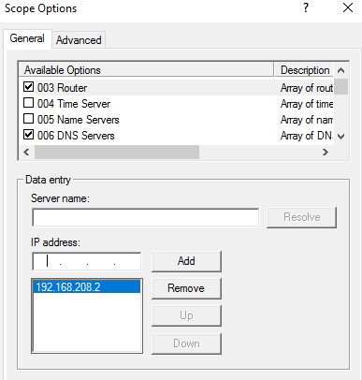

This demonstrates that Option 3 was configured appropriately.

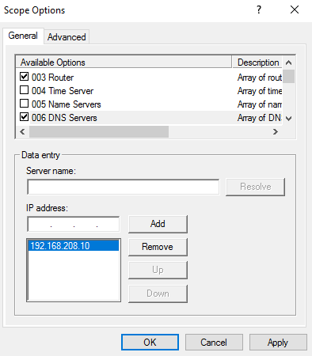

This shows that Option 6 was configured appropriately.

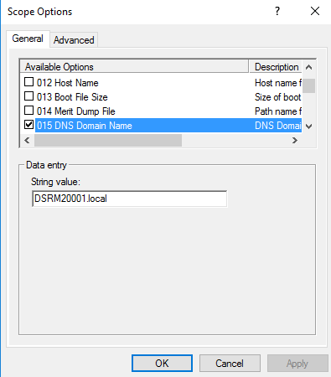

This shows that Option 15 was configured appropriately.

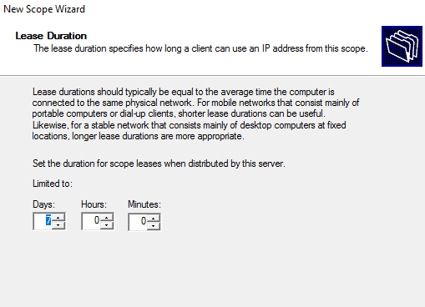

This demonstrates that the lease duration was set appropriately.

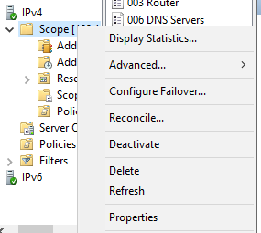

This screenshot shows that the scope was activated as the option “Deactivate” is there instead of “Activate”.

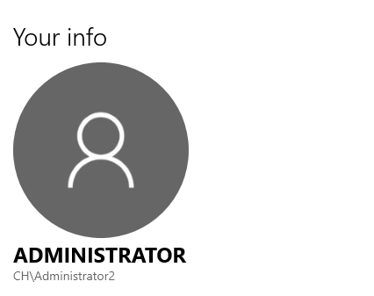

This screenshot demonstrates that I was able to log in to the domain after the configuration and that I logged into the backup administrator from the client as indicated.

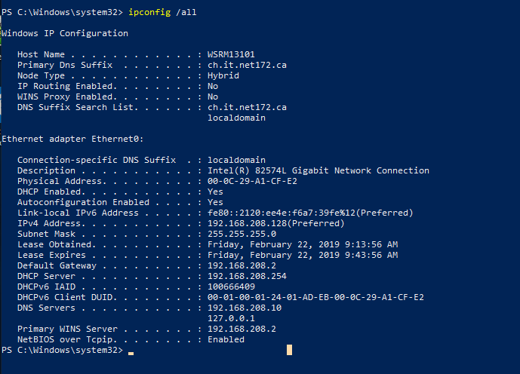

This demonstrates that the DHCP configuration was successful.

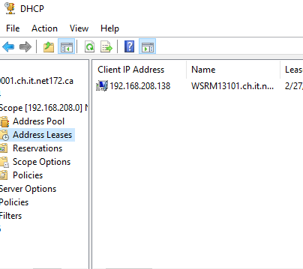

This demonstrates the new client’s IP lease.



This is the lease expiration for the client’s IP.

# Task 3

## Introduction to Task 3

The purpose of this section is to demonstrate the installation of the printer role and deploying a printer in a server.

## Screenshots

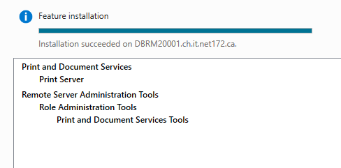

This demonstrates that the Print and Document Services role along with required features and configurations was installed.

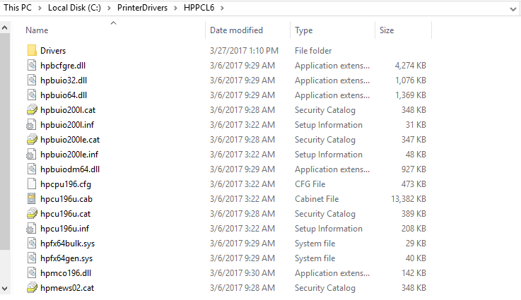

This demonstrates that the appropriate printer drivers folder and sub folder was created and that the correct driver file was extracted into the subfolder.

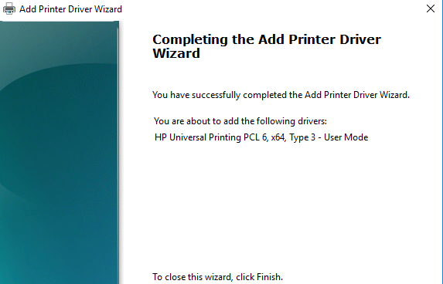

This demonstrates that the appropriate printer driver was added.

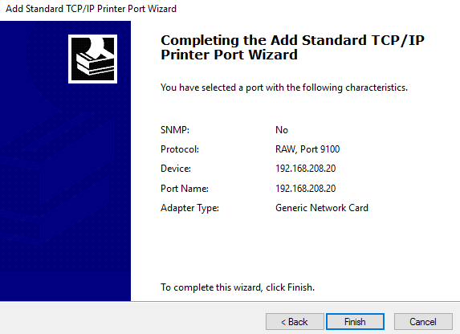

This demonstrates that the port was added with the appropriate configurations as per the assignment.

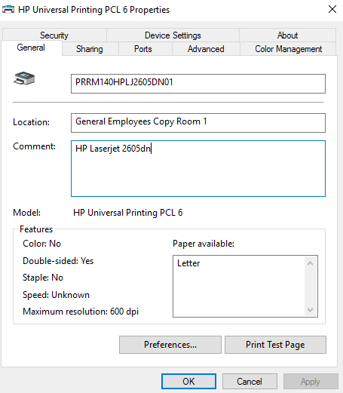

This shows the printer’s name and information.

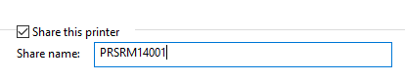

This shows the printer share’s name.

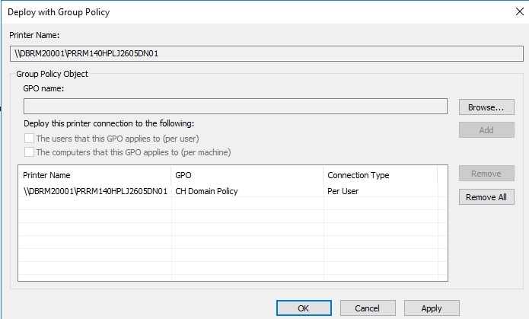

This demonstrates that the printer was deployed with group policy as per the assignment instructions.

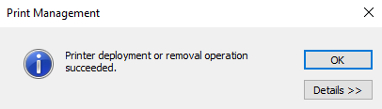

This demonstrates that the deployment was successful.

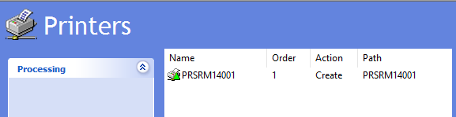

This shows that the printer deployment was setup in group policy.

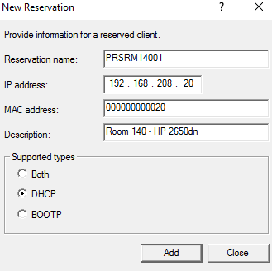

This demonstrates that the reservation was created.

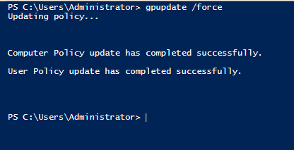

This shows the command was run to force the group policy update.

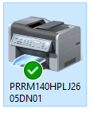

This shows that the device was available and set to the default printer.

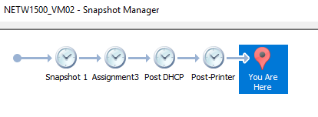

This demonstrates appropriate client snapshots were taken.

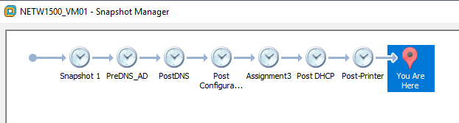

This demonstrates appropriate server snapshots were taken.

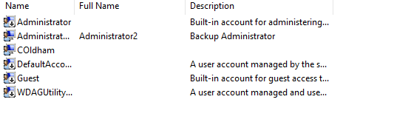

This shows that the server administrator was not added locally to the workstation.

# Questions

## Questions Introduction

The purpose of this section is to answer relevant questions as per the assignment.

## Question 1

The difference between deploying a printer by computer and by user is that computer is more location based and by user is more permissions based. One may have access to a computer but not a user account that can print in the vicinity of that computer. Basically, the advantages of printing based on user permissions is that you can select who needs to print based on roles and save money from people using it unnecessarily. The weakness of it is if there is an instance where someone not authorized to print really needs to, it can cause a security issue with either users lending out their accounts or receiving potentially harmful files to “print”. The advantage of deploying by printer is it creates a simple association of where people can print and that it alleviates people sharing their user accounts, but a disadvantage is that anyone can use the printer for anything and it may not be relevant to the needs of a business yet may be costing them money.