Final Project

Courtney Hagen

W0263284

NETW1500

Table of Contents

Introduction 3

Screenshots 3

Modified Logon Script 9

FSRM20001 Activity Plan 11

FSRM20001 Change Management Log 11

# Introduction

The purpose of this assignment is to demonstrate the things I learned over the course of the semester. In this project I installed a Windows Server 2016 Datacenter Core server, adding it to my domain and managing it from my domain controller that I have been using the entire semester, along with using it resources with the workstation VM I have also been using.

# Screenshots

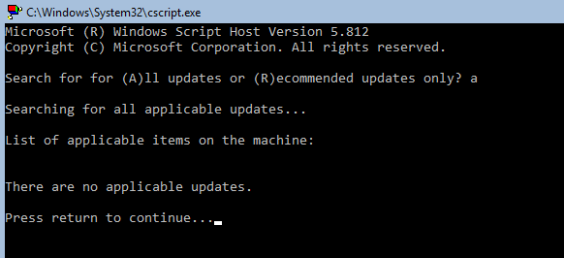  
This screenshot demonstrates that the core server is up to date.

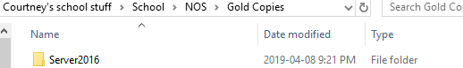

This shows that I made a gold copy before continuing with the configurations.

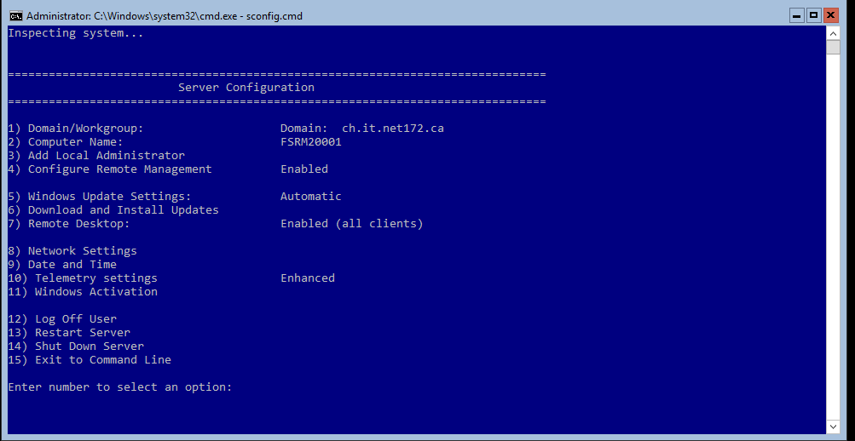

This shows the server has the correct computer name, is a member of the domain, and remote desktop is enabled.

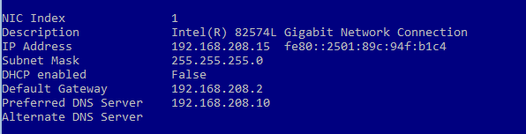

This demonstrates the appropriate network configuration for the file server.

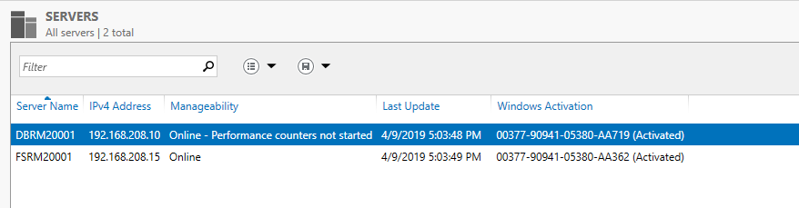

This demonstrates that the file server was added to the server manager.

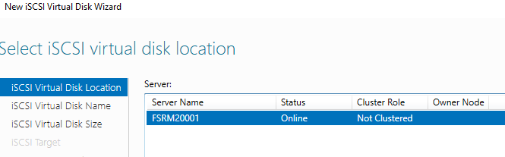

This demonstrates that the iSCSI role was added to FSRM20001

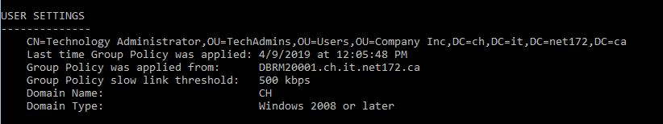

This demonstrates that the group policy was applied to the file server, and it also demonstrates that TechAdmin was used as the domain user.

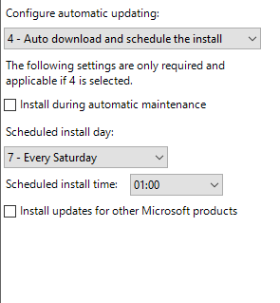

This shows that updates are scheduled on Saturdays at 1am

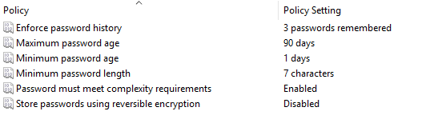

This shows that the password complexity settings were set.

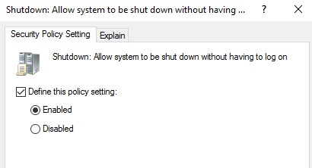

This demonstrates that the system can be shut down from the logon screen.

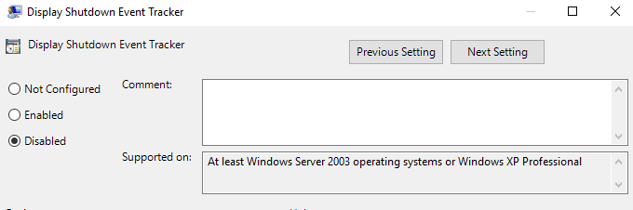

This shows that the shutdown event tracker is disabled.

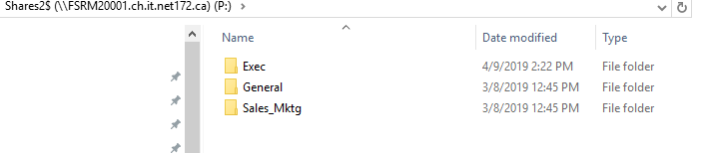

This shows that Shares2$ was created with the same folder structure as shares$

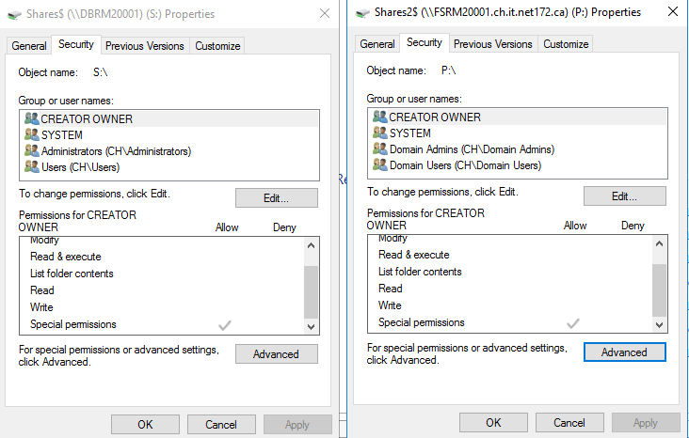

This demonstrates that the shares have the same permissions.

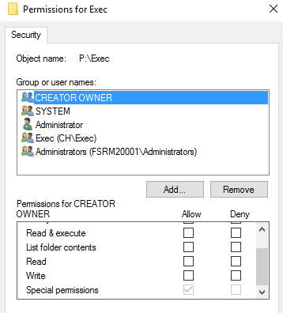

This provides an example of how the Shares2$ subfolders also have the appropriate permissions.

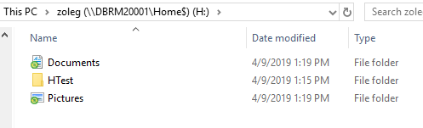

This demonstrates that the HTest folder was successfully created in the correct area.

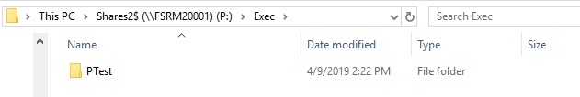

This demonstrates that the STest folder was successfully created in the correct area.

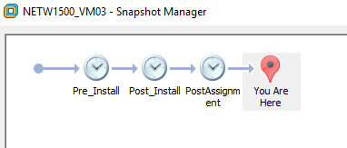

This shows that the appropriate snapshots were taken.

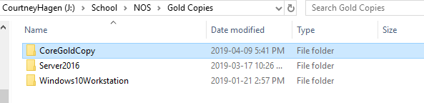

This shows that another gold copy was created after finishing all of the configurations.

# Modified Logon Script

'********************************************************************

' *

'                       MAP NETWORK DRIVES *

' *

' This VB Script maps network drives based on group membership. *

' *

'********************************************************************

'**** This section gets the distinguished name from the Active Directory and pass it to varible DistinguishedName.

Set objSysInfo = CreateObject("ADSystemInfo")

DistinguishedName = objSysInfo.UserName

strUserDN = DistinguishedName

set objUser = GetObject("LDAP://" & strUserDN)

'Wscript.Echo "Group membership for " & objUser.Get("cn") & ":"

strSpaces = ""

set dicSeenGroup = CreateObject("Scripting.Dictionary")

DisplayGroups "LDAP://" & strUserDN, strSpaces, dicSeenGroup

'**********  This function enumerates the groups **********

Function DisplayGroups ( strObjectADsPath, strSpaces, dicSeenGroup)

  set objObject = GetObject(strObjectADsPath)

  on error resume next

  currentGroupName = objobject.name

  CheckGroup (currentgroupname)

  if IsArray( objObject.Get("memberOf") ) then

     colGroups = objObject.Get("memberOf")

  else

     colGroups = Array( objObject.Get("memberOf") )

   end if

  for each strGroupDN In colGroups

     if Not dicSeenGroup.Exists(strGroupDN) then

        dicSeenGroup.Add strGroupDN, 1

        DisplayGroups "LDAP://" & strGroupDN, strSpaces & " ", dicSeenGroup

      end if

  next

End Function

'********  This function assign drive map if group is found.  ************

Function CheckGroup (CurrentGroup)

   Trim(CurrentGroup)                                                  'Removes Blank spaces from the string

   Set objNetwork = Wscript.CreateObject("WScript.Network")

'    ********** This function checks for group membership and assings drive mapping. *************

If CurrentGroup = "CN=General" Then

     objNetwork.MapNetworkDrive "P:","\\FSRM20001\Shares2$\General"

ElseIf CurrentGroup = "CN=Exec" Then

     objNetwork.MapNetworkDrive "P:","\\FSRM20001\Shares2$\Exec"

ElseIf CurrentGroup = "CN=Sales_Mktg" Then

     objNetwork.MapNetworkDrive "P:","\\FSRM20001\Shares2$\Sales_Mktg"

End If

End Function

# FSRM20001 Activity Plan



# FSRM20001 Change Management Log

