Courtney Hagen

W0263284

OSYS1000

Assignment 4

Step 5) It displayed ten lines.

Step 6) It counted 12 lines because there are two lines that are not unique therefore did not display in the previous command.

Step 7) Two lines displayed: 127.0.0.1    localhost

127.0.1.1    courtney-virtual-machine

Step 11) It did not find any files because Linux is capitalized in the text.

Step 12) Grep -i ‘linux’ verbiage.txt

Step 13) grep -v ‘Potato’ veg1

My script:

#!/bin/bash

# The following command displays the unique lines of the file myhosts, meaning it does not repeat lines that are repeated in the text.

uniq myhosts

# The following command does a count on the lines in myhosts. This will count lines that aren't unique.

wc -l myhosts

# The following command displays the first unique line that was duplicated.

uniq -d myhosts

# The following two commands sort the veg1 file into a new file called veg1a.

sort veg1 > veg1a

sort -o veg1a veg1

# The following two commands do the same as the previous two commands, but with veg2 and veg2a

sort veg2 > veg2a

sort -o veg2a veg2

# The following command compares similarities between veg1a and veg2a

comm veg1a veg2a

# The following command shows the differences between veg1a and veg2a

diff veg1a veg2a

# The following command looks for occurances of 'linux' in the file verbiage.txt

grep 'linux' verbiage.txt

The awk command used displays columns 4, 5, 6, and 7 in the coin.txt file where the word gold is used in the row.

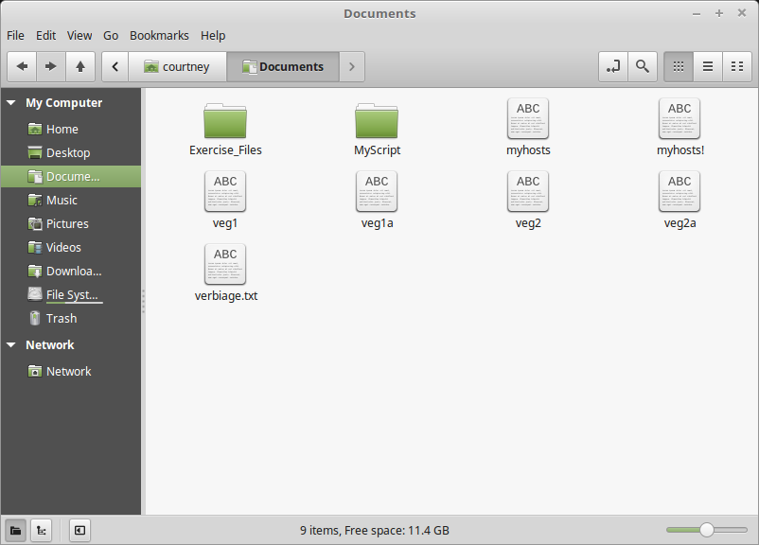

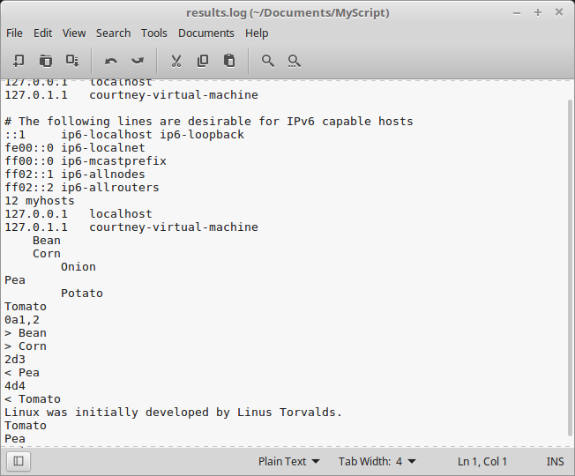

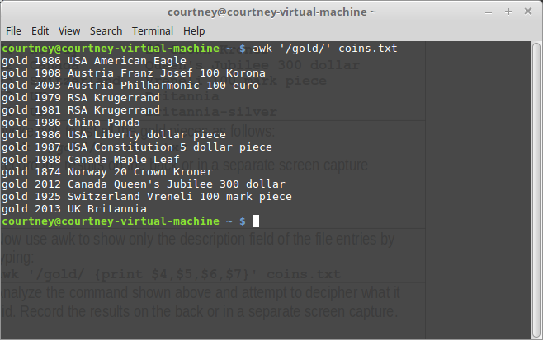

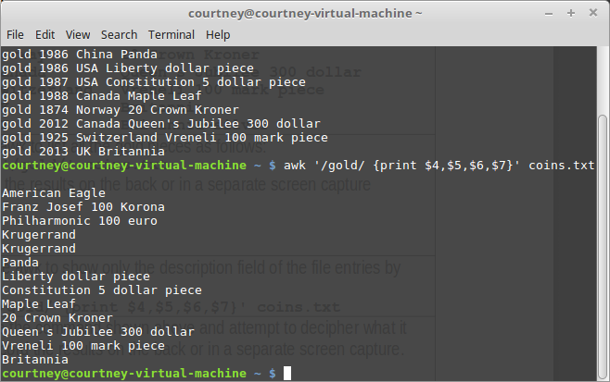

awk 'BEGIN { count=0;}  
$1 ~ /gold/ { count++; }  
END { print "Number gold medals =",count;}' coins.txt && awk 'BEGIN { count=0;}  
$1 ~ /silver/ { count++; }  
END { print "Number silver medals =",count;}' coins.txt

