Microsoft Azure Stack Requirements

Courtney Hagen

W0263284

NETW 2710

Microsoft Azure Stack Requirements

As many businesses move towards cloud technologies, some are finding some appeal in setting up their own cloud services. Microsoft’s Azure Stack provides them with a back-end to utilize in building their cloud infrastructure. There are many factors to consider before deciding whether this is worth the trouble to the business or not. Microsoft’s Azure Stack has its’ own hardware, software, and networking requirements that may prove costly for a business.

Undoubtedly, the hardware requirements for Microsoft’s Azure Stack are more than just the average business computer. Microsoft outlines both recommended and minimum requirements for their Azure Stack. For the CPU, they recommend two processors with 16 physical cores. However, in the minimum requirements, only 12 physical cores are required. In terms of memory, 96gb ram is minimally required, but 128gb of ram is recommended. The BIOS must be Hyper-V Enabled with SLAT support. In terms of disk drives, Azure Stack requires one operating system devoted disk with a minimum of 200gb space along with 4 separate disks each requiring 140gb of space. However, it is recommended that each of the 4 separate disks have 250gb of space. (Kotlyarenko, 2015)

Equally, Microsoft’s Azure Stack has software requirements that need some consideration. Fortunately, though it is a Microsoft product, there are many operating systems that Azure Stack will work on. In terms of Windows operating systems, Azure Stack is compatible with Windows Server version 1709, Windows Server 2016, Windows Server 2012 R2, Windows Server 2012, Windows Server 2008 R2 SP1, Windows Server 2008 SP2, and Windows 10. In terms of Linux distributions, Azure Stack is usable on CentOS-based 6.9 distributions, Cent-OS-based 7.4 distributions, ClearLinux, Container Linux, Debian 8, Debian 9, Red Hat Enterprise Linux 7.x, SLES 11SP4, SLES12SP3, Ubuntu 14.04-LTS, Ubuntu 16.04-LTS, and Ubuntu 18.04-LTS. (Supported guest operating systems for Azure Stack, 2019)

Finally, network requirements are vital in the deployment of cloud technologies. Network hardware has speed requirements of 1gb, 10gb, or 25gb speeds. As stated per Microsoft’s website, “the Azure Stack solution requires a resilient and highly available physical infrastructure.” (Network integration considerations for Azure Stack integrated systems, 2019) As well, Microsoft provides the following diagram for a recommended design.

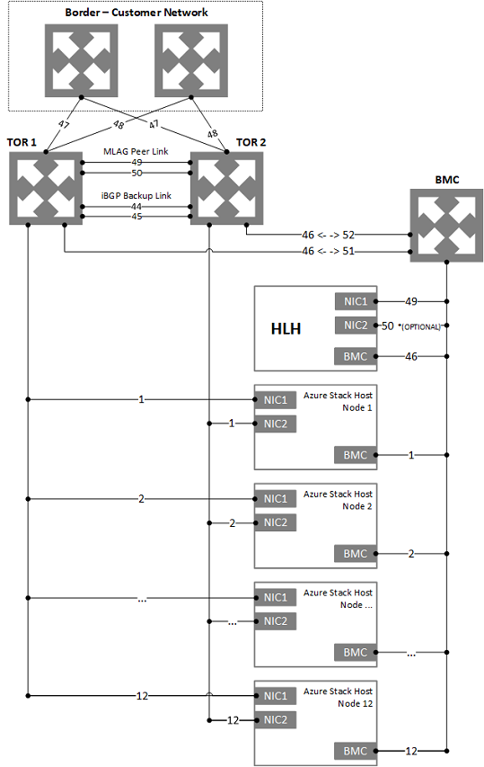

(Network integration considerations for Azure Stack integrated systems, 2019)

Microsoft also provides requirements for logical networks. Azure Stack requires a Public VIP logical network that must be a /26 to a /22 network, though /24 is recommended. Of the available hosts, Azure Stack uses 31 of these addresses, the rest are used by virtual machines, unless App Service and SQL resource providers are used, then 7 extra addresses are allotted to that. 15 of the IP’s are also made available for Azure services that may be required in the future. (Network integration considerations for Azure Stack integrated systems, 2019) Another logical network required is the switch infrastructure logical network, which must be a /26 network. There is also an infrastructure logical network that must be a /24 to be used for Azure Stack internal components. Another private logical network that must be a /24 network must be available for use of storing network and private VIPs. Finally, a BMC logical network that must be a /26 network must be available to communicate with the BMC’s on physical hosts. (Network integration considerations for Azure Stack integrated systems, 2019) Microsoft provides a diagram showing the interactions between these logical networks as shown below.

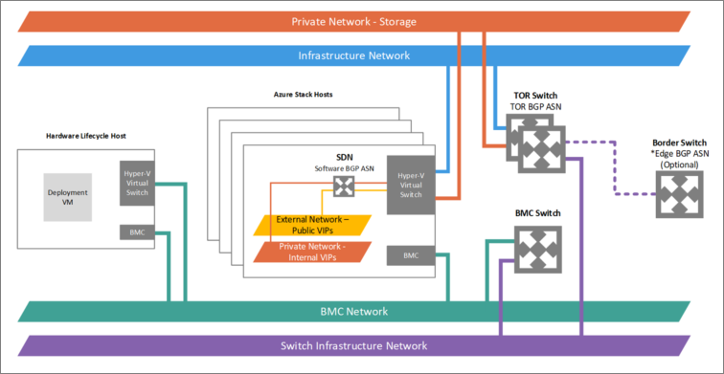

(Network integration considerations for Azure Stack integrated systems, 2019)

Within the private network logical network there are two subnets. These subnets are both /25, and one is a storage network for the services Spaces Direct and Server Message Block, and the other subnet is the internal virtual IP network which is only for internal-only VIPs for the software load balance. (Network integration considerations for Azure Stack integrated systems, 2019) Finally, Azure Stack requires routing with border gateway protocol. (Border connectivity network integration considerations for Azure Stack integrated systems, 2019)

In conclusion, Microsoft’s Azure Stack has advanced requirements in hardware, software, and network specifications. When planning to provide cloud services, it is important to use these requirements in weighing the cost against the benefits. Many of these requirements would need to be purchased above and beyond what a business already has, and therefore, may be more money then what a business is willing to spend. However, as cloud technologies become more prevalent and in use in the general public’s everyday lives, hosting cloud technologies may be a worthy investment.

References

Border connectivity network integration considerations for Azure Stack integrated systems. (2019, February 11). Retrieved April 5, 2019, from <https://docs.microsoft.com/en-us/azure/azure-stack/azure-stack-border-connectivity>

Kotlyarenko, K. (2015, December 22). Azure Stack - Hardware requirements. Retrieved April 5, 2019, from <https://blogs.technet.microsoft.com/hybridcloudbp/2015/12/22/azure-stack-hardware-requirements/>

Network integration considerations for Azure Stack integrated systems. (2019, February 11). Retrieved April 5, 2019, from https://docs.microsoft.com/en-us/azure/azure-stack/azure-stack-network

Supported guest operating systems for Azure Stack. (2019, February 16). Retrieved April 5, 2019, from https://docs.microsoft.com/en-us/azure/azure-stack/azure-stack-supported-os