NewsBot Intelligence System (NLP)

The NewsBot Intelligence System demonstrates how machine learning and natural language processing can be applied to analyze and classify news data effectively. By converting raw JSON data into a structured format and applying preprocessing and modeling techniques, the system can extract meaningful insights from large volumes of text.
This project highlights the importance of data preparation, feature engineering, and model evaluation in building intelligent systems. While there are limitations, the framework provides a strong foundation for more advanced applications in automated news analysis and information retrieval.

1. Introduction
The NewsBot Intelligence System project focuses on building a data-driven pipeline to analyze and extract insights from news articles using Python. The primary dataset used in this project is sourced from an online repository and contains categorized news articles in JSON format. These articles are converted into a structured CSV file for easier manipulation and analysis using the Pandas library.
The goal of this project is to simulate an intelligent news analysis system that can process textual data, identify patterns, and support tasks such as classification, sentiment analysis, and topic exploration. With the rapid growth of digital news content, automated systems like NewsBot are essential for filtering, organizing, and interpreting large volumes of information efficiently.

2. Dataset Overview and Preparation
The dataset is loaded directly from a public URL using Pandas:
url = "https://raw.githubusercontent.com/selva86/datasets/master/newsgroups.json"
df = pd.read_json(url)
This dataset contains news articles categorized into different topics such as politics, sports, technology, and more. Each record typically includes:
- Content/Text – The main body of the news article
- Category/Label – The classification of the article
- Metadata – Additional identifiers or attributes
After loading the dataset, it is converted into a CSV file:
df.to_csv('news_dataset.csv', index=False)
Data Preparation Steps
Before analysis, several preprocessing steps are typically required:
- Handling missing values to ensure data quality
- Text cleaning (removing punctuation, stopwords, special characters)
- Tokenization to break text into words
- Normalization (lowercasing, stemming, or lemmatization)
These steps are critical for improving the performance of machine learning models and ensuring accurate analysis.

3. Exploratory Data Analysis (EDA)
Exploratory Data Analysis helps understand the structure and distribution of the dataset.
Key Observations
- The dataset contains multiple categories, making it suitable for classification tasks
- Some categories may have more samples than others, leading to class imbalance
- Text length varies significantly across articles
Visualization Opportunities
- Bar charts showing the number of articles per category
- Word clouds to highlight frequently used terms
- Distribution plots for article lengths
EDA helps identify trends such as which topics dominate the dataset and whether certain keywords are strongly associated with specific categories.

4. Model Design and Intelligence Features
The NewsBot system can incorporate several intelligent features:
1. Text Classification
Using machine learning algorithms such as:
- Naïve Bayes - Predicts the category of a data point using probability
- Logistic Regression - y = mx +b
- Support Vector Machines (SVM) – Best classifier in supervised learning for complex data
The system can classify news articles into predefined categories.
2. Sentiment Analysis
Although news articles are typically neutral, sentiment analysis can still detect:
- Positive tone (e.g., success stories)
- Negative tone (e.g., disasters, conflicts)
This can be implemented using tools like:
- TextBlob - Polarity: A score between -1 (negative) and 1 (positive)
- VADER - class provides a polarity_scores (-1 to 1)
- Pre-trained NLP models
3. Keyword Extraction
Techniques such as TF-IDF (Term Frequency–Inverse Document Frequency) can identify important words in each article.

4. System Workflow
The NewsBot Intelligence System follows a structured pipeline:
- Data Collection – Load dataset from URL
- Data Conversion – Convert JSON to CSV
- Preprocessing – Clean and prepare text
- Feature Extraction – Convert text into numerical form (TF-IDF, Bag-of-Words)
- Model Training – Train classification or sentiment models
- Evaluation – Measure accuracy, precision, recall
- Output Generation – Display predictions and insights

5. Performance Evaluation
To measure the effectiveness of the system, several metrics can be used:
- Accuracy – Overall correctness of predictions - Accuracy (%) = (True Positives + True Negatives) / (True Positives + False Positives + True Negatives + False Negatives)
- Precision – Correct positive predictions - Precision = TP / (TP + FP)
- Recall – Coverage of actual positives - Recall = True Positives / (True Positives + False Negatives).
- F1 Score (TP,TN,FP,FN) – Balance between precision and recall
Cross-validation can also be applied to ensure that the model generalizes well to unseen data.

6. Challenges and Limitations
Despite its usefulness, the project has several challenges:
1. Text Complexity
Natural language is inherently complex, with sarcasm, ambiguity, and context affecting interpretation.
2. Data Imbalance
Some categories may dominate, leading to biased models.
3. Limited Context
Short or incomplete articles may reduce classification accuracy.
4. Preprocessing Sensitivity
Over-cleaning text may remove important information, while under-cleaning introduces noise
import pandas as pd
url = "https://raw.githubusercontent.com/selva86/datasets/master/newsgroups.json"
df = pd.read_json(url)
# Convert to CSV
df.to_csv('news_dataset.csv', index=False)
df.head()
WORDS COUNT ANALYSIS
==================================================
Descriptive statistics for 'content' word count:
count 11314.000000
mean 287.470126
std 541.482636
min 14.000000
25% 108.000000
50% 176.000000
75% 293.000000
max 11821.000000
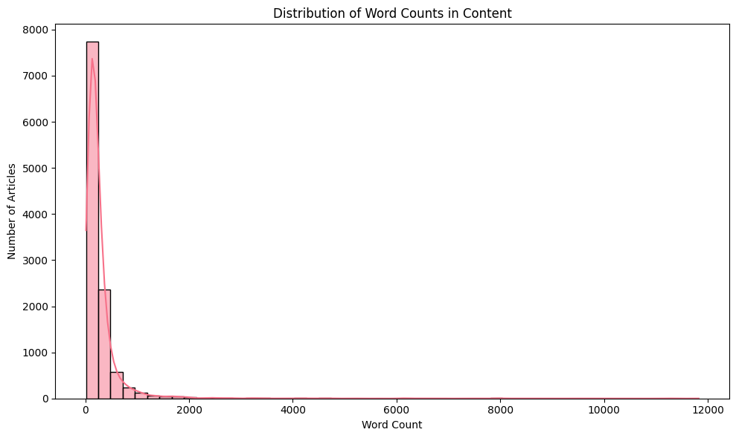

2 TARGET NAMES DISTRIBUTION
==================================================
target_names
rec.sport.hockey 600
soc.religion.christian 599
rec.motorcycles 598
rec.sport.baseball 597
sci.crypt 595
sci.med 594
rec.autos 594
sci.space 593
comp.windows.x 593
comp.os.ms-windows.misc 591
sci.electronics 591
comp.sys.ibm.pc.hardware 590
misc.forsale 585
comp.graphics 584
comp.sys.mac.hardware 578
talk.politics.mideast 564
talk.politics.guns 546
alt.atheism 480
talk.politics.misc 465
talk.religion.misc 377
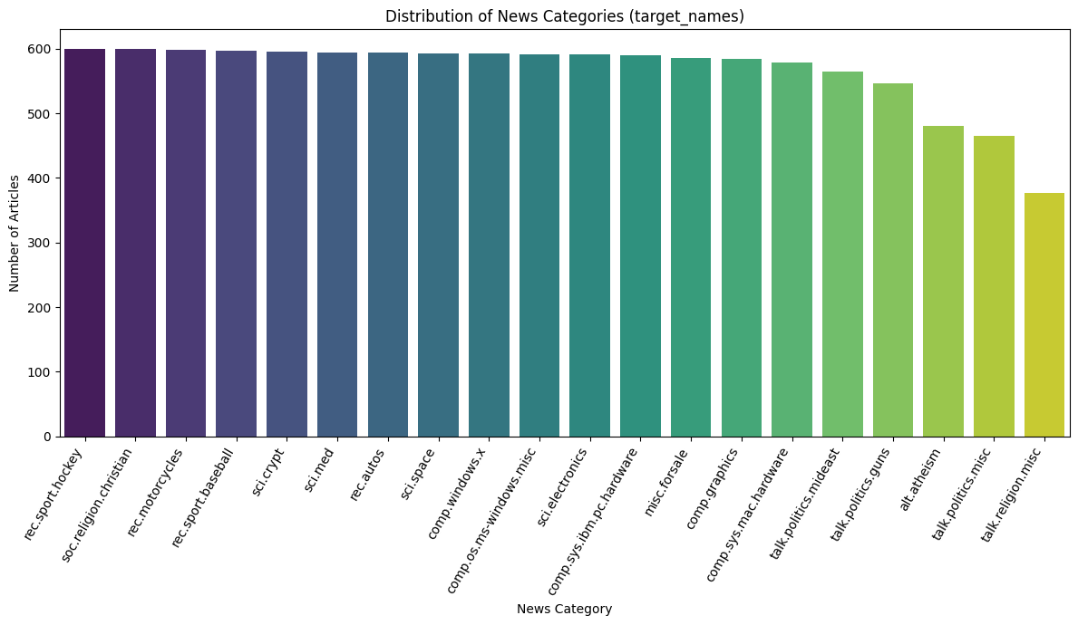❓ MISSING VALUES
==================================================
content 0
target 0
target_names 0

Text Cleanup
Original text:
Apple Inc. announced record quarterly earnings today! Visit https://apple.com for more info. #TechNews

Cleaned text:
apple inc announced record quarterly earnings today visit for more info technews

Fully preprocessed text:
apple inc announced record quarterly earnings today visit info technews
📝 BEFORE AND AFTER EXAMPLES
============================================================

Example 1:
Original: From: lerxst@wam.umd.edu (where's my thing)
Subject: WHAT car is this!?
Nntp-Posting-Host: rac3.wam....
Processed: wheres thing subject car nntppostinghost racwamumdedu organization university maryland college park ...

Example 2:
Original: From: guykuo@carson.u.washington.edu (Guy Kuo)
Subject: SI Clock Poll - Final Call
Summary: Final ca...
Processed: guy kuo subject clock poll final call summary final call clock report keywords siaccelerationclockup...

Example 3:
Original: From: twillis@ec.ecn.purdue.edu (Thomas E Willis)
Subject: PB questions...
Organization: Purdue Univ...
Processed: thomas willis subject question organization purdue university engineering computer network distribut...

Module 3: TF-IDF Analysis
🏷️ TOP TF-IDF TERMS BY CATEGORY
==================================================

📰 REC.AUTOS:
car: 0.1275
engine: 0.0295
writes: 0.0262
article: 0.0257
would: 0.0253
dealer: 0.0233
oil: 0.0233
like: 0.0206
nntppostinghost: 0.0203
one: 0.0202

📰 COMP.SYS.MAC.HARDWARE:
mac: 0.0688
apple: 0.0559
drive: 0.0395
monitor: 0.0310
problem: 0.0288
quadra: 0.0280
centris: 0.0263
simms: 0.0255
card: 0.0244
duo: 0.0240

📰 COMP.GRAPHICS:
graphic: 0.0550
file: 0.0448
image: 0.0443
university: 0.0279
program: 0.0273
thanks: 0.0261
polygon: 0.0260
format: 0.0246
color: 0.0239
nntppostinghost: 0.0238

📰 SCI.SPACE:
space: 0.0878
moon: 0.0361
orbit: 0.0342
nasa: 0.0327
launch: 0.0289
pat: 0.0280
would: 0.0279
writes: 0.0252
shuttle: 0.0234
article: 0.0232

📰 TALK.POLITICS.GUNS:
gun: 0.0978
weapon: 0.0386
firearm: 0.0374
would: 0.0367
people: 0.0342
right: 0.0301
waco: 0.0265
law: 0.0263
fbi: 0.0262
writes: 0.0257

📰 SCI.MED:
gordon bank: 0.0457
gordon: 0.0433
msg: 0.0422
bank: 0.0414
food: 0.0306
disease: 0.0302
doctor: 0.0291
patient: 0.0243
article: 0.0243
one: 0.0236

📰 COMP.SYS.IBM.PC.HARDWARE:
drive: 0.0655
scsi: 0.0508
card: 0.0501
ide: 0.0366
controller: 0.0349
monitor: 0.0312
bus: 0.0300
disk: 0.0295
system: 0.0273
thanks: 0.0250

📰 COMP.OS.MS-WINDOWS.MISC:
window: 0.1251
file: 0.0698
driver: 0.0547
font: 0.0296
program: 0.0288
card: 0.0282
problem: 0.0272
university: 0.0271
use: 0.0257
win: 0.0243

📰 REC.MOTORCYCLES:
bike: 0.1007
dod: 0.0596
motorcycle: 0.0393
article: 0.0316
ride: 0.0312
writes: 0.0312
bmw: 0.0286
dog: 0.0284
helmet: 0.0273
riding: 0.0265

📰 TALK.RELIGION.MISC:
god: 0.0583
christian: 0.0531
jesus: 0.0450
people: 0.0297
article: 0.0287
morality: 0.0286
writes: 0.0273
one: 0.0265
say: 0.0264
kent: 0.0252

📰 MISC.FORSALE:
sale: 0.0961
offer: 0.0450
shipping: 0.0350
email: 0.0308
new: 0.0293
university: 0.0290
distribution: 0.0286
price: 0.0278
condition: 0.0261
game: 0.0249

📰 ALT.ATHEISM:
god: 0.0628
keith: 0.0447
atheist: 0.0401
one: 0.0337
people: 0.0336
writes: 0.0334
morality: 0.0297
atheism: 0.0286
islam: 0.0279
dont: 0.0275

📰 SCI.ELECTRONICS:
circuit: 0.0301
one: 0.0248
use: 0.0246
would: 0.0240
power: 0.0225
chip: 0.0223
university: 0.0221
anyone: 0.0219
know: 0.0210
nntppostinghost: 0.0202

📰 COMP.WINDOWS.X:
window: 0.0661
server: 0.0403
widget: 0.0401
motif: 0.0380
application: 0.0305
xterm: 0.0264
sun: 0.0261
file: 0.0259
program: 0.0247
problem: 0.0233

📰 REC.SPORT.HOCKEY:
team: 0.0740
game: 0.0705
hockey: 0.0590
player: 0.0465
nhl: 0.0403
playoff: 0.0388
play: 0.0350
season: 0.0278
win: 0.0272
leaf: 0.0272

📰 REC.SPORT.BASEBALL:
game: 0.0545
baseball: 0.0495
team: 0.0441
player: 0.0435
year: 0.0387
run: 0.0291
writes: 0.0270
win: 0.0266
season: 0.0260
hit: 0.0259

📰 SOC.RELIGION.CHRISTIAN:
god: 0.0966
christian: 0.0625
jesus: 0.0500
church: 0.0434
bible: 0.0349
christ: 0.0336
people: 0.0321
would: 0.0305
one: 0.0303
faith: 0.0293

📰 TALK.POLITICS.MIDEAST:
israel: 0.0790
israeli: 0.0787
armenian: 0.0704
arab: 0.0484
jew: 0.0455
turkish: 0.0434
people: 0.0306
serdar: 0.0289
armenia: 0.0276
turk: 0.0260

📰 TALK.POLITICS.MISC:
people: 0.0358
writes: 0.0350
article: 0.0335
tax: 0.0325
government: 0.0313
homosexual: 0.0293
clinton: 0.0286
gay: 0.0271
would: 0.0271
clayton: 0.0266

📰 SCI.CRYPT:
key: 0.1032
clipper: 0.0735
chip: 0.0696
encryption: 0.0674
government: 0.0382
clipper chip: 0.0376
system: 0.0328
nsa: 0.0312
crypto: 0.0307
would: 0.0303

📊 POS (Part-of-Speech) PATTERNS BY CATEGORY
NN → Noun, singular, NNS → Noun, plural, NNP → Proper noun, singular, VB → Base form, VBD → Past tense, VBG → Gerund/present participle
running, eating
==================================================

🎯 Key POS patterns by category:
NN NNS NNP NNPS VB VBD \
category
alt.atheism 0.1410 0.0324 0.1252 0.0032 0.0380 0.0154
comp.graphics 0.1535 0.0339 0.1632 0.0058 0.0313 0.0084
comp.os.ms-windows.misc 0.1441 0.0269 0.1735 0.0049 0.0310 0.0103
comp.sys.ibm.pc.hardware 0.1476 0.0282 0.1598 0.0044 0.0304 0.0116
comp.sys.mac.hardware 0.1456 0.0272 0.1649 0.0045 0.0312 0.0117
comp.windows.x 0.1598 0.0272 0.1631 0.0053 0.0337 0.0071
misc.forsale 0.1548 0.0267 0.2173 0.0059 0.0207 0.0083
rec.autos 0.1535 0.0320 0.1419 0.0040 0.0313 0.0167
rec.motorcycles 0.1494 0.0271 0.1509 0.0043 0.0289 0.0161
rec.sport.baseball 0.1354 0.0285 0.1764 0.0067 0.0280 0.0187
rec.sport.hockey 0.1289 0.0262 0.1954 0.0062 0.0284 0.0176
sci.crypt 0.1550 0.0354 0.1188 0.0040 0.0403 0.0106
sci.electronics 0.1591 0.0324 0.1409 0.0048 0.0323 0.0111
sci.med 0.1508 0.0358 0.1182 0.0038 0.0314 0.0134
sci.space 0.1507 0.0311 0.1573 0.0039 0.0315 0.0148
soc.religion.christian 0.1301 0.0312 0.1178 0.0059 0.0376 0.0169
talk.politics.guns 0.1366 0.0370 0.1410 0.0038 0.0360 0.0186
talk.politics.mideast 0.1299 0.0376 0.1608 0.0069 0.0310 0.0209
talk.politics.misc 0.1413 0.0362 0.1379 0.0048 0.0347 0.0149
talk.religion.misc 0.1390 0.0307 0.1348 0.0044 0.0338 0.0181

VBN → Past participle, VBP → Present (non-3rd person singular), VBZ → Present (3rd person singular), JJ → Adjective big, fast - JJR → Comparative adjective

VBG VBN VBP VBZ JJ JJR \
category
alt.atheism 0.0107 0.0131 0.0279 0.0323 0.0606 0.0020
comp.graphics 0.0114 0.0095 0.0209 0.0220 0.0536 0.0013
comp.os.ms-windows.misc 0.0105 0.0090 0.0231 0.0237 0.0468 0.0017
comp.sys.ibm.pc.hardware 0.0104 0.0094 0.0225 0.0245 0.0515 0.0018
comp.sys.mac.hardware 0.0098 0.0097 0.0237 0.0243 0.0525 0.0020
comp.windows.x 0.0123 0.0108 0.0209 0.0230 0.0523 0.0011
misc.forsale 0.0081 0.0073 0.0162 0.0145 0.0548 0.0014
rec.autos 0.0116 0.0112 0.0240 0.0226 0.0562 0.0023
rec.motorcycles 0.0127 0.0087 0.0223 0.0225 0.0535 0.0019
rec.sport.baseball 0.0098 0.0094 0.0200 0.0242 0.0515 0.0023
rec.sport.hockey 0.0091 0.0093 0.0180 0.0203 0.0483 0.0017
sci.crypt 0.0117 0.0153 0.0222 0.0277 0.0646 0.0022
sci.electronics 0.0107 0.0106 0.0232 0.0223 0.0567 0.0019
sci.med 0.0113 0.0136 0.0226 0.0290 0.0613 0.0017
sci.space 0.0113 0.0132 0.0187 0.0226 0.0582 0.0022
soc.religion.christian 0.0121 0.0152 0.0286 0.0291 0.0534 0.0015
talk.politics.guns 0.0124 0.0146 0.0242 0.0223 0.0563 0.0022
talk.politics.mideast 0.0113 0.0142 0.0217 0.0240 0.0592 0.0012
talk.politics.misc 0.0117 0.0129 0.0245 0.0252 0.0609 0.0023
talk.religion.misc 0.0108 0.0133 0.0252 0.0277 0.0589 0.0012

JJS → Superlative adjective- biggest, RB → Adverb quickly, RBR → Comparative adverb, RBS → Superlative adverb, CD → Cardinal number
one, 100

JJS RB RBR RBS CD
category
alt.atheism 0.0013 0.0406 0.0012 0.0002 0.0159
comp.graphics 0.0009 0.0256 0.0006 0.0002 0.0293
comp.os.ms-windows.misc 0.0011 0.0272 0.0004 0.0001 0.0316
comp.sys.ibm.pc.hardware 0.0009 0.0278 0.0006 0.0002 0.0384
comp.sys.mac.hardware 0.0013 0.0285 0.0008 0.0002 0.0348
comp.windows.x 0.0008 0.0232 0.0005 0.0001 0.0264
misc.forsale 0.0018 0.0168 0.0003 0.0001 0.0563
rec.autos 0.0014 0.0338 0.0008 0.0003 0.0274
rec.motorcycles 0.0013 0.0312 0.0009 0.0002 0.0278
rec.sport.baseball 0.0020 0.0323 0.0008 0.0004 0.0343
rec.sport.hockey 0.0016 0.0297 0.0007 0.0003 0.0411
sci.crypt 0.0011 0.0361 0.0013 0.0002 0.0191
sci.electronics 0.0013 0.0283 0.0006 0.0003 0.0311
sci.med 0.0013 0.0361 0.0010 0.0004 0.0179
sci.space 0.0010 0.0322 0.0009 0.0003 0.0266
soc.religion.christian 0.0013 0.0409 0.0008 0.0005 0.0139
talk.politics.guns 0.0011 0.0358 0.0012 0.0002 0.0176
talk.politics.mideast 0.0012 0.0318 0.0006 0.0003 0.0199
talk.politics.misc 0.0010 0.0366 0.0012 0.0003 0.0188
talk.religion.misc 0.0011 0.0357 0.0010 0.0002 0.0190
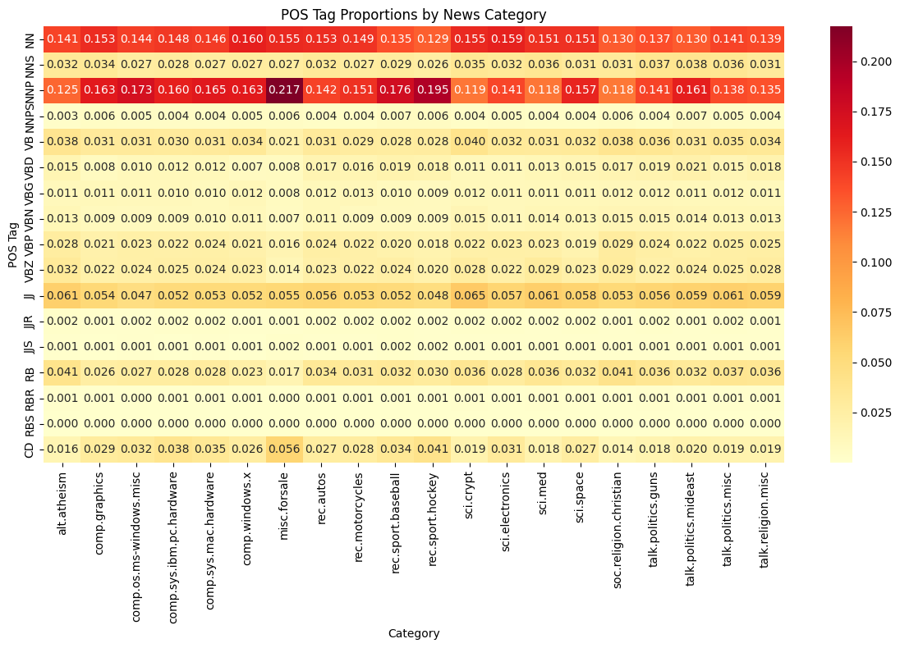
💡 ANALYSIS QUESTIONS:
- Which category has the highest proportion of proper nouns (NNP/NNPS)?
misc.forsale (NNP - 0.2173) talk.politics.mideast (NNPS - 0.0069)

- Which category uses the most action verbs (VB, VBD, VBG)?
sci.crypt (VB - 0.0403)

- Are there interesting patterns in adjective (JJ) usage?
Mininmum value: comp.os.ms-windows.mis (0.0468)
Maxiumum value: sci.crypt (0.0646)

- How does number (CD) usage vary across categories?
Mininmum value: alt.atheism (0.0159)
Maxiumum value: misc.forsale (0.0563)

Performing syntactic analysis...
✅ Syntactic analysis complete!

📰 Article 1 (rec.autos):
Sentences: 9
Tokens: 173
Noun phrases: ['lerxst@wam.umd.edu', 'my thing', 'subject']...
Subjects: ['thing', 'car', 'this']...
Objects: ['lerxst@wam.umd.edu', 'subject', 'maryland']...

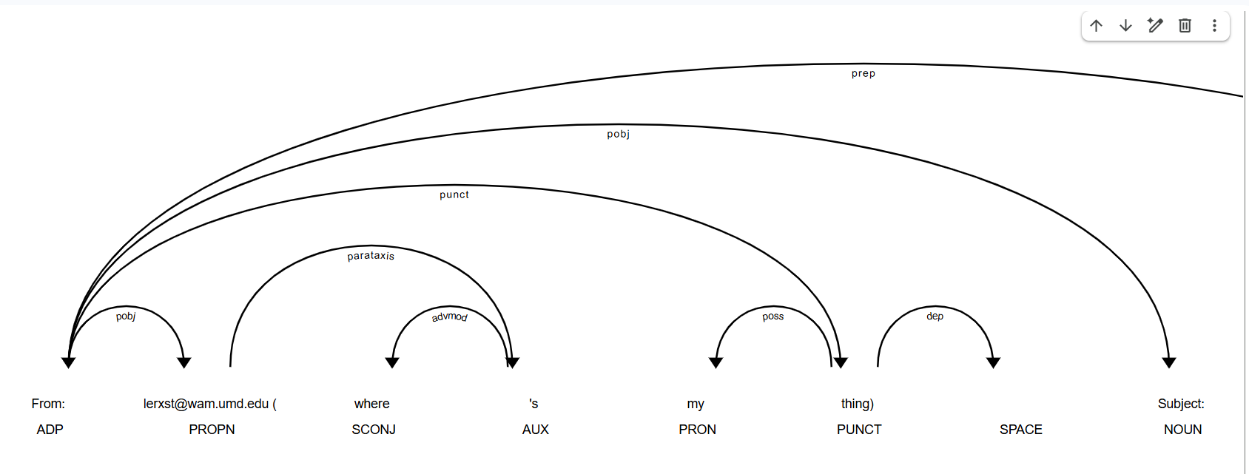

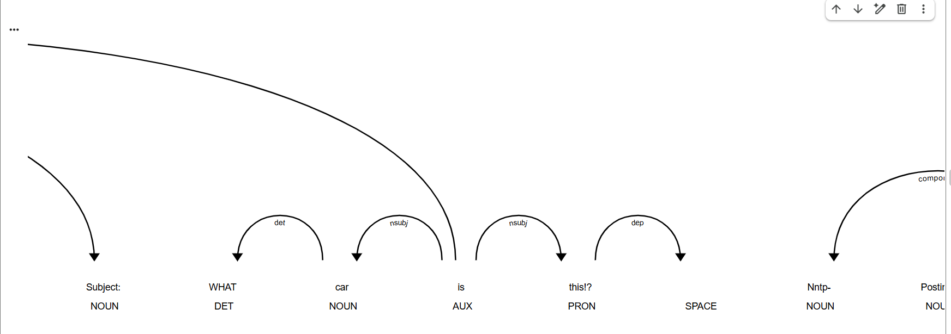
😊 Analyzing sentiment...
✅ Sentiment analysis complete!
📊 Analyzed 11314 articles

📝 Sample sentiment results:
category full_sentiment full_label
0 rec.autos 0.8070 positive
1 comp.sys.mac.hardware 0.9468 positive
2 comp.sys.mac.hardware 0.9521 positive
3 comp.graphics 0.6648 positive
4 sci.space -0.9481 negative

📊 SENTIMENT ANALYSIS BY CATEGORY
==================================================

📈 Sentiment statistics by category:
full_sentiment pos_score \
mean std min max mean
category
alt.atheism 0.1388 0.8169 -0.9999 0.9999 0.0896
comp.graphics 0.5737 0.4794 -0.9778 1.0000 0.0869
comp.os.ms-windows.misc 0.3913 0.6267 -0.9959 0.9994 0.0764
comp.sys.ibm.pc.hardware 0.4371 0.6001 -0.9943 0.9980 0.0802
comp.sys.mac.hardware 0.3760 0.6404 -0.9863 0.9996 0.0746
comp.windows.x 0.3975 0.6318 -0.9757 0.9999 0.0728
misc.forsale 0.5341 0.4941 -0.9936 0.9999 0.0844
rec.autos 0.3047 0.6995 -0.9961 0.9975 0.0822
rec.motorcycles 0.3123 0.6971 -0.9987 0.9986 0.0792
rec.sport.baseball 0.4892 0.6024 -0.9970 0.9998 0.0960
rec.sport.hockey 0.4629 0.6648 -0.9949 0.9999 0.0940
sci.crypt 0.3685 0.6978 -0.9992 0.9999 0.0836
sci.electronics 0.4729 0.5639 -0.9896 0.9994 0.0756
sci.med 0.1929 0.7352 -0.9998 0.9998 0.0764
sci.space 0.4028 0.6475 -0.9976 0.9999 0.0708
soc.religion.christian 0.3659 0.7632 -0.9998 0.9997 0.1062
talk.politics.guns -0.3159 0.7723 -0.9999 0.9976 0.0779
talk.politics.mideast -0.2816 0.7955 -0.9999 0.9994 0.0701
talk.politics.misc 0.1305 0.8078 -1.0000 1.0000 0.0867
talk.religion.misc 0.2110 0.7837 -0.9997 0.9991 0.0917

neu_score neg_score
mean mean
category
alt.atheism 0.8309 0.0794
comp.graphics 0.8898 0.0232
comp.os.ms-windows.misc 0.8871 0.0366
comp.sys.ibm.pc.hardware 0.8824 0.0374
comp.sys.mac.hardware 0.8869 0.0385
comp.windows.x 0.8933 0.0340
misc.forsale 0.8921 0.0235
rec.autos 0.8651 0.0527
rec.motorcycles 0.8712 0.0496
rec.sport.baseball 0.8587 0.0452
rec.sport.hockey 0.8581 0.0478
sci.crypt 0.8637 0.0527
sci.electronics 0.8948 0.0296
sci.med 0.8622 0.0615
sci.space 0.8902 0.0390
soc.religion.christian 0.8251 0.0687
talk.politics.guns 0.8182 0.1039
talk.politics.mideast 0.8357 0.0943
talk.politics.misc 0.8361 0.0772
talk.religion.misc 0.8366 0.0717

📊 Sentiment distribution (%) by category:
full_label negative neutral positive
category
alt.atheism 40.42 1.67 57.92
comp.graphics 10.79 5.99 83.22
comp.os.ms-windows.misc 21.49 6.43 72.08
comp.sys.ibm.pc.hardware 21.02 2.54 76.44
comp.sys.mac.hardware 23.53 5.02 71.45
comp.windows.x 22.26 4.72 73.02
misc.forsale 12.65 7.01 80.34
rec.autos 29.80 3.20 67.00
rec.motorcycles 29.10 2.68 68.23
rec.sport.baseball 18.59 4.86 76.55
rec.sport.hockey 23.50 1.67 74.83
sci.crypt 27.73 2.02 70.25
sci.electronics 17.94 3.72 78.34
sci.med 38.22 2.02 59.76
sci.space 24.45 2.70 72.85
soc.religion.christian 29.38 2.17 68.45
talk.politics.guns 66.12 0.73 33.15
talk.politics.mideast 64.36 0.71 34.93
talk.politics.misc 41.51 1.29 57.20
talk.religion.misc 36.60 0.80 62.60

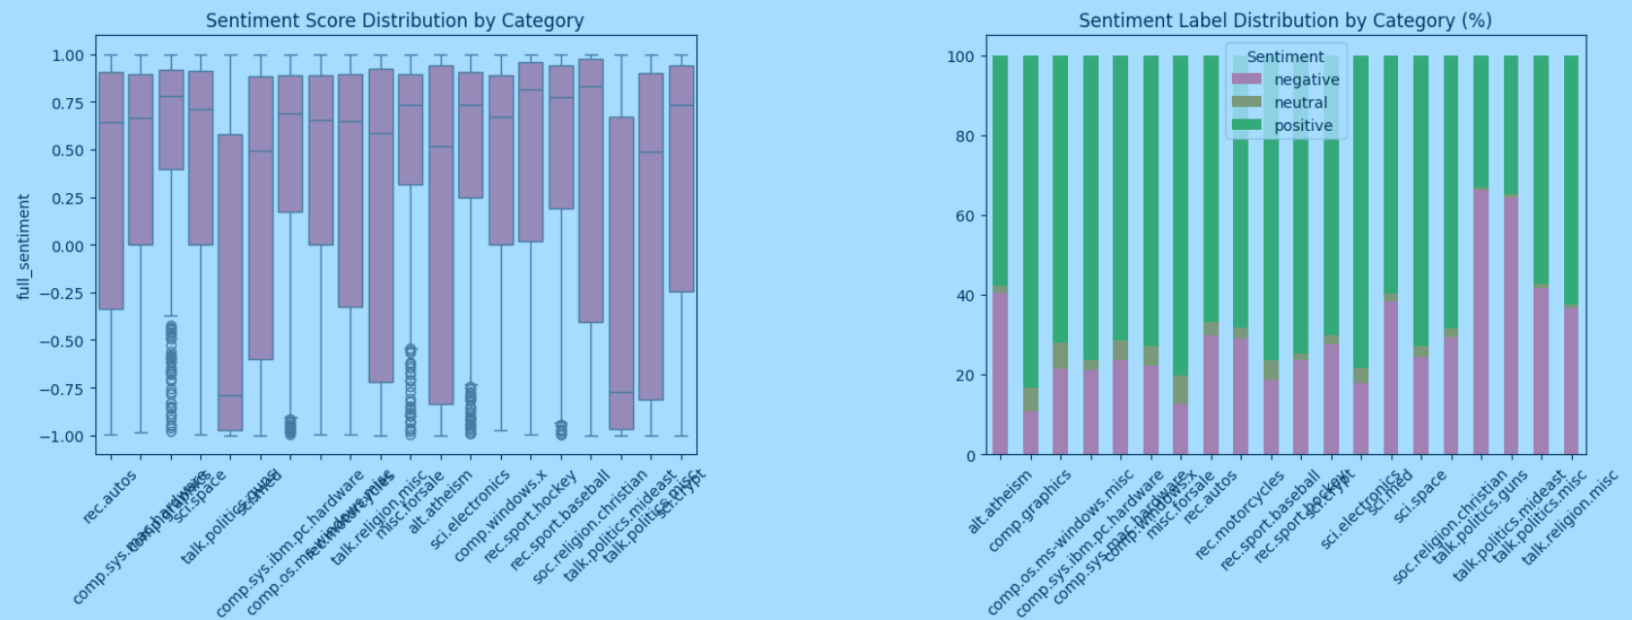

Analyze sentiment using VADER sentiment analyzer
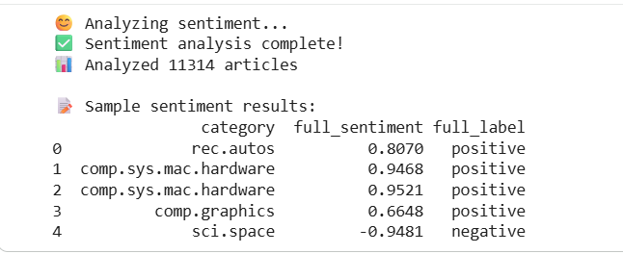

🔧 Preparing features for classification...
✅ Feature matrix prepared!
📊 Feature matrix shape: (11314, 5007)
🎯 Number of classes: 20
📋 Classes: ['alt.atheism' 'comp.graphics' 'comp.os.ms-windows.misc'
'comp.sys.ibm.pc.hardware' 'comp.sys.mac.hardware' 'comp.windows.x'
'misc.forsale' 'rec.autos' 'rec.motorcycles' 'rec.sport.baseball'
'rec.sport.hockey' 'sci.crypt' 'sci.electronics' 'sci.med' 'sci.space'
'soc.religion.christian' 'talk.politics.guns' 'talk.politics.mideast'
'talk.politics.misc' 'talk.religion.misc']

📈 Data split:
Training set: 9051 samples
Test set: 2263 samples

============================================================
📈 NEWSBOT INTELLIGENCE SYSTEM - COMPREHENSIVE REPORT
============================================================

📊 DATASET OVERVIEW:
Total Articles: 11314
Categories: rec.autos, comp.sys.mac.hardware, comp.graphics, sci.space, talk.politics.guns, sci.med, comp.sys.ibm.pc.hardware, comp.os.ms-windows.misc, rec.motorcycles, talk.religion.misc, misc.forsale, alt.atheism, sci.electronics, comp.windows.x, rec.sport.hockey, rec.sport.baseball, soc.religion.christian, talk.politics.mideast, talk.politics.misc, sci.crypt

Average Article Length: 1949 characters
Average Words per Article: 287 words

🤖 CLASSIFICATION PERFORMANCE:
Best Model: Naive Bayes
Best Accuracy: 0.4675

😊 SENTIMENT INSIGHTS:
Most Positive Category: comp.graphics
Most Negative Category: talk.politics.guns
Overall Sentiment: 0.3071

🔍 ENTITY INSIGHTS:
Total Entities: 305947
Unique Entities: 81770
Entity Types: GPE, CARDINAL, DATE, PERSON, ORG, LAW, TIME, PRODUCT, WORK_OF_ART, ORDINAL, NORP, PERCENT, MONEY, QUANTITY, FAC, LOC, EVENT, LANGUAGE

💡 BUSINESS RECOMMENDATIONS:
1. ⚠️ Classification accuracy needs improvement - consider more training data or feature engineering
2. 📊 comp.graphics articles are most positive - good for uplifting content recommendations
3. 📊 talk.politics.guns articles are most negative - may need balanced coverage monitoring
4. 🔍 Rich entity extraction enables advanced search and relationship analysis

Predicted Category: rec.sport.baseball (54.59% confidence)

📊 Category Probabilities:
rec.sport.baseball: 0.546
rec.sport.hockey: 0.106
sci.electronics: 0.066
comp.graphics: 0.043
misc.forsale: 0.039
comp.sys.mac.hardware: 0.036
sci.space: 0.036
sci.med: 0.020
rec.autos: 0.018
talk.religion.misc: 0.014
sci.crypt: 0.012
alt.atheism: 0.012
soc.religion.christian: 0.012
rec.motorcycles: 0.011
talk.politics.misc: 0.008
comp.sys.ibm.pc.hardware: 0.008
talk.politics.mideast: 0.005
talk.politics.guns: 0.004
comp.windows.x: 0.003
comp.os.ms-windows.misc: 0.000

