Jenkins
  - Set up local Jenkins CI/CD server with Docker for KitchenMate

- Pull latest Jenkins image
docker pull jenkins/jenkins:latest
- Create container with parameters
docker run -d -p 9000:8080 -p 50000:50000 --name km_jenkins -v km_jenkins_vol:/var/jenkins_home jenkins/jenkins:latest
- Open up localhost:9000 on browser
- Get default admin password
docker exec -it km_jenkins cat /var/jenkins_home/secrets/initialAdminPassword
- Login with the default password
- Install suggested plugins + NodeJS, Docker, Docker Pipeline
- Create your first user
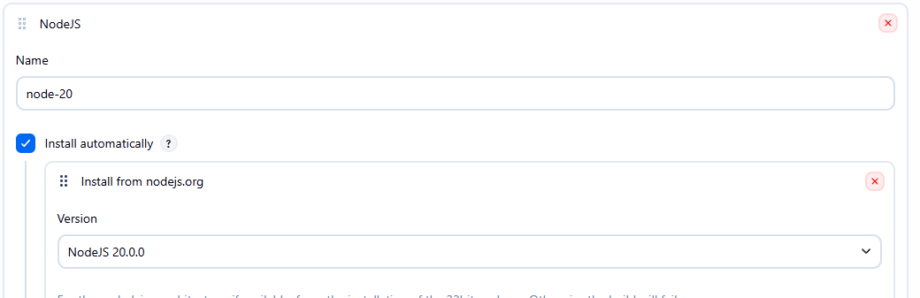
- Configure NodeJS tool

- Create a job -> Give name -> Item type: Pipeline

- In general section of configuration, give url to GitHub Project,

- In triggers section toggle Github Trigger, it will poll Github repository after pushing to repo
- In pipeline section, define script from SCM (Git), give repo url and only build master branch
- Write jenkinsfile script (see repository root for file)

