SQL Assignment – 1

Creating sample tables and inserting values. Create the following tables with the given structures and insert sample data as specified: -

A) SALESPEOPLE
Snum int(4)
Sname varchar(10)
City varchar(10)
Comm float(3,2)

Ans:
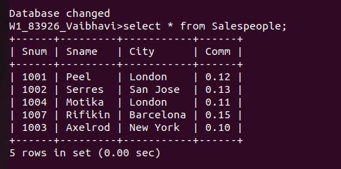
.

B) CUSTOMERS

Cnum int(4)
Cname varchar(10)
City varchar(10)
Rating int(4)
Snum int(4)
Ans:
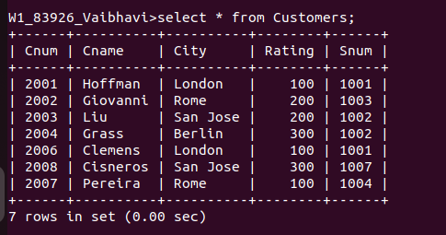

C) ORDERS
Onum int(4)
Amt float(7,2)
Odate date
Cnum int(4)
Snum int(4)

Ans:
