SQL Assignment – 2

Introducing Relational Databases.

1. Which field of the Customers table is the primary key?
Ans:
CNUM is the primary key of Customers.

2. What is the 4th Column of the Customers table?
Ans:

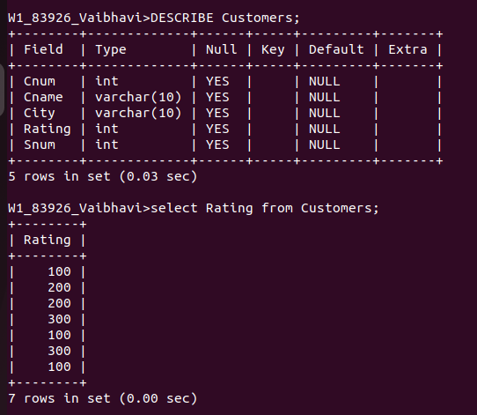
.

3. What is another word for row? For Column?
Ans:
row is knows as Record and Column is also known as field.

4. Why isn't it possible to see the first five rows of a table?

Ans:
When multi-users INSERT a row into a table whenever it finds a free space in the DB Server HD, it will store the row there.
Once row has been inserted the address of that row is constant.
Whenyou update a row, if row length is increasing and if the free space is not available at the location then the entire row is moved to some other address.
Later when you SELECT from that table, you will see that row at some other position.
It's only in the case of Varchar, that the row length may increase or decrease. This is coomon for all RDBMS.
Hence it is not possible to see the first 5 rows of a table.

