

**Jewelry Auction Project**

Software Requirements Specification

N3_SE1841

V2.1

17/07/2024

# **Revision History**

| **Date** | **Description** | **Author** | **Comments** |
| --- | --- | --- | --- |
| 15/06/2024 | Version 1.0 | Nguyen Van Dai | Initial document |
| 16/07/2024 | Version 2.0 | Nguyen Van Dai | Update User UI, Edit Use case List, Update database diagram |
| 17/7/2024 | Version 2.1 | Nguyen Van Dai | Add Technical requirements |

# **Document Approval**

The following Software Requirements Specification has been accepted and approved by the following:

| **Printed Name** | **Title** | **Date** |
| --- | --- | --- |
|  |  |  |

# **Table of content**

**Revision History 2**

**Document Approval 2**

**Table of content 3**

**1. Introduction 4**

**2. Database diagram 4**

**3. Function Requirements 4**

**4. Function List 6**

**5. User Interface Preview 9**

5.1 User UI 10

5.1.1 Login page 10

5.1.2 Home Page 11

5.1.3 Auction Session details 12

5.1.4 Real time Bidding 12

5.1.5 Payment 13

5.2 Manager UI 15

5.2.1 Login page 15

5.2.2 Request management 16

5.2.3 Auction session management 18

5.2.4 User management 19

5.2.5 Dashboard view 20

**6. Technical Requirements 20**

**7. Screen Flow 21**

Screen Details of Member Screen 21

Screen Details Staff Screen 23

Screen Details Manager Screen 23

**8. Business Rule 25**

# **Introduction**

This is a capstone project developed by Team 6 - SE1839 - SWP391. The project involves creating an auction system where anyone can initiate an auction with their jewelry or participate in an online auction.

# **Database diagram**

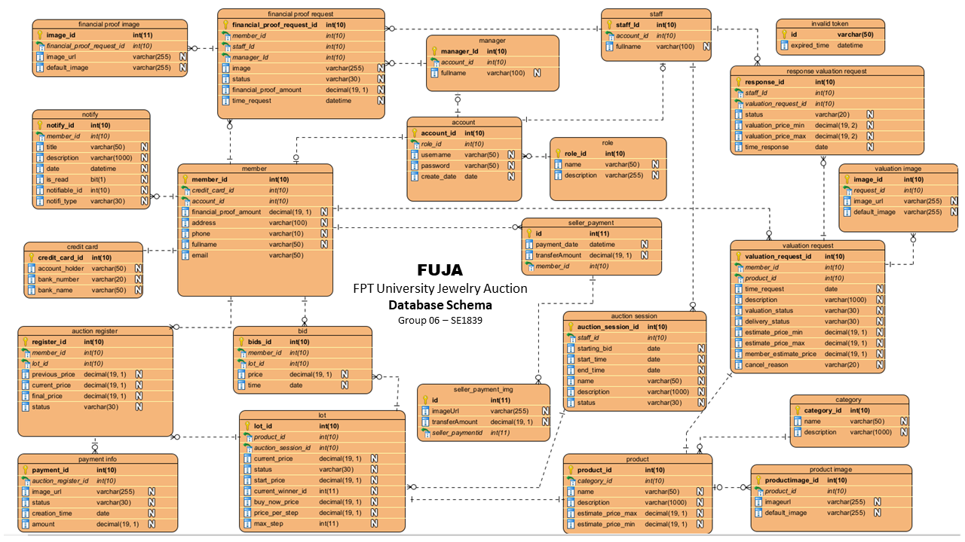

# **Function Requirements**

This jewelry auction system has 5 major actors

| **No** | **Actors** | **Description** |
| --- | --- | --- |
| 1 | Guest | A Guest is an unregistered user who visits the auction platform to explore its offerings. Guests have limited access to the platform's features and cannot participate in auctions or create listings until they register. |
| 2 | Member | A Member is a registered user of the auction system who can participate in various activities such as bidding on auctions, creating their own auctions, and interacting with other users. |
| 3 | Staff | Staff members are responsible for assisting with the management and moderation of the platform. |
| 4 | Manager | Managers oversee the overall operations of the auction platform. They are responsible for ensuring that the platform functions efficiently and meets business objectives. |

| **Module Name (SR#)** | **Applicable Roles** | **Description** |
| --- | --- | --- |
| User Account Management | Member  Guest  Admin | Implement functionality for guests to register as members and for members to manage their account details securely and efficiently.  Develop secure login and logout functionalities to ensure only authorized users can access and manage their accounts |
| Auction Session Management | Staff  Admins | Facilitate the creation, scheduling, and management of auction sessions, providing admins with tools to organize and oversee auctions effectively |
| Bid Participation | Member | Implement bid registration and real-time bidding functionalities, ensuring a competitive and engaging auction experience for members |
| Transaction Management | Member  Staff  Manager | Develop secure online payment processing and order completion features, enabling members to finalize their purchases smoothly after winning bids. |
| Valuation and Financial Proof Requests | Member  Staff  Manager | Allow members to submit valuation and financial proof requests, ensuring their items are assessed and they are ready for participating in auctions |
| Notifications | Member | Implement a robust notification system to inform users about important events, updates, and actions required, ensuring timely and effective communication.. |
| Dashboard view | Admin | Member can see the Total Revenue, Total Auction Session, Total Auction Lots, Total Lot Sold and chart of Monthly Total Revenue of year after auction past |

# **Function List**

| **No** | **ID** | **Function** | **Actors** | **Description** |
| --- | --- | --- | --- | --- |
| **1** | FN-01 | Member Register | Guest | A Guest register a Member account |
| **2** | FN-02 | Login | Member | A Member login to the platform |
| **3** | FN-03 | Logout | Member | Member logout from the platform |
| **4** | FN-04 | Add Bank Card | Member | Member create credit card in member profiles |
| **5** | FN-05 | Update Bank Card | Member | Member update credit card when created credit card |
| **6** | FN-06 | Send valuation request | Member | Function that member can sent a request to valuation their own jewelries, by provide it's images and description and they can give an expected price for the that jewelries |
| **7** | FN-07 | Send preliminary valuation | Staff, Manager | Based on the information of jewelry that member send, Staff or Manager sent back a preliminary valuation for it |
| **8** | FN-08 | Confirm jewelry received | Staff, Manager | After member deliver the jewelry to company, Staff or Manager confirm that jewelry is received |
| **9** | FN-09 | Setup jewelry information | Staff, Manager | Staff or Manager fields all informations of product |
| **10** | FN-10 | Confirm final valuation | Staff, Manager | Manager confirms the final valuation after re-pricing upon receiving the product from the customer. |
| **11** | FN-11 | Sent back final valuation | Staff, Manager | After confirming the final valuation, Staff or Manager sent back the final valuation to the customer. |
| **12** | FN-12 | Confirm jewelry auction | Member | Member get the response for final valuation and new jewelry information, so Member can approve to start auction for their jewelry, or reject it |
| **13** | FN-13 | Create auction session | Manager | Manager create an auction session, assign a staff to manage |
| **14** | FN-14 | Edit auction session | Manager | Manager edit auction session information |
| **15** | FN-15 | Set lot to auction session | Manager | Manager chooses a lot and has status READY then added to an auction session has status CREATED. |
| **16** | FN-16 | Public an auction session | Manager | After confirm session's information, Manager publish the session to Upcoming session |
| **17** | FN-17 | Sent financial proof request | Member | When participating in the auction, members must prove their finances to bid by submitting a request for financial proof |
| **18** | FN-18 | Confirm financial proof request | Staff, Manager | Staff or Manager confirm financial proof requests of members. If approved, Staff or Manager sets the amount for request. |
| **19** | FN-19 | Confirm VIP financial proof request | Manager | Manager confirm financial proof request of member If amount larger than 100,000 dollars |
| **20** | FN-20 | View upcoming session information | Guest, Member | Get details about upcoming sessions and its lots. Everyone can view these sessions and lots. |
| **21** | FN-21 | View live session information | Member | Get details about live sessions and its lots. Only members who has registered to bid can access these information |
| **22** | FN-22 | View past session information | Guest, Member | Guest Members can view the list of the past auction session details. |
| **23** | FN-23 | Register to bid without bid | Member | Members register to participate in the auction of that product but do not place a bid in advance |
| **24** | FN-24 | Register to bid with a bid | Member | Members register to participate in the auction and reserve an amount according to starting price and have options increase according to the step. |
| **25** | FN-25 | Auto start an auction session | N/A | This function automatically checks if any auction session has reached its start time. For each such session, it sends a notification to each registered member for each lot, informing them that the lot is now live. After sending the notifications, it starts that session. |
| **26** | FN-26 | Real time bidding | Member | Supports real time bidding, sync within every client. Update lot price, bid history, financial proof amount in real time. |
| **27** | FN-27 | Buy now a jewelry | Member | This function helps members to buy jewelry directly if they are willing to pay the jewelry full price without having to wait for the lot to end. |
| **28** | FN-28 | Auto end an auction session | N/A | This function automatically checks if any auction session has reached its end time. If a lot has a current winner, it sends a notification to the winner. After that, it updates session state, that lot's state and registers. |
| **29** | FN-29 | Create win lots payment | Member | After winning the auction, Member can view the lot they have won then proceed to payment |
| **30** | FN-30 | Third party payment support | Member | Members proceed to payment via VNPay. |
| **31** | FN-31 | Confirm winner delivered | Manager | Confirm product delivery to winner |
| **32** | FN-32 | Confirm seller payment |  | After winner purchased, Manager can get the information of product owner, Manager send transfer bill photo and confirm transferred |
| **33** | FN-33 | Create staff account | Manager | This allows manager to setup staff account |
| **34** | FN-34 | Edit staff account | Manager | Manager can edit staff accounts' information |
| **35** | FN-35 | Send notification | N/A | System sends notification to members automatically. Notification can have many different contents such as: auction session start announcement, valuation request result, financial proof request result, order updates.... |
| **36** | FN-36 | View notification | Member | Members can view their notifications |
| **37** | FN-37 | Show dashboard | Manager | Show Total Revenue, Total Auction Session, Total Auction Lots, Total Lot Sold and chart of Monthly Total Revenue of year after auction past |

# 

# 

# **User Interface Preview**

In this project, we have 2 UI, User UI for Guest, Member and Manager UI for Staff and Manager

## 5.1 User UI

### 5.1.1 Login page

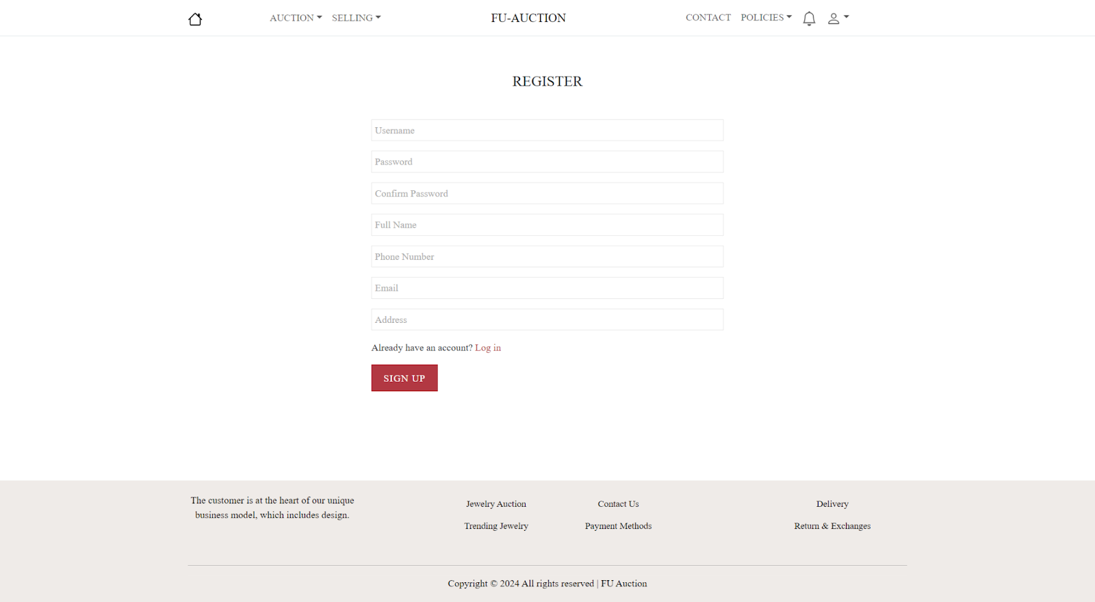

***Register Screen***

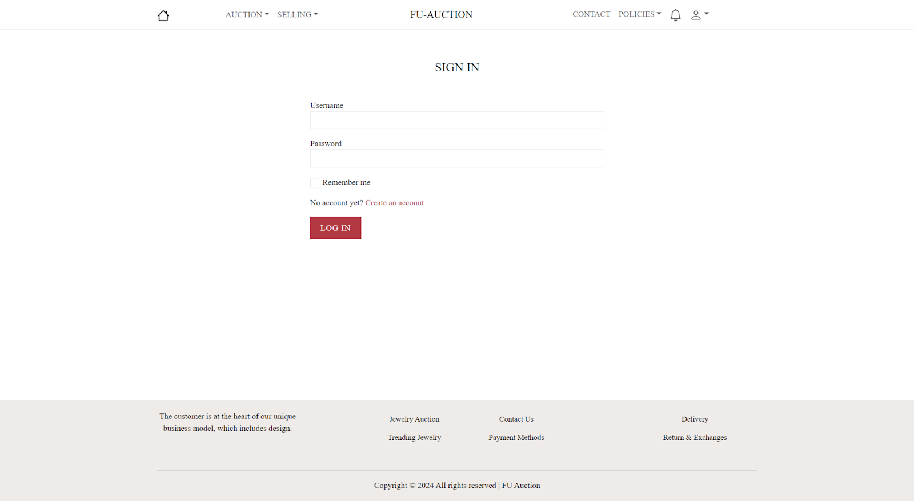

***Login Screen***

### 5.1.2 Home Page

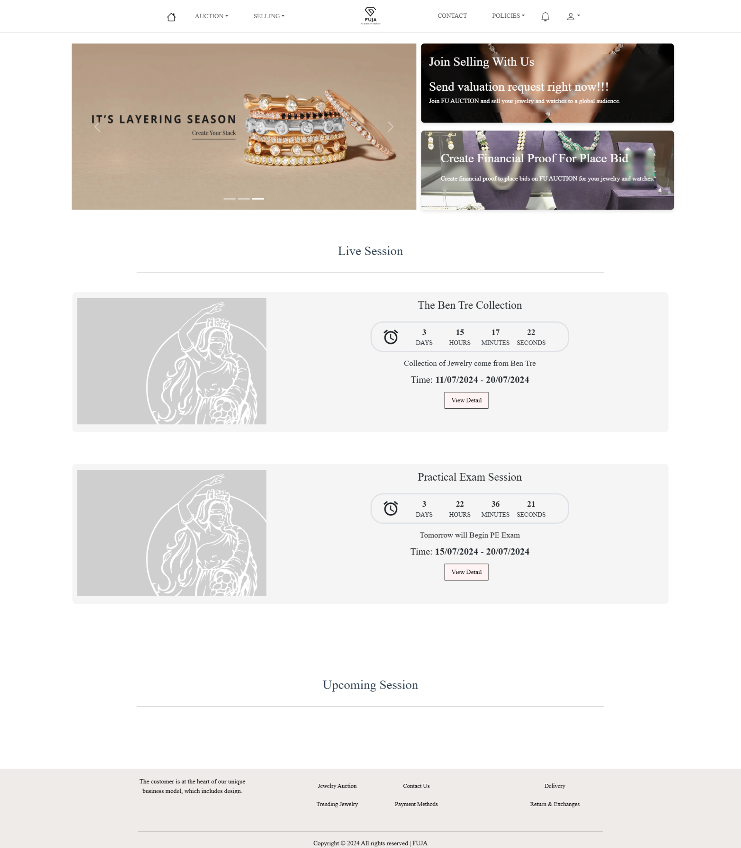

***Home page***

### 5.1.3 Auction Session details

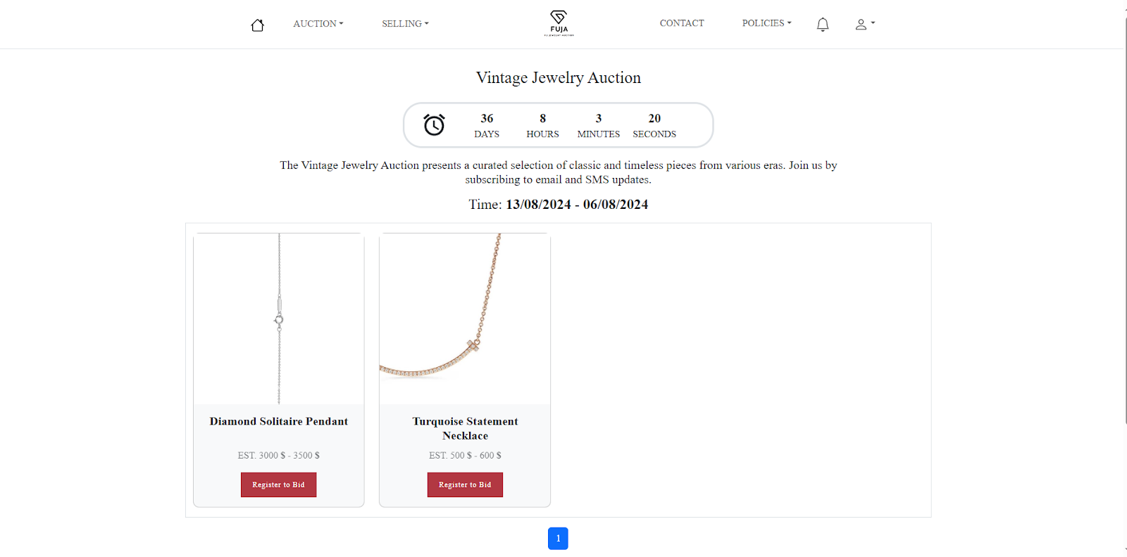

***Auction session details***

### 5.1.4 Real time Bidding

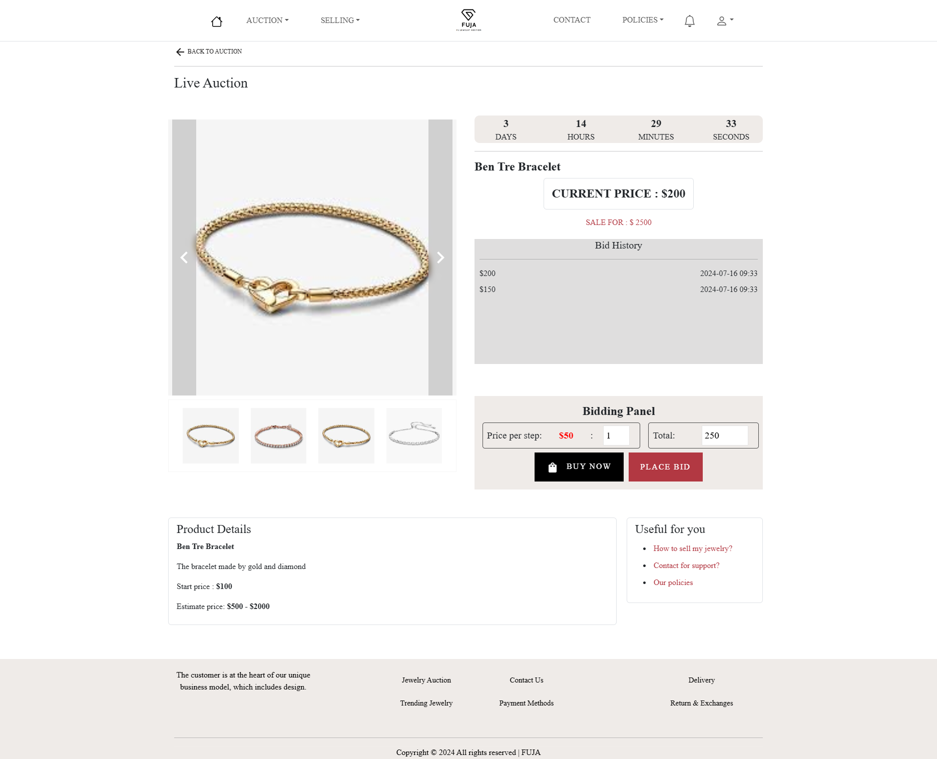

***Real time bidding***

### 5.1.5 Payment

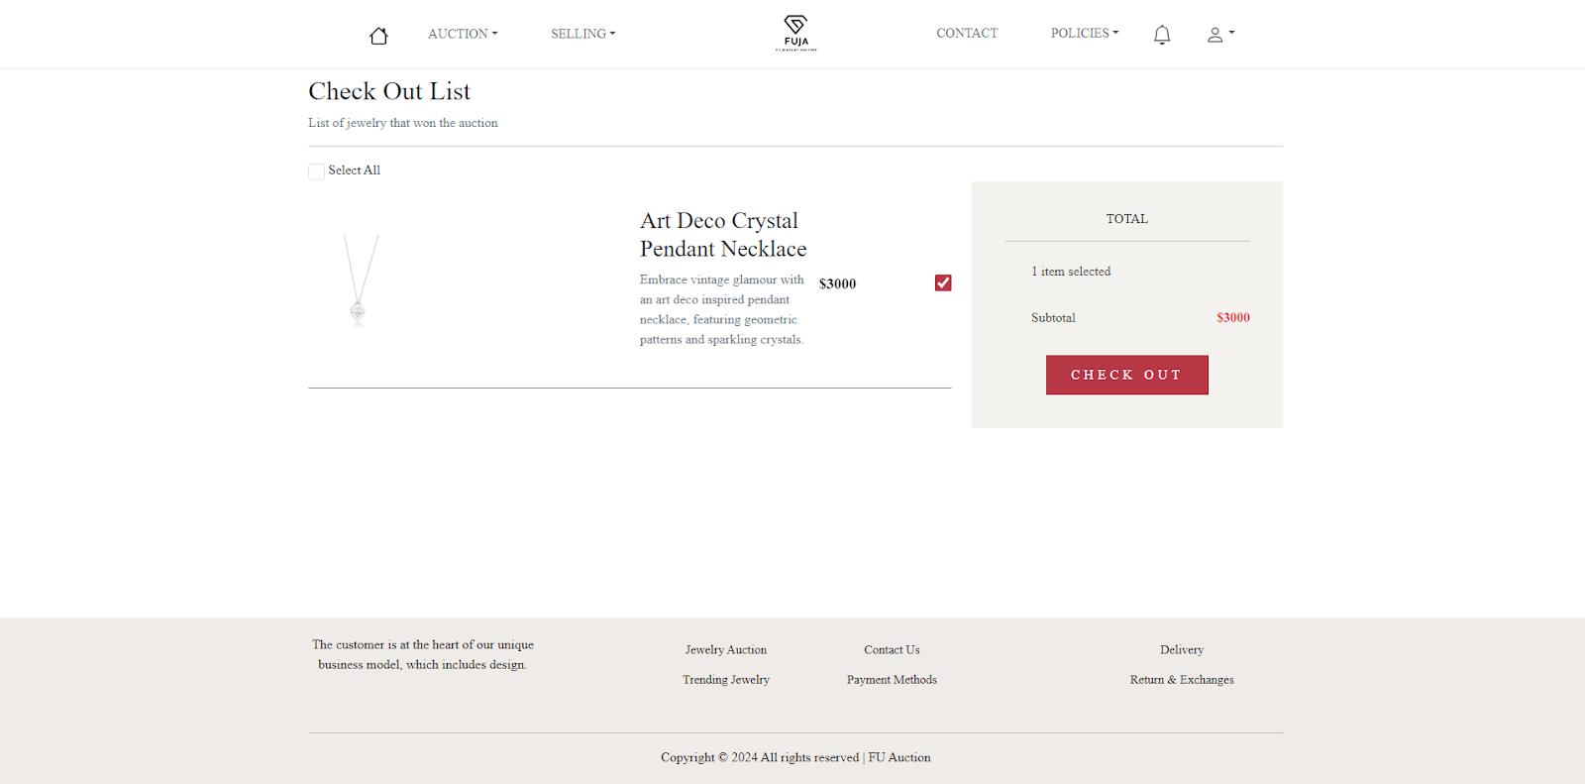

***Win auction***

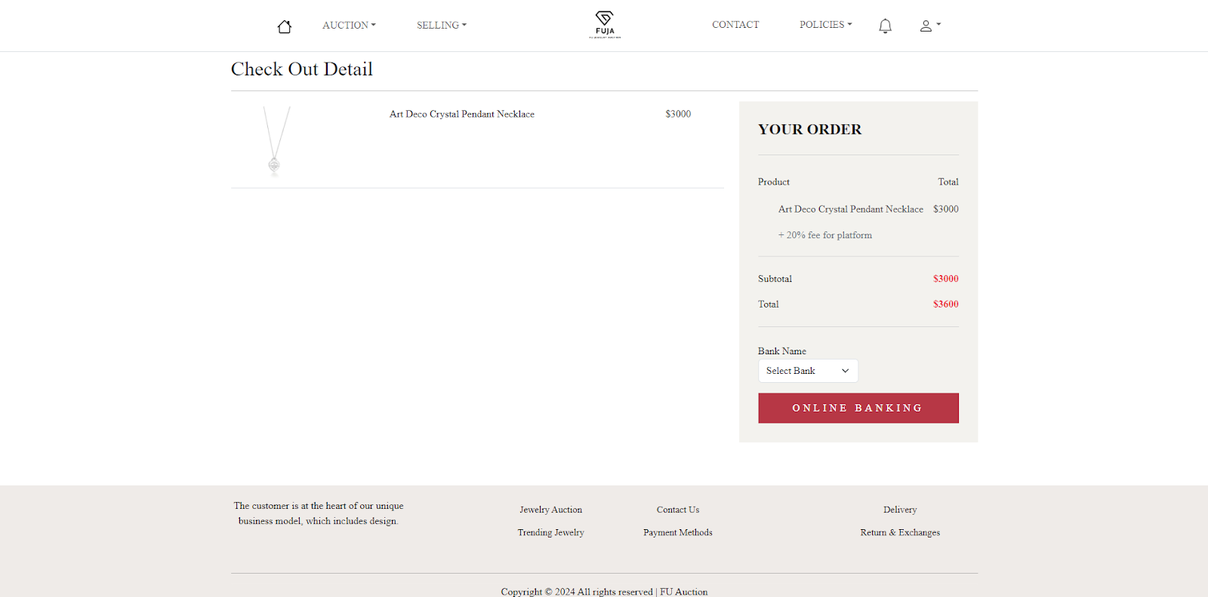

***Real time bidding***

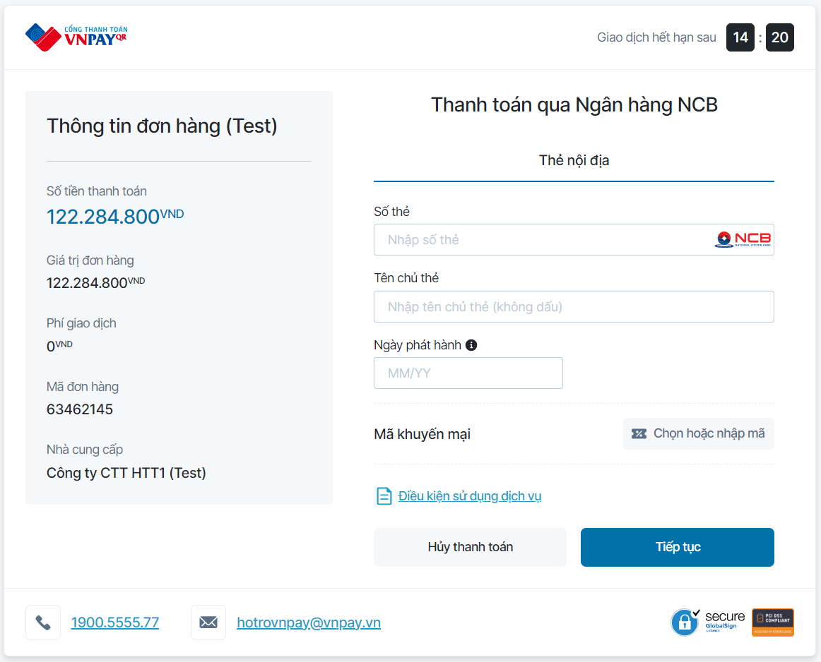

***VNPay payment***

## 5.2 Manager UI

### 5.2.1 Login page

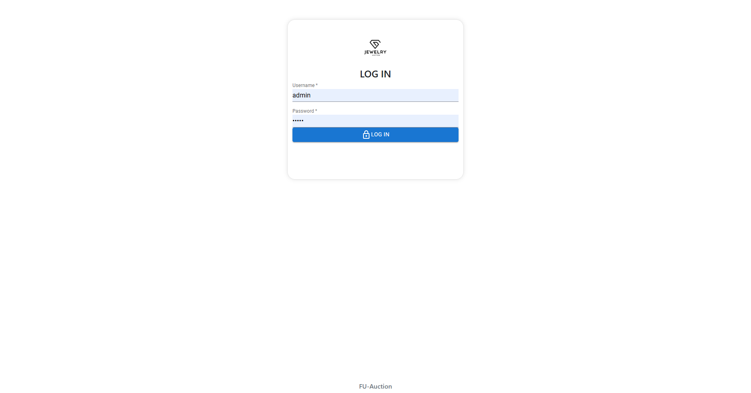

***Login page***

### 5.2.2 Request management

***Valuation request form***

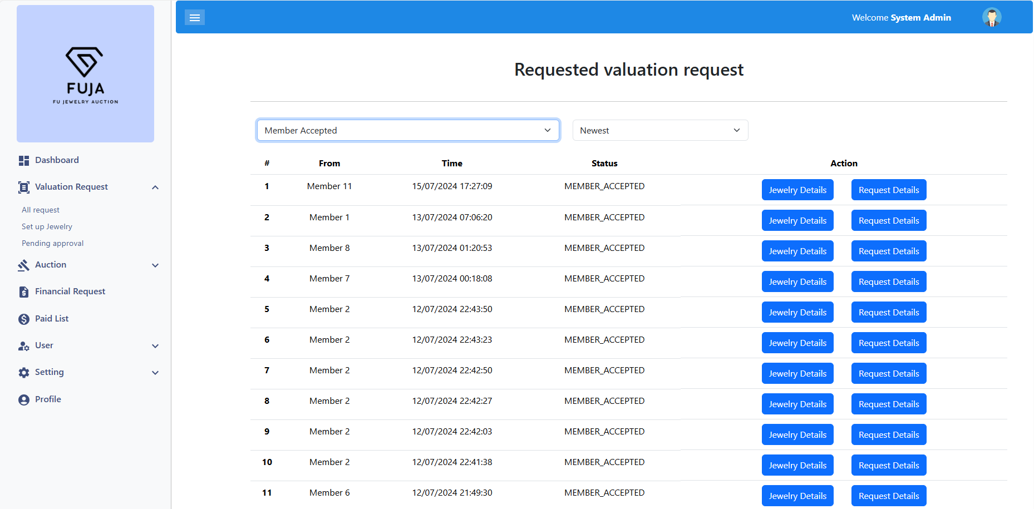

***Valuation request list***

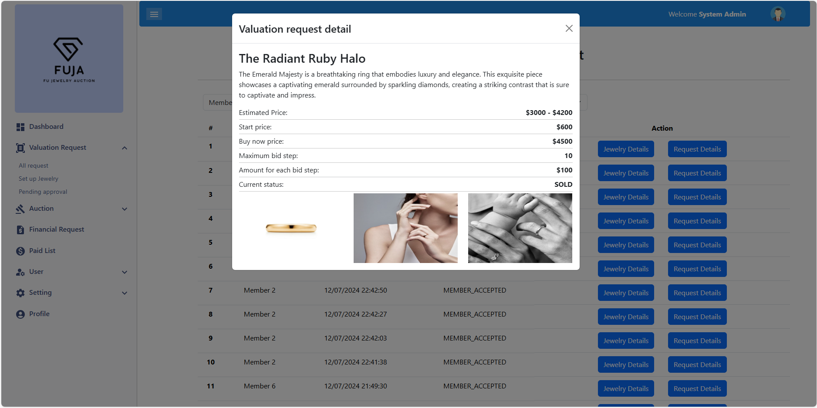

***Valuation request details***

### 5.2.3 Auction session management

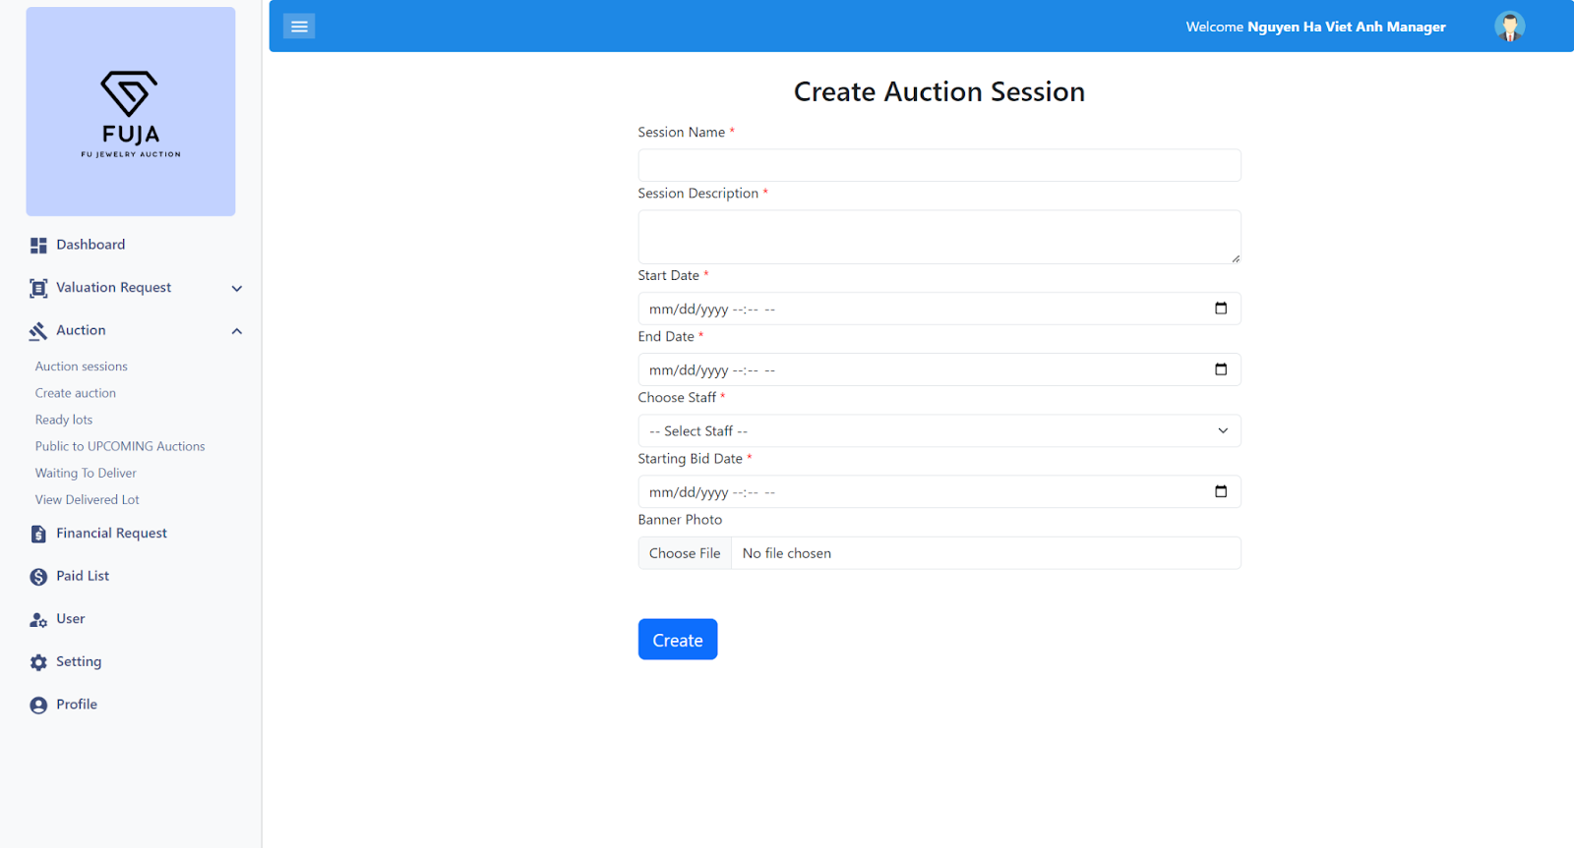

***Create Auction session***

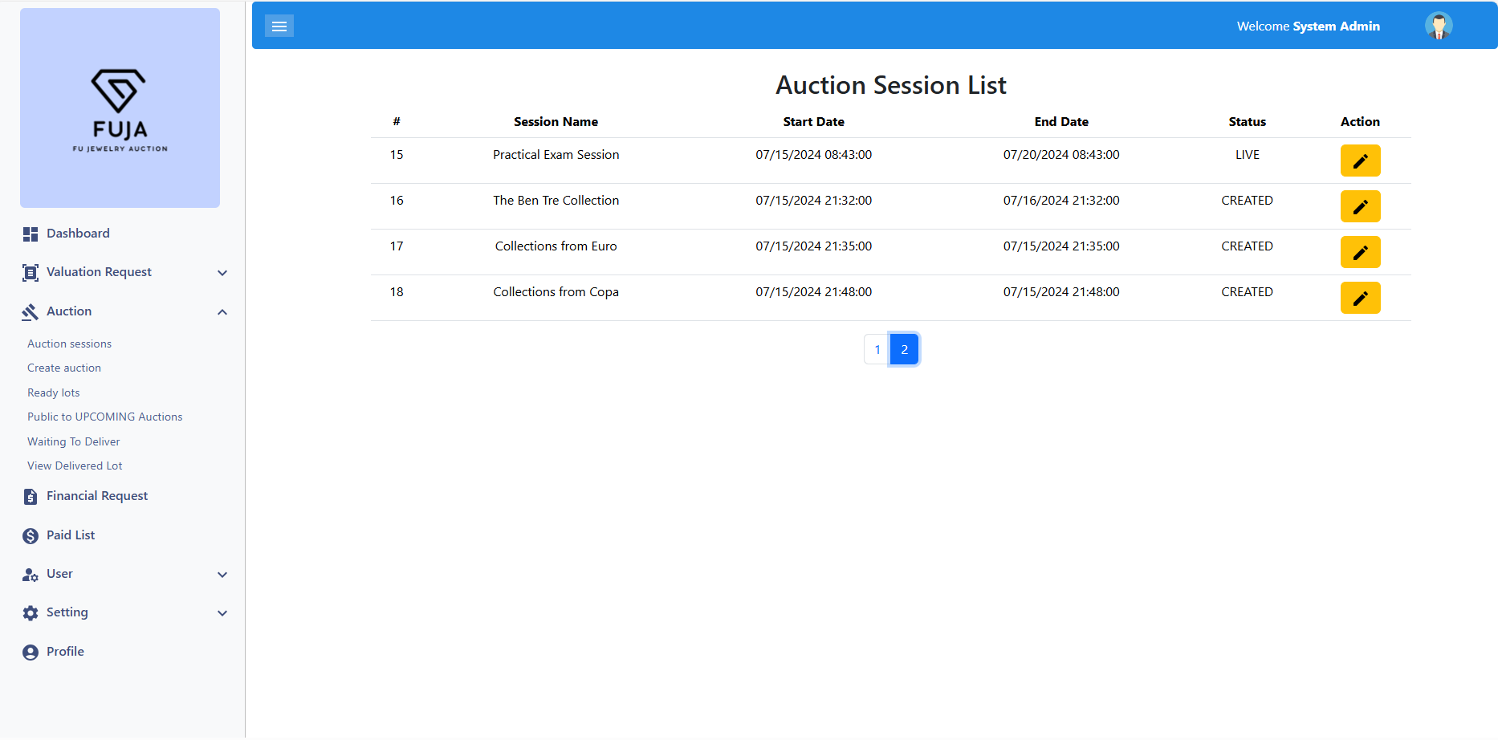

***Auction session list***

### 5.2.4 User management

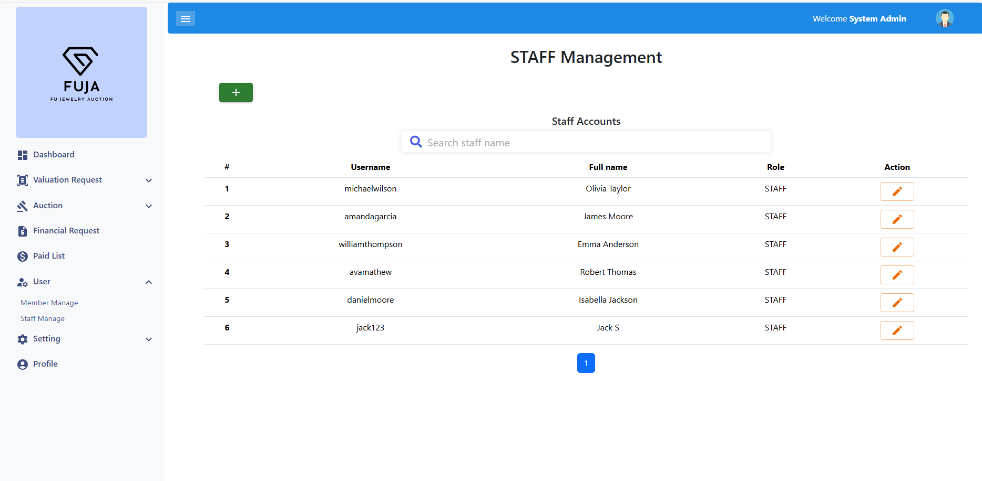

***Account management***

### 5.2.5 Dashboard view

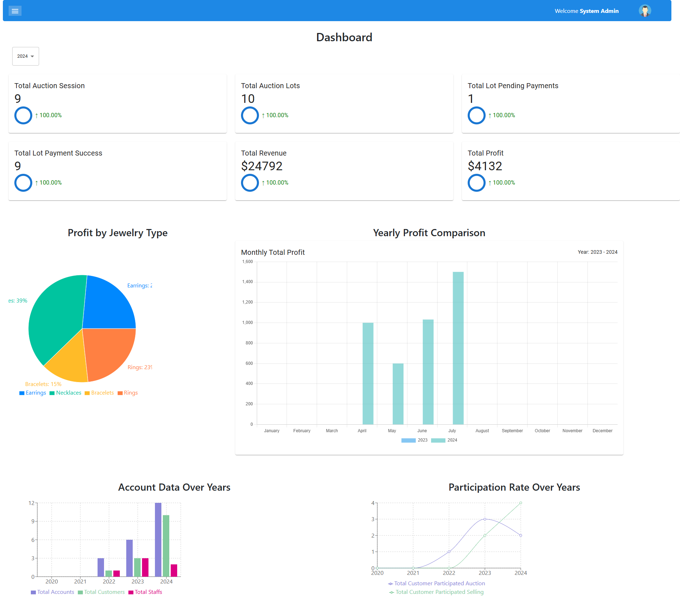

***Dashboard view***

# **Technical Requirements**

| **Technical requirements** | | |
| --- | --- | --- |
| **ID** | **Function** | **Description** |
| **FR-01** | **FN-01** | Member can successfully register with valid email, password, and required profile information |
| **FR-02** | Duplicate email addresses cannot be used for registration. |
| **FR-03** | **FN-02** | Members can login with the correct email and password. |
| **FR-04** | Login fails with incorrect credentials |
| **FR-05** | **FN-03** | Logging out clears the session and redirects the member to the login page. |
| **FR-06** | Attempts to access member-only pages after logout redirect to the login screen. |
| **FR-07** | **FN-04** | Members can securely add a credit card to their profile. |
| **FR-08** | Verify that adding an invalid card number or expiration date fails gracefully. |
| **FR-09** | **FN-05** | Test that members can update existing credit card details |
| **FR-10** | Updates are saved correctly and old information is replaced. |
| **FR-11** | **FN-06** | Member submission of jewelry details (images, description) for valuation. |
| **FR-12** | Ensure that large image files and various formats are handled correctly. |
| **FR-13** | Image and description fields are required are to be validated and accepted |
| **FR-14** | **FN-07** | Staff send preliminary valuation for member with valid values |
| **FR-15** | The staff may reject a request for a quote if the content is deemed inappropriate. |
| **FR-16** | **FN-08** | The process for confirming that jewelry has been received from the member |
| **FR-17** | Requests for valuaiton sent more than 30 days but not received will automatically change to canceled status. |
| **FR-18** | **FN-09** | Staff or managers can accurately enter all required information about jewelry items. |
| **FR-19** | Handling various jewelry types (rings, necklaces, etc.) and materials. |
| **FR-20** | **FN-10** | The manager approves the final valuation based on the jewelry information provided by the staff. |
| **FR-21** | If the manager rejects the final price, the request is moved back to pending setup status. |
| **FR-22** | **FN-11** | Once the final valuation is approved by the manager, the staff can send the final valuation back to the seller. |
| **FR-23** | Sellers get full visibility into their jewelry including final valuation, photos taken, etc. |
| **FR-24** | **FN-12** | Based on the information received, the seller agrees to auction the jewelry, the jewelry will be transferred to the ready to auction status. |
| **FR-25** | If the user disagrees with the pricing information and refuses to bid, the product is put into a pending setup status for re-pricing. |
| **FR-26** | **FN-13** | Creation of auction sessions by managers with accurate session details. |
| **FR-27** | The created auction will appear when selecting a session for each lot. |
| **FR-28** | **FN-14** | Manager can update auction session details (date, time, description). |
| **FR-29** | The changes are reflected correctly in upcoming and live session views. |
| **FR-30** | Manager cannot edit the past auction |
| **FR-31** | **FN-15** | Lots are only added to sessions that have a status of created |
| **FR-32** | At a time, a lot belongs to only one session. |
| **FR-33** | Lot statuses are updated correctly from Ready to Auctioning |
| **FR-34** | **FN-16** | Manager makes public the up auction is in created state |
| **FR-35** | Once published, members can view that auction sesion in the Upcoming auctions. |
| **FR-36** | **FN-17** | Members can send a financial proof request by providing images that can proof their asset |
| **FR-37** | Ensure that large image files and various formats are handled correctly. |
| **FR-38** | **FN-18** | Nhân viên thực hiện định mức cho yêu cầu chứng minh tài chính |
| **FR-39** | Financial proof requests with amounts greater than 100,000$ must be approved by the Manager. |
| **FR-40** | **FN-19** | The manager accepts requests for financial evidence that have been determined to be in excess of $100,000. |
| **FR-41** | **FN-20** | Members can view all lots in an upcoming auction session. |
| **FR-42** | **FN-21** | Members can only view lots they have registered for in an ongoing auction. |
| **FR-43** | **FN-22** | Members can view all lots in a past auction session. |
| **FR-44** | **FN-23** | Members can only register once with 1 lot in an upcoming auction session. |
| **FR-45** | After registration, the registration result notification without pre-bid appears in the lot that the user registered for. |
| **FR-46** | **FN-24** | Members may pre-bid on a lot in an upcoming auction |
| **FR-47** | After pre-bidding, the bid amount is announced to the members registered for that lot |
| **FR-48** | **FN-25** | Upcoming auctions automatically go live when they reach their start time. |
| **FR-49** | All members who have registered lots in the auction to move to live will receive a notification. |
| **FR-50** | **FN-26** | Multiple members bid live and real time update result for all clients |
| **FR-51** | The lot will end auction immediately if the bid is higher than the buy now price |
| **FR-52** | Members cannot set a bid step higher than the set bid step for each lot. |
| **FR-53** | The member's financial proof amount is deducted corresponding to the amount each time they bid. |
| **FR-54** | **FN-27** | The lot will end auction immediately if a member buys the lot immediately. |
| **FR-55** | The member who purchased that lot is notified that he has won. |
| **FR-56** | **FN-28** | Live auctions automatically go past when they reach their end time. |
| **FR-57** | The system determines the winner based on the highest bid price of the lots. |
| **FR-58** | Winning bidders receive notification of their winning lots after the auction ends. |
| **FR-59** | **FN-29** | Members can choose 1 or more lots to pay at once. |
| **FR-60** | The total amount payable by the winner must include the auction winning amount plus the platform fee. |
| **FR-61** | **FN-30** | Member's ability to complete transactions securely via third party payment system |
| **FR-62** | Member receives payment result successful or failed |
| **FR-63** | **FN-31** | After delivering the jewelry to the winning bidder, the staff confirms that the lot has been shipped. |
| **FR-64** | **FN-32** | Admin confirms that the auction winnings have been sent to the seller by providing photo proof of transfer |
| **FR-65** | After payment to seller, profit result is updated in dashboard |
| **FR-66** | **FN-33** | Managers can create new accounts for staffs |
| **FR-67** | The newly created account can log into the system for staffs |
| **FR-68** | **FN-34** | Managers can edit all infomation of staff accounts |
| **FR-69** | **FN-37** | Only Manager can see the dashboard |
| **FR-70** | Managers can export statistical information as files. |

# **Screen Flow**

***Member Screen***

#### 

#### 

#### **Screen Details of Member Screen**

| **#** | **Feature** | **Screen** | **Description** |
| --- | --- | --- | --- |
| 1 | Login | Login Screen | Guest login to the system |
| 2 | Register | Register Screen | Guest register account |
| 3 | Profile Information | Profile Screen | Show information of account |
| 4 | Add Credit Card | Profile Screen | Member add credit card for payment |
| 5 | Edit Credit Card | Profile Screen | Member edit credit card for payment |
| 6 | Delete Credit Card | Profile Screen | Member delete credit card for payment |
| 7 | Change Password | Profile Screen | Member change password |
| 8 | Financial Proof | Profile Screen | Member view financial proof information |
| 9 | Create Financial Proof | Profile Screen | Member Add financial proof information |
| 10 | My Valuation Request | Profile Screen | Member view valuation request information |
| 11 | My Attend History | Profile Screen | Member view my attend history |
| 12 | My Winer Auction | Profile Screen | Member view their bill of auction won |
| 13 | Payment | Payment Screen | Member payment for lot won |
| 14 | Upcoming Auction List | Upcoming Auction Screen | View list of upcoming auction |
| 15 | Upcoming Auction Detail | Upcoming Auction Screen | View detail of upcoming auction, list lots in auction. |
| 16 | Lot Detail Of Upcoming Auction | Upcoming Auction Screen | View lot detail in auction |
| 17 | Register For Upcoming Auction | Upcoming Auction Screen | Register for Auction |
| 18 | Past Auction List | Past Auction Screen | View list of past auction |
| 19 | Past Auction Detail | Past Auction Screen | View details of past auctions, list lots in auction. |
| 20 | Live Auction List | Live Auction Screen | View list of live auction |
| 21 | Lot detail of current auction | Live Auction Screen | View lot detail in auction |
| 22 | Place Bid | Live Auction Screen | Member place bid when live auctioning |
| 23 | Create My Financial Proof | Financial Proof Screen | Member send financial proof request to participate place bid |
| 24 | About Selling | About Selling Screen | Introduce how to selling with FUJA |
| 25 | Send Valuation Request | Send Valuation Request Screen | Member send valuation request to participate selling their product |
| 26 | Privacy and Policy | Privacy and Policy screen | FUJA introduce about privacy and policy for their web system |
| 27 | Terms And Conditions | Terms And Conditions Screen | FUJA introduce about terms and conditions for their web system |
| 28 | Delivery Instructions | Delivery Instructions Screen | Instruct the seller to package the product and send it to FUJA 's company |
| 29 | Notification | Notification Screen | The system send notifications to member for their actions |
| 30 | Contact Us | Contact Us Screen | Introduce about FUJA ‘s company, information to contact |

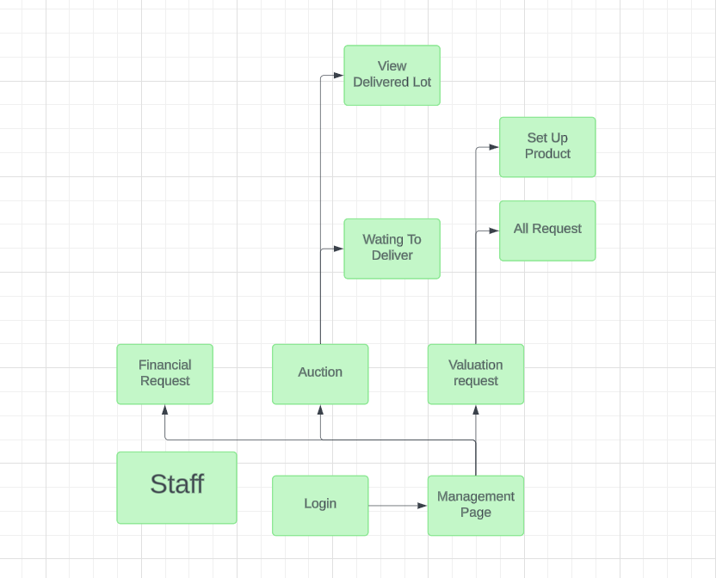

***Staff Screen***

#### **Screen Details Staff Screen**

| **#** | **Feature** | **Screen** | **Description** |
| --- | --- | --- | --- |
| 1 | Login | Login Screen | Staff login to the system |
| 2 | Financial Request | Financial Request Screen | Staff confirm financial request from member |
| 3 | Waiting To Deliver | Auction Screen | Staff confirm product delivered to member |
| 4 | View Delivered Lot | Auction Screen | Staff view delivered product to member |
| 5 | All Request | Valuation Request Screen | Staff view all request types from members. |
| 6 | Set Up Product | Valuation Request Screen | After received a product from a member. Staff set up the product to lot. |

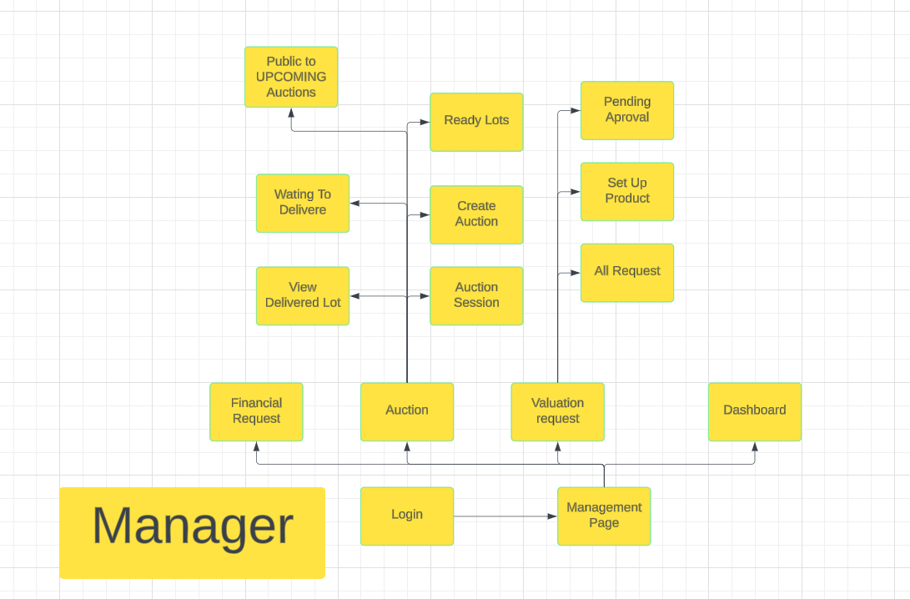

***Manager Screen***

#### **Screen Details Manager Screen**

| **#** | **Feature** | **Screen** | **Description** |
| --- | --- | --- | --- |
| 1 | Login | Login Screen | Manager login to the system |
| 2 | Financial Request | Financial Request Screen | Manager confirm financial request from member |
| 3 | Waiting To Deliver | Auction Screen | Manager confirm product delivered to member |
| 4 | View Delivered Lot | Auction Screen | Manager view delivered product to member |
| 5 | Public to UPCOMING Auctions | Auction Screen | Manager public auction to upcoming when set up auction done. |
| 6 | Ready Lots | Auction Screen | Manager view all lot ready ( set up done) and add to session |
| 7 | Create Auction | Auction Screen | Manager created the auction session, set up the name, description, time start, time end, choose staff, choose starting bid, image. |
| 8 | Auction Session | Auction Screen | Manager view all list auction session |
| 9 | All Request | Valuation Request Screen | Manager view all request types from members. |
| 10 | Set Up Product | Valuation Request Screen | After received a product from a member. Staff set up the product to lot. |
| 11 | Pending Approval | Valuation Request Screen | Manager view list request sent by Staff after receiving product and final valuation. |
| 12 | Dashboard | Dashboard Screen | Manager view total revenue of the system in year, view chart monthly total revenue, compare total revenue each month current year and before year. |

# **Business Rule**

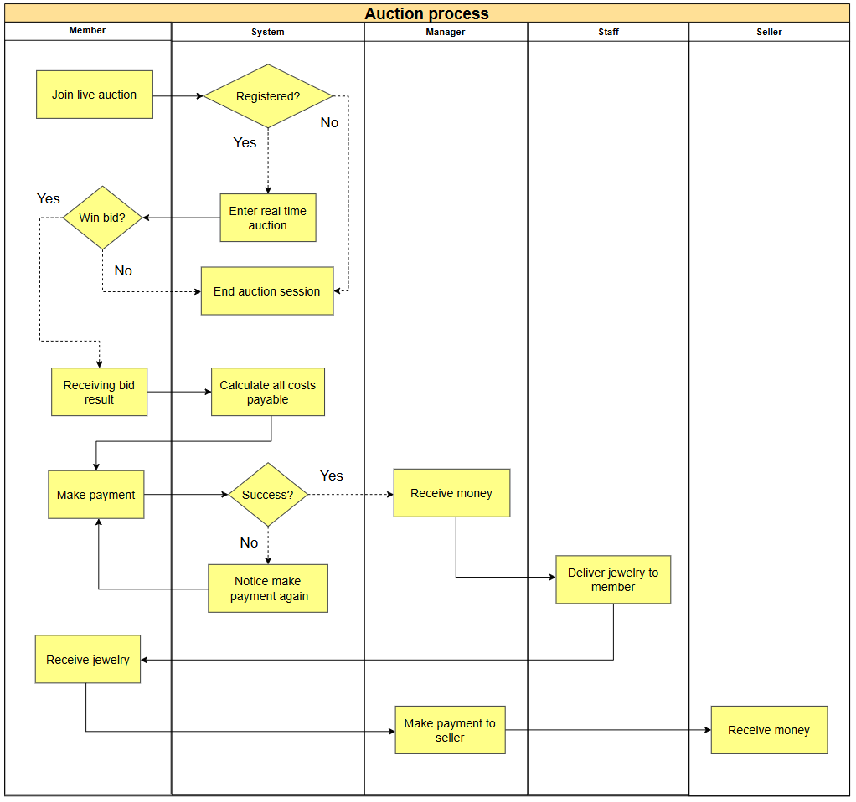

| **#** | **Process Step** | **Description** |
| --- | --- | --- |
| 1 | Join live auction | A member with an available financial proof amount and credit card wants to join a live auction. |
| 2 | Registered? | The system checks if the member has already registered for that Lot. |
| 3 | Enter real time auction | If the member is registered, they proceed to real-time bidding, synchronized for all clients. |
| 4 | Win bid? | The system determines if the member wins the Lot auction. |
| 5 | End auction session | The auction session for a Lot ends or becomes unavailable. |
| 6 | Receiving bid result | The member receives the bid result for the auction they participated in. |
| 7 | Calculate all costs payable | The system calculates the total cost the winning member must pay, including a fee of 20-30%. |
| 8 | Make payment | The member makes payment for the jewelry they won through a third-party payment system. |
| 9 | Success? | The system checks the success of the payment. |
| 10 | Notice make payment again | If the payment fails, the system notifies the member to make the payment again. |
| 11 | Receive money  (of Manager) | The manager receives money from the auction winner. |
| 12 | Deliver jewelry to member | After receiving the payment, the staff delivers the jewelry to the winner. |
| 13 | Receive jewelry | The winner receives the jewelry they won and purchased. |
| 14 | Make payment to seller | Once the winner receives the jewelry, the manager processes the payment for the seller who consigned the jewelry to the auction. |
| 15 | Receive money | The seller receives the money for the jewelry they sold, equal to the final auction price. |