**Name :** Aditya Muley **Emp ID :** 206016

**Project : BMI Calculator App**

**Tools/ Technologies Used :** Springboot, Jenkins, Docker

**(A) : Springboot Project :**

1. Created initial springboot maven project zip.

2. Importing Maven project to Eclipse

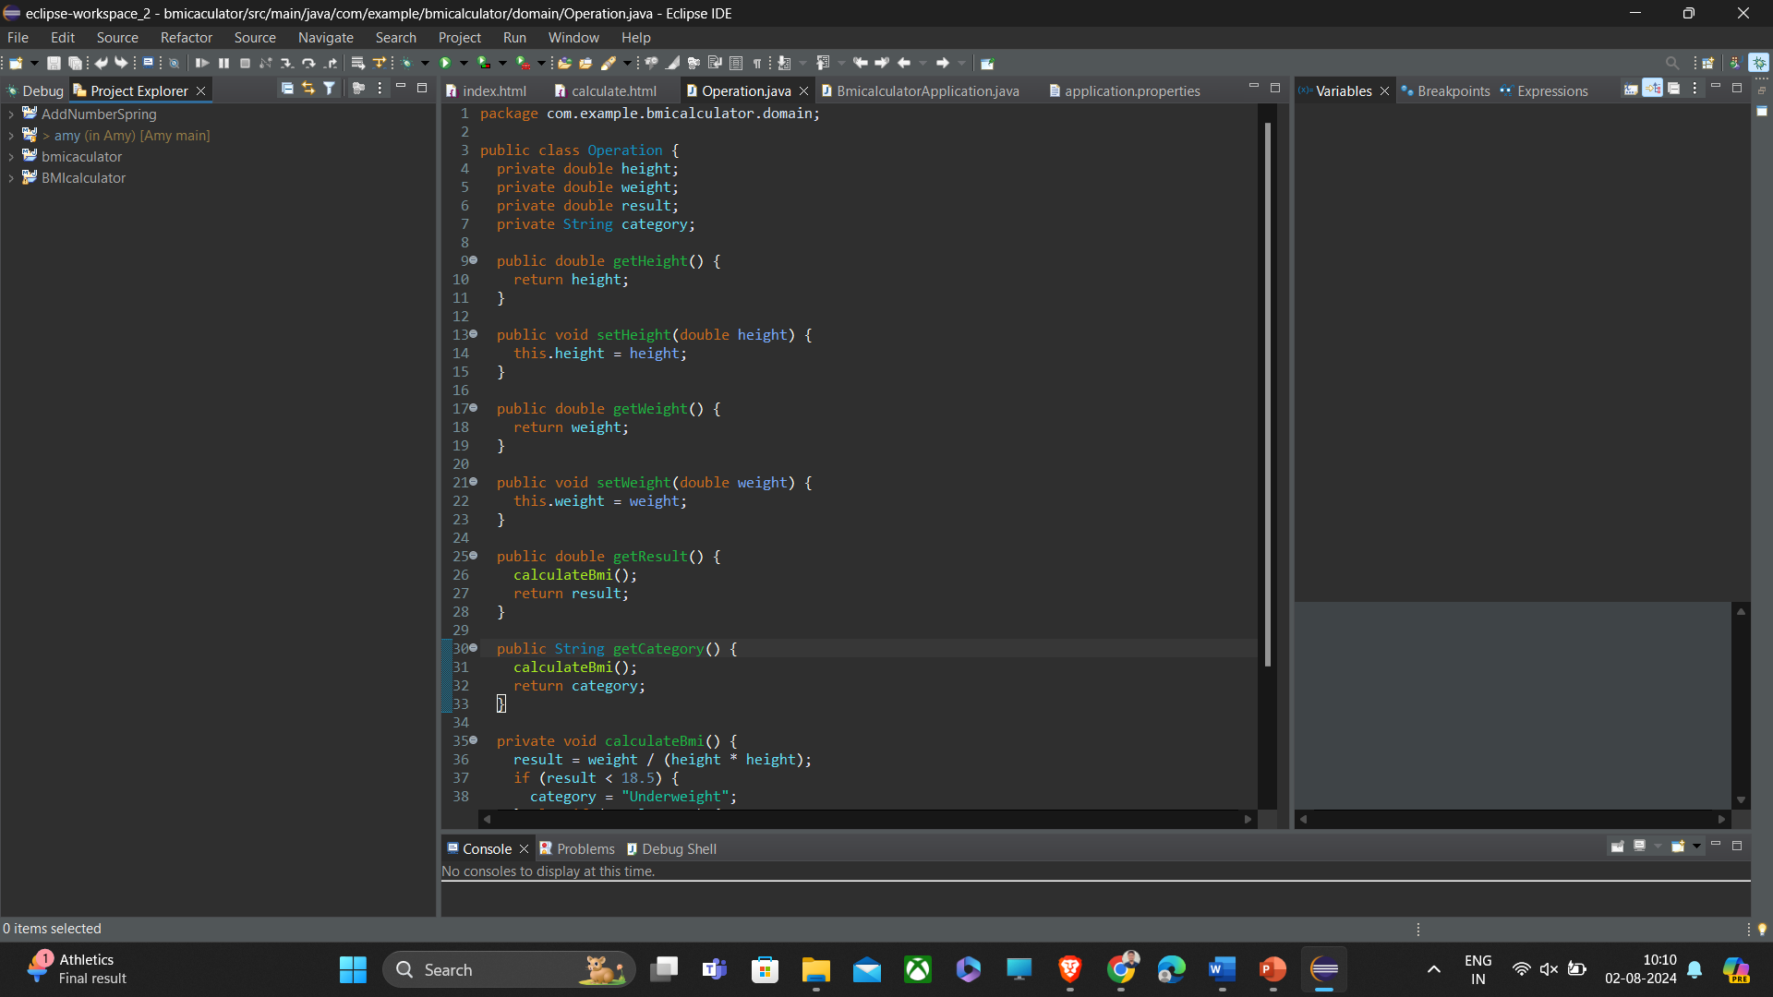

(index.html)

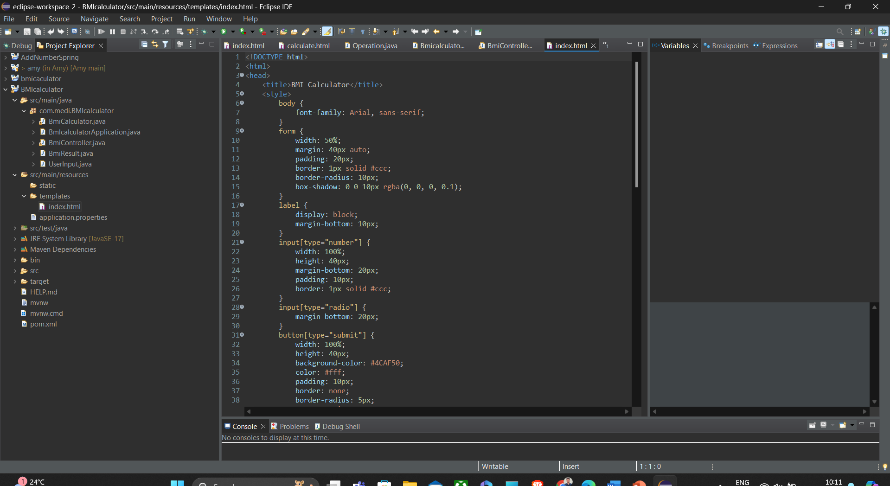

(application.properties) : Setting Server Port number

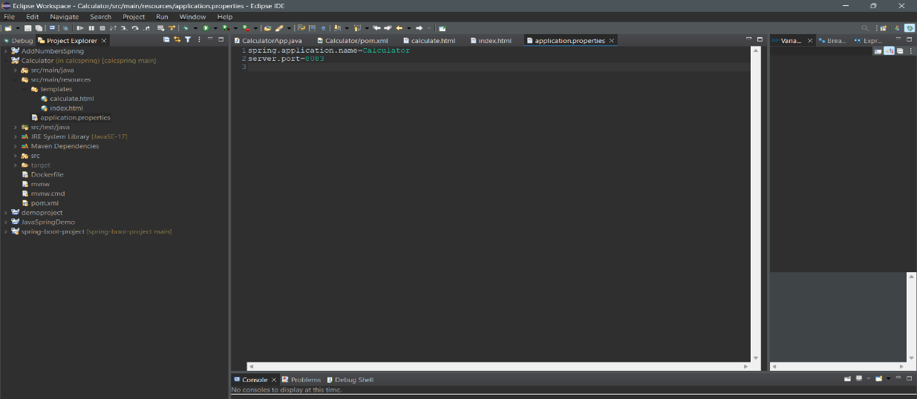

3. Project pushed to github :

**(B) Jenkins Setup :**

1. Creating account :

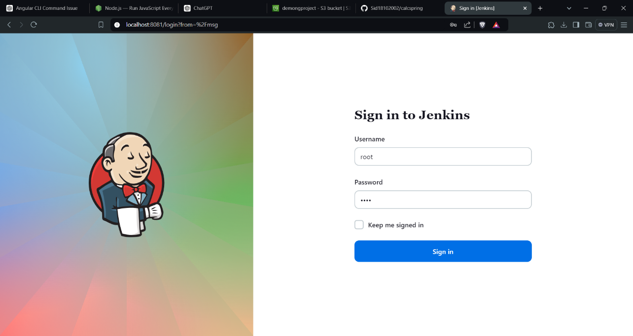

2. Select project type as Freestyle project

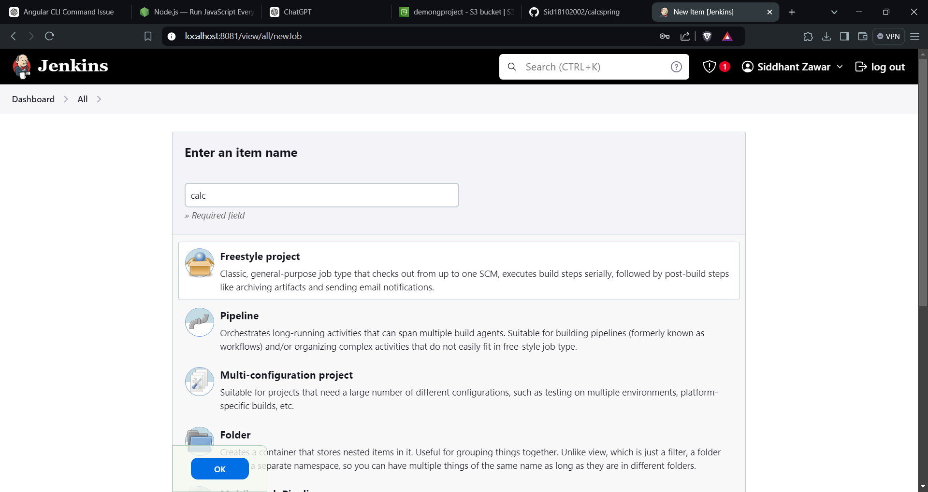

3. Project Configuration :

(added github details to Jenkins)

(Project Build successfully)

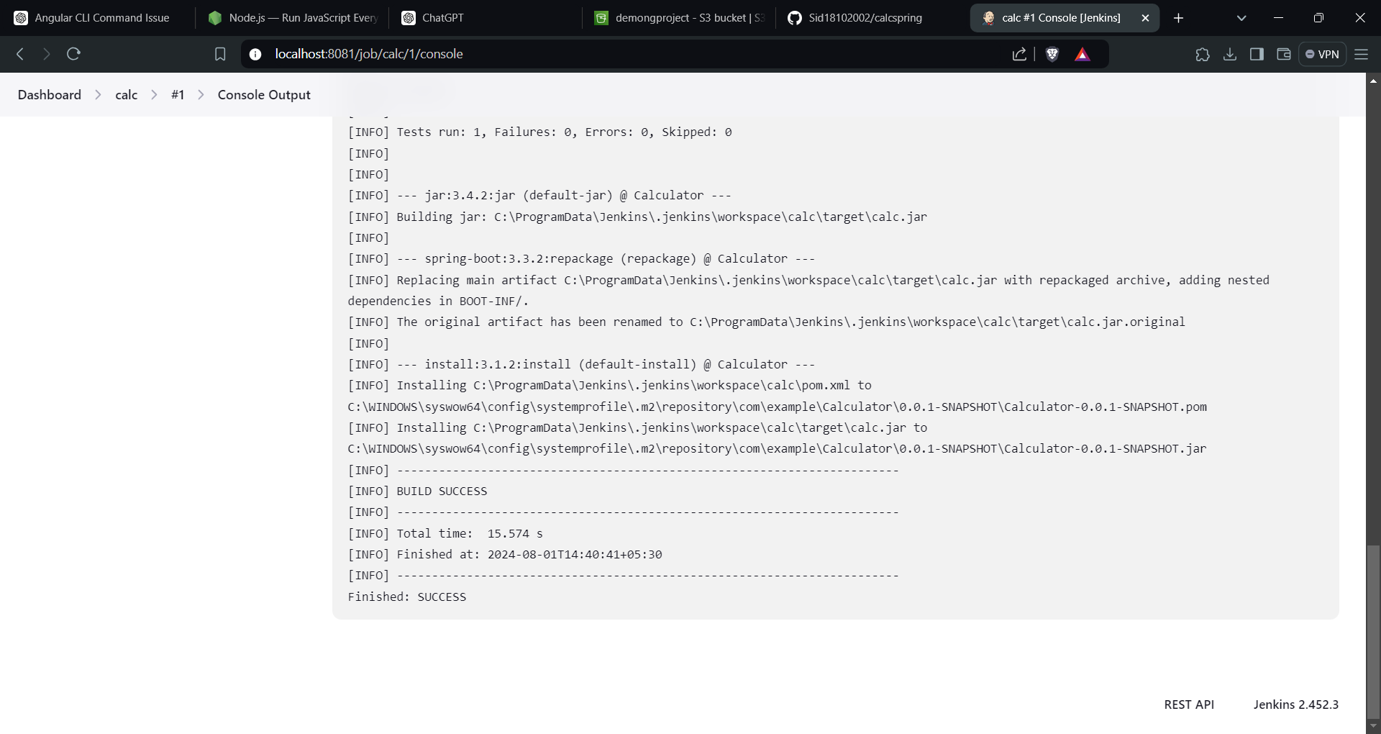

**(C) Creation of JAR File of Springboot project :**

1. Create ‘Dockerfile’ in your project and insert all used dependencies in it

3. Then use ‘maven install’ command by right clicking project folder 🡪 run as 🡪maven install

4. JAR file is created under target folder :

**(D) Docker Setup :**

1. Created a repository on Dockerhub

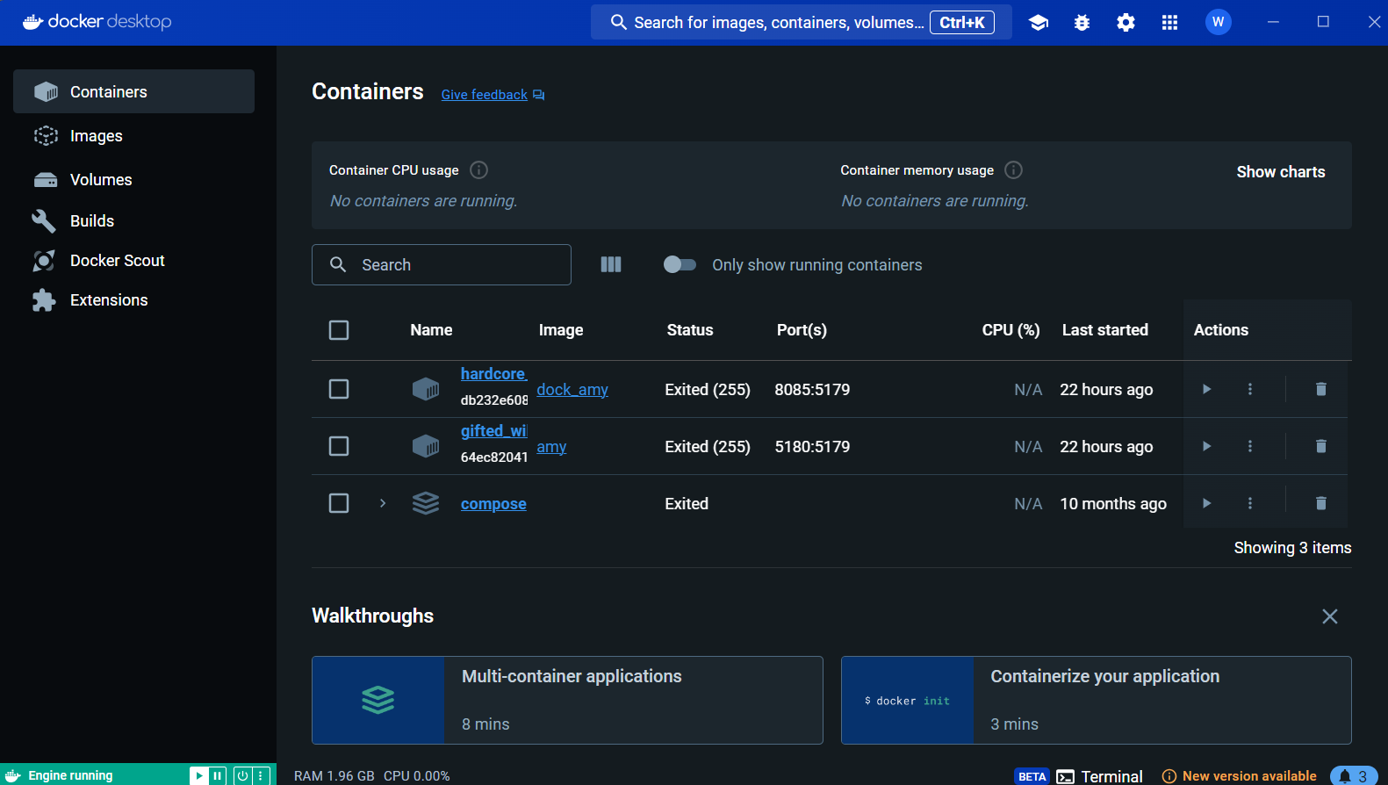

2. Built docker image

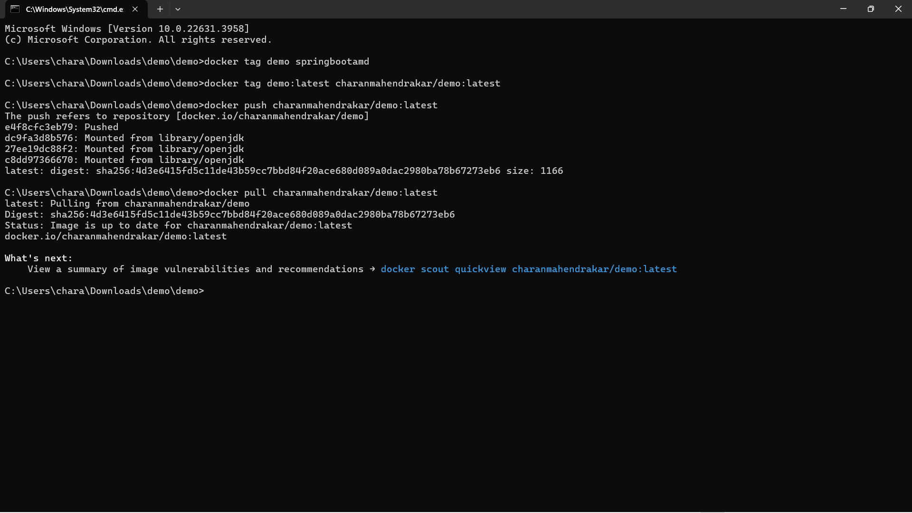

3. Running docker container from the specific image

4. Pushed tagged image to docker registry



**(D) Final output :**

