Assignment -1
Creating sample tables and Inserting values.
Create the following tables with the gives structures and insert sample data as specified:-
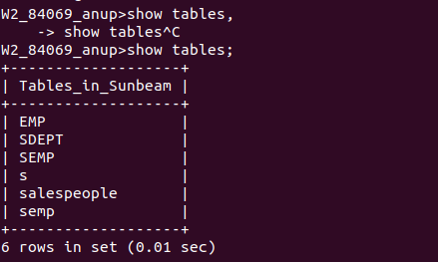
A) SALESPEOPLE:-

B) CUSTOMERS
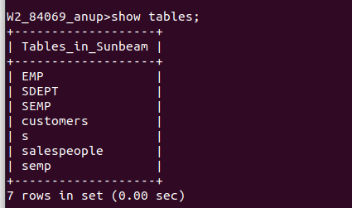

C) ORDERS
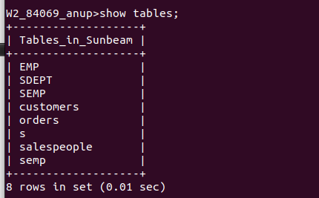

TABLES
SALES PEOPLE
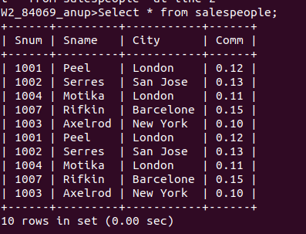

CUSTOMERS
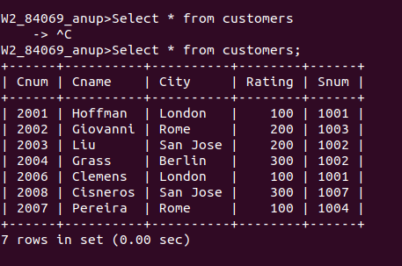

ORDERS
