Assignmaent-4
1) Write a select command that produces the order number, amount, and date for all rows in the Orders table.
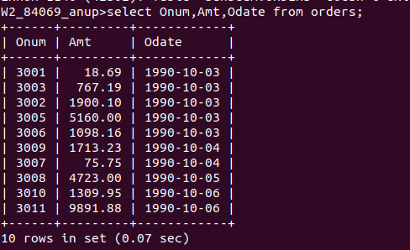

2) Write a query that produces all rows from the Customers table for which the salesperson’s number is 1001.
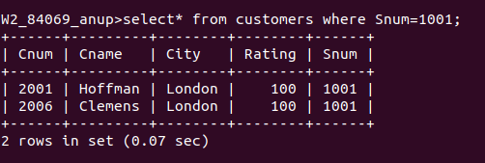

3) Write a query that displays the Salespeople table with the columns in the following order: city, sname, snum, comm.
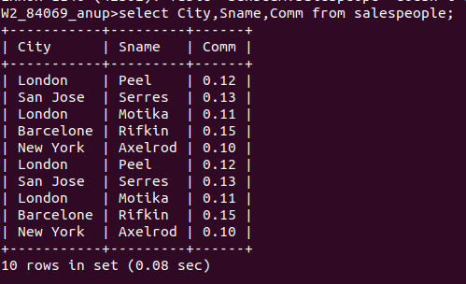

4) Write a select command that produces the rating followed by the name of each customer in San Jose.
