Database Technologies – Assignment 5
Use appropriate SQL functions to solve following queries. Note: To solve below queries, use “hr” database
- Display all the first names in lower case and the last names in upper case as the single column separated with ' - '. Provide the meaningful name to the column.
SELECT CONCAT(LOWER(FIRST_NAME), ' - ', UPPER(LAST_NAME)) AS FIRST_Name
FROM employees;
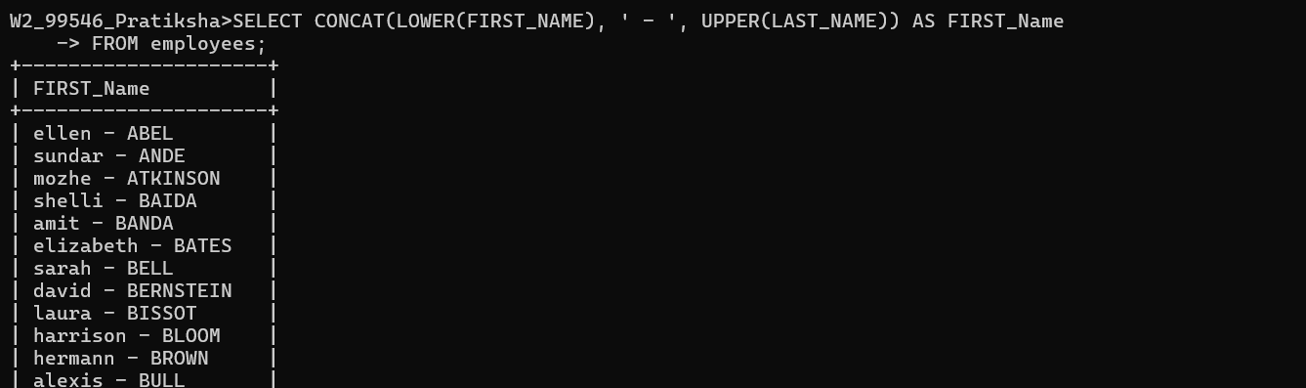
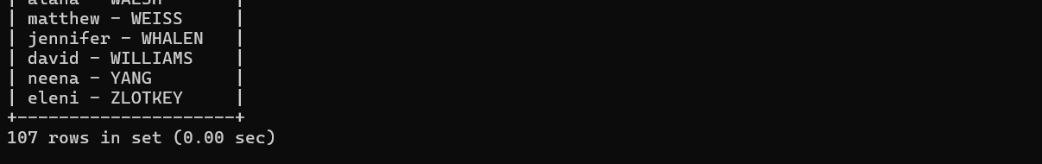

- Display the first word of the job title. (Hint : Use substring_index).
SELECT SUBSTRING_INDEX(JOB_TITLE, ' ',1)AS first_word_of_job FROM jobs;

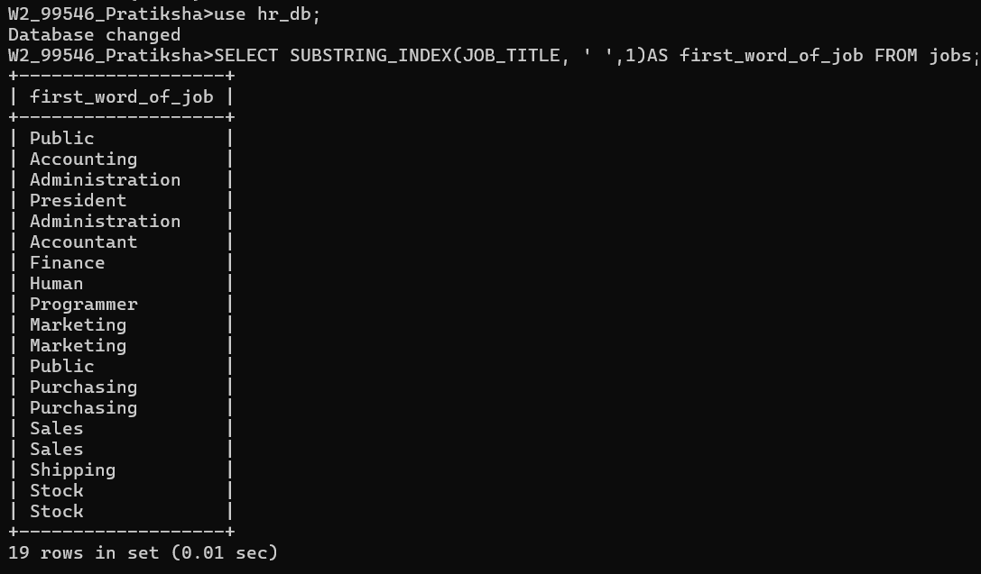
- Display the First name, last name and length of first name for the employees whose last name contains character ‘b’ anywhere after 3rd position.
SELECT FIRST_NAME, LAST_NAME, LENGTH(FIRST_NAME)
FROM employees
WHERE LAST_NAME LIKE ' ---%B%';
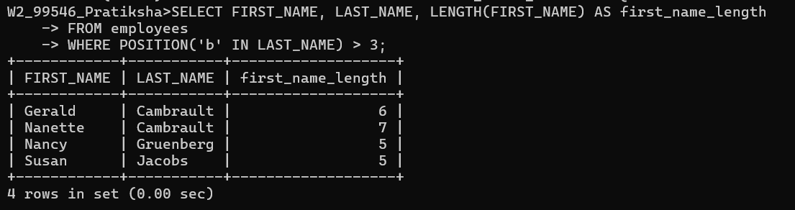
- Display the employee id, first name and last name of the employees whose first or last name includes a space in between.
Select employee_id,first_name,last_name from employees where first_name LIKE ' % %' OR last_name LIKE ' % %';

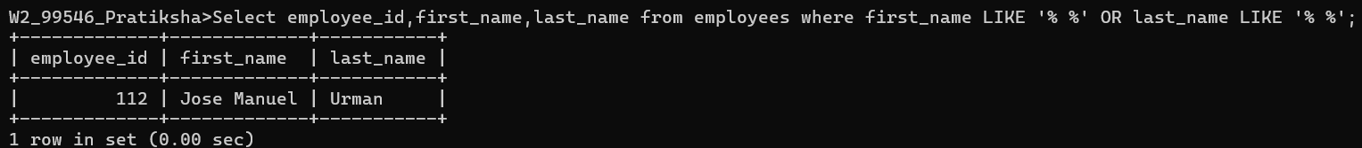
- Display first name, salary, and round the salary to thousands.
SELECT FIRST_NAME,SALARY,ROUND(SALARY,-3)FROM EMPLOYEES AS ROUNDSALARY;
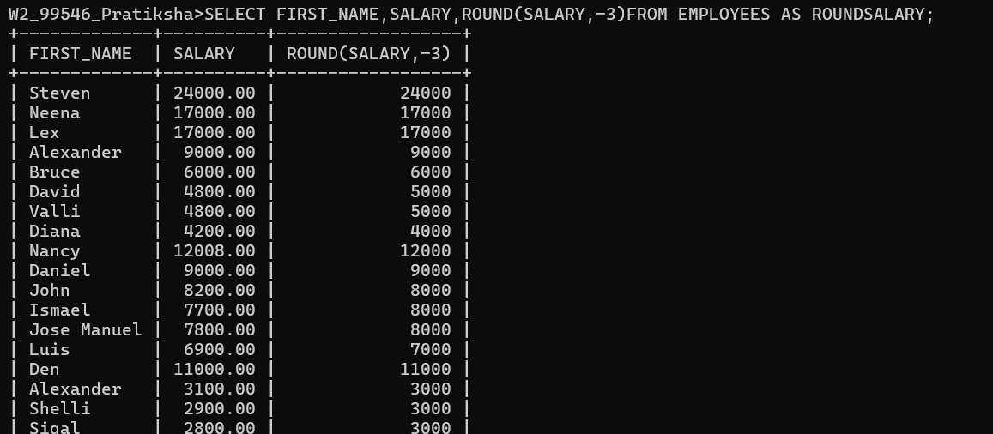
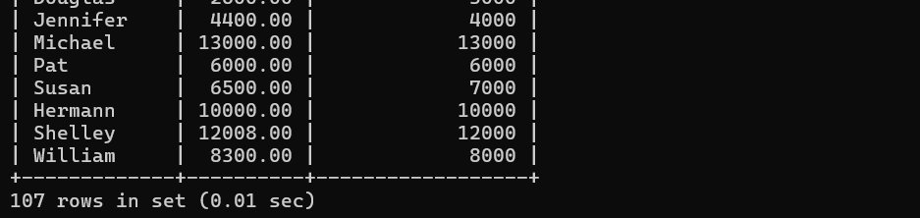

- Display employee ID and the date on which he ended his previous job in the format as mentioned. (Format: Thursday, October 27th 2011)
Select employee_id, end_date,DATE_FORMAT(end_date, ' %w,%m,%d,%y') AS JOB_END_DATE FROM job_history;
- Display first name and date of first salary of the employees. (Consider 1st day of month as salary day. HINT: LAST_DAY).
SELECT EMPLOYEE_ID,first_name,hire_date,date_add(last_day)(HIRE_date),interval +1 day)as first_salary from employees;
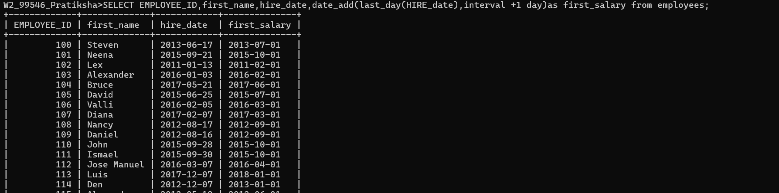
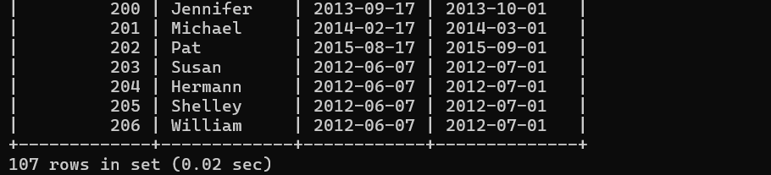
- Display first name and experience of the employees in the format of number of years, months and days completed.
SELECT FIRST_NAME, HIRE_DATE, CONCAT(TIMESTAMPDIFF(YEAR, HIRE_DATE, NOW()),'YEARS',TIMESTAMPDIFF(MONTH, HIRE_DATE, NOW()%12, 'MONTH',TIMESTAMPDIFF(DAY,HIRE_DATE,NOW()%31)AS EXPERINCED FROM EMPLOYEES;

SELECT FIRST_NAME, HIRE_DATE,
CONCAT(
TIMESTAMPDIFF(YEAR,HIRE_DATE,NOW()), ' YEARS ',
TIMESTAMPDIFF(MONTH,HIRE_DATE,NOW()) % 12, ' MONTHS ',
TIMESTAMPDIFF(DAY,HIRE_DATE,NOW()) % 31, ' DAYS'
) AS EXPERIENCE
FROM EMPLOYEES;
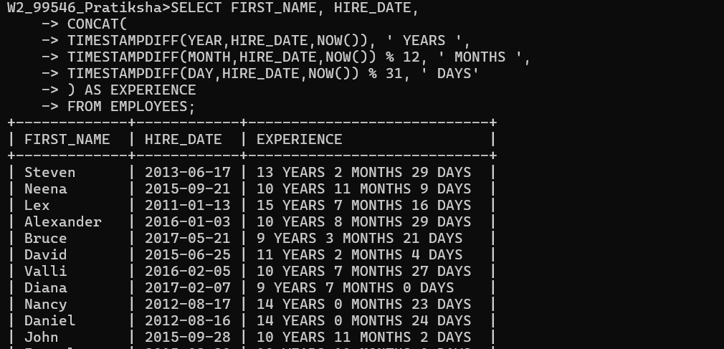
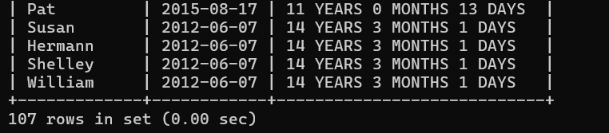

- Display the employee id, first name and joining date of the employees who joined in the month of august of any year.
SELECT EMPLOYEE_ID,FIRST_NAME,HIRE_DATE FROM EMPLOYEES WHERE MONTH(HIRE_DATE)=8;
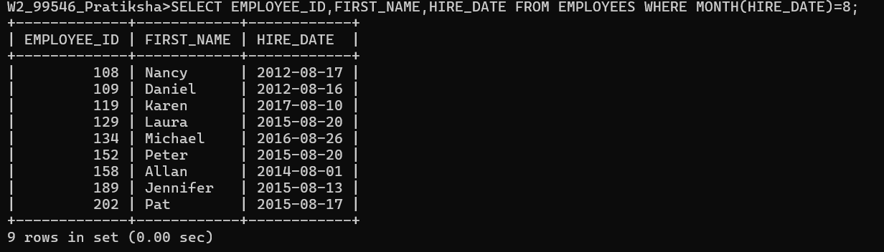
- Display the details of employees who joined before the year 2015.
SELECT EMPLOYEE_ID,HIRE_DATE FROM EMPLOYEES WHERE HIRE_DATE <' 2015-01-01';
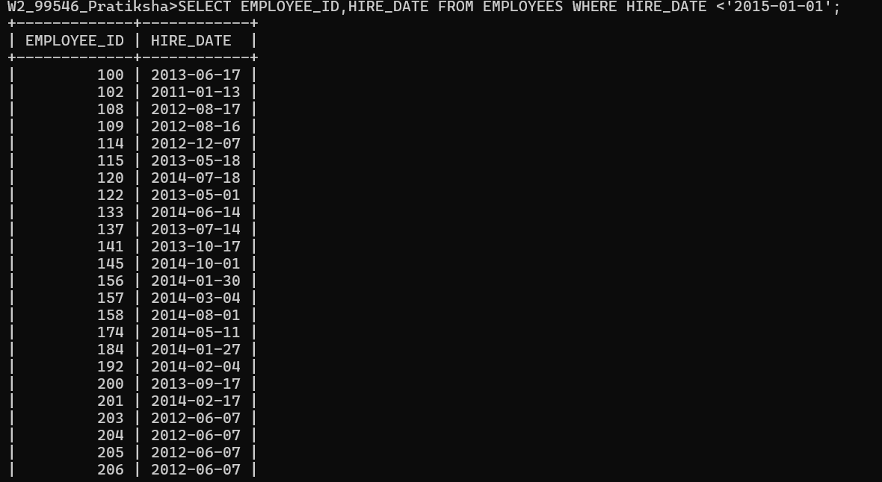
- Display the number of days between system date and 1st January 2011.
SELECT TIMESTAMPDIFF(DAY, ' 2011-01-01', ' 2026-09-09')AS DIFF;
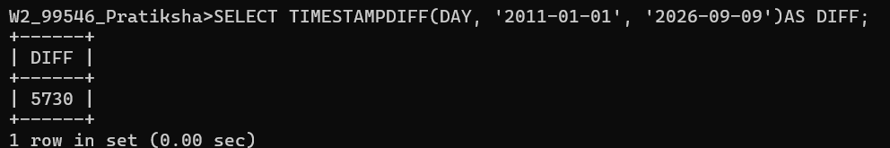
- Display number of employees joined after 15th of any month.
SELECT COUNT(*)AS EMPLOYEE_COUNT FROM EMPLOYEES WHERE DAY (HIRE_DATE)>15;

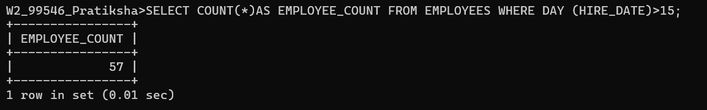

- Display third highest salary of employees.
SELECT DISTINCT SALARY FROM EMPLOYEES ORDER BY SALARY DESC LIMIT 1 OFFSET 2;
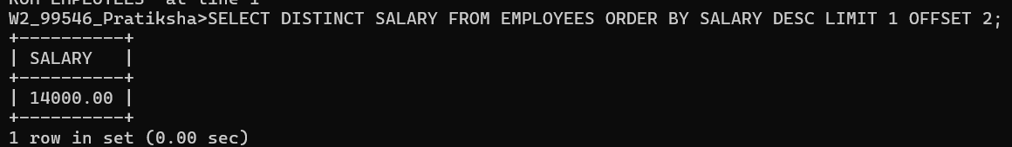

Assignment 5
Note: To solve below queries, use “spj” database
- Display all the Suppliers, belonging to cities starting with the letter ‘L’.
SELECT * FROM S WHERE CITY LIKE ' L%';
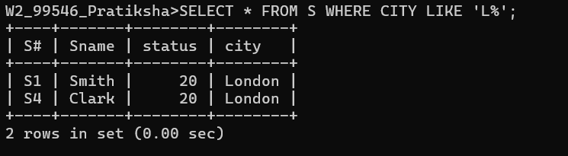

- Display all the Jobs, with the third letter in JNAME as ‘n’.
SELECT * FROM J WHERE JNAME LIKE ' __N%';
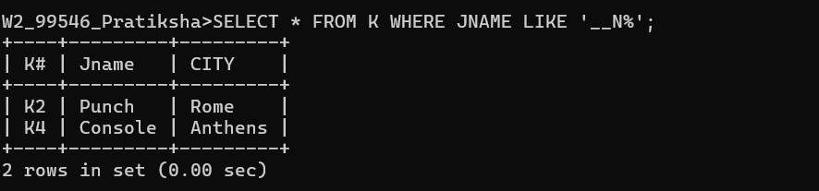
- Display all the Supplier names with the initial letter capital.
SELECT CONCAT(UPPER(LEFT(SNAME,1)),LOWER(SUBSTRING(SNAME,2)))AS NAMES FROM S;
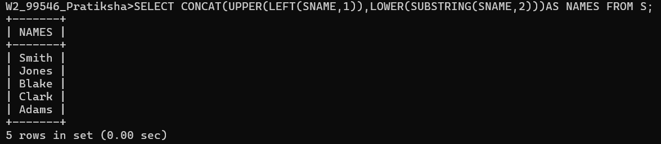
- Display all the Supplier names in upper case.
SELECT UPPER(SNAME)AS NAME FROM S;
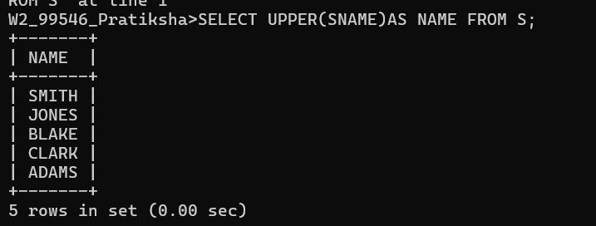
- Display all the Supplier names in lower case.
SELECT LOWER()SNAME AS NAME FROM S;
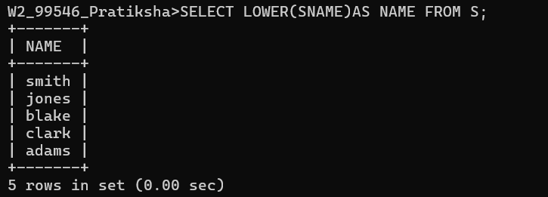
- Display the Supplier names and the lengths of the names.
SELECT SNAME,LENGTH(SNAME)AS LENGTH_OF_NAME FROM S;
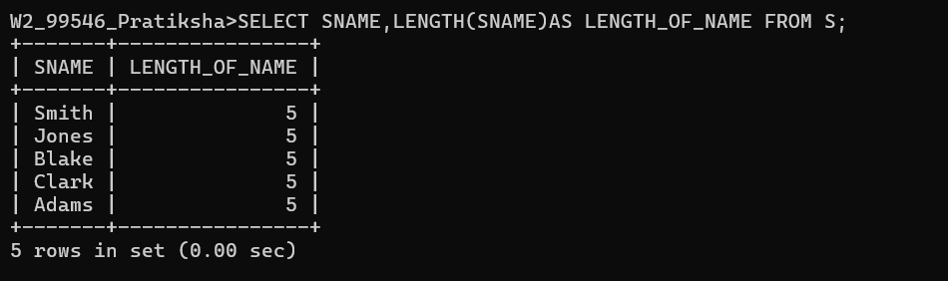
- Display the current day (e.g. Thursday).
SELECT DAYNAME (CURRENT_DATE());
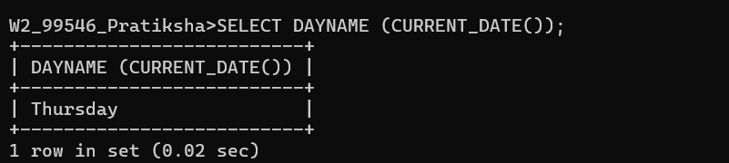
- Display the minimum Status in the Supplier table.
SELECT MIN(STATUS)AS MIN_STATUS FROM S;
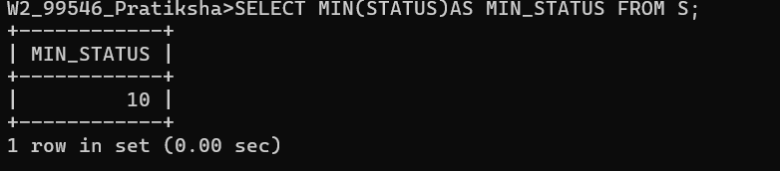

- Display the maximum Weight in the Parts table.
SELECT MAX(WEIGHT)AS MAX_WEIGHT FROM P;
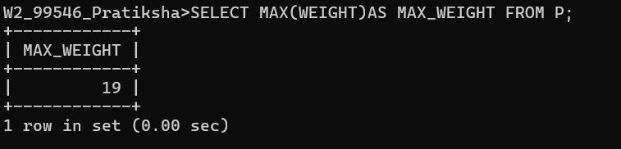

- Display the average Weight of the Parts.
SELECT AVG(WEIGHT)AS MIN_STATUS FROM P;
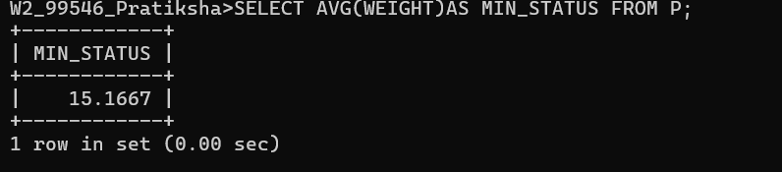
- Display the total Quantity sold for part ‘P1’.
SELECT SUM(QTY)AS TOTAL_QUANTITY FROM SP WHERE `P#`='P1';
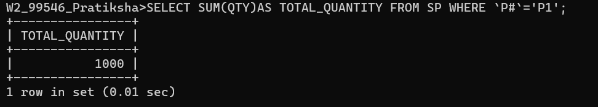
- Display all the Supplier names (with ‘la’ replaced by ‘ro’). HINT: REPLACE.
SELECT SNAME,REPLACE(SNAME, 'LA', 'RO')AS NEW_NAME FROM S;
