Blog Management System

Name Of Team Members

1. Govind Vyas
2. Kaustubh Ganorkar
3. Yanti Sawant
4.Samyak Ghatode

SKY-G Blogs
Think Beyond your imagination

Scope :

A blog management system is a software or platform designed to help individuals or organizations create, publish, and manage their blogs efficiently. The scope of a blog management system can vary depending on the specific needs and goals of the bloggers or the organization, but here are some key components and features commonly included in such systems:
- Content Creation and Editing:
  - Text editor: A user-friendly text editor with basic formatting tools for creating and editing blog posts.
  - Media support: Ability to add images content to blog posts.
- Content Organization:
  - Categories : Tools for categorizing blog posts to help users and search engines find relevant content.
- User Management:
  - User roles and permissions: Different levels of access for administrators, authors & Support users.
  - User registration and authentication: Features to allow user registration and login for commenting and authoring posts.
- Comments and Interaction:
  - Comment management: Tools to moderate and manage comments on blog posts.
- Reporting:
  - Performance insights: Data on the performance of blog posts, such as views, likes, and shares.
- Security:
  - User authentication and authorization: Protecting the blog from unauthorized access.
- Backup and Recovery:
  - Regular backups of blog content and settings to prevent data loss.
  - Restore functionality in case of data corruption or accidental deletion.
- Mobile Responsiveness:
  - Ensuring that the blog is accessible and functions well on various devices, including smartphones and tablets.
- Performance and Scalability:
  - Optimization for fast loading times and the ability to handle increased traffic.
Purpose:
The main objective of the project online blogging system is to manage the details of blogs, comment, New Category.

It manages all the information about Blogs, Likes & comment.

The project is totally built at administrative end and thus only the administrator is guaranteed the access.

In administrative end we have also given an access to support user which will have the access of the feedback and contact us section.

The purpose of the project is to built an application program to reduce the manual work for managing the Blogs, Comment, New Category.

It tracks all the details about the New category, New blog & New Users.

Flow Diagram :

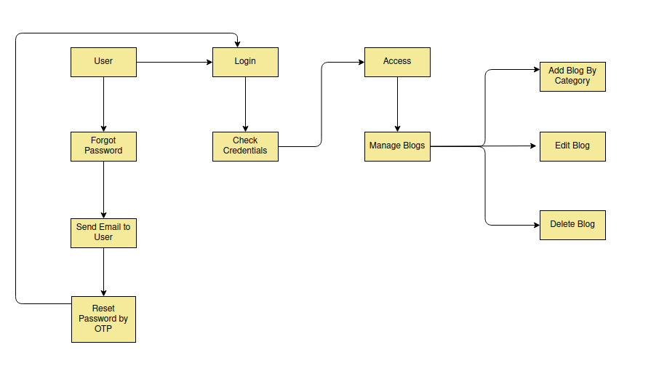

Use Case Diagram Of User :

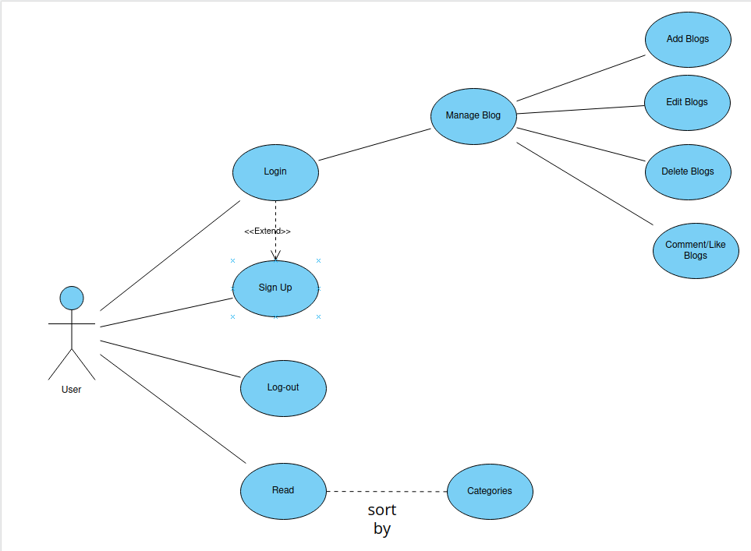

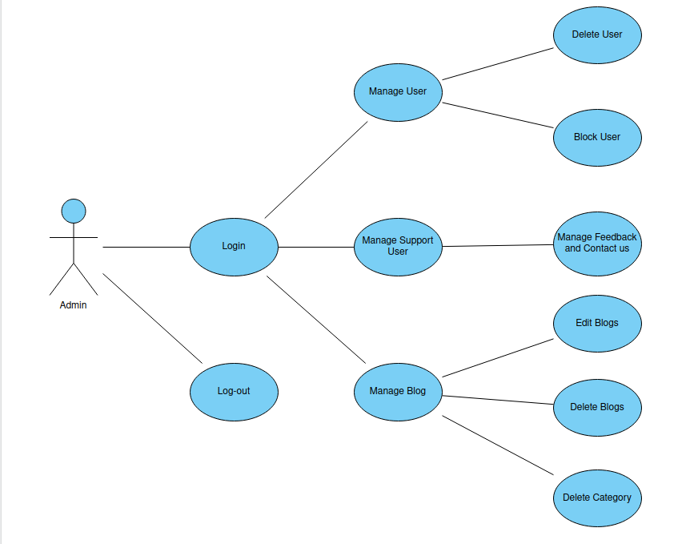
Use Case Diagram of Admin :

