Lehigh Valley Amateur Radio Club Hoagie Sale
Delivery Date: Thursday, November 9 Seller:
HOAGIES $ 3.50 Sandwiches $ 2.50
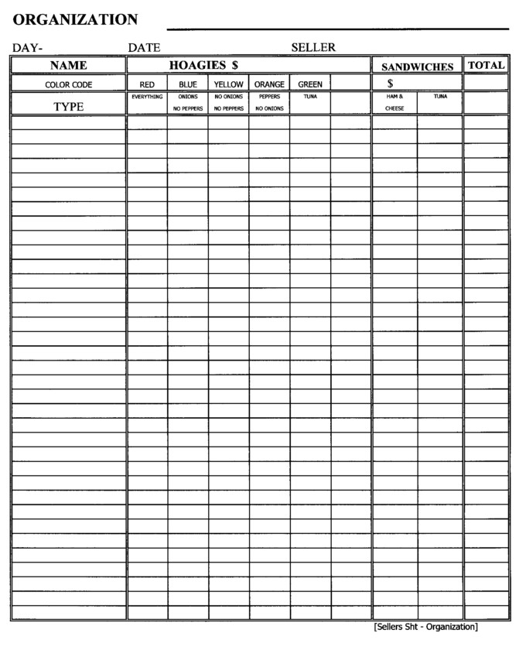

Lehigh Valley Amateur Radio Club Sandwich Fundraiser

Ingredients: Meat Hoagies – 9 inch roll
2 slices white American cheese
3 slices Hormel oval spiced ham
3 slices Swift premium hard salami
1 slice square cooked ham
- Lettuce, tomato, onion, sliced hot peppers, oil, vinegar, and oregano

Ingredients: Tuna Hoagies – 9-inch roll
Tuna, lettuce, celery, hard-boiled eggs, grated white American cheese, and mayonnaise.

Ingredients: Ham and Cheese Sandwiches – Kaiser Roll
2 slices white American cheese
2-½ oz. Of chipped square cooked ham
Mustard pack

Ingredients: Tuna Sandwiches – Kaiser Roll
Tuna, lettuce, celery, hard-boiled eggs, grated white American cheese, and mayonnaise.

All Hoagies are wrapped and sealed in a plastic bag.
All Hoagies are identified with a color code band (as indicated on order sheet)
NO SPECIAL ORDERS OTHER THAN LISTED ON ORDER SHEET
Red – Everything, Blue – Onions / No Peppers, Yellow – No Onions / No Peppers, Orange – Peppers / No Onions, Green – Tuna.

Payment due at time of order pick up: Wednesday, November 8, 6:30 pm at the Red Cross Parking Lot.

DEADLINE for ORDERS: 6 pm on Friday November 3.
Call your totals to Rodney 610-266-3355 or email totals to rjwolfe@rcn.com

