Auto-Calibrated RTC GPS WSPR Si5351A Project
Gene Marcus W3PM GM4YRE

This is a full featured WSPR signal sourced using the very popular Si5351A clock generator board. Frequency and time accuracy are maintained by a highly accurate temperature compensated DS3231 real time clock (RTC) board. Extensive menu options allow the user to change all necessary parameters in addition to selecting a built in SWR bargraph indicator for antenna adjustments. Band switched WSPR bands cover 6 – 2200m .

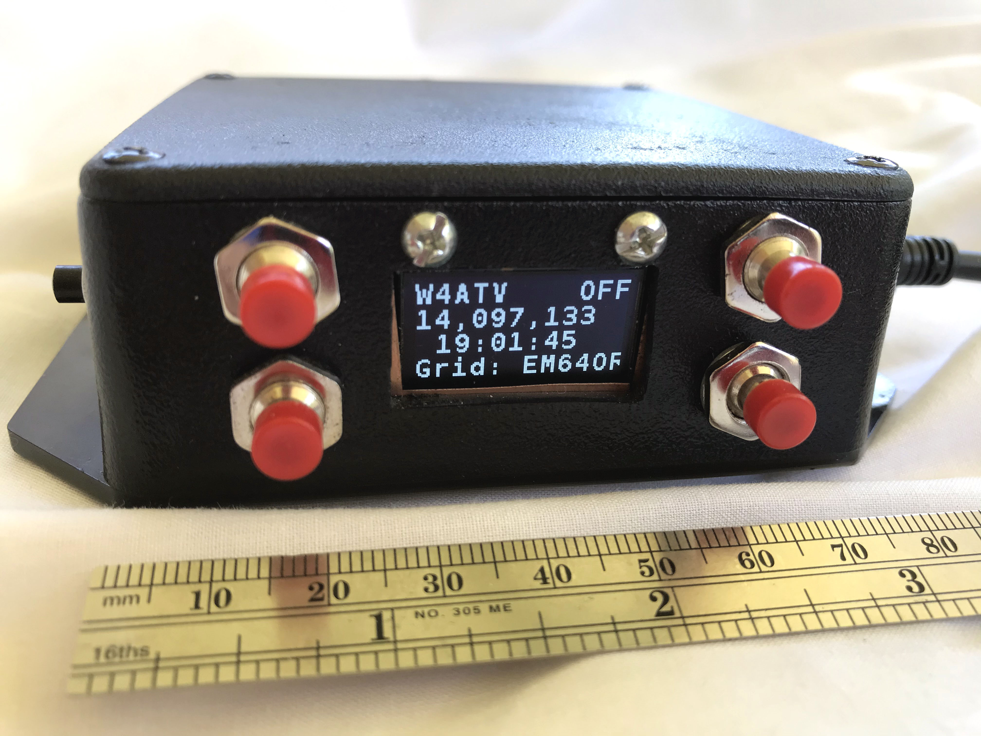

Figure 1
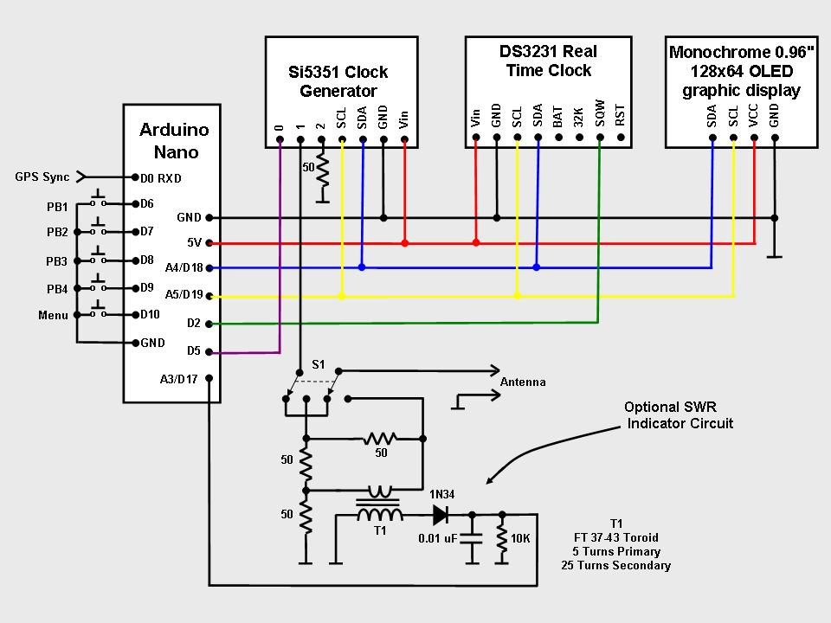

Figure 2

Introduction

The unit described here is a WSPR signal source. An amplifier to increase the power output and a low pass for the band of choice will complete the project. However, operation at the unit’s 5 milliwatt level using an external low pass filter and a good antenna will result in a surprising number of WSPR spots from a large geographical area depending upon the band used and band conditions.

As shown in Figure 2 the building blocks for this project consist of four boards: an Arduino Nano (or Uno) microcontroller, a Si5351A clock generator breakout board, a DS3231 real time clock (RTC) board, and a 0.96 inch 128x64 serial I2C OLED display board.

The boards communicate with the Nano microcontroller over an I2C bus using only three wires. The boards were chosen because they are highly capable, inexpensive, well documented, and available over the internet from a wide variety of vendors. The completed unit draws little power and can be powered by the Nano microcontroller through the USB cable connected to a computer, a USB charger, or by some 5V USB battery backup chargers.

Unlike other Si5251A based WSPR projects, this project does not require calibration. Both time and frequency accuracy are derived from a DS3231 real time clock (RTC) which has an uncertainty of about 2 parts per million from 0 – 40 degrees C (32 to 104 degrees F).

Critical WSPR timing can be synchronized manually or by an external GPS receiver. Once synchronized, the unit will not require re-synchronization for 7-10 days. This timeframe may be extended by adjusting the DS3231 aging offset.

The optional SWR indicator circuit based upon the Dan Tayloe, N7VE, resistive SWR bridge. When selected, the “ANT TUNE” display will not tell you what the actual SWR is, but will serve as an indicator to let you know when the antenna is tuned to a nominal 50 ohm impedance. Simply adjust the displayed bar graph for a minimum amount of bars.

All the necessary parameters required for WSPR operation can be changed by using 5 pushbuttons.

Construction

NOTE: Frequency and timing accuracy is provided by the DS3231SN RTC. Be sure your project uses the DS3231SN, some vendors substitute the DS3231M version which is not as accurate as the “N” version.

Construction of the unit is not critical provided adequate RF techniques are used. Do not use long unshielded wires for RF and 1pps connections. I first built the system using a solderless breadboard without any problems. The circuit was then transferred to a piece of perfboard and placed in a plastic project box. Mounting the unit in a metal cabinet is the preferred way to house this project. To improve short and long term accuracy the unit should be kept at a constant temperature away from any drafts. Figure 1 shows my completed unit with the WSPR function selected and band set to 20 meters.

The Si5351A, DS3231SN, and the display are powered from the 5 volt pin of the Arduino. You can use the USB programming cable, a separate 5VDC source connected to the “+5V” pin, or 7-12VDC source connected to the Arduino Nano’s “VIN” pin to power the unit.

Software Installation and Setup

The Arduino download website <http://arduino.cc/en/Main/Software> outlines installation instructions for the first-time Arduino user.

The sketch requires the open source library; “SSD1306Ascii” by Bill Greiman. The library is located in the Arduino IDE at; Sketch > Include Library > Manage Libraries. (Windows users will find the menu bar on top of the active window. Linux and MAC users will find the menu bar at the top of the primary display screen.) I found that other more robust ASCII/Graphics libraries were not compatible with the functions and timing complexity of this sketch.

In the unlikely event of operational problems, I suggest the builder check the Arduino, OLED display, and RTC boards individually to ensure proper operation. The Arduino board can be checked using some of the example sketches provided with the open source Arduino software. The simple “blink” example sketch will confirm that a sketch can be loaded and the Arduino board is functioning. The OLED display may be checked by running one of the AvrI2C examples found with the SSD1306Ascii library. The DS3231SN RTC board may be checked by running a time initialization sketch. A search of the internet will provide a number of methods to initialize the board. Adafruit Industries provides a very good tutorial to confirm the board is operational. Upon initialization, the time will be a few seconds slow. This is because the time set is the time the sketch was compiled, not the current time. If WSPR is to be used, the time will have to be updated using the “Clock Set” push buttons after the project is completed. Provided a battery is used with the DS3231, the date will not require setting for a year or more.

Prior to using WSPR, your callsign, grid square locator, power level, transmit offset frequency, and transmit interval will require customization within the sketch or by the use of the pushbuttons. The sketch is fully documented and configuration instructions are found in the WSPR configuration data section near the beginning of the sketch.

Operation

When the unit is turned on, the auto-calibration algorithm begins to calculate the correction factor for the
Si5351A’s 25 MHz clock. This takes 40 seconds to complete. The internal DS3231 temperature compensation algorithm concurrently calculates its correction factor every 64 seconds. The correction factors are continuously updated, therefore you may see small frequency jumps for the first few minutes until the unit stabilizes.

The function selection menu is first displayed beginning with the WSPR function. Depress pushbutton 3 to scroll through the other functions. Depress pushbutton 2 to select the desired function.

Once selected, all functions are controlled by pushbuttons. An outline of pushbutton operation follows:

WSPR CLOCK SET DATE SET EDIT CALL
PB1 N/A Time sync / Set Hour* Set Day* Select alphanumeric
PB2 ON / OFF Set Minute* Set Month* Depress with PB3 to save data
PB3 Band Select N/A Set Year* Depress with PB2 to save data
PB4 N/A *Hold to change time *Hold to change date Select character position
Note: end CALL with "#" before saving

EDIT GRID EDIT POWER TX INTERVAL
PB1 Select alphanumeric Increase power level Increase TX interval
PB2 Depress with PB3 to save data Depress with PB3 to save data Depress with PB3 to save data
PB3 Depress with PB2 to save data Depress with PB2 to save data Depress with PB2 to save data
PB4 Select character position Decrease power level Decrease TX interval
Note: end GRID with "#"
before saving

SET OFFSET TX FREQ HOP ANT TUNE
PB1 increase offset "YES" N/A
PB2 Depress with PB3 to save data Depress with PB3 to save data N/A
PB3 Depress with PB2 to save data Depress with PB2 to save data Band Select
PB4 Decrease offset "NO" N/A

GPS SYNC
PB1 N/A
PB2 Depress with PB3 to sync data
PB3 Depress with PB2 to sync data
PB4 N/A

Depress the MENU pushbutton to exit and return to the original function selection.

When the “WSPR” function is selected the WSPR On/Off status, frequency, and time will continuously be displayed. Important operating parameters such as grid square location, TX interval, offset frequency, TX hop On/Off status, power level, day of the week and date will be displayed at 4 second intervals.

Prior to WSPR operation, ensure that your callsign, grid square locator, and power level have been properly entered.

Setting the correct time within +/- 2 seconds is critical for successful WSPR operation. The time is set by selecting the “CLOCK SET” function. Hold down pushbutton 4 while depressing pushbutton 1 to set hours or pushbutton 2 to set minutes. Release pushbutton 4 at the top of the minute. A GPS time and grid square synchronization function is available. This function will only work with the W3PM GPS display project found at: http://www.knology.net/~gmarcus/ or <https://github.com/w3pm/>. Connect the 9600 baud output of the GPS display to the serial input of the Nano (pin D0 RX0). Select “GPS SYNC”. The time and grid square will be displayed when valid GPS data is available. Depress pushbuttons 2 and 3 to synchronize the time and update the grid square. This function is particularly useful for portable operation.

A shortcut to synchronize the time is available provided the displayed time is correct to within +/- 30 seconds. Simply depress pushbutton 1 at the top of the minute while in the “CLOCK SET” function to synchronize the time.

WSPR frequency accuracy is dependent upon the uncertainty of the DS3231 RTC which is about 2 parts per million between 0 and 40 degrees C. This will keep transmissions within the 200 Hz WSPR window provided “TX OFFSET” is set to 1500 Hz which is the middle of the WSPR window. If you want to use the optional in-band frequency hopping, or want to transmit nearer to the edge of the WSPR window, a calibration crystal aging offset register adjustment is documented near the end of the sketch.

Short term frequency stability during WSPR transmissions is particularly important on bands above 20 meters. Short term drift stems from the Si5351 25 MHz oscillator and can be minimized by connecting a 50 ohm resistor or dummy load to the unused CLK2 output. Also, keep the unit enclosed and away from drafts.

Use Pushbutton 2 to turn the transmitter on or off. When the display is showing that the WSPR transmitter is “ON” a WSPR transmission will begin on an even minute after a few minutes of stabilization time and then repeat based upon the “TX INTERVAL”.

DS3231 Aging Offset Adjustment

While the default RTC is already very accurate, its accuracy can be pushed even higher by adjusting its aging offset register. The documentation located at the end of the sketch provides methods to determine the correction factor and upload it to the aging offset register.

For normal operation this adjustment is not required. The default 2 parts per million accuracy of the RTC will result in an uncertainty of less than +/- 30 Hz on 20 meters.

The time will require synchronization every 7 – 10 days without offset adjustment. The re-synchronization timeframe can be stretched to a month or more with proper adjustment.

Gene Marcus W3PM GM4YRE
113 Wickerberry Lane
Madison, AL 35756
w3pm(at)arrl(dot)net

