Table of Contents

My Learning Journey Plan 2

1. Introduction 2

2. Future Plan Upon Graduation 3

2.1 My Dream Job 3

2.2 My Realistic Job 3

2.3 Identify the Gaps –Roadmap 3

2.3.1 Identify suitable personal attributes and skills 3

2.3.2 Identify up to 3 modules in your course 4

2.3.3 Identify suitable CCA, ICT Society, and/or Special Interest Group (SIG) activities 4

2.4 Is Further Studies an option? 4

3. Tools To Help Yourself 5

4. Conclusion 6

5. References 6

6. Appendices 6

# My Learning Journey Plan

# 1. Introduction

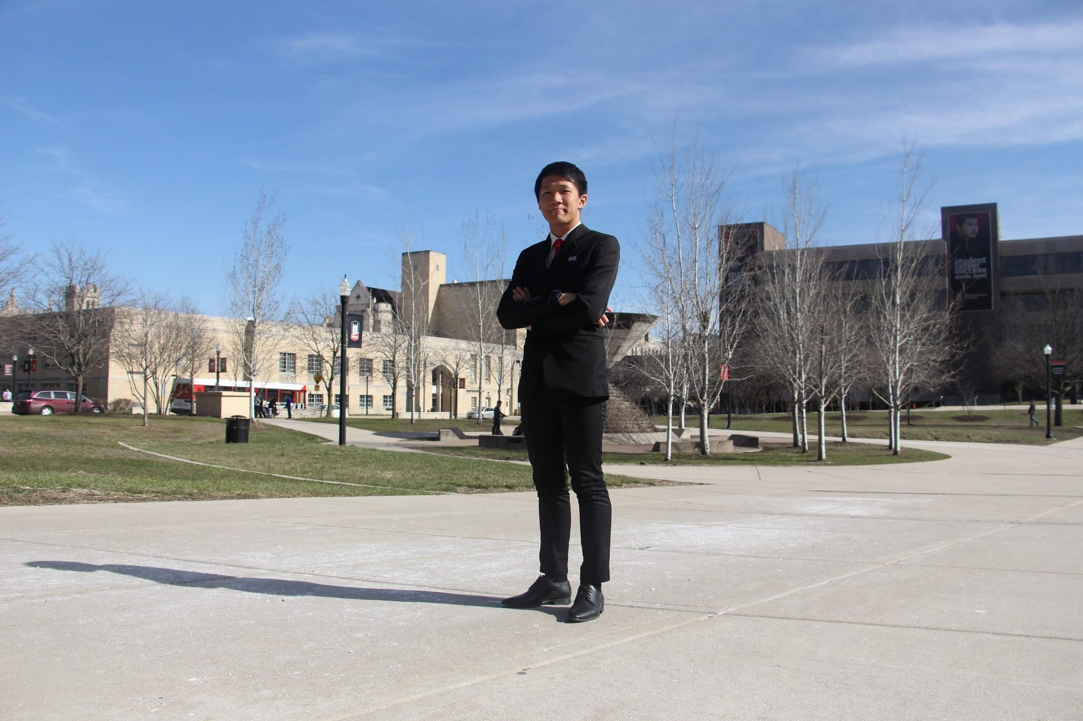My name is Lee Quan Sheng, and I am currently in my first year at Ngee Ann Polytechnic where I am studying Information Technology. I would describe myself as a curious and a self-drive person because I always question others and including myself on how things work.

When I started using the internet, I am fascinated by the technology they had back in the day such as email, AOL instant messenger etc. How does this work, why does it work were the first thing and what is the magic behind all these technologies that came into my mind. These curiosities have led me to choose Information technology as my course. One of the key points that kept me going is technology are constantly evolving and limitless

In this report, I will be sharing on my personal career goal settings. I will explain what I did to explore my goals and how these helped me to choose my career goals.

# 2. Future Plan Upon Graduation

After graduation, I would like to further my studies in Bachelor of computer science at Nanyang Technological University. The GPA requirement needed for computer science is range from 3.68 to 3.97. I plan to take private H2 Mathematics as NTU requires H2 math or equivalent, so I would not have to take bridging module in NTU.

## 2.1 My Dream Job

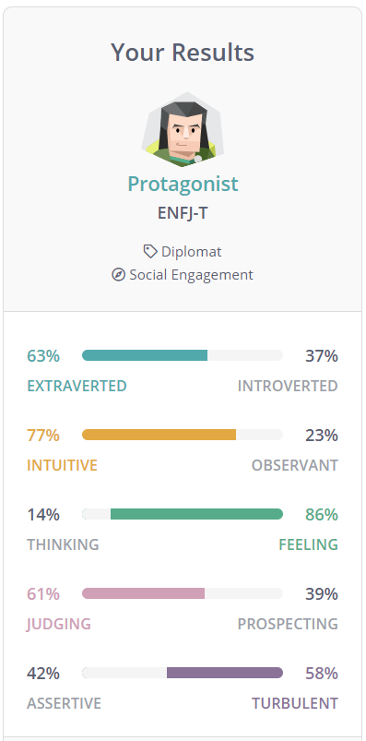

My dream job is to be a motivational speaker. My MBTI profile is a protagonist based on 16 personalities. I always love to engage in conversation when it comes to lending a listening ear and guide them to think differently. I will want to be able to make an impact and influence on the world.

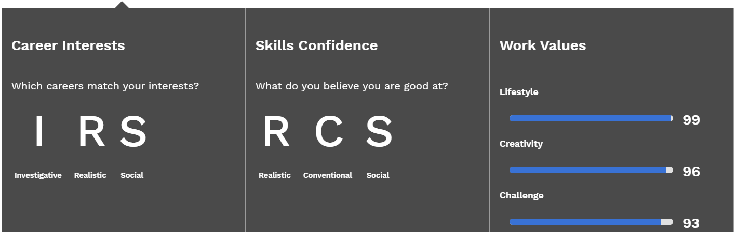Being a motivational speaker, it requires a lot of confidence to speak in front of a large crowd and being able to deliver my message to everyone is not easy. I may like to talk and listen to others to help them, but when it comes to speaking in front of a large crowd, I do not have the confidence to speak. The ways that I can overcome is to start off by trying to speak in front of a small crowd and identify how I can improve. Taking small steps to achieve to be able to speak in front a large crowd. Other than class presentation, I can approach CCAs that are available to provide my trainings to also build up my confidence.

## 2.2 My Realistic Job

My realistic job is to be a data analyst. I am a curious and detail-oriented person who loves to explore. Data analyst is one of the jobs that suits my personality. Being a data analyst, my role is to help companies to interpret and manage data and solve complex problems using expertise in a variety of data niches. This requires a lot of data exploration.

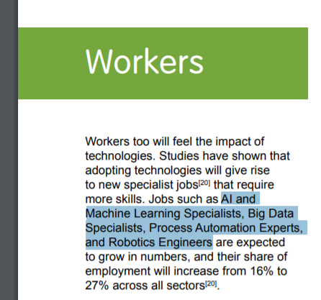

I have done Python, SQL, ETL, Java and Apache Hadoop that meets some of the requirement as a data analyst. There are numerous of software and programming languages that I must learn such as Hive, HBase, Splunk, C++, R programming etc. to achieve to be in this field.

According to the IMDA report, big data are expected to grow in numbers in the future.

Aside from the skills and software, I also need to have a strong knowledge of statistic, data structure and mathematics. I have not taken A math and higher in my education, this is an opportunity for me to take diploma plus programme in poly and further my math to h2 level.

## 2.3 Identify the Gaps –Roadmap

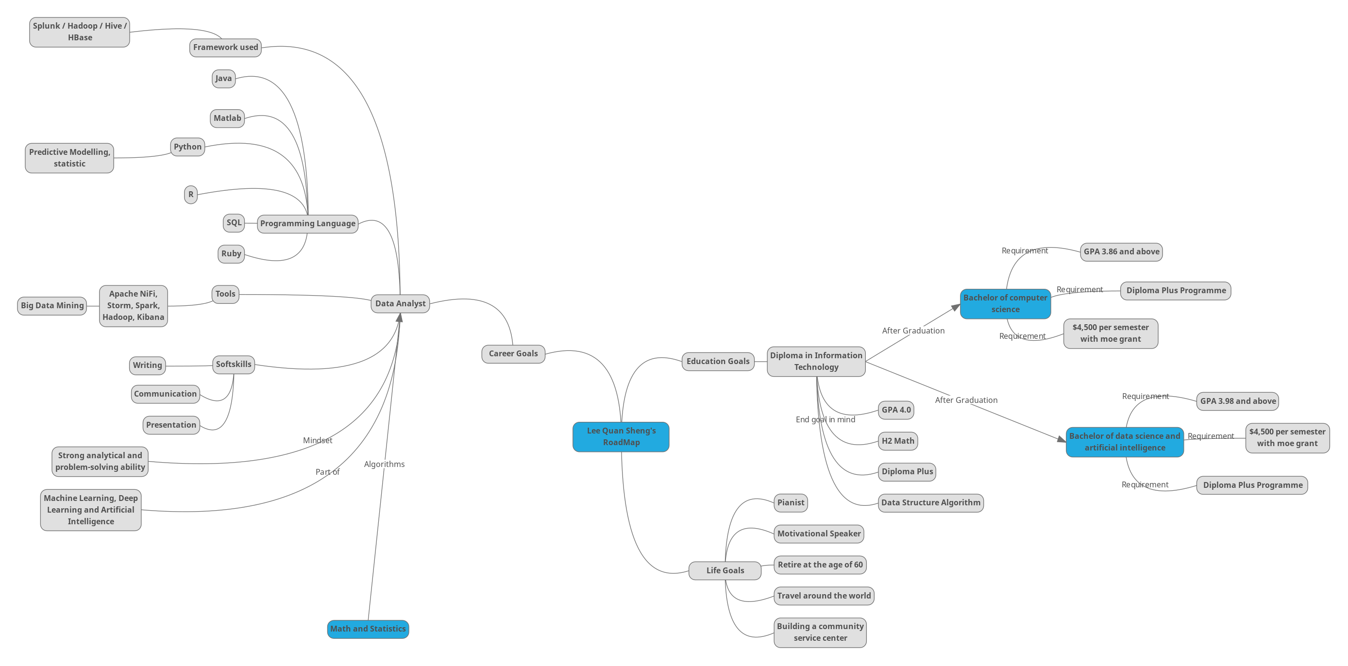

## 2.3.1 Identify suitable personal attributes and skills

that you need to develop to reach your goal, and how they can be developed.

I only have a N level math certification. My goal is to attain h2 math to have better knowledge on complexity of statistics. Ngee Ann poly provide a diploma programme for the students. I will take the opportunity to take diploma plus programme to prepare myself for h2 math. This requires determination and persistence as I must balance my time and I do not have prior knowledge on math.

## 2.3.2 Identify up to 3 modules in your course

Data structure and algorithms allows me to come up with more creative algorithmic solutions when processing large volumes of data. Being a data analyst deals a lot with data and requires producing the results efficiently. It might not be able to get me the job, but it is a step for me towards my realistic job.

Communication essentials can help me to build up my confidence in presentation and communicating in a team. Being a data analyst requires to communicate with a team for require data set, expectation etc. and give presentation on share on the finding of patterns. At the same time, being a motivational speaker needs to be able to speak confidently.

Business & Data Analytics can allow me to attain the hard skill of data analytics. With better knowledge of the types of analysis. Data analyst require these knowledges to be fulfil the job’s skill criteria.

## 2.3.3 Identify suitable CCA, ICT Society, and/or Special Interest Group (SIG) activities

explain how they may help you to get to your dream job and realistic job.

Overflow interest group have many different activities such as machine learning, Lego mindstorm, splash etc. to explore in many different fields. These activities are usually for us to prepare for competitions. Some of the activities are related to my realistic job as a data analyst such as machine learning. Competitions is where I can apply my knowledge and challenging myself.

Current affairs club is a cca which does debate, such activities can build up my communication skills and allow me to speak confidently.

ICT society have workshop that allow me to build up my soft skills. Based on my research, being a data analyst it is important to have soft skills as this role is not only produce results but to give presentation on the research.

## 2.4 Is Further Studies an option?

I believe that further studies is an option depends on my interest. If I do not like the course that I am in, I feel that I should explore for other areas instead but knowing that I have a strong passion in IT, I would like to pursue further studies for a bachelor’s degree in Nanyang Technological University either on Science in Data Science and Artificial Intelligence or Computer Engineering & Computer Science. By achieving this degree, it opens up to numerous career opportunities because most of the jobs require a bachelor’s degree. I believe that by pursuing this degree, it will continue to develop my soft skills such as teamwork, communication, leadership, etc. through the projects and diving in deeper thoughts and ideas on technologies before entering the workforce. I feel that I must fully prepare myself to be able to cope before entering the workforce as this determines my career life.

# 3. Tools To Help Yourself

The LinkedIn profile can allow people to apply for job without a physical resume and it is also a platform where we can look for jobs that suitable for us based on our achievements and course. It is also important to update my LinkedIn profile to keep track on the modules that I’m taking and what I have achieve to allow employers to discover talent. LinkedIn also allows me to connect to other people and this can be beneficial if I were to be going for an interview as it allows me to understand the people that are interviewing me.

Creating a mind map will allow me to have a better understanding of my future and be more efficient for categorizing. Mind map allows me to classify my future such as education, career, personal goals and etc with links and relationships between ideas so I don’t have to disconnect facts. With this visual diagram, it can give me a overview on my future where I can plan efficiently and not missing out the parts. Mind map is indeed important as it can show me what is coming up ahead and what are the alternative routes I can take to achieve my goal. Without mind map, I may know what I want to pursue but I will not know how to plan my steps for my goals as there are always requirements needed to achieve that goal.

Creating a blog allows the company to know more about me. A blog includes about myself, my awards that I have attained, the things I have learnt and the projects that I have done. These information on the blog allows the employer to view on the details about the module that I have taken. Module is just a title but stating what I have learnt, and my understanding will give the employer to know about the module’s description.

# 4. Conclusion

This assignment has benefited me in thinking and planning for my future. It allows me to differentiate between dream job and realistic job. Planning on how I should take the steps towards my goal. It has given me more confidence as I have a clearer picture of my future. I have better understand my personality and where and which area I can develop my personal attribute for my goal. It also allows me to think through that furthering my studies is not just for the sake of studying but the learning points I can develop to achieve my goals as well.

# 5. References

GPA requirement retrieve from website:

<http://www3.ntu.edu.sg/oad2/website_files/IGP/NTU_IGP.pdf>

Why is LinkedIn important retrieve from website:

<https://www.thebalancecareers.com/is-linkedin-a-waste-of-time-2062320>

Being a motivation speaker from website:

<https://www.inc.com/amy-morin/how-to-become-a-successful-motivational-speaker.html>

IMDA report on the industry development from website:

<https://www.imda.gov.sg/-/media/imda/files/industry-development/infrastructure/technology/technology-roadmap/main-report.pdf>

What do I need to be in a position of a data scientist

<https://www.kdnuggets.com/2018/05/simplilearn-9-must-have-skills-data-scientist.html>

Why is linkedin profile is important from website:

<https://www.topresume.com/career-advice/why-linkedin-is-important>

Many jobs now require at least bachelor degree from website:

<https://www.northeastern.edu/bachelors-completion/news/10-reasons-why-a-bachelors-degree-is-important/>