CONEICL CLUTCH

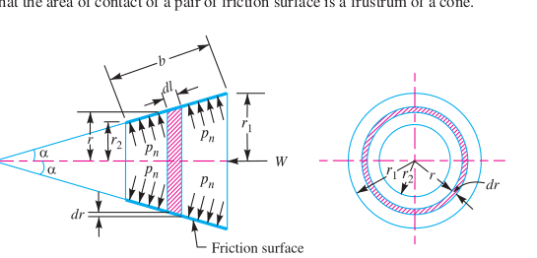

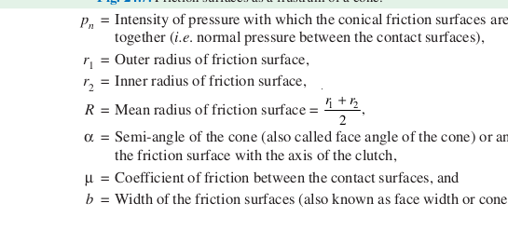

IMPORTANT DERIVATION AND FORMULES

IN CONE CLUTCH THE NORMAL AND THE AXIAL FORCE BOTH ARE DIFFERENT

FOR THE NORMAL FORCCE WE USE THE NORMAL PRESSURE AND THE AREA OF THE RING

THAT IS SIGMA W= INTENSITY OF THE PRESSURE WITH WHICH THE CONICAL FRICTION SURFACES ARE TOGETHER * 2 PI R DR COSEC ALPHA

NOR FOR THE AXIAL FORCE

SIGMAWN= SIGMA W* SIN ALPHA WHERE ALPHA IS THE CONE ANGLE THAT IS SEMI

NOW FOR THE TOTAL AXIAL FORCE WE WILL TAKE THE AXIAL FORCE AND INTERGRATE THE WHOLE AXIAL FORCE FROM R1 TO R2

WHICH GIVES US THE EXPRESSION ABOUT THE INTENSITY OF THE PRESSURE WITH THE AXIAL LOAD WITH THE DIVISION OF THE PI ALONG WITH THE R1 AND R2
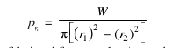

NOW COMING TO THE FRICTIONAL AND THE TORQUE DUE TOP THE FRICTIONAL FORCES

FOR THE FRICTIONAL FORCE WE WILL MULTIPLEY THE MYU TIMES THE AXIAL FORCES ACTING ON THE RING

FR=MYU TIMES 2 PIE R DR INTESITY OF THE OPRESUURE

THIS IS THE FRICTIONAL FORCE NOW FOR THE FRICTIONAL TORQUE DUE TO THE FRICTIONAL FORCE

TR= FR TIMES R

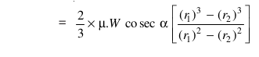

WE WILL AGAIN

INTEGRATE THE FOLLOWING TO GET A FRICTIONAL TORQUE WITH RESPECT TO THE WHOLE CONE CUTCH

WHICH COMES AS T= 2/3 MYU W COSEC ALPHA THEN THE R1-R2/R1-R2 SQUARE CUBE THIS WAS FOR ALL THE UNIFORM PRESSURE

NOW FOR THE UNIFORM WEAR

PR R= C(WHICH IS CONSTANT)

THE NORMAL FORCE WILL BE THE SAME BUT NOT THE AXIAL FORCE

INT THE FORMULA WE WILL CHANGE THE THE PR INTO THE C/R

SIGMA W= 2 PIE C DR

FOR THE TOTAL AXIAL FROCE WE WILL SIMPLY INTGRATE W=2 PI C( R1-R2)

OR C=W/ 2 PIE R1-R2

FOR THE TORQUE WE WILL WRITE THE EQUATION AS T= MYU W COSEC ALPHA R1+R2/2

NOW FOR TTHTE NEW TERM WHICH IS B
IF B IS GIVEN

W=PN* 2 PI R B SIN ALPHA

T=2 PI MYU PN R SQUARE B

