Parsing a sentence...
Sudan's Arab-dominated government has been battling ethnic African rebels in Darfur since 2003.
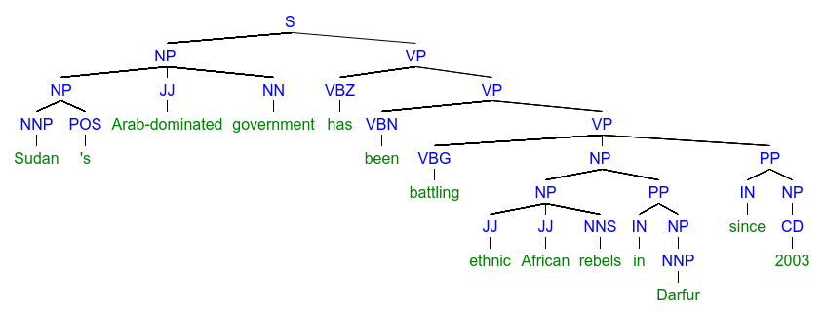
Up to 300,000 people have been killed and 2.7 million have been driven from their homes.
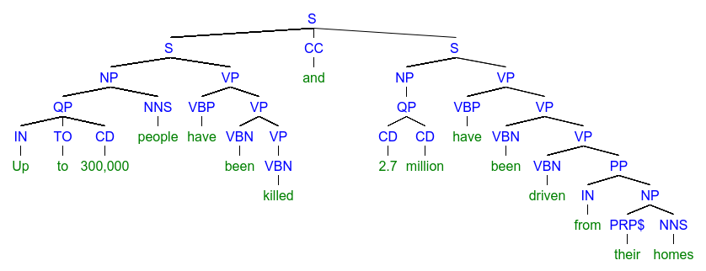
About six gunmen seized 32-year-old Sharon Commins of Dublin and her 42-year-old colleague, Hilda Kuwuki, from the Darfur base of the Irish aid agency GOAL.
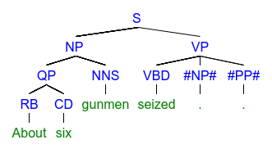
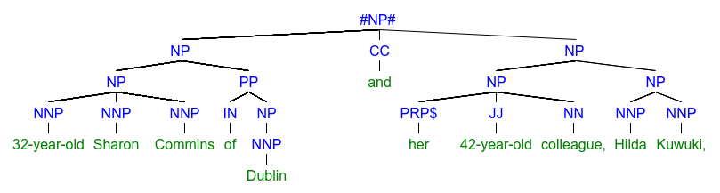
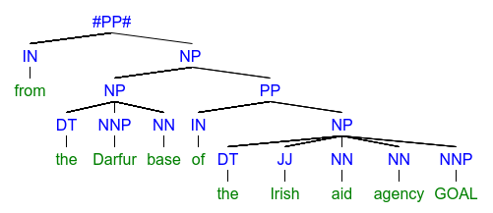
Officials said the first kidnapping was carried out by a group seeking to retaliate for the arrest warrant against the president.
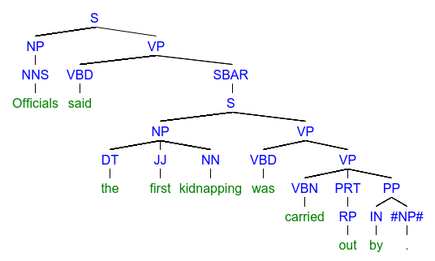
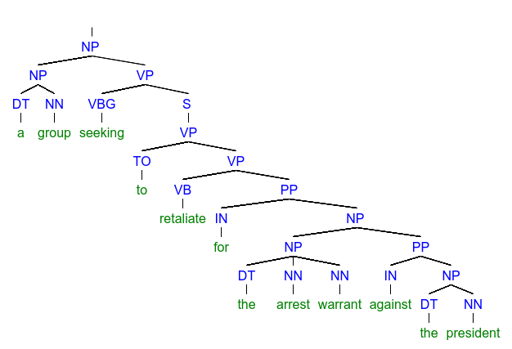

Mr. Stephen D. Vance was shot and killed on the morning of November 12, 2008, in Peshawar, Pakistan, along with his driver.
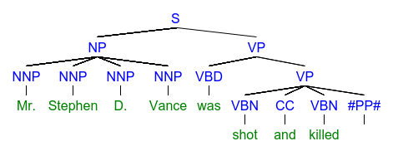
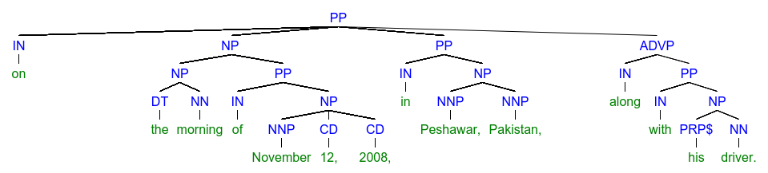
Parser vocabulary
CC - Coordinating conjunction
CD - Cardinal number
DT - Determiner
EX - Existential there
FW - Foreign word
IN - Preposition or subordinating conjunction
JJ - Adjective
JJR - Adjective, comparative
JJS - Adjective, superlative
LS - List item marker
MD - Modal
NN - Noun, singular or mass
NNS - Noun, plural
NNP - Proper noun, singular
NNPS - Proper noun, plural
PDT - Predeterminer
POS - Possessive ending
PRP - Personal pronoun
PRP$ - Possessive pronoun (prolog version PRP-S)
RB - Adverb
RBR - Adverb, comparative
RBS - Adverb, superlative
RP - Particle
SYM - Symbol
TO - to
UH - Interjection
VB - Verb, base form
VBD - Verb, past tense
VBG - Verb, gerund or present participle
VBN - Verb, past participle
VBP - Verb, non-3rd person singular present
VBZ - Verb, 3rd person singular present
WDT - Wh-determiner
WP - Wh-pronoun
WP$ - Possessive wh-pronoun (prolog version WP-S)
WRB - Wh-adverb

