Matt Sandoval

CS-330

September 9, 2023

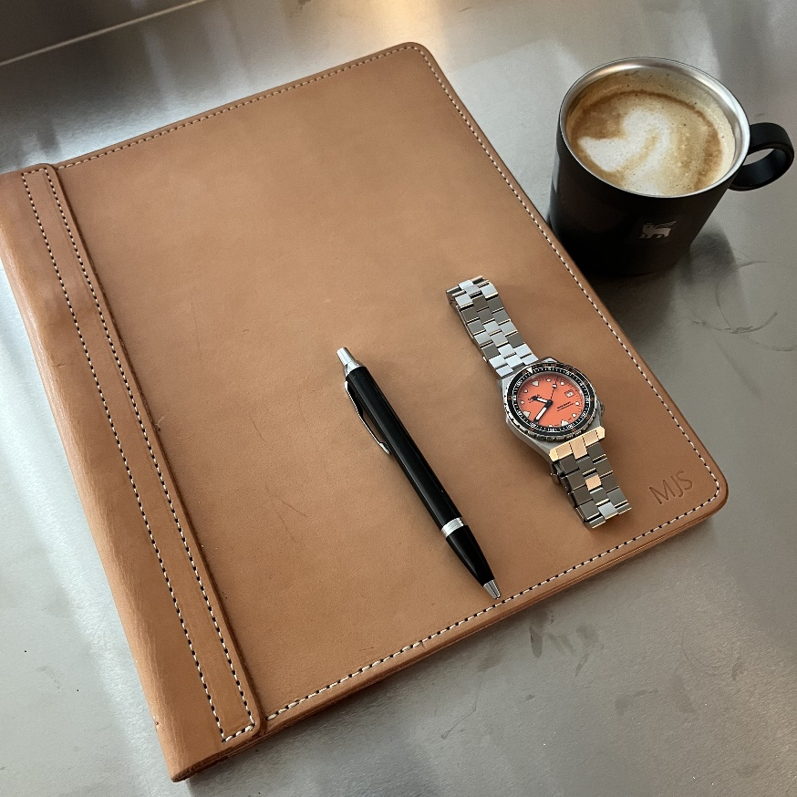

**Project Proposal:**

I propose to model a leather portfolio, pen, watch, and coffee cup. Each item will require a diverse array of primitive shapes to recreate. The portfolio will need some creativity to add corner radiuses. The pen can be simple to very complicated, depending on how accurately I model it. The watch has many opportunities to learn about combining primitive shapes and possibly surfaces. The coffee cup will allow me to work with tori, which I think is an uncommon shape.

**Leather portfolio:**

**Face/back:** The front of the portfolio can be created by two intersecting cubes that will form the face surface, bottom edge, top edge, and right edge. Two cylinders will be placed at the top right and bottom right corners to form the radius corners.

**Spine:** The left side of the spine will be created with a cylinder split halfway down, lengthwise. The flat portion will be made with a cube.

**Paper:** The paper will be represented with a cube.

**Watch:**

**Bracelet:** The bracelet would need to be simplified to a rectangle cube, with a cylinder at each end to create the appearance of a continuous loop. A texture could be applied to the outside surface to simulate the links' appearance.

**Case:** The watch case would start with a cylinder, then two rectangular cubes to form the lugs the bracket attaches to. Then, calculate the tangent intersection of the vertices on the lugs and the cylinder and create a triangle surface to mimic the facets of the watch design.

**Bezel**: The bezel can be created from an inner and outer cylinder.

**Face:** The face would be a cylinder subtracted from the case to better represent the height difference.

**Date:** The date display would be a cube subtracted from the watch face.

**Crown:** The crown would be created with a cylinder and a half sphere.

**Pen:**

**Body:** The body would be created with a cylinder.

**Clip:** The clip could be made with a long rectangular cube on top of a small cube. The end could be built with a pyramid attached to the long rectangle, the point facing the pen body.

**Tip:** The tip of the pen could be created with a cone or pyramid.

**Push button:** A cylinder would represent the push button.

**Coffee Cup:**

**Vessel:** The vessel can be made with an inner and outer cylinder and a quarter torus to create the radius at the top.

**Handle:** The handle can be created with a cylinder and a torus at each end to form the rounded edges.

**Surface:**

A plane would be used to create the surface that the items are sitting on.