Results from Test Project

Fall 2023

## Test Project

Insert text here about your project summary

## Soil Health

Soil health is a term that describes how well a soil ecosystem supports plants, animals, and humans. It also recognizes the living nature of soils and the importance of soil microorganisms. Healthy soils can provide wildlife habitat, support biodiversity, reduce the effects of climate change, filter air and water, increase crop productivity and food security, and ensure thriving rural economies.

## Soil Science 101

A crucial part of the soil health journey is measuring changes in your soil and understanding how to interpret those measurements. We can measure soil health with a range of indicators describing a soil’s physical, chemical, and biological properties, which can relate to important soil functions. Each indicator measures a different property of the soil and can be affected differently by management.

To learn more about management practices that support healthy soil, check out these resources from the [Natural Resources Conservation Service (NRCS) principles of building soil health](https://www.nrcs.usda.gov/conservation-basics/natural-resource-concerns/soils/soil-health).

## What We Measured in Your Soil

## Biological

***Aggregate Stability*** measures the resistance of groups of soil particles, or aggregates, to disintegration. Aggregates are formed when soil particles associate with organic matter, plant roots, fungal hyphae, and “glues” made by soil microorganisms. Water and wind can break down unstable aggregates, while stable aggregates can reduce erosion and increase water infiltration, drainage, and storage capacity. Aggregate stability is an excellent example of how biological life impacts soil physical properties. Soils high in clay tend to have higher aggregate stability than sandy soils, but increasing soil organic matter improves aggregate stability across all soil textures.

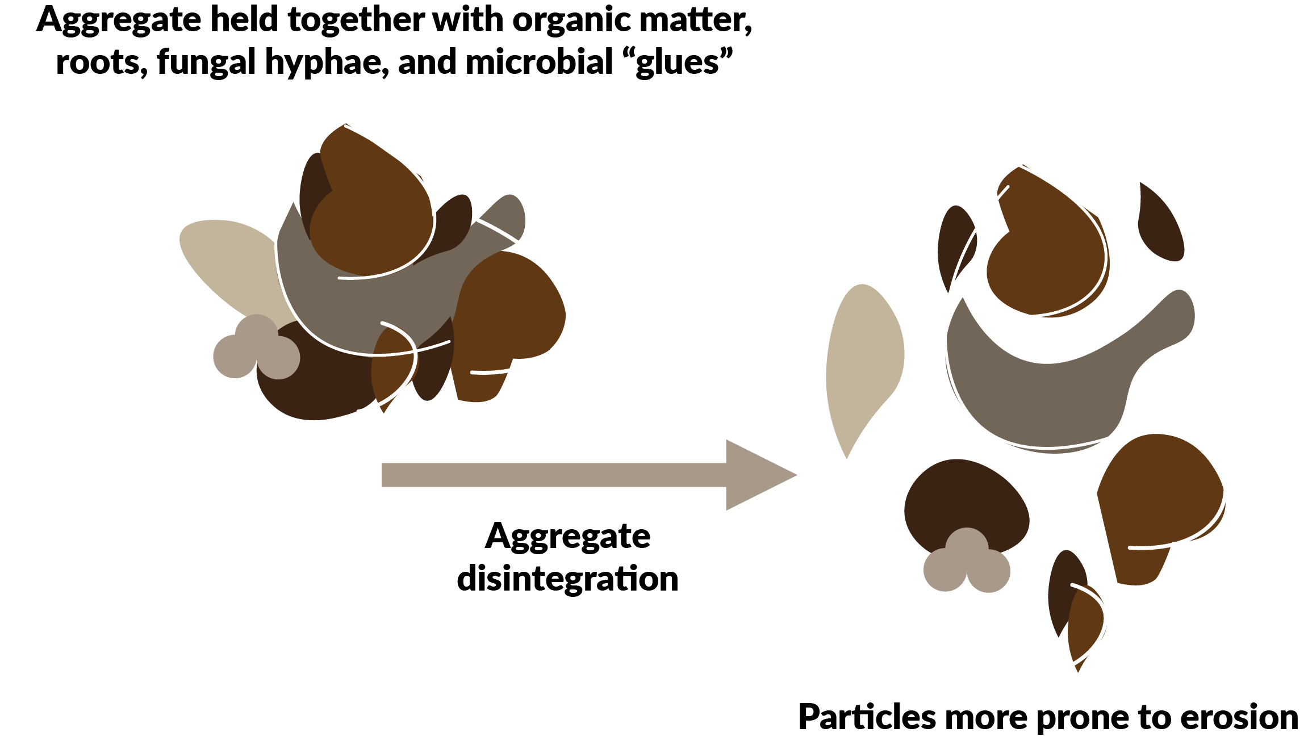

## Physical

***Water Holding Capacity*** (WHC) is the amount of water a soil can hold. WHC describes how the soil will store and supply water during high rainfall events and times of drought. WHC varies by soil texture and bulk density, and can be greatly impacted by management. Generally, soils with finer textures, high organic matter, and low bulk density have higher WHC.

## Soil Health Indicators

The below table describes: 1. What each indicator helps measure in your soil; 2. Whether you want the measured value to be higher (more is better), lower (less is better), or in the middle (optimal range); and 3. How often to measure each indicator. Our understanding of these indicators is rapidly evolving as researchers measure them in diverse soils, cropping systems, and climates.

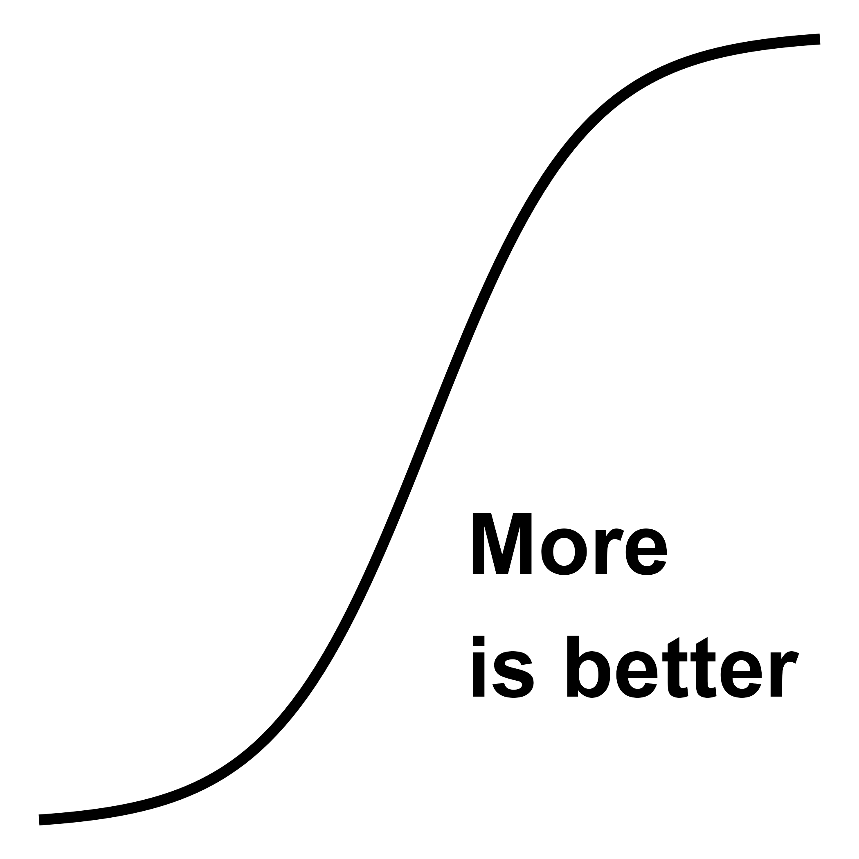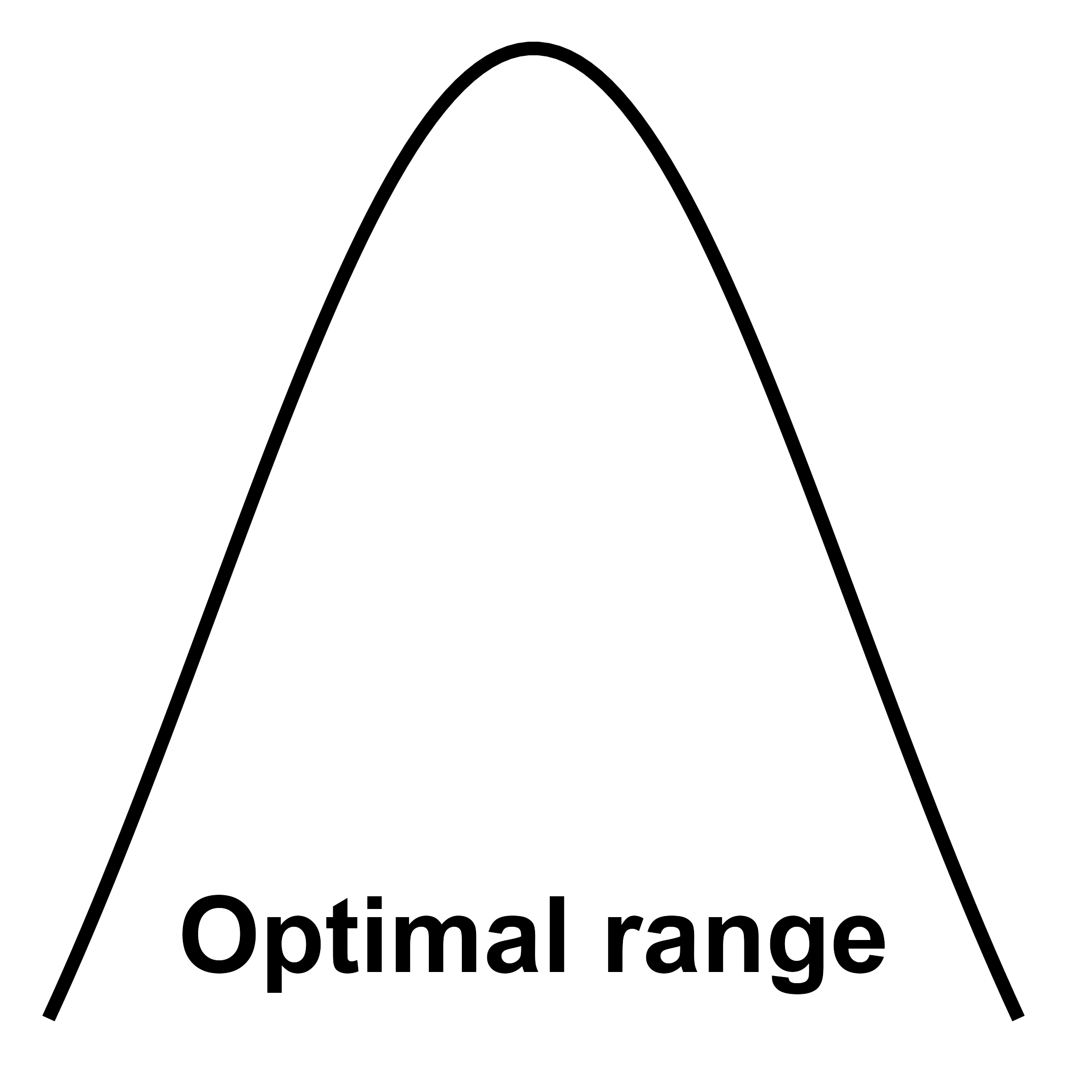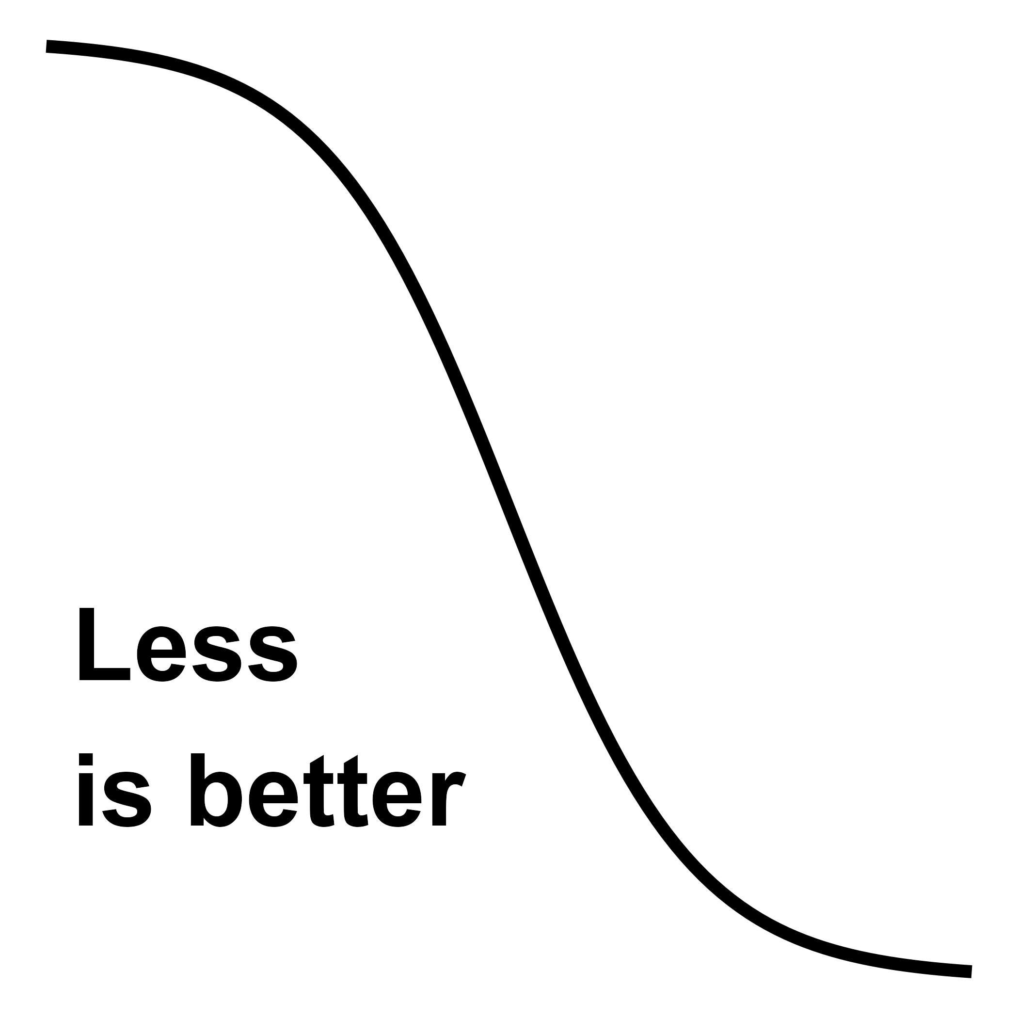

| Soil Health Indicator | Soil Function | Scoring Curve Type |
| --- | --- | --- |
| Measure every: 1-3 years | | |
| ACE Soil Protein | Nutrient cycling, biodiversity & habitat, filtering & resilience | More is better |
| Aggregate Stability | Physical support, water relations, biodiversity & habitat, filtering & resilience | More is better |
| Electrical Conductivity (EC) | Physical support, nutrient cycling, filtering & resilience | Less is better |
| Mineralizable Carbon | Nutrient cycling, biodiversity & habitat, filtering & resilience | More is better |
| Permanganate Oxidizable Carbon (POXC) | Biodiversity & habitat, nutrient cycling, filtering & resilience | More is better |
| Potentially Mineralizable Nitrogen (PMN) | Nutrient cycling, biodiversity & habitat, filtering & resilience | More is better |
| Soil pH | Nutrient cycling, filtering & resilience | Optimal range |
| Total Nitrogen | Nutrient cycling, biodiversity & habitat, filtering & resilience | Optimal range |
| Plant Essential Nutrients | Nutrient cycling | Optimal range |
| Measure every: 3-5 years | | |
| Bulk Density | Physical support, water relations, biodiversity & habitat, filtering & resilience | Optimal range |
| Cation Exchange Capacity | Nutrient cycling, filtering & resilience | More is better |
| Infiltration | Water relations, physical support | More is better |
| Soil Organic Matter (SOM) | Nutrient cycling, filtering & resilience | More is better |
| Water Holding Capacity (WHC) | Water relations, physical support | More is better |

## Soil Health Testing

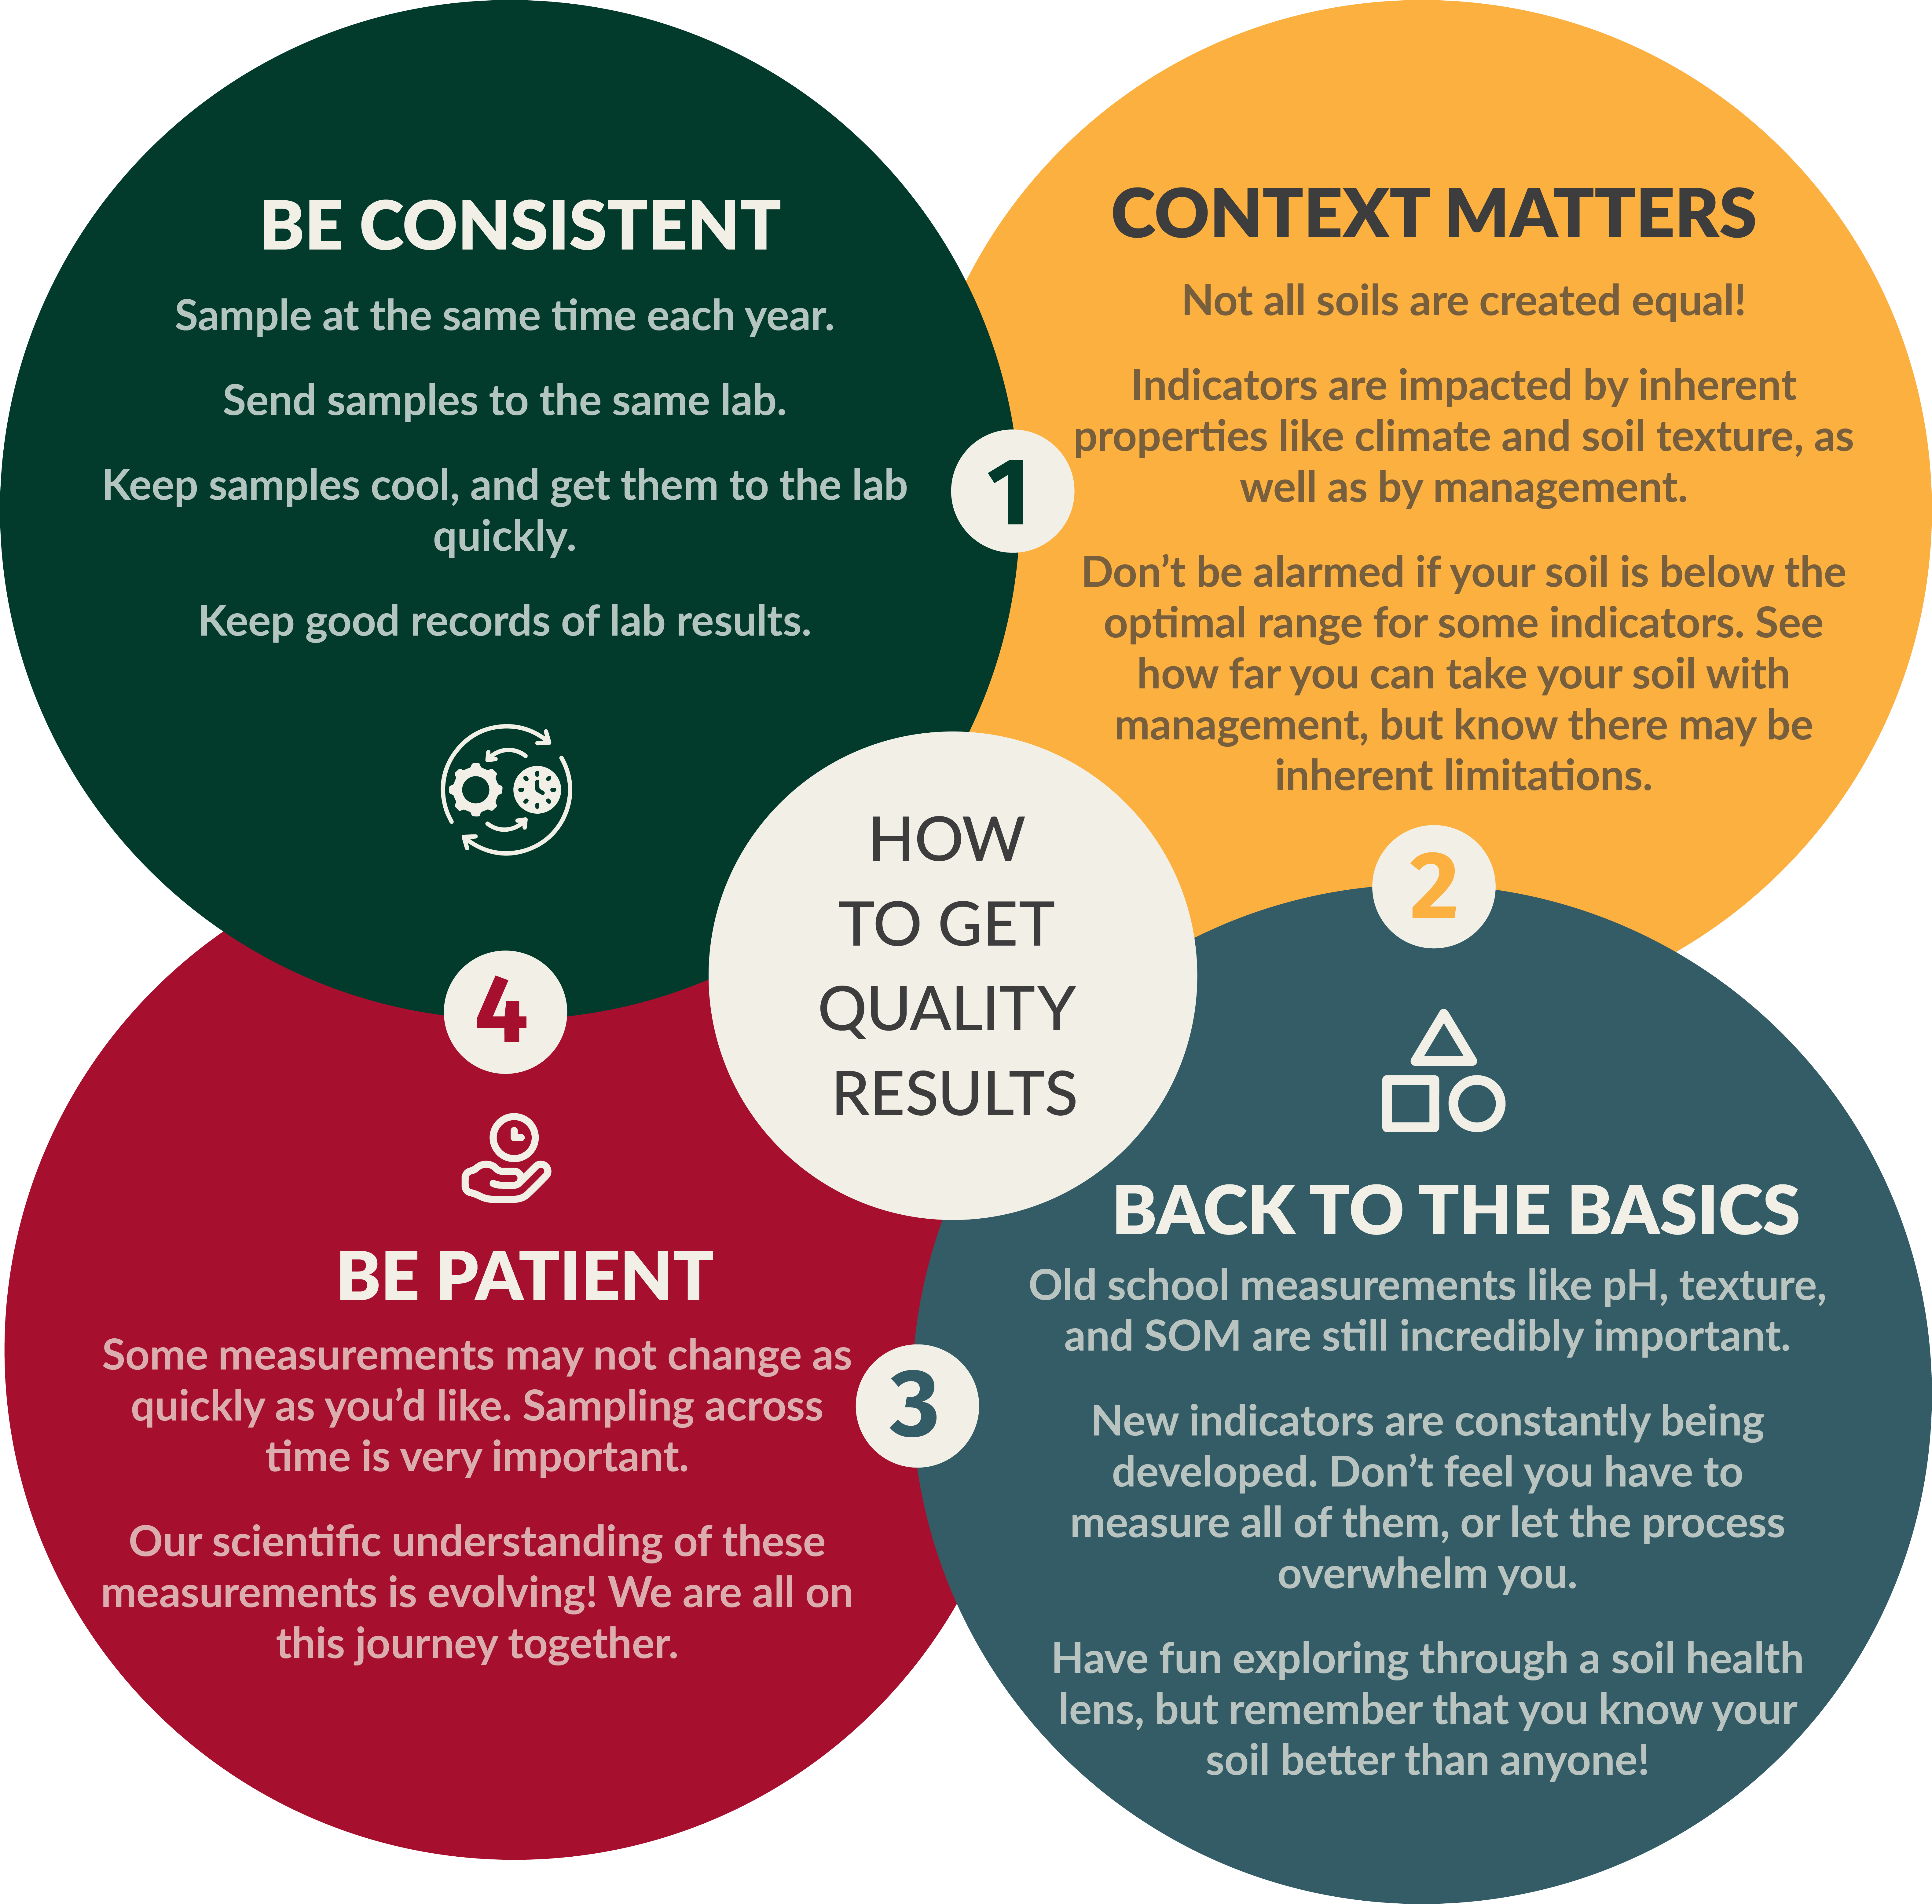

## Looking Forward

Insert text to add to the look forward section