Results from Test Project

Fall 2023

## Test Project

Insert text here about your project summary

## Soil Health

Soil health is a term that describes how well a soil ecosystem supports plants, animals, and humans. It also recognizes the living nature of soils and the importance of soil microorganisms. Healthy soils can provide wildlife habitat, support biodiversity, reduce the effects of climate change, filter air and water, increase crop productivity and food security, and ensure thriving rural economies.

## Soil Science 101

A crucial part of the soil health journey is measuring changes in your soil and understanding how to interpret those measurements. We can measure soil health with a range of indicators describing a soil’s physical, chemical, and biological properties, which can relate to important soil functions. Each indicator measures a different property of the soil and can be affected differently by management.

To learn more about management practices that support healthy soil, check out these resources from the [Natural Resources Conservation Service (NRCS) principles of building soil health](https://www.nrcs.usda.gov/conservation-basics/natural-resource-concerns/soils/soil-health).

## What We Measured in Your Soil

## Chemical

***Infiltration*** measures the rate at which water enters the soil surface. If the infiltration rate is low, water will pond on the surface. This can make it difficult to enter the field and lead to erosion and runoff. High salinity, plow pans, and cemented layers in the soil can lead to poor infiltration and drainage. Soil texture is also a major factor, as large pores created by sand particles quicken infiltration rates while small pores from clay particles slow infiltration rates. Management also plays a role. Excessive tillage can break up soil structure which slows infiltration. Adding organic matter can form soil aggregates, which can quicken infiltration. This indicator is typically measured in the field, as outlined in this [NRCS protocol](https://www.nrcs.usda.gov/sites/default/files/2022-10/Infiltration.pdf).

## Soil Health Indicators

The below table describes: 1. What each indicator helps measure in your soil; 2. Whether you want the measured value to be higher (more is better), lower (less is better), or in the middle (optimal range); and 3. How often to measure each indicator. Our understanding of these indicators is rapidly evolving as researchers measure them in diverse soils, cropping systems, and climates.

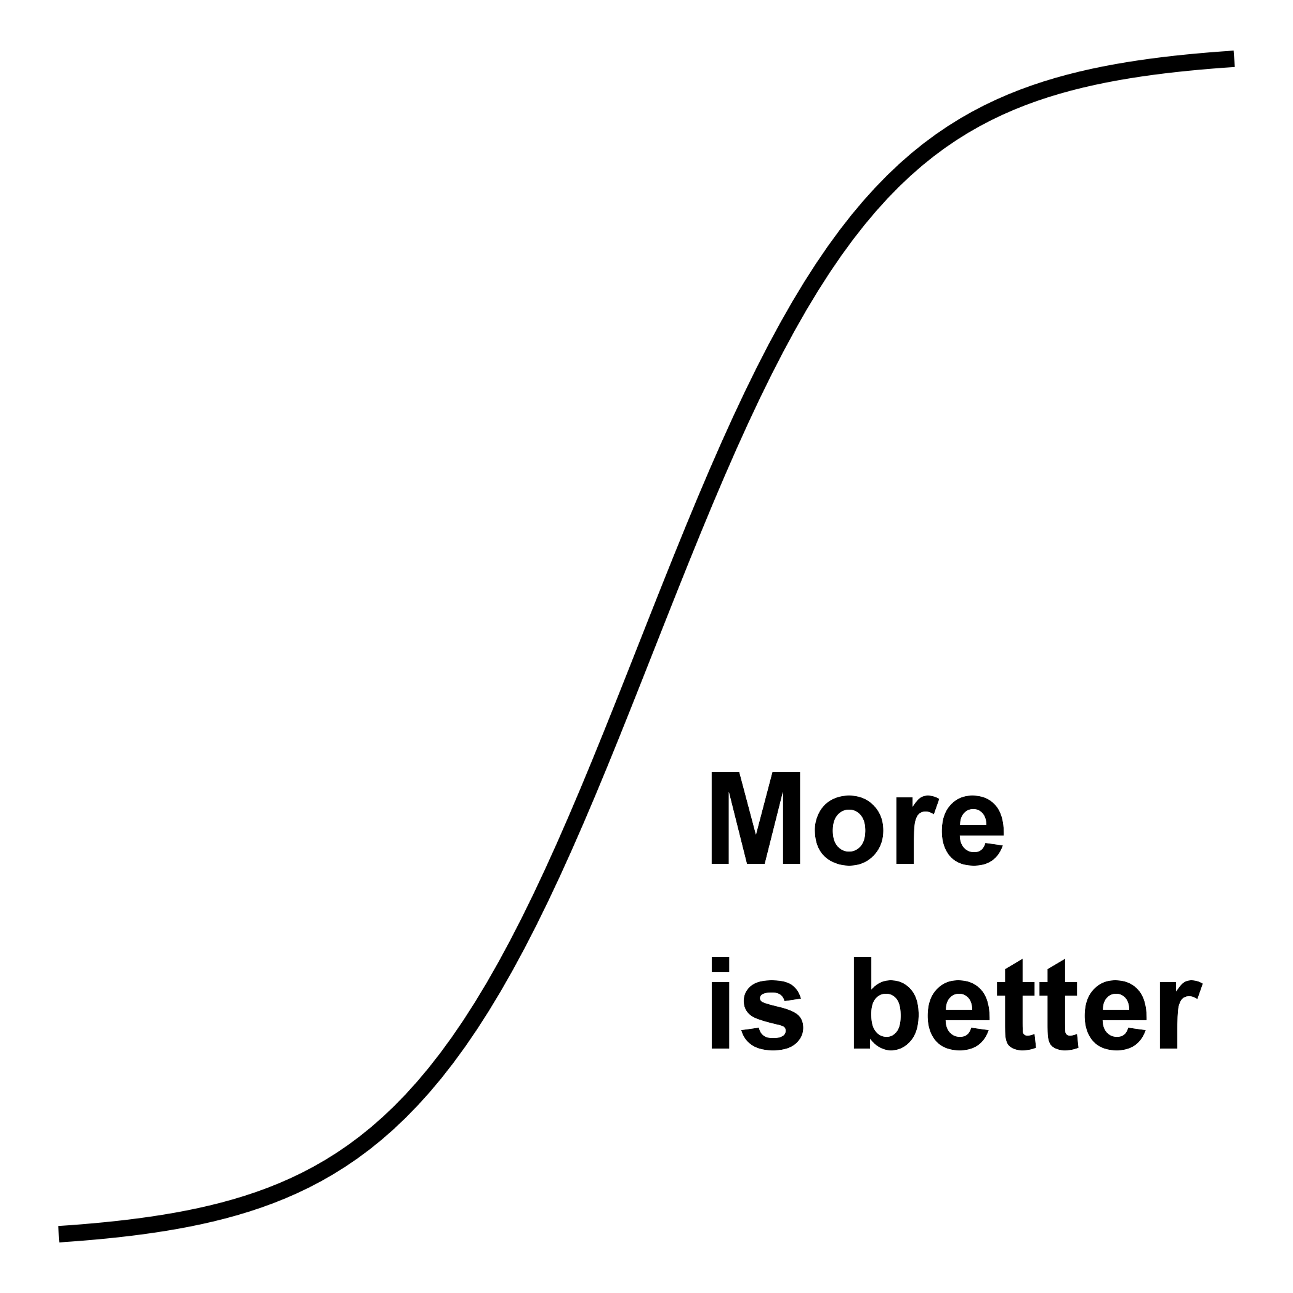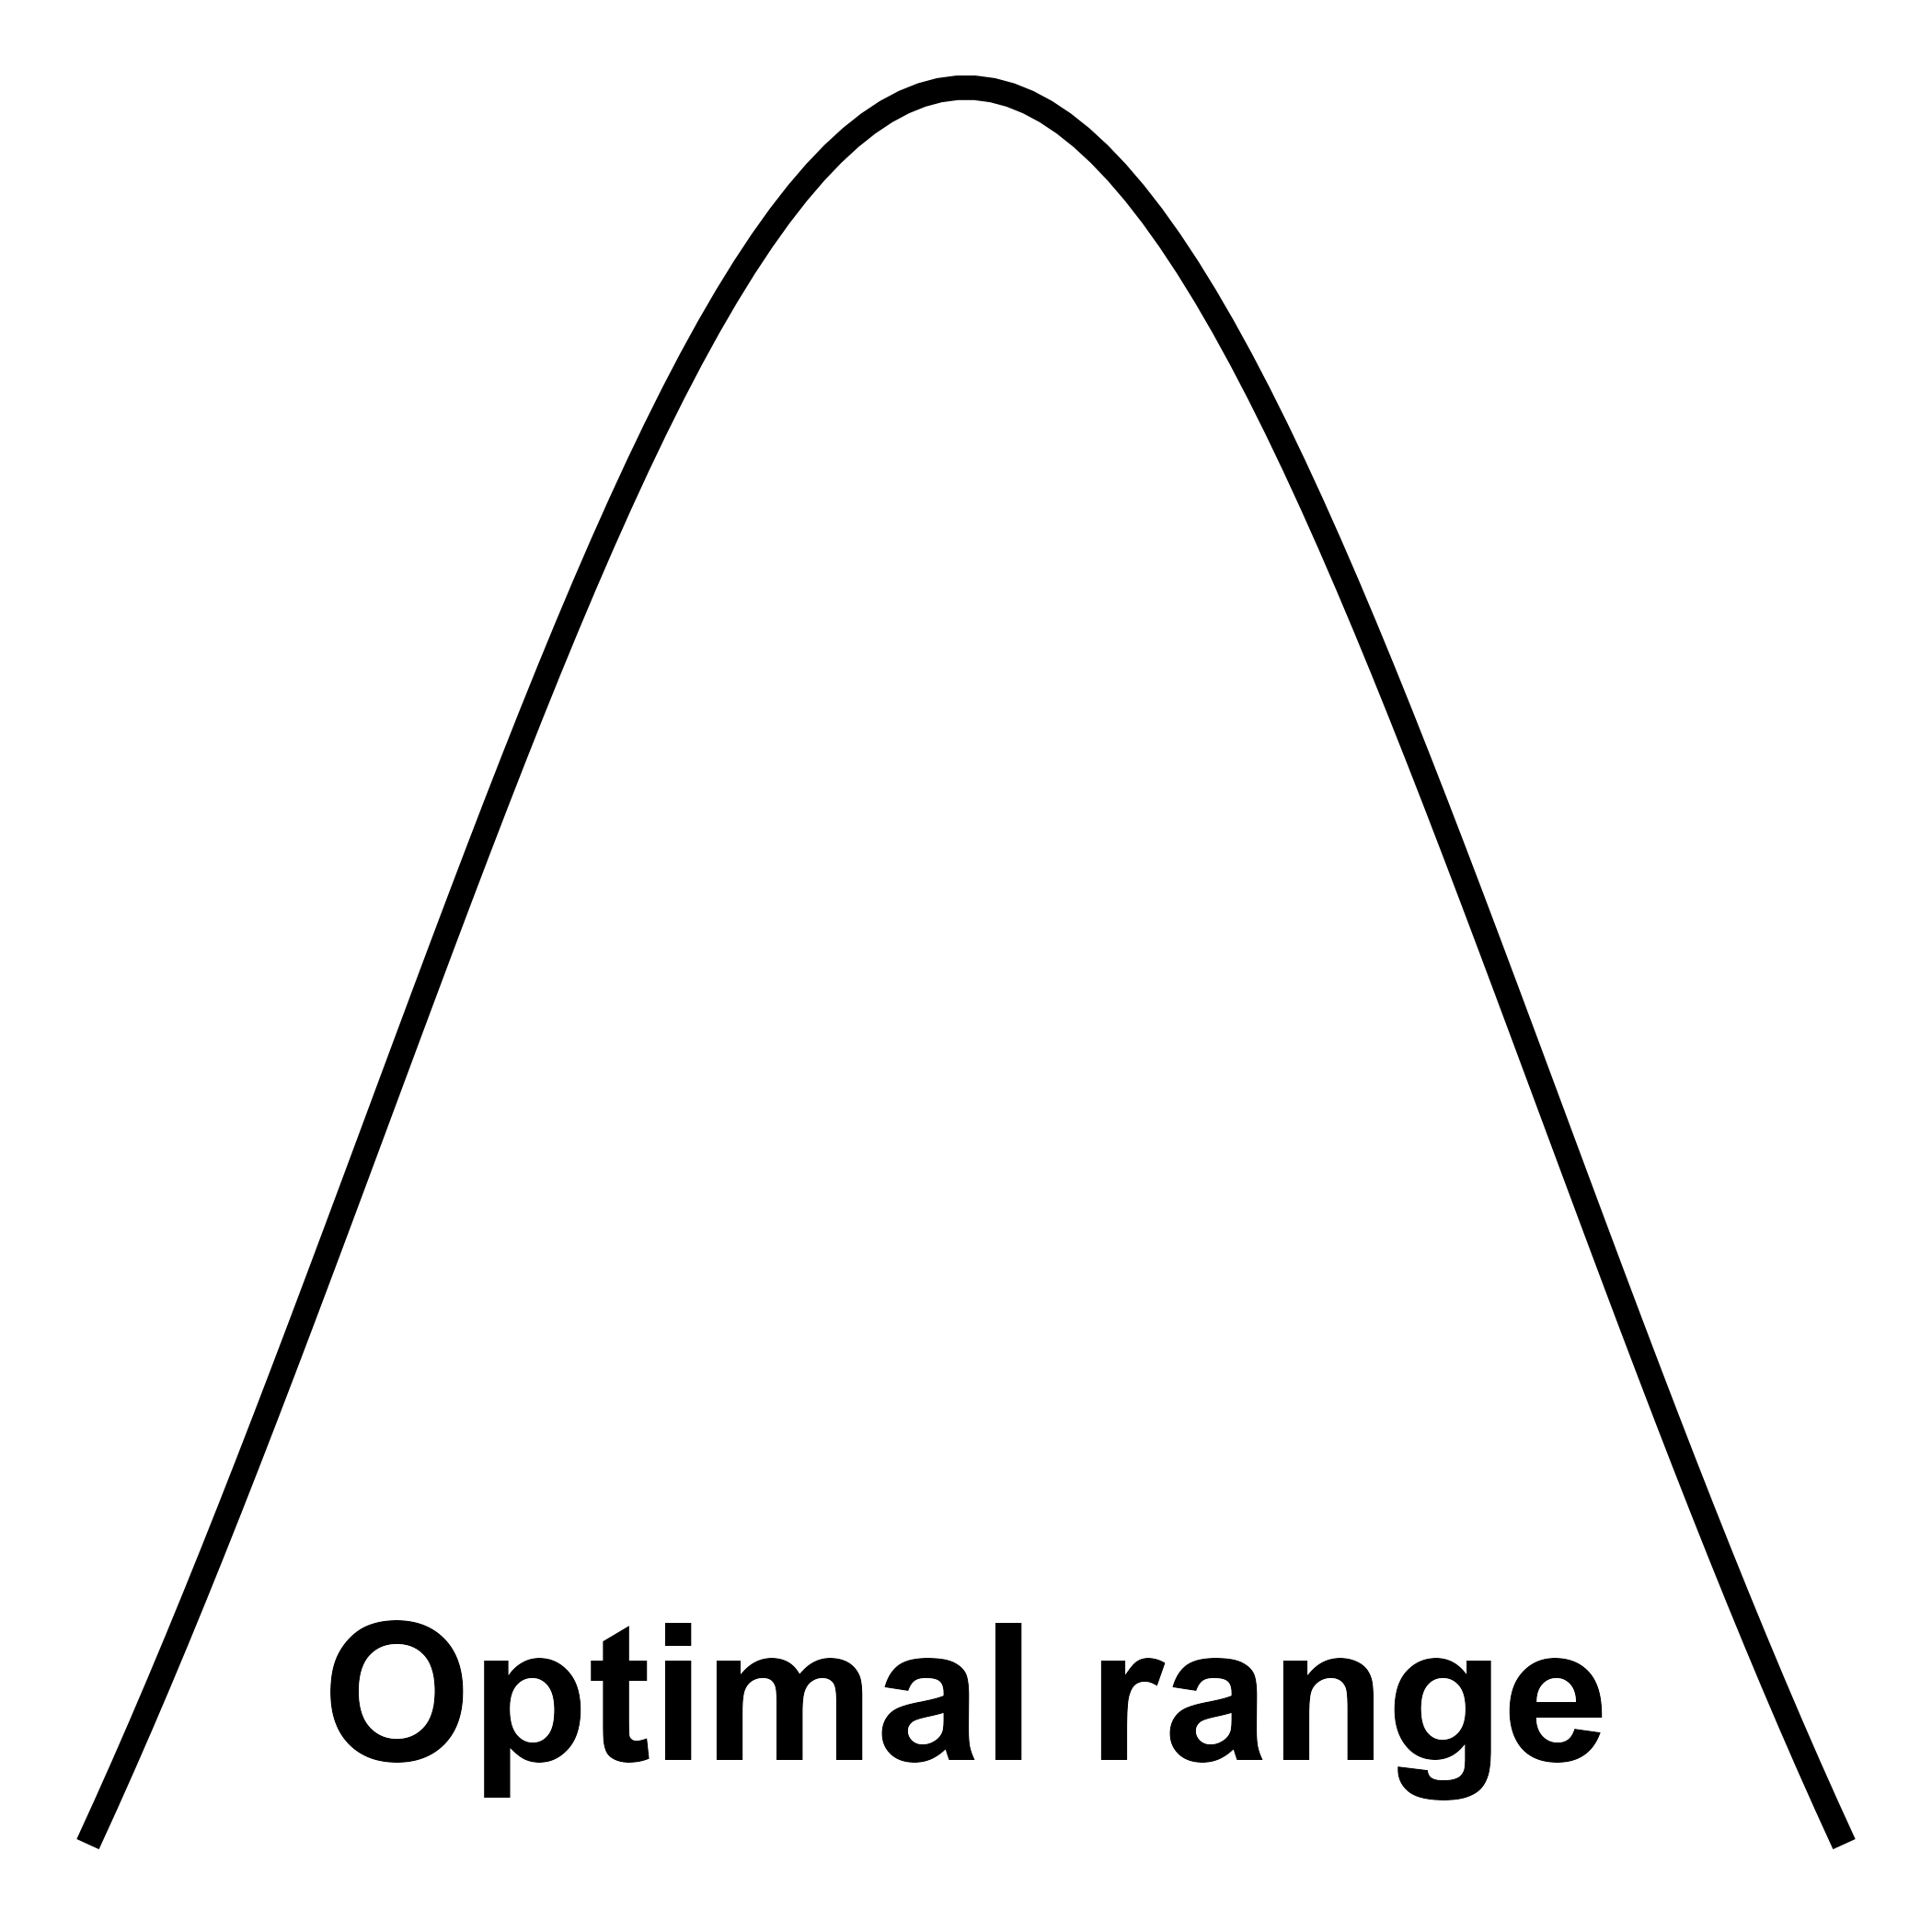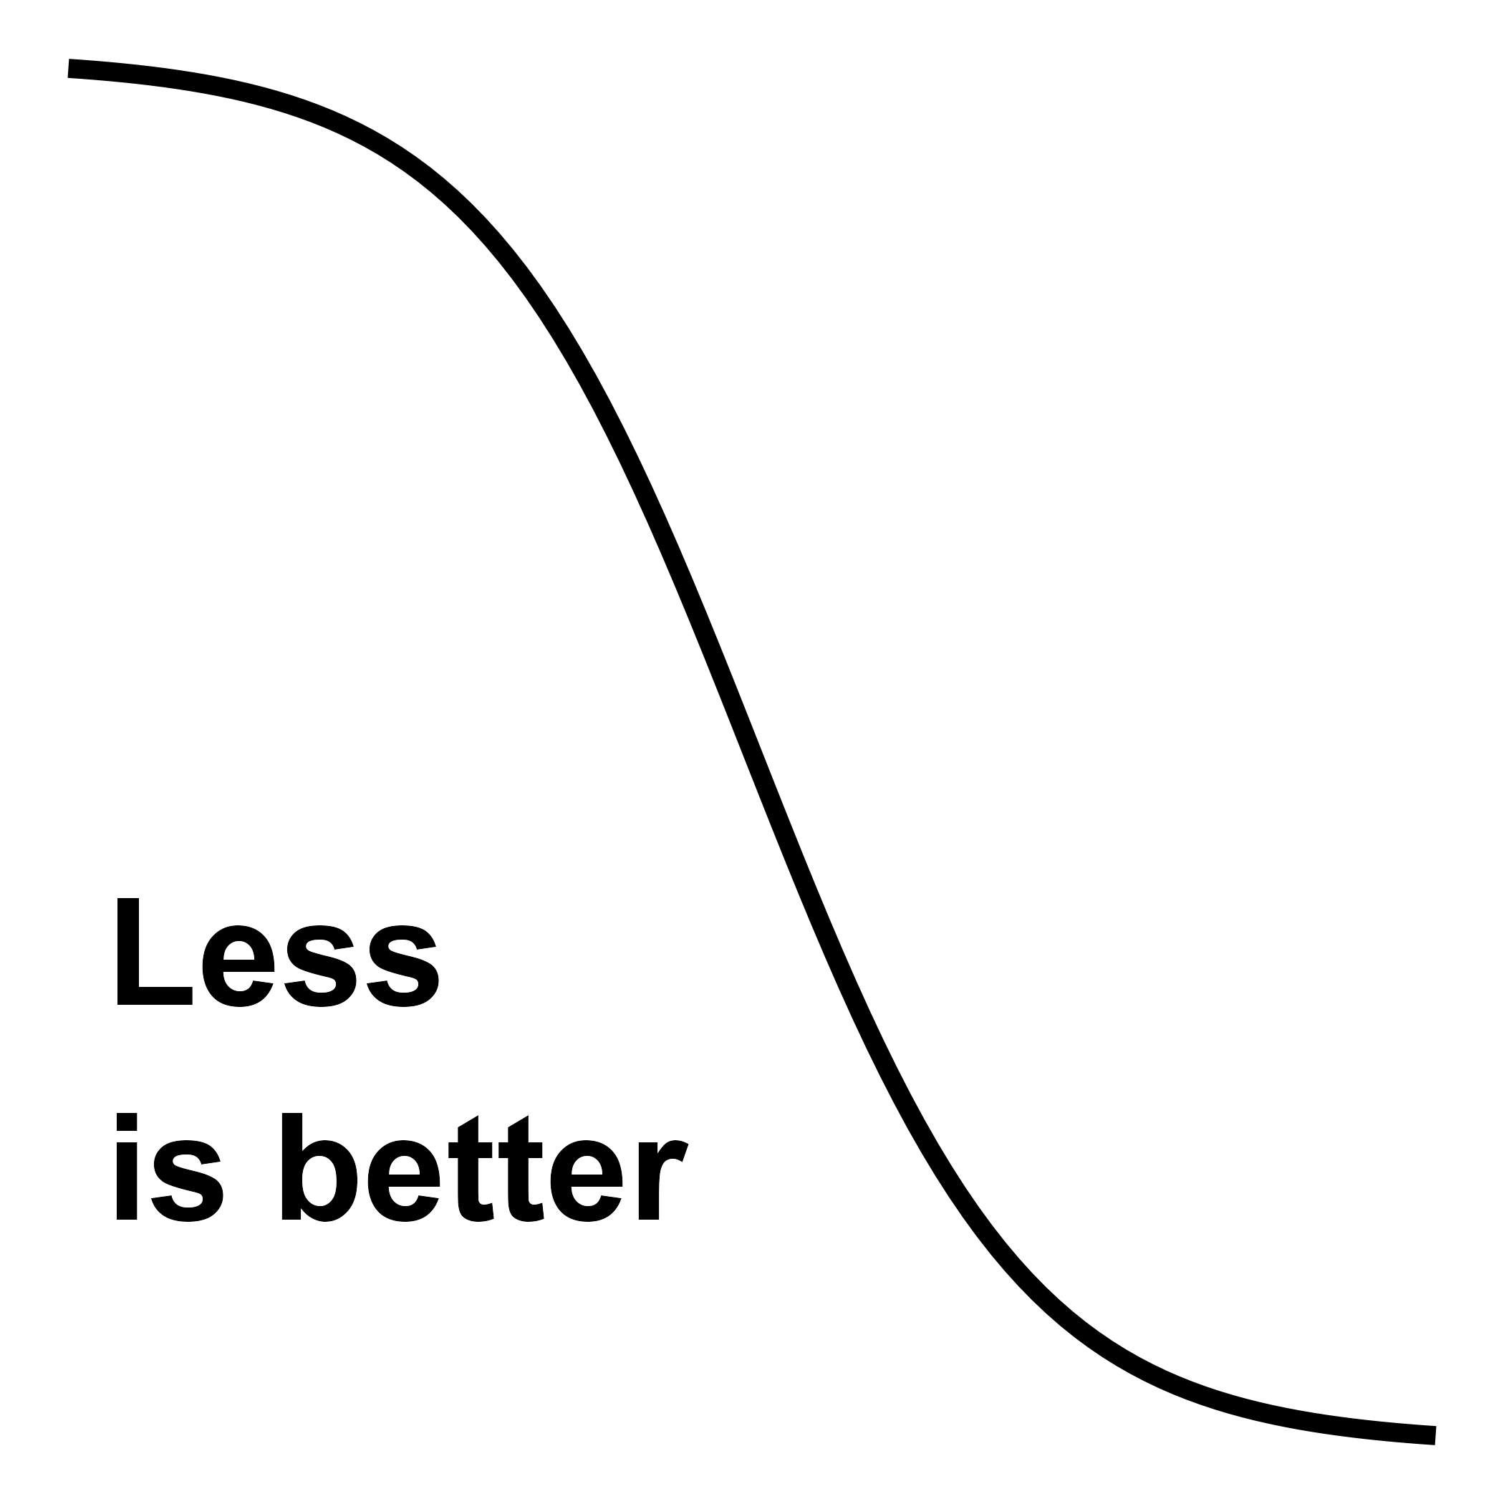

| Soil Health Indicator | Soil Function | Scoring Curve Type |
| --- | --- | --- |
| Measure every: 1-3 years | | |
| ACE Soil Protein | Nutrient cycling, biodiversity & habitat, filtering & resilience | More is better |
| Aggregate Stability | Physical support, water relations, biodiversity & habitat, filtering & resilience | More is better |
| Electrical Conductivity (EC) | Physical support, nutrient cycling, filtering & resilience | Less is better |
| Mineralizable Carbon | Nutrient cycling, biodiversity & habitat, filtering & resilience | More is better |
| Permanganate Oxidizable Carbon (POXC) | Biodiversity & habitat, nutrient cycling, filtering & resilience | More is better |
| Potentially Mineralizable Nitrogen (PMN) | Nutrient cycling, biodiversity & habitat, filtering & resilience | More is better |
| Soil pH | Nutrient cycling, filtering & resilience | Optimal range |
| Total Nitrogen | Nutrient cycling, biodiversity & habitat, filtering & resilience | Optimal range |
| Plant Essential Nutrients | Nutrient cycling | Optimal range |
| Measure every: 3-5 years | | |
| Bulk Density | Physical support, water relations, biodiversity & habitat, filtering & resilience | Optimal range |
| Cation Exchange Capacity | Nutrient cycling, filtering & resilience | More is better |
| Infiltration | Water relations, physical support | More is better |
| Soil Organic Matter (SOM) | Nutrient cycling, filtering & resilience | More is better |
| Water Holding Capacity (WHC) | Water relations, physical support | More is better |

## Soil Health Testing

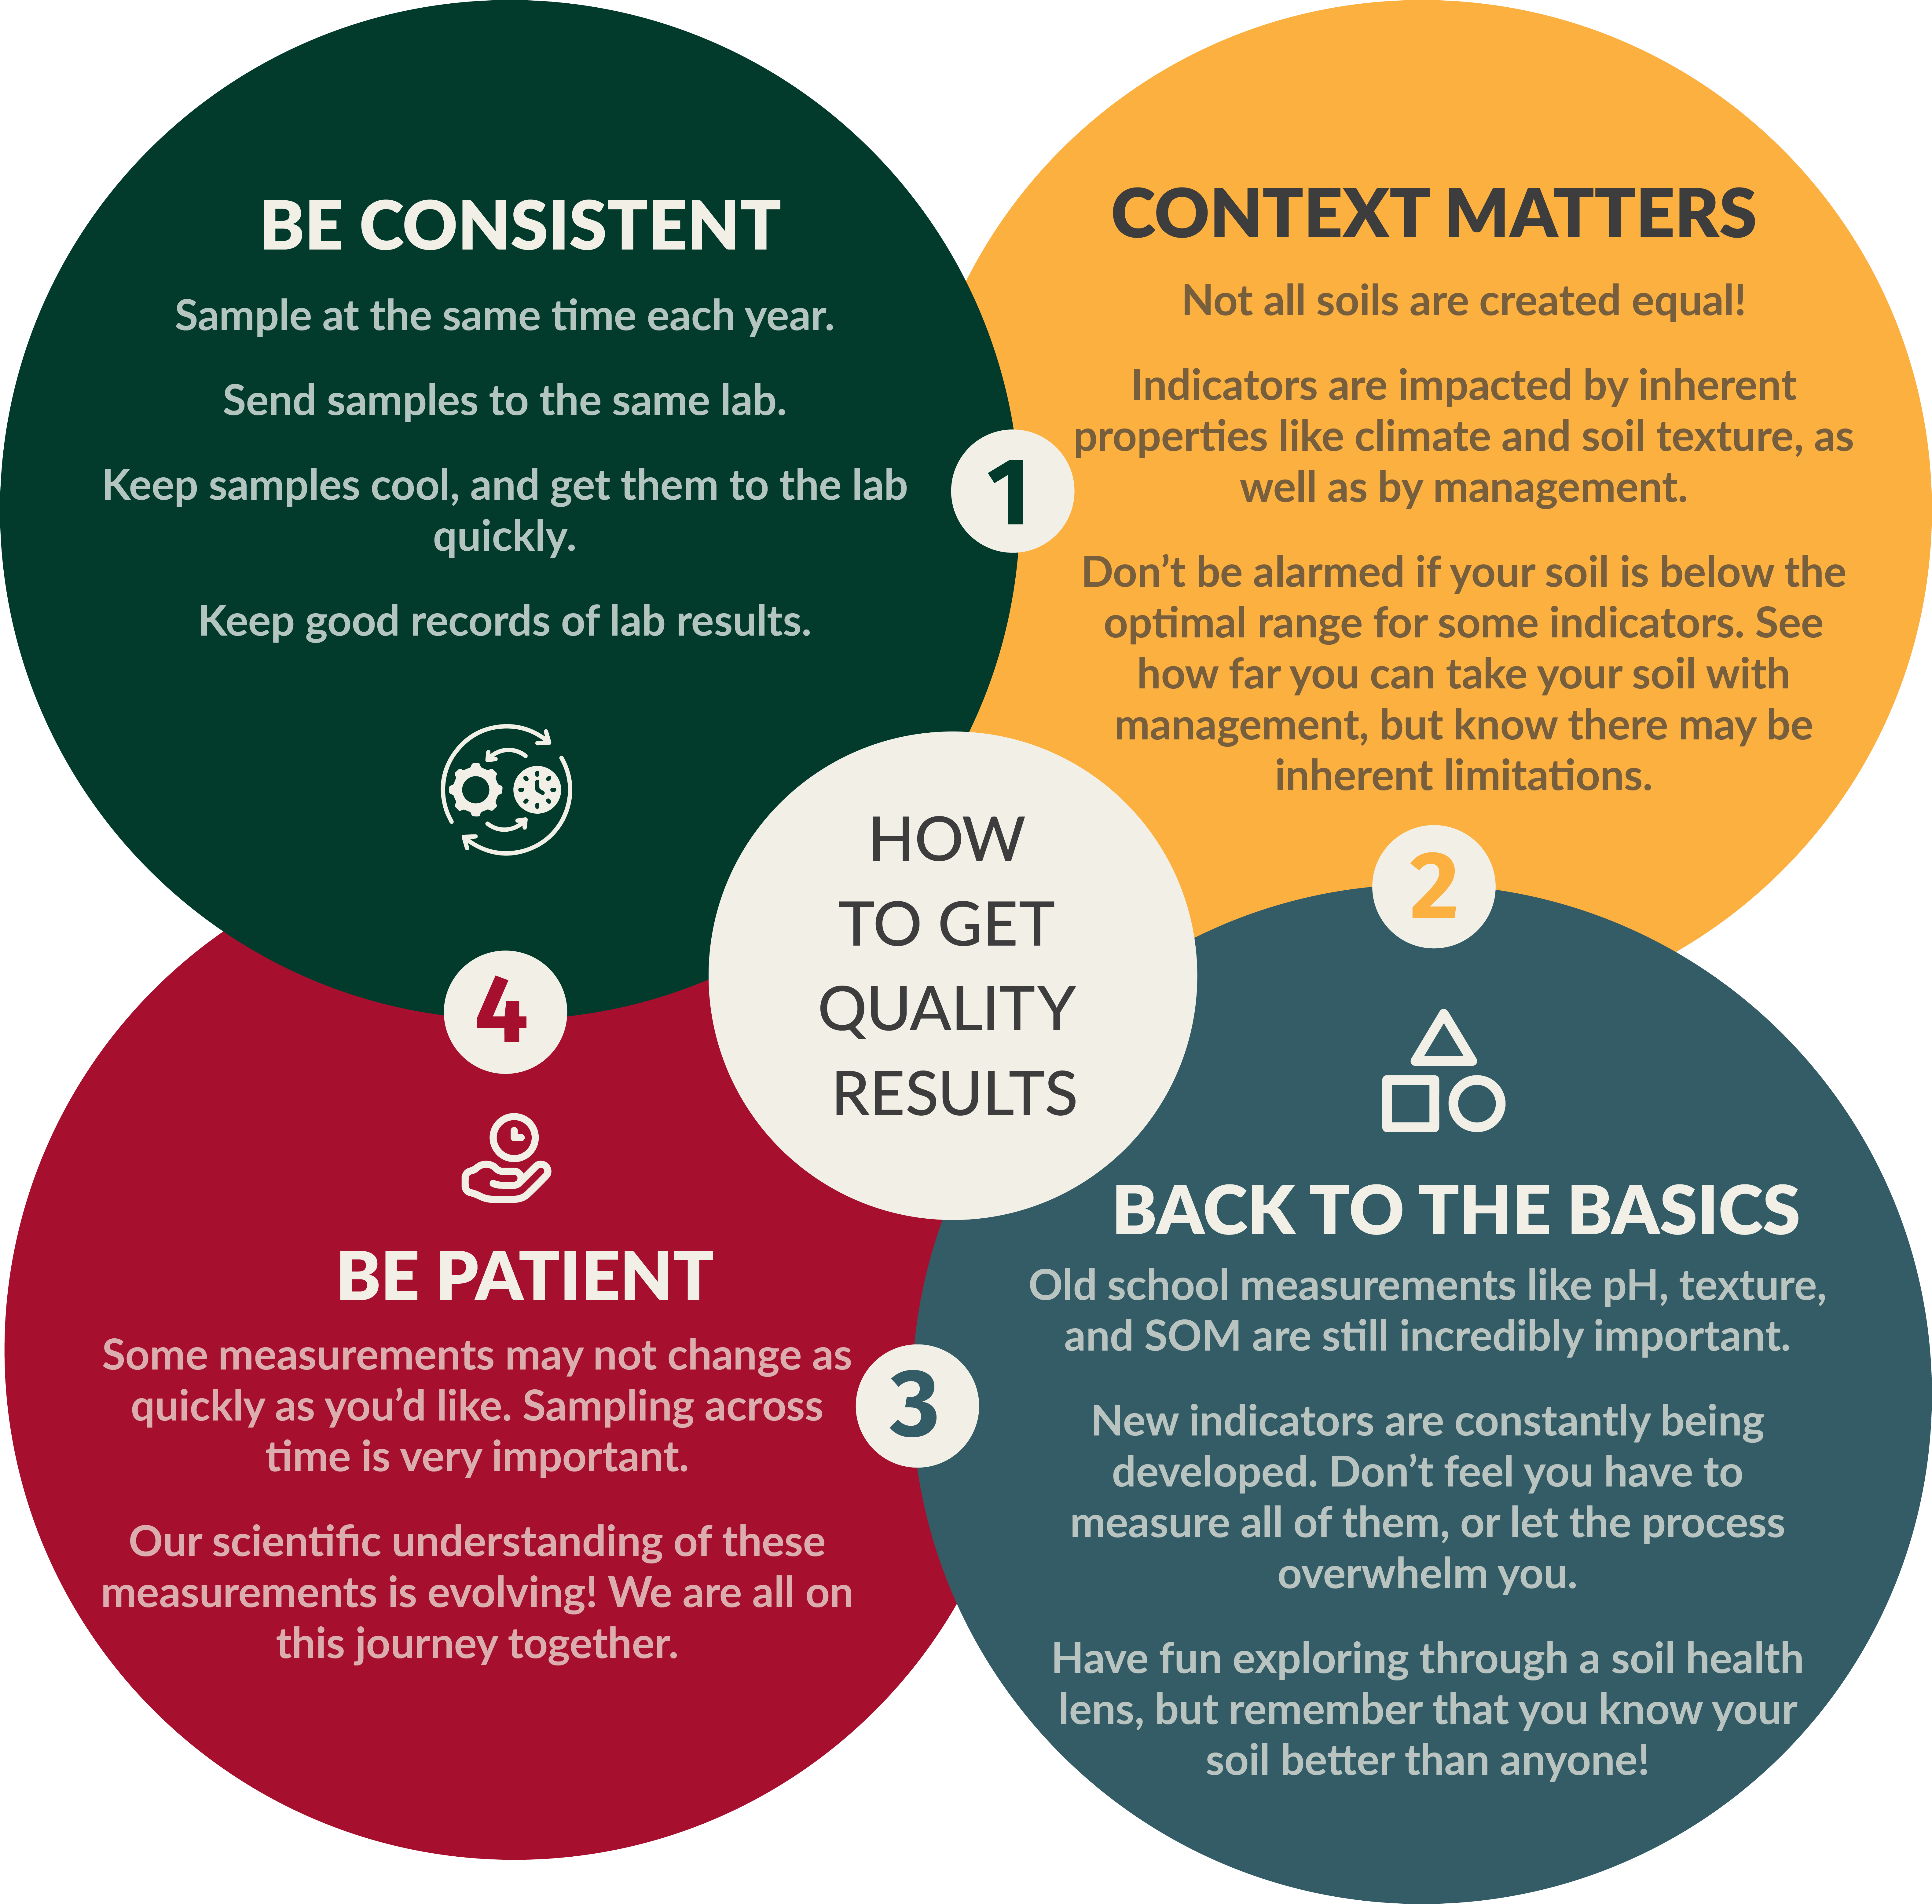

## Looking Forward

Insert text to add to the look forward section